**Hyaluronic acid promotes the proliferation of human amniotic epithelial cells via TGF-β/BMP signaling pathway**

Ya-Bing Tian1†, Nuo-Xin Wang1, 2†*, Chang-Yin Yu3*, Ru-Ming Liu1, 2, Yi Luo1, 2, Jian-Hui Xiao1, 2*

1Zunyi Municipal Key Laboratory of Medicinal Biotechnology, 2Center for Translational Medicine, 3Department of Neurology, Affiliated Hospital of Zunyi Medical University, Zunyi 563003, China

**Supplementary figures**

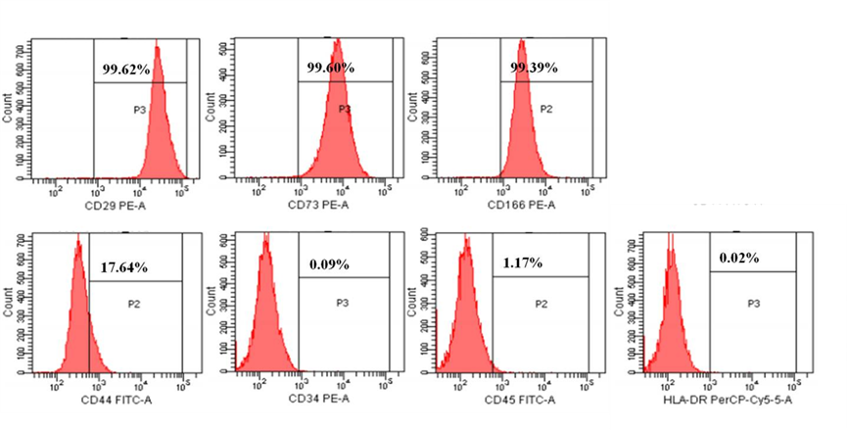

**Figure S1. Phenotypic analysis of hAECs by flow cytometry.**

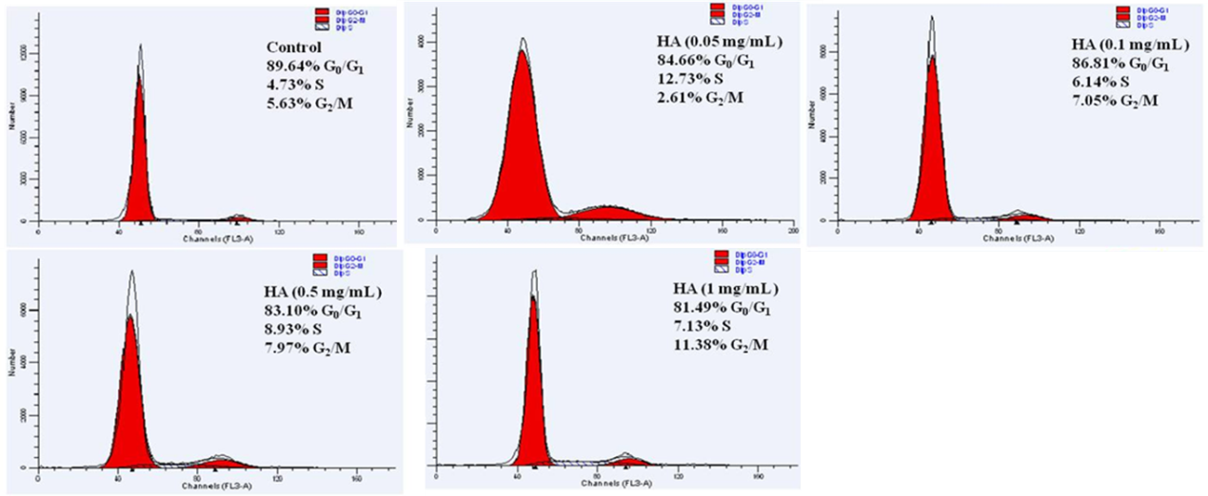

**Figure S2. Cell cycle analysis of hAECs by flow cytometry.**