Step-by-step Guide to Reproduce the MutRank Example Workflow Results

Example workflow 1: Integrating coexpression analyses of genes encoding a specialized metabolic pathway with supporting information

- In the side panel of the “Data Input” tab select the example files below:

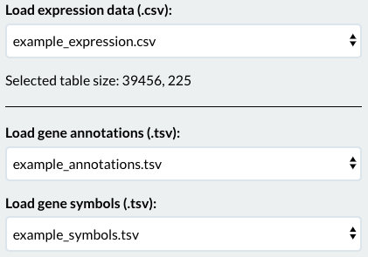

- Select the “Mutual Rank” tab at the top of the MutRank app

- Select “Reference gene list” as the reference gene method

- Paste into the ﻿ “List of reference genes” box the list of Bx genes from Supplementary Table 8 or directly from the gene list below: GRMZM2G085381,GRMZM2G085661,GRMZM2G167549,GRMZM2G172491,GRMZM2G063756,GRMZM2G085054,GRMZM2G161335,GRMZM2G311036,GRMZM2G336824,GRMZM2G023325,AC148152.3_FG005,GRMZM2G127418

- Press the “Calculate MR Values” button to generate the coexpression table

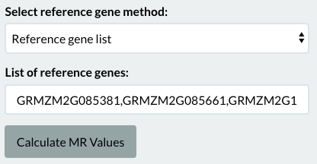

- Deselect ﻿the “Add custom categories” and “﻿Add foldchange values” options

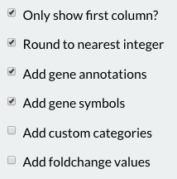
- This will reproduce the MR-based coexpression table presented in Figure 2A

- Select the “Heatmap” tab at the top of the MutRank app

- Change the “Text MR threshold” box to 100

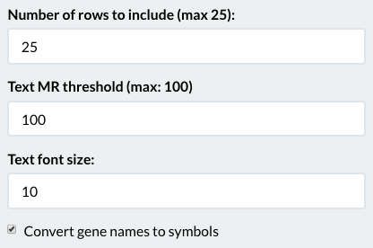

- This will reproduce the MR-based coexpression heatmap presented in Figure 2B

- Select the “Network” tab at the top of the MutRank app

- Change the “Select MR Threshold” box to 100

- Deselect the “Change bait gene to star shape?” and “Color vertices with foldchange data” options

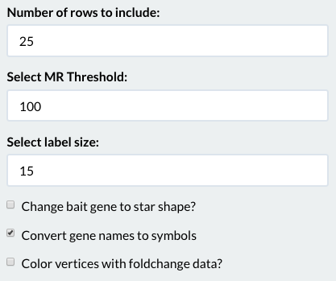

- This will reproduce the MR-based coexpression network presented in Figure 2C

Example workflow 2: Using MutRank to predict enzymes in specialized metabolism.

- In the side panel of the “Data Input” tab select example files below

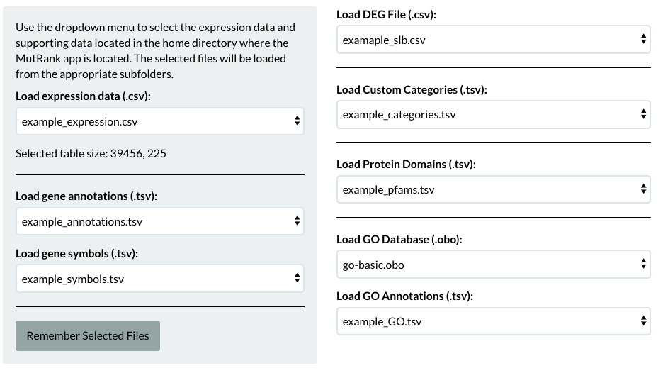

- Select the “Mutual Rank” tab at the top of the MutRank app

- Select “Single reference gene” as the reference gene method

- Paste into the ﻿“List of reference genes” box the gene ID for ZmAN2 from Supplementary Table 8 or use: GRMZM2G044481

- Press the “Calculate MR Values” button to generate the coexpression table

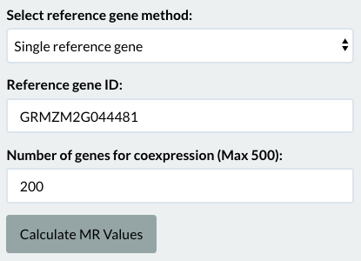

- Keep all additional options selected

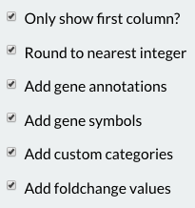

- This will reproduce the MR-based coexpression table presented in Figure 3A (Figure 3A is a screenshot of the first 12 genes from this table. The complete table can be found in Supplementary Table 9)

- Select the “Network” tab at the top of the MutRank app

- Change the “Number of rows to include” box to 12

- Change the “Select MR Threshold” box to 10

- Deselect the "Change bait gene to star shape?" option and keep all additional options selected

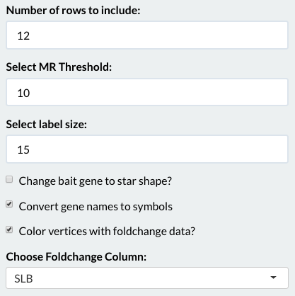

- In the “Category for diamond shape” select “TPS” and in the “Category for square shape” select “CYP”

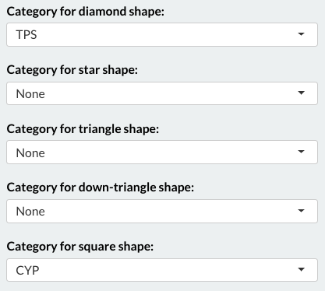

- This will reproduce the MR-based coexpression network presented in Figure 3B

- Select the “Heatmap” tab at the top of the MutRank app

- Change the “Number of rows to include” box to 12

- Change the “Text MR threshold” box to 100

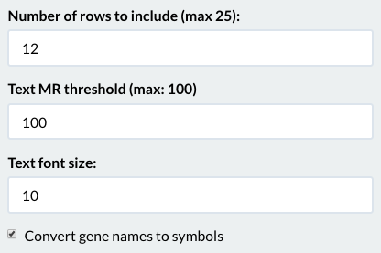

- This will reproduce the MR-based coexpression heatmap presented in Figure 3C

- Select the “Enrichment” tab at the top of the MutRank app

- Deselct the “Include non-adjusted p values?” option

- This will reproduce the MR-based GO enrichment table presented in Figure 3D

