A Bayesian brain model of adaptive behavior: An application to the Eisconsin Card Sorting Task
Supplementary Material

Marco D’Alessandro, Stefan T. Radev, Andreas Voss, and Luigi Lombardi
Corresponding author: Marco D’Alessandro (marco.dalessandro@unitn.it)

In what follows, we provide the full joint posterior densities of the two cognitive parameters, namely, flexibility (λ) and information loss (δ), together with the mean coordinates (dotted lines) used as point estimates to recover information-theoretic quantities in the main text.

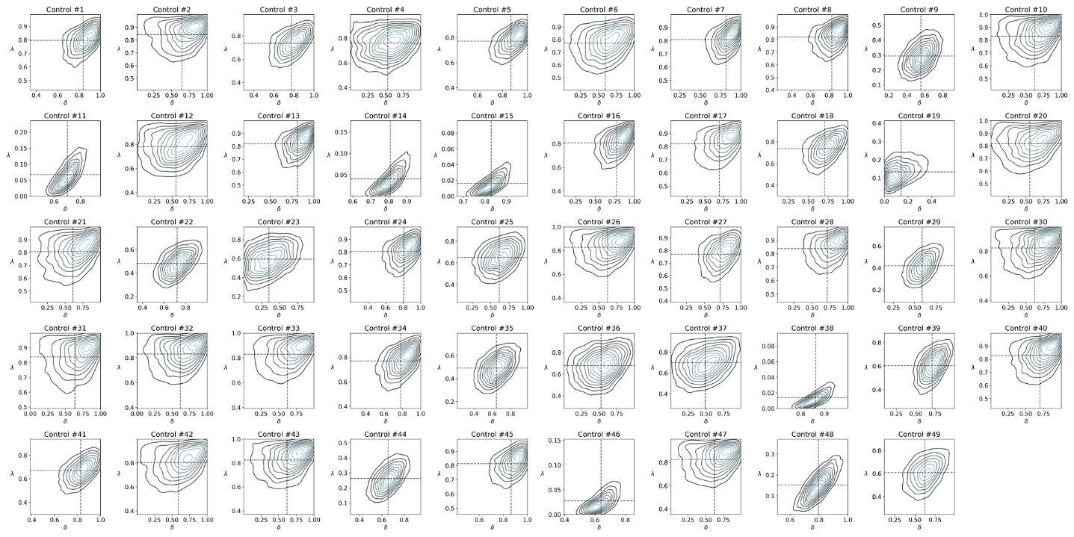

Healthy individuals. The figure shows the joint posterior density of the two cognitive parameters for each participant in the control group. Dotted lines show the distribution mean.

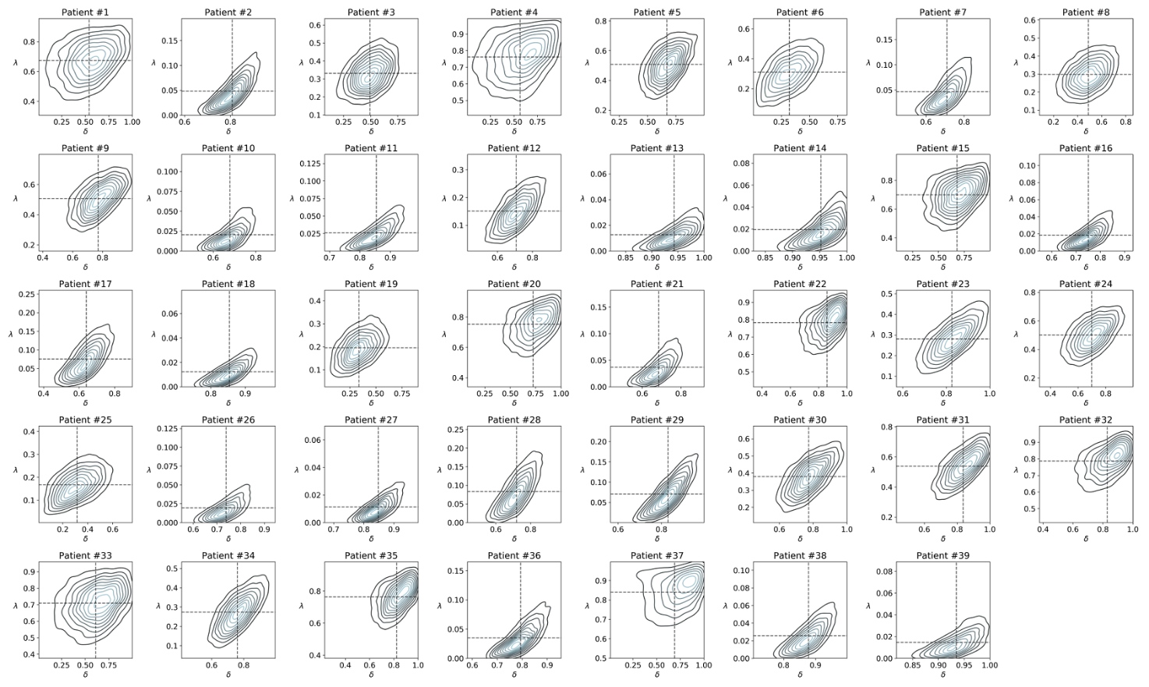
Sudstance dependent individuals. The figure shows the joint posterior density of the two cognitive parameters for each patient in the SDI group. Dotted lines show the distribution mean.

