Exogenous Fe²⁺ alleviated the toxicity of CuO nanoparticles on Pseudomonas tolaasii Y-11 under different nitrogen sources

Yuran Yang¹, Can Zhang¹, Xuejiao Huang¹, Xuwei Gui¹, Yifang Luo², Zhenlun Li^{1*}

¹ Chongqing Key Laboratory of Soil Multiscale Interfacial Process, College of Resources and Environments, Southwest University, Chongqing, China
² Chongqing Key Laboratory of plant disease biology, College of Plant Protection, Southwest University, Chongqing, China

*Corresponding Author:
Zhenlun Li
No. 2 Tiansheng Road, Tiansheng Street, Beibei District, Chongqing, 400715, China.
Email address: lizhlun4740@sina.com

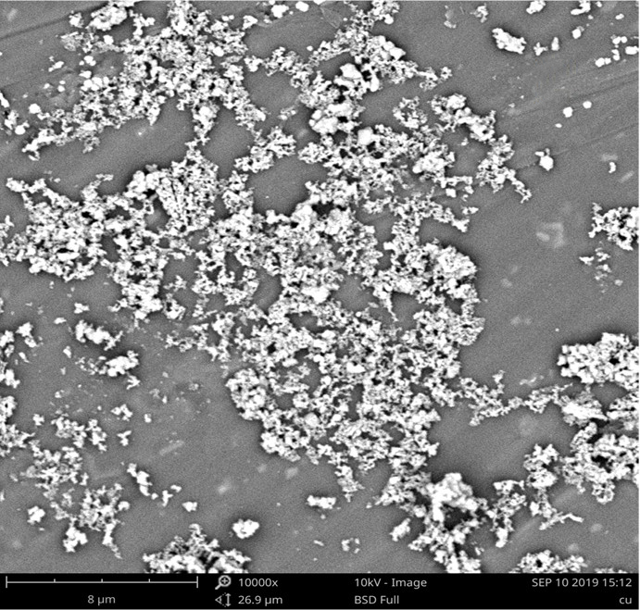
Suppl. Fig S1: SEM image of 2000 mg/L CuO-NPs.

