Supplementary file of “Effect of plastic mulching on the accumulation and distribution of macro and micro plastics in soils of two farming systems in Northwest China”
Fanrong Meng, Tinglu Fan, Xiaomei Yang, Michel Riksen, Minggang Xu, Violette Geissen

Table S1: Climate data and soil information
Table S2: Plastic specification used in S1 and S2
Table S3: Summary of the one way ANOVA for macroplastics number and content in 0-30 cm.
Table S4: The number and mass percentage of MaPs in different size categories in two study region
Table S5: Summary of the one way ANOVA for the number and mass percentage of MaPs in different size categories in two study region
Table S6: Summary of the one way ANOVA for macroplastics number and mass in different soil layer in S1
Table S7: Summary of the one way ANOVA for macroplastics number and mass in different soil layer in S2
Figure S1: PP flat weave mesh bag.
Figure S2: Macroplastics shapes.
Figure S3: Macroplastics size group classification.
Figure S4: PP bag for collecting soil samples for microplastic extraction.
Figure S5: Microplastics identification set up.
Table S1: Climate data and soil information.
Indicators | S1 | S2
Annual average temperature | 7-10°C | 6.5-7.2 °C
Accumulate temperature (>10℃) | 2 722 ℃ | 2 950 ℃
Annual average precipitation | 540 mm | 210 mm
Annual sunshine duration | 2 262 h | 2 865 h
Frost-free days | 160 days | 160 days
Annual average wind speed | 2.16 m/s | 1.75 m/s
Soil type | Calcarid Regosol | Calcaric Fluvisol
Soil pH | 7.98±0.14 | 7.90±0.05
Soil organic matter content (SOM) | 13.1±1.76 g·kg⁻¹ | 14.3±0.44 g·kg⁻¹
Note. SOM measured by method:H₂SO₄-K₂Cr₂O₇.Soil pH and soil organic matter (SOM) content was the average of selected fields in each study region.

Table S2: Plastic specification used in S1 and S2
Plastic film | Colour | Thickness  (mm) | Density  (g·cm⁻³) | Materials | Standard | Manufacturer
S1 | Transparent | 0.01 | 0.9 | LLDPE | GB 13735-1992(II) | Gansu Swift Management Consulting Co., Ltd., China
S2 | Transparent | 0.01 | 0.9 | LLDPE & LDPE | GB 13735-1992(IV) | Xinjiang Tianshili Plastic Industry Co., Ltd.
Note: low-density polyethylene (LDPE) and linear low-density polyethylene (LLDPE).

Table S3: Summary of the one way ANOVA for macroplastics number and content in 0-30 cm.
MaPS accumulation | Study region | df | F | Sig
MaPs number | S1 | 5,12 | 20.9 | 0.00
 | S2 | 4,10 | 61.7 | 0.00
MaPs mass | S1 | 5,12 | 4.24 | 0.02
 | S2 | 4,10 | 17.1 | 0.00

Table S4 : The number and mass percentage of MaPs in different size categories in two study region (one way ANOVA and followed by LSD test at the p <0.05 level).
MaPs accumulation | Fields | 0.25-2 cm² |  | 2-10 cm² | 10-50 cm² |  | 50-100 cm² |  | >100 cm²
MaPs number | S1 Continuous | 3.55±2.16d |  | 34.4±8.19b | 46.9±7.64a |  | 9.57±2.57c |  | 5.55±2.05d
 | S1 Intermittent | 4.20±3.21d |  | 31.6±9.63b | 44.5±11.2a |  | 8.73±4.77c |  | 11.0±10.2c
 | S2 | 40.6±13.0a |  | 41.1±9.43a | 14.7±4.71b |  | 2.54±2.04c |  | 1.09±1.13c
MaPs mass | S1 Continuous | 0.16±0.09d |  | 7.17±2.23c | 35.8±5.27a |  | 22.0±4.50b |  | 34.8±8.24a
 | S1 Intermittent | 0.26±0.31d |  | 6.28±3.91c | 34.2±21.6a |  | 16.3±7.29b |  | 42.9±24.0a
 | S2 | 8.93±5.19c |  | 26.2±7.95b | 36.4±7.1a |  | 17.4±8.06c |  | 11.1±10.8c
Note: Lowercase letters (a,b,c) indicate significant difference between different MaPs size categories within same fields.
Table S5: Summary of the one way ANOVA forthe number and mass percentage of MaPs in different size categories in two study region. Data have been transformed using arcsine square root.
MaPs accumulation |  |  | Fields |  |  | df |  | F |  | Sig.
MaPs number |  |  | S1 Continuous |  |  | 4,40 |  | 148 |  | 0.00
 |  |  | S1 Intermittent |  |  | 4,40 |  | 35.9 |  | 0.00
 |  |  | S2 |  |  | 4,70 |  | 18.4 |  | 0.00
MaPs mass |  |  | S1 Continuous |  |  | 4,40 |  | 217 |  | 0.00
 |  |  | S1 Intermittent |  |  | 4,40 |  | 28.4 |  | 0.00
 |  |  | S2 |  |  | 4,70 |  | 172 |  | 0.00

Table S6: Summary of the one way ANOVA for macroplastics number and mass in different soil layer in S1. Data have been transformed using arcsine square root.
MaPs accumulation | Study region | df | F | Sig
MaPs number | S1-1 | 2,6 | 12.1 | 0.01
 | S1-2 | 2,6 | 16 | 0.00
 | S1-3 | 2,6 | 39.4 | 0.00
 | S1-4 | 2,6 | 7.74 | 0.02
 | S1-5 | 2,6 | 11.7 | 0.01
 | S1-6 | 2,6 | 4.88 | 0.06
MaPs mass | S1-1 | 2,6 | 28.9 | 0.001
 | S1-2 | 2,6 | 22.2 | 0.002
 | S1-3 | 2,6 | 46.7 | 0.000
 | S1-4 | 2,6 | 9.19 | 0.015
 | S1-5 | 2,6 | 4.38 | 0.067
 | S1-6 | 2,6 | 12.6 | 0.007

Table S7: Summary of the one way ANOVA for macroplastics number and mass in different soil layer in S2. Data have been transformed using arcsine square root.
MaPs accumulation | Study region | df | F | Sig
MaPs number | S2-1 | 2,6 | 4.51 | 0.064
 | S2-2 | 2,6 | 4.83 | 0.056
 | S2-3 | 2,6 | 4.5 | 0.064
 | S2-4 | 2,6 | 32.5 | 0.001
 | S2-5 | 2,6 | 6.79 | 0.029
MaPs mass | S2-1 | 2,6 | 5.55 | 0.043
 | S2-2 | 2,6 | 24.6 | 0.001
 | S2-3 | 2,6 | 16.9 | 0.003
 | S2-4 | 2,6 | 18.7 | 0.003
 | S2-5 | 2,6 | 19.2 | 0.002

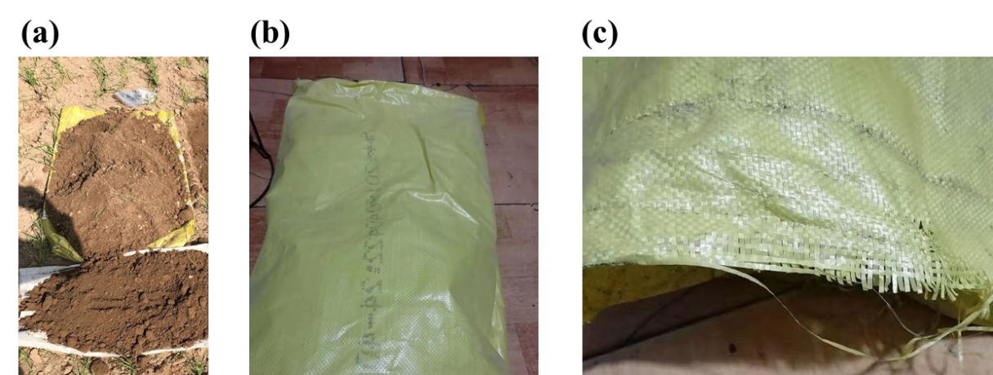
Fig. S1. Flat PP wire weaved mesh sheet. (a), (b) are the Flat PP wire weaved mesh sheet used in the field sampling, (c) is the flat wire used for weave the bag.

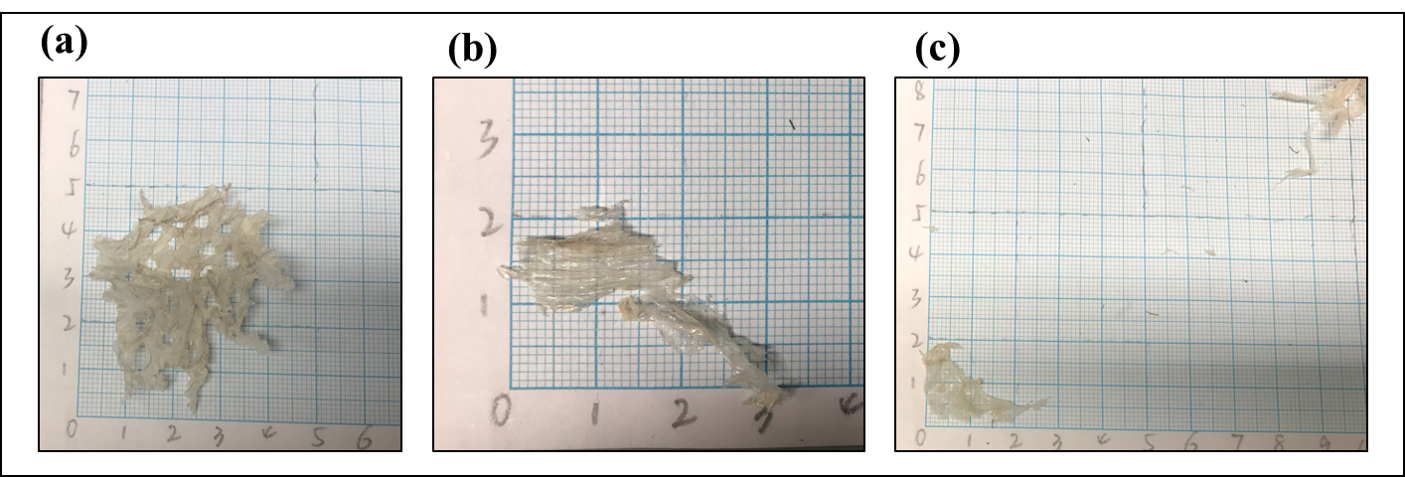
Fig. S2. The shapes and smallest size of collected Macroplastics. (a) arbitrary shape; (b) curved shape; (c) flake shape and curved shape; (d) the macroplastic buried in soil layers and collected macroplastics.

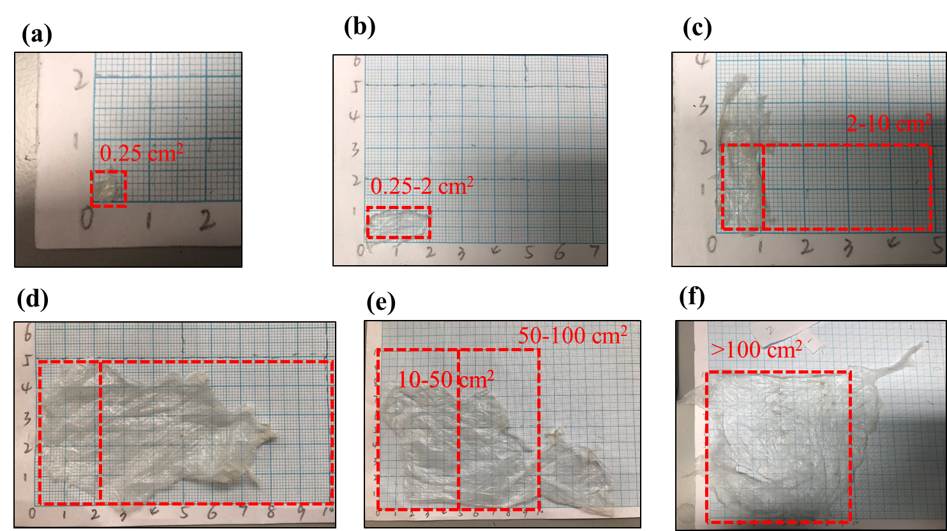
Fig. S3. Macroplastics different size group; (a) the smallest size of detected MaPs (approximately 0.25 cm²); (b) Macroplastics size 0.25-2cm²; (c) Macroplastics size 2-10 cm²; (d) Macroplastics size 10- 50 cm²; (e) Macroplastics size 50- 100 cm²; (f) Macroplastics size > 100 cm².
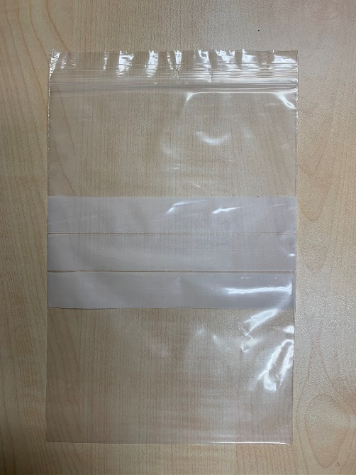
Fig. S4. PP bag for collecting soil samples for microplastic extraction.

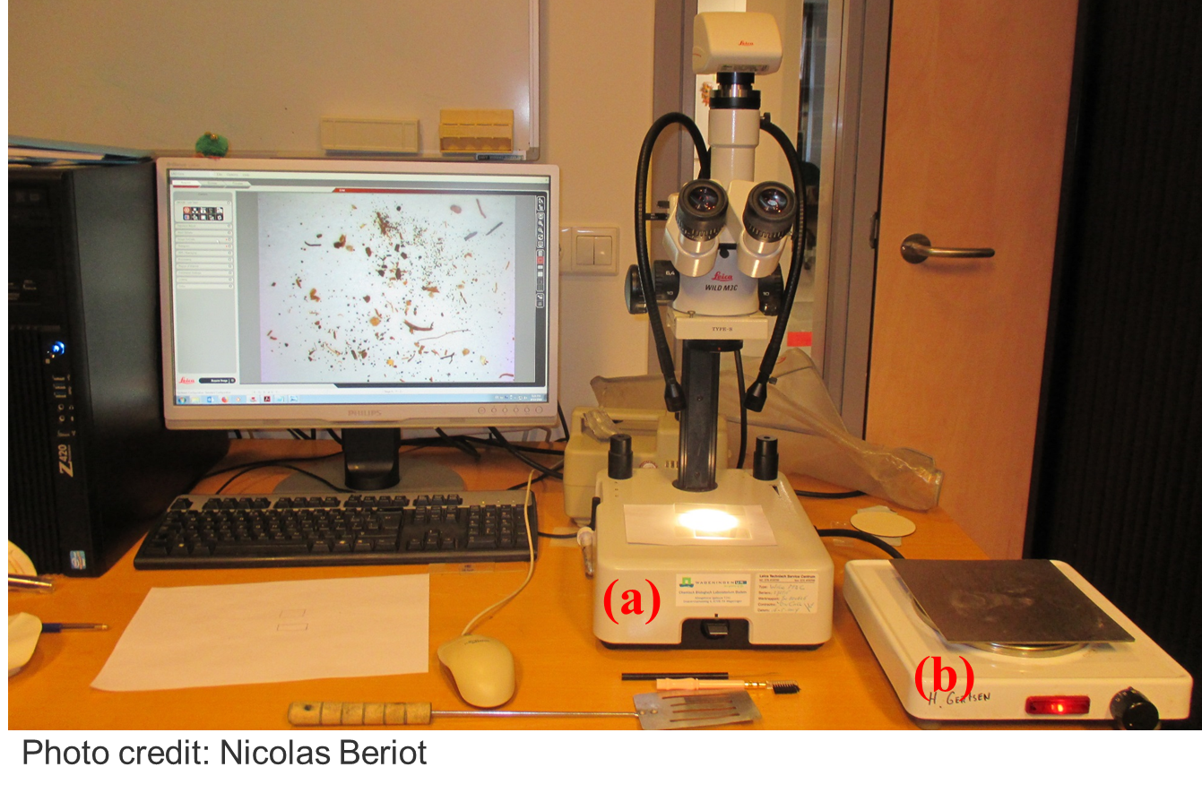
Fig. S5. Microplastics identification set up; (a) microscope, Leica wild M3C, Type S, simple light; (b) hot plate, TYPE A 1500-145, KEMA KEUR. Copyright: Beriot, Nicolas nicolas.beriot@wur.nl.

