Yuuii
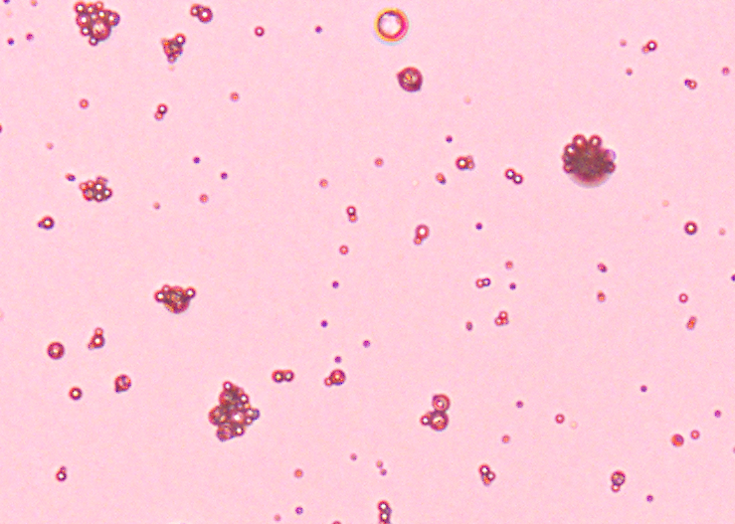
Figure Image of the LSPMbs obtained by Light microscope. The LSPMbs present round and ovoid shaped.10×40
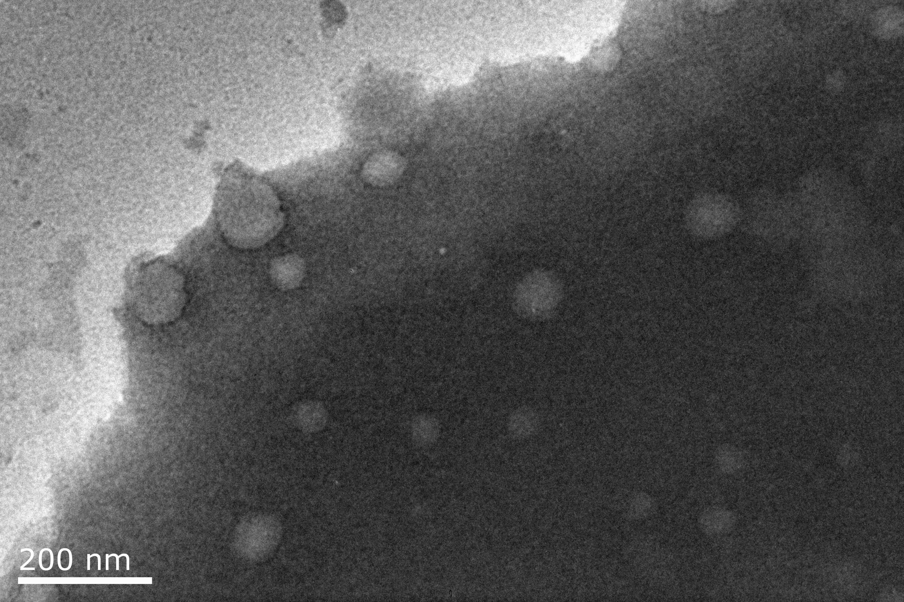
Figure Image of the LSPMbs obtained by transmission electron microscope. The LSPMbs present round shaped on a sectional view, with different size, without aggregation.
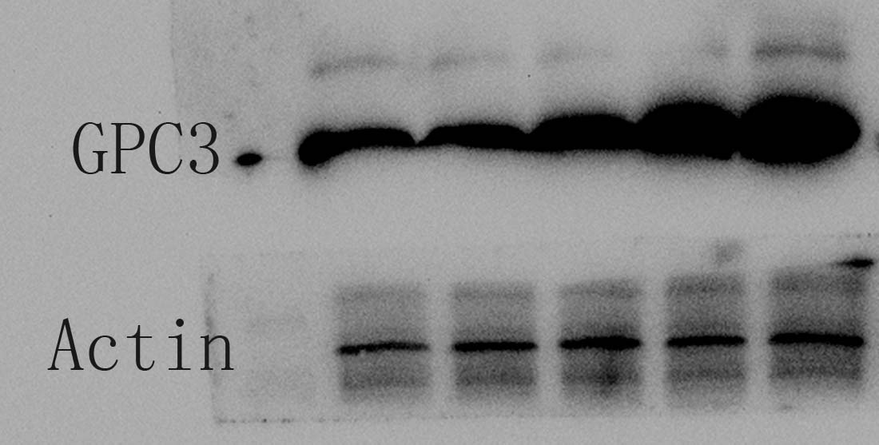
Figure 3 GPC3 is expressed in Huh-7 cells obtained by Western Blot.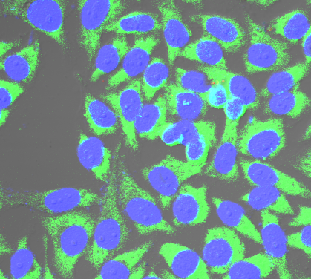
Figure Image of GPC3 expression of Huh-7 cells obtained by confocal laser scanning microscope.
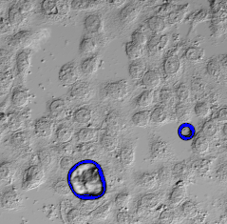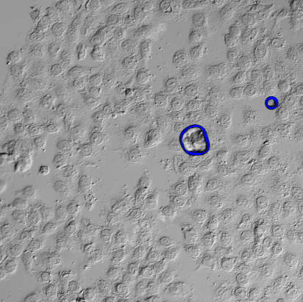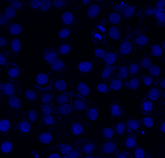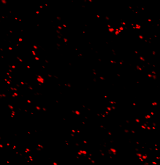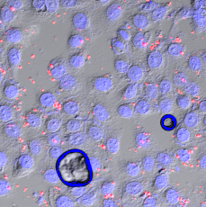
Figure Images of Huh-7 cells incubated with DiI lablled LSPMbs obtained by light microscope and confocal laser scanning microscope. DiI lablled LSPMbs present read, and cell nucleus of Huh-7 cells presents blue after DAPI staining.

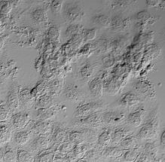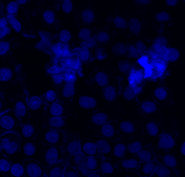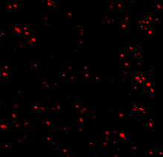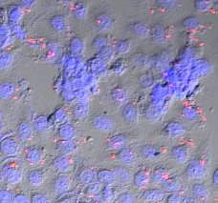
Figure Images of Huh-7 cells incubated with DiI lablled LSGMbs obtained by light microscope and confocal laser scanning microscope. DiI lablled LSPMbs present read, and cell nucleus of Huh-7 cells presents blue after DAPI staining.

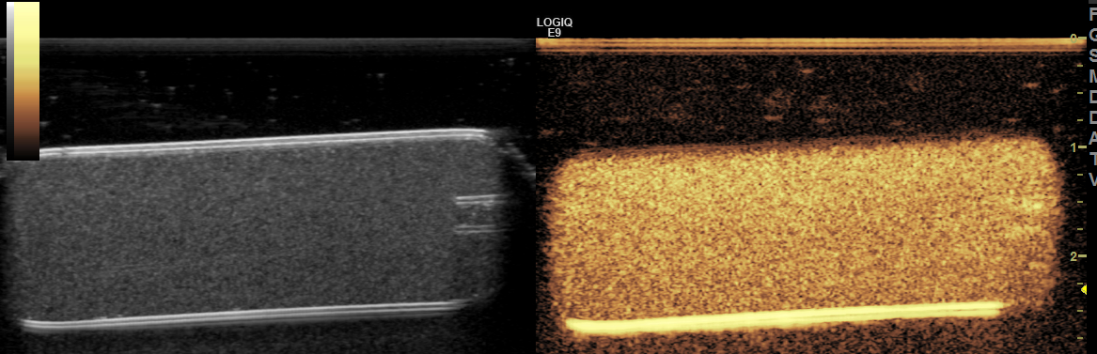
Figures Image obtained from LSPMbs (1.5mg/mL) in a tube scanned by ultrasound with a scanner of frequency of 12 MHz (MI 0.6).
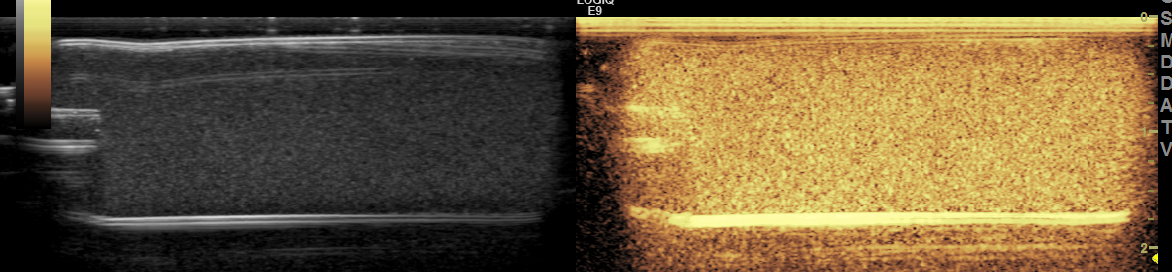

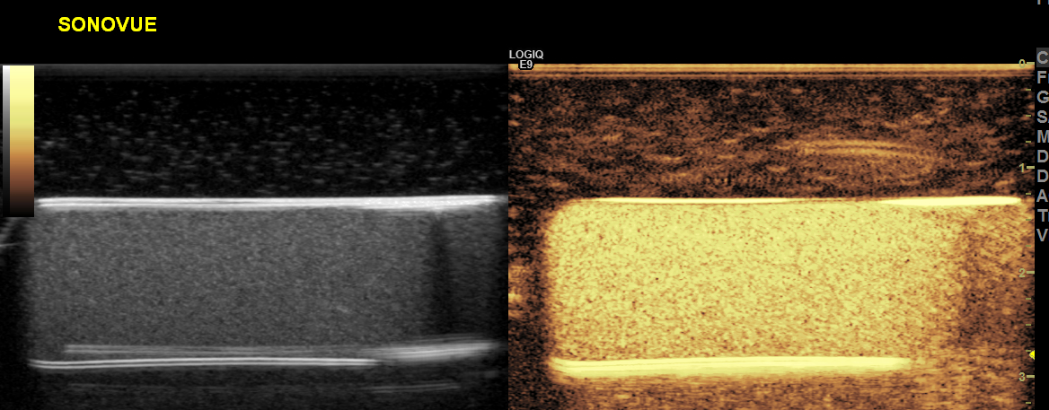

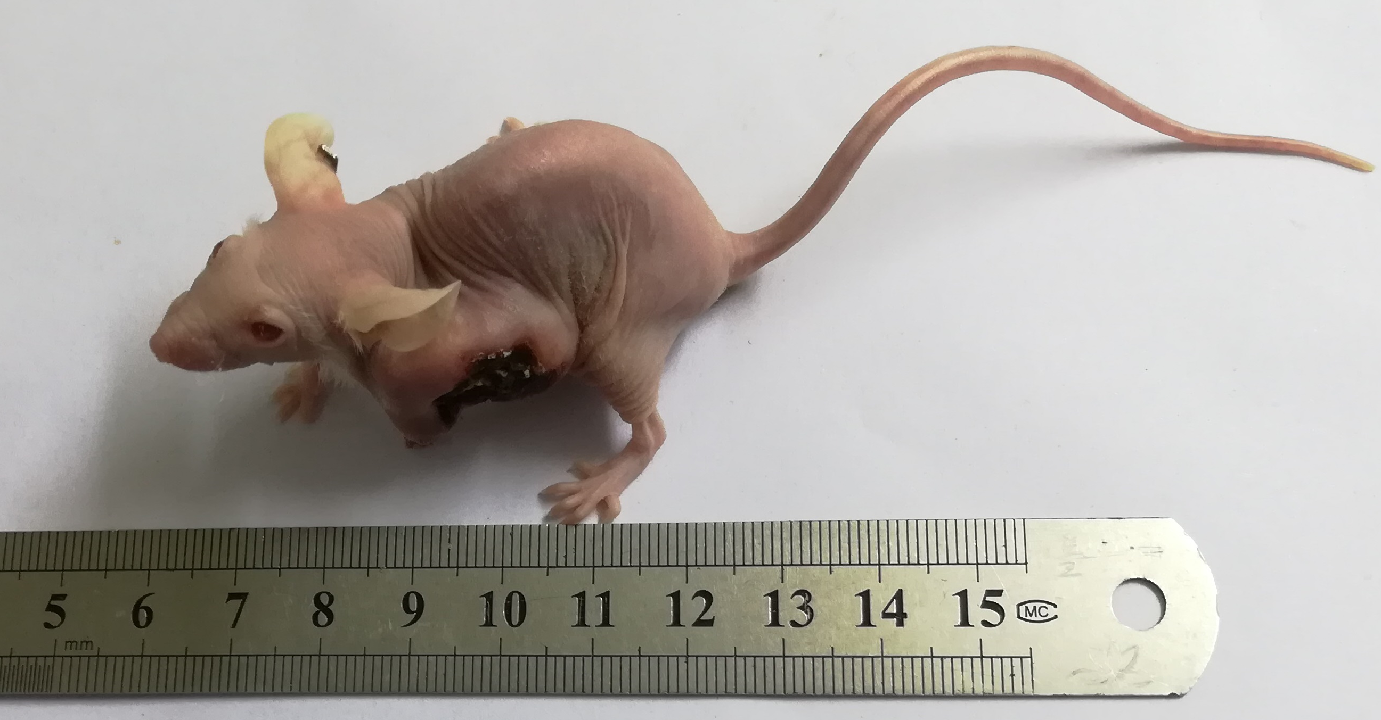
Figure A mouse model with xenograft tumor.
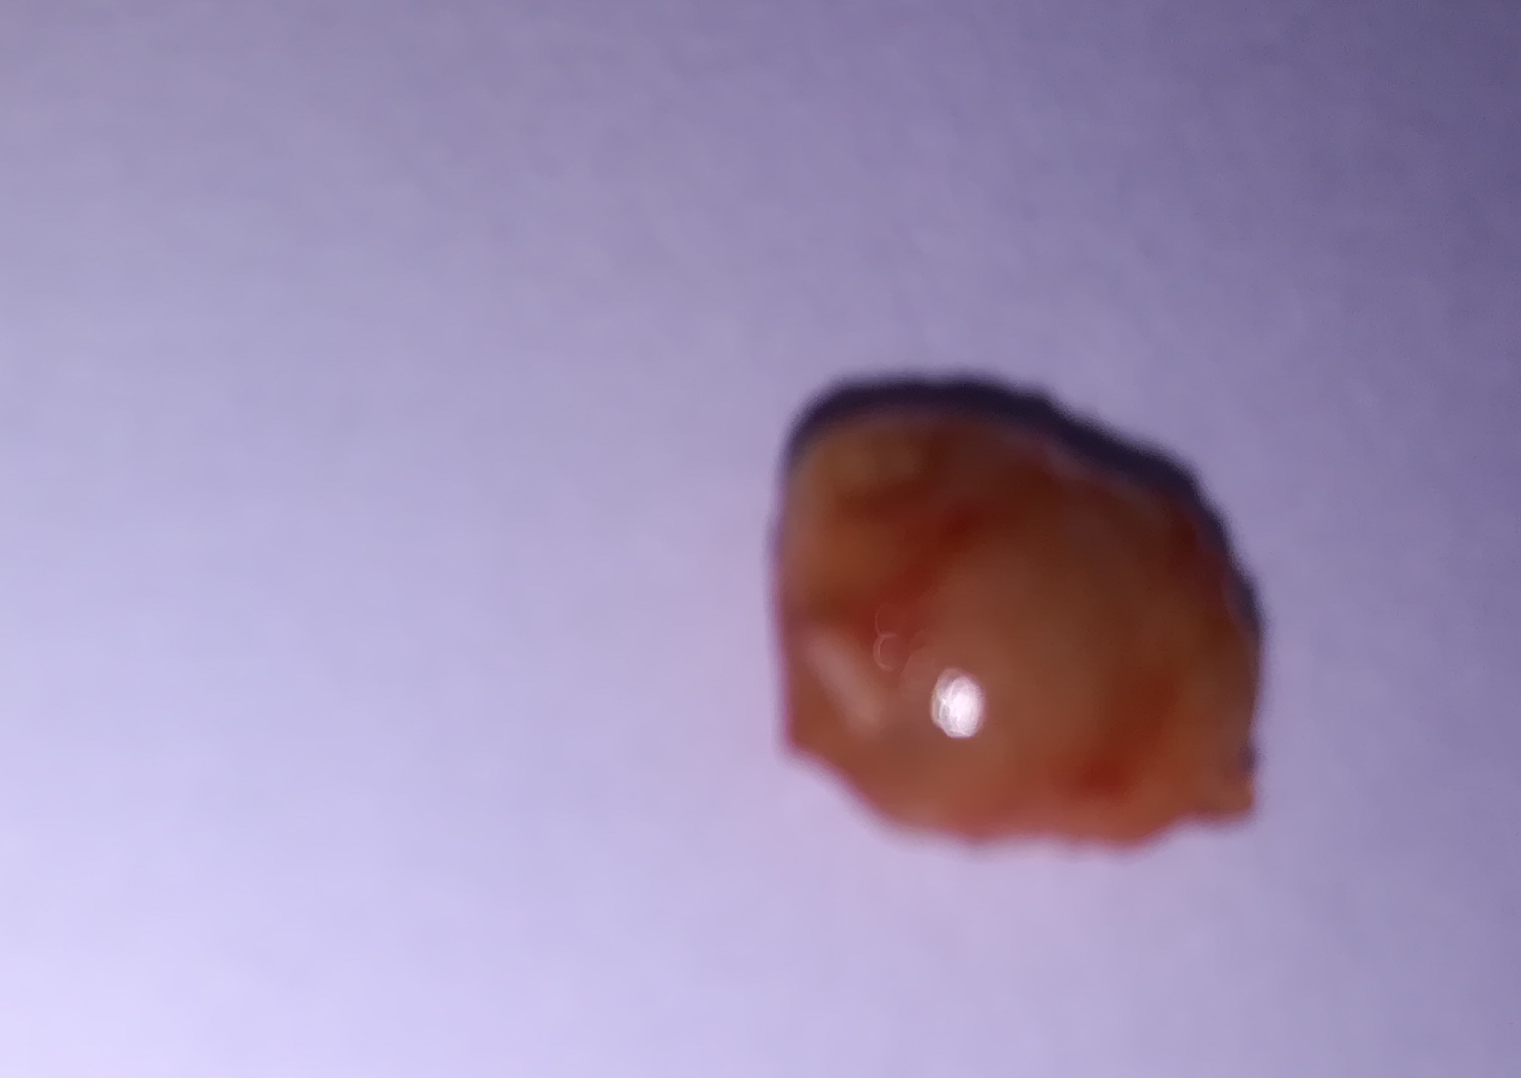
Figure
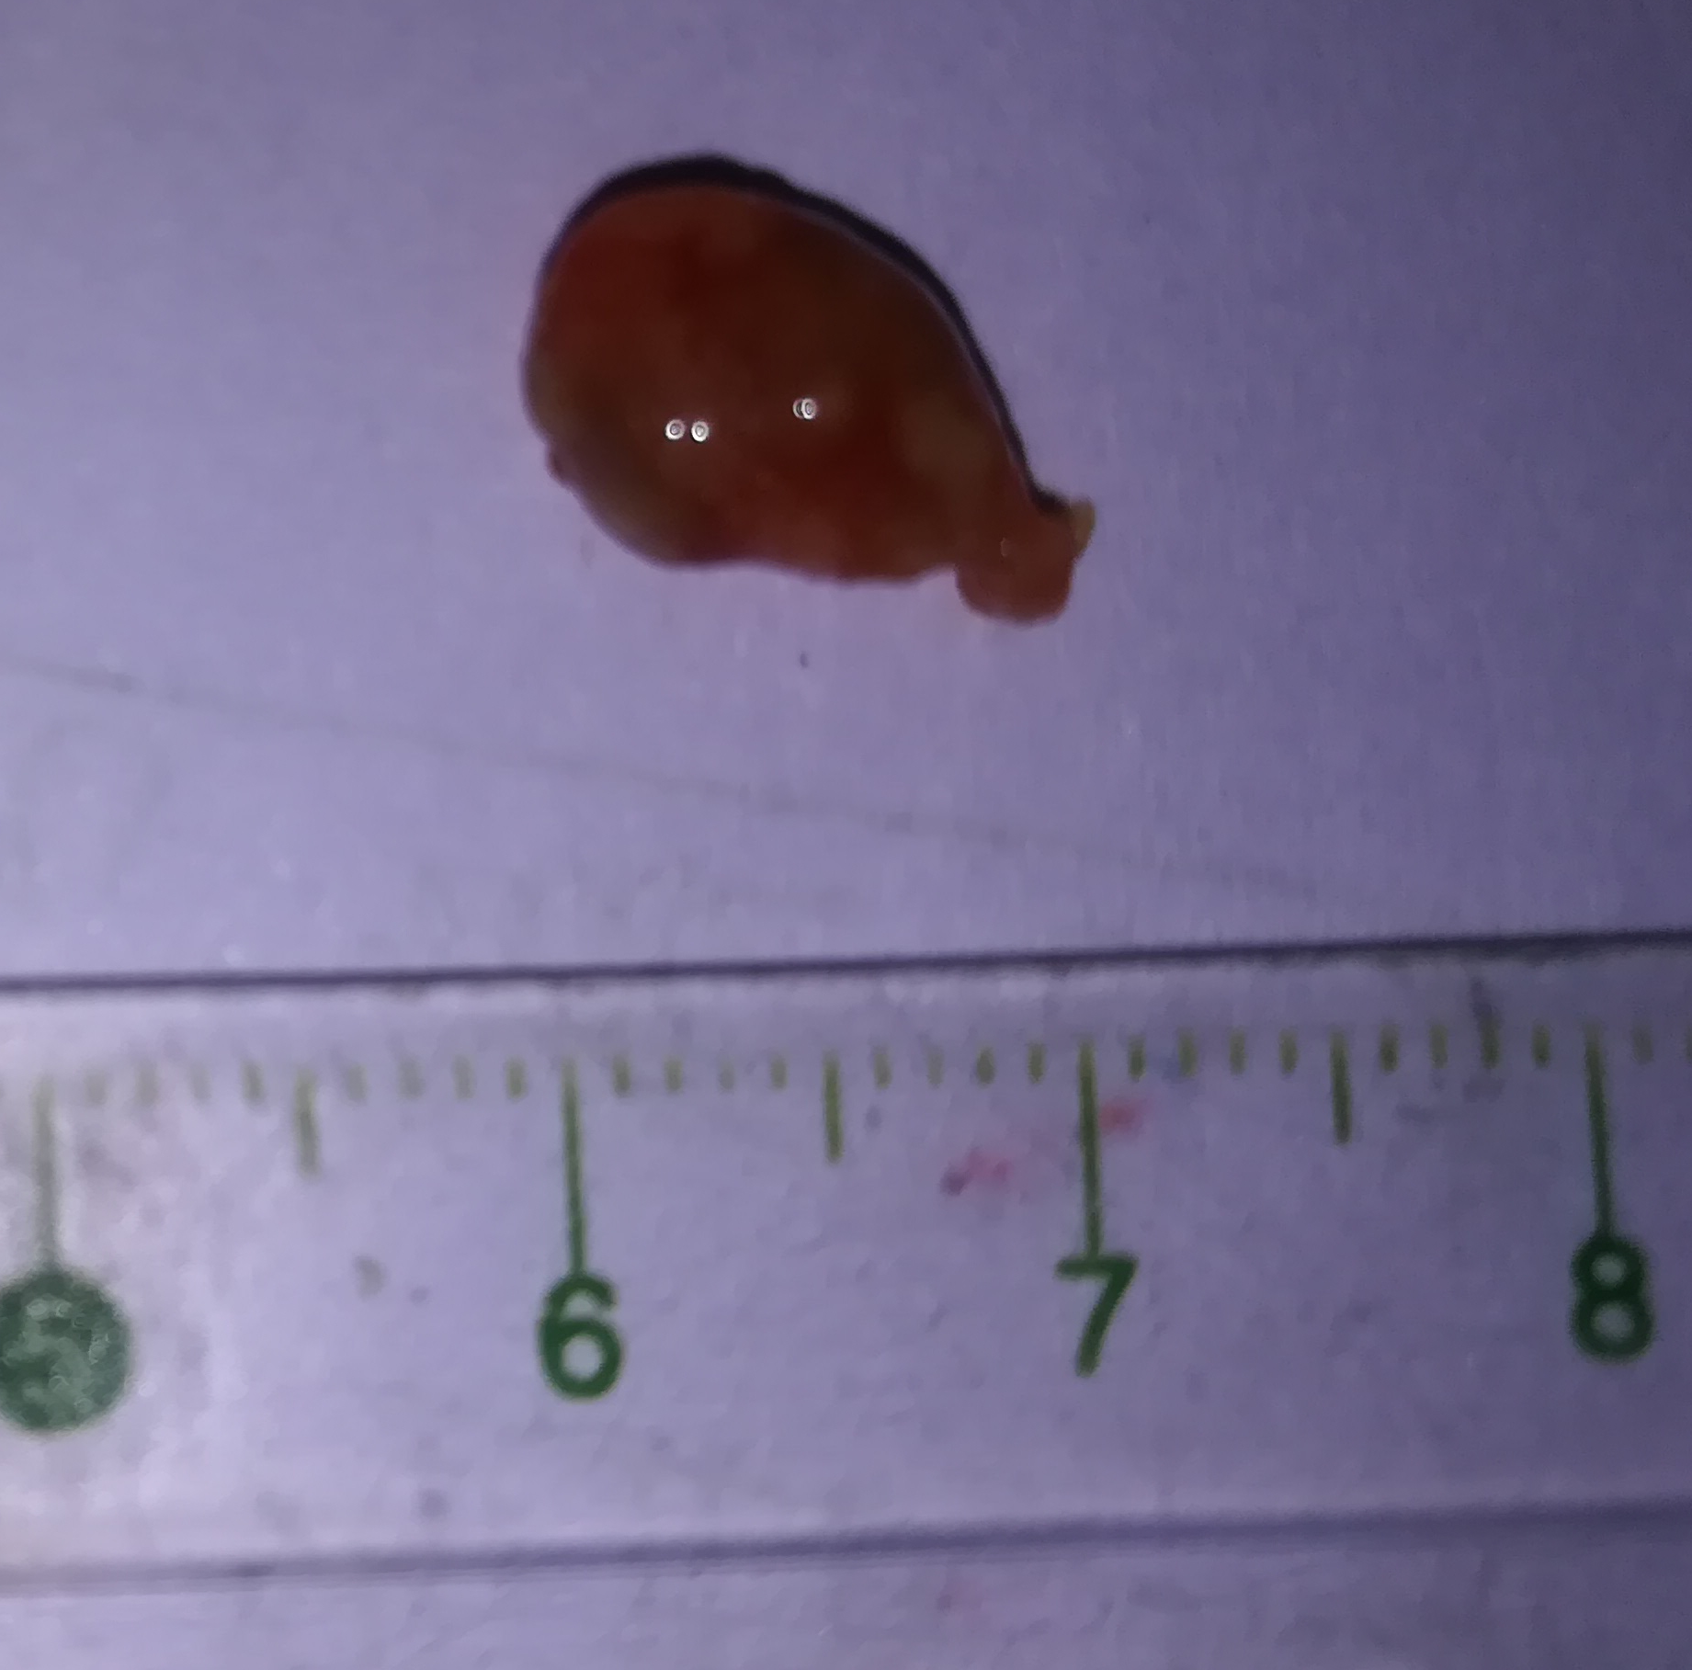
Figure A sample of xenograft tumor of the mouse.
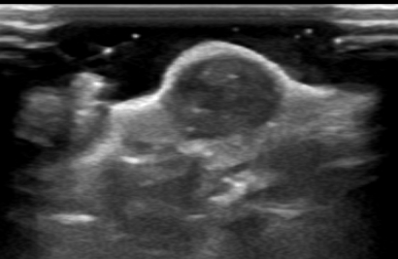
Figure Image of xenograft tumor of the mouse obtained by ultrasound with a scanner of frequency of 12 MHz ,
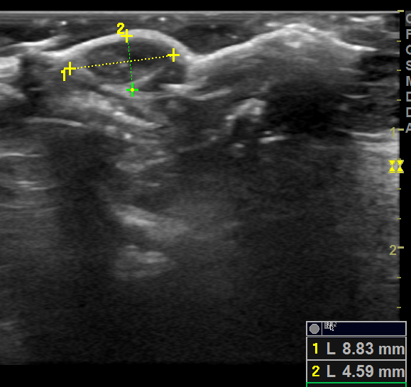
Figure
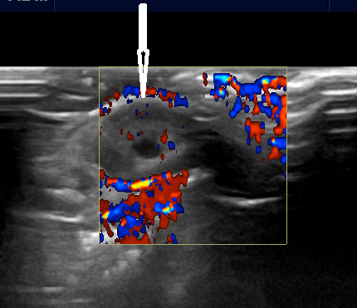
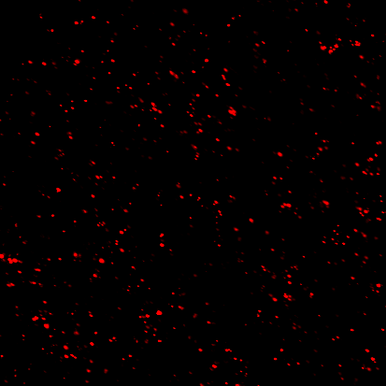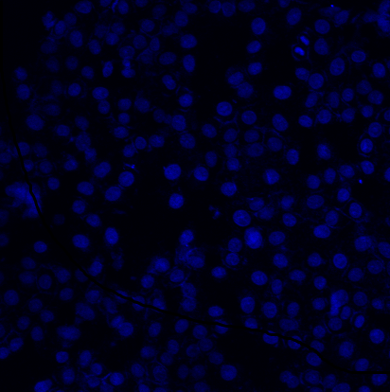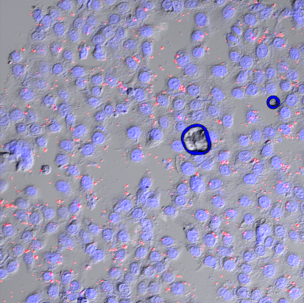 Figure
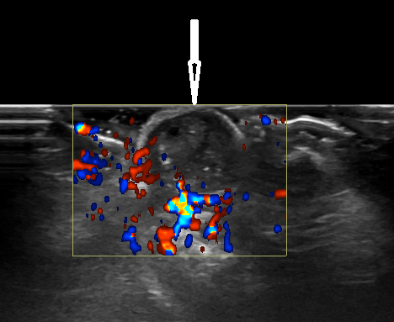
Figure Image of xenograft tumor of the mouse obtained by duplex ultrasound with a scanner of frequency of 12 MHz
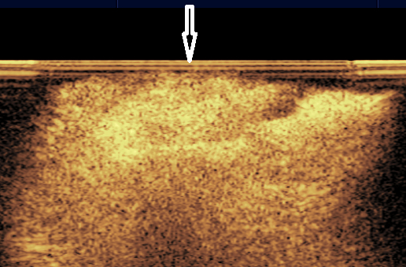
Figure Image of xenograft tumor of the mouse obtained by ultrasound with a scanner of frequency of 12 MHz (MI 0.6) after intravenously injection of 0.2 mL LPSMbs.
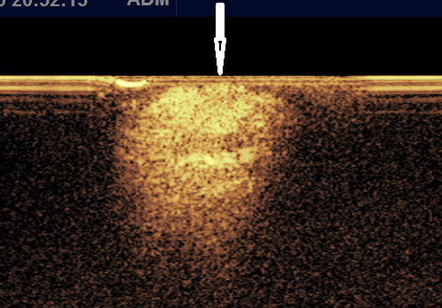
Figure

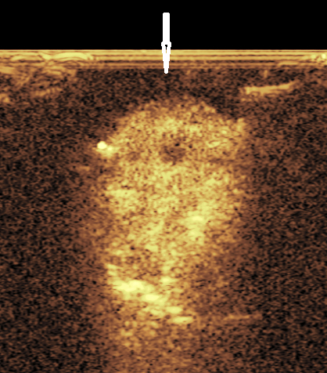
Figure
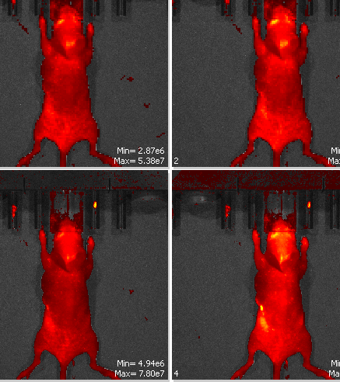
Figure Images obtained by an IVIS Lumina image system (Xenogen) (IVIS® Lumina XR) (Caliper life sciences) after intravenously injection of 0.2 mL Cy5.5 labelled LPSMbs.

