Supplementary materials for “Phospho-islands and the evolution of phosphorylated amino acids in mammals”

- Supplementary Figures

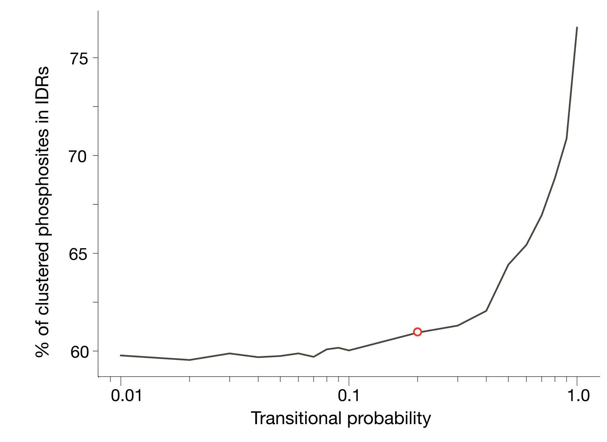
Supplementary Figure S1 | Stability of hidden Markov model clustered editing site predictions with respect to transitional probability values. Red circle represents the chosen value 0.2.
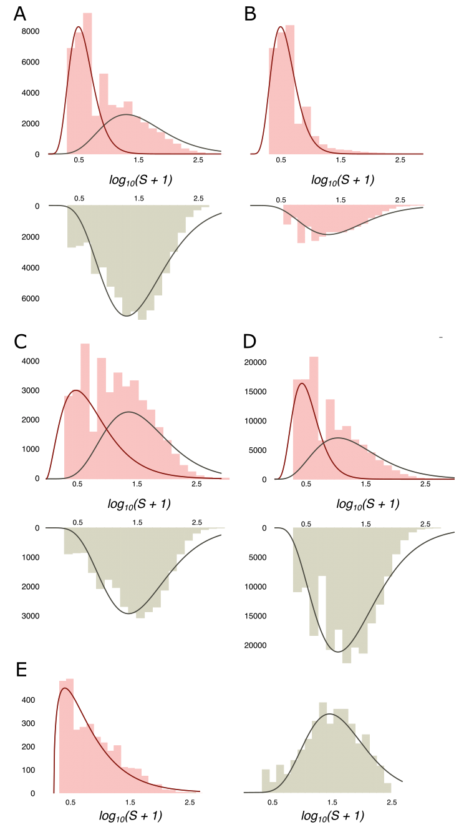
Supplementary Figure S2 | Phospho-island analysis in various datasets. (A, B) Prediction of phospho-islands for the mouse dataset. (A) (Above) The distribution of log₁₀(S + 1) values (pink histogram; see the main text for definitions) and its decomposition in two gamma distributions, for phospho-islands (red curve) and for individual phosphosites (red curve). (Below) log₁₀(S + 1) values for non-phosphorylated STY amino acids randomly sampled from IDRs with the same sample size and amino acid content as in the HMR dataset. (B) (Above) The distribution of log₁₀(S + 1) values for phosphosites predicted to be in phospho-islands. (Below) log₁₀(S + 1) values for predicted individual phosphosites. (C) Histograms of log₁₀(S + 1) values for real (pink) and randomly assigned (grey) phosphosites with respective gamma-approximations for the rarefied human dataset. (D) Histograms of S values for real (pink) and randomly assigned (grey) phosphosites with respective gamma-approximations for the human dataset. (E) Distributions of the log₁₀(S + 1) values of phosphosites located in ORs (pink) and the distribution of log₁₀(S + 1) for STY amino acids randomly sampled from ORs (grey) with respective gamma-approximation. Note the good fit of a single gamma-distribution for the log₁₀(S + 1) values observed in ORs.

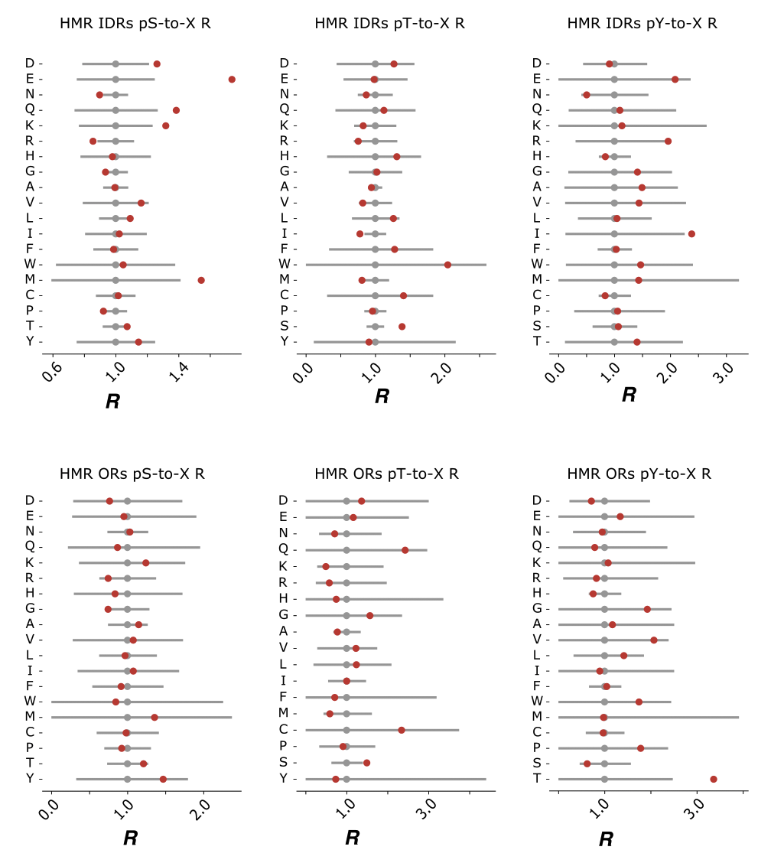
Supplementary Figure S3 | Comparison of the mutational patterns observed in HMR phosphosites located in intrinsically disordered and ordered regions. R values are defined in the main text. 95% two-tail confidence intervals are generated from the сhi-squared distribution with the Bonferroni correction. Red dots mark the actual R values. Grey dots represent the respective R values of non-phosphorylated STY amino acids.

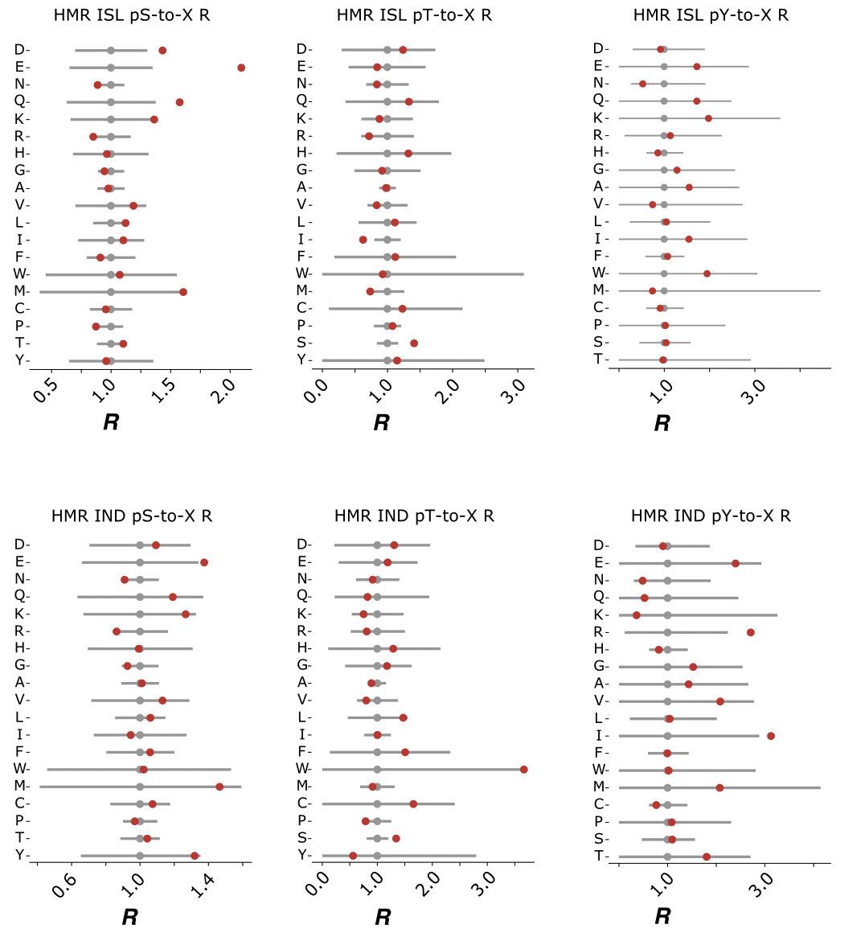
Supplementary Figure S4 | Comparison of the mutational patterns observed in HMR phosphosites located in phospho-islands vs. individual ones. Notation as in Suppl. Fig. S2.

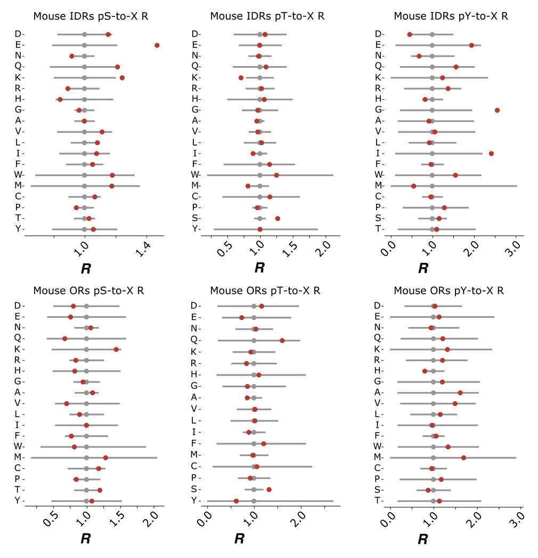
Supplementary Figure S5 | Comparison of the mutational patterns observed in mouse phosphosites located in intrinsically disordered and ordered regions. Notation as in Suppl. Fig. S2.

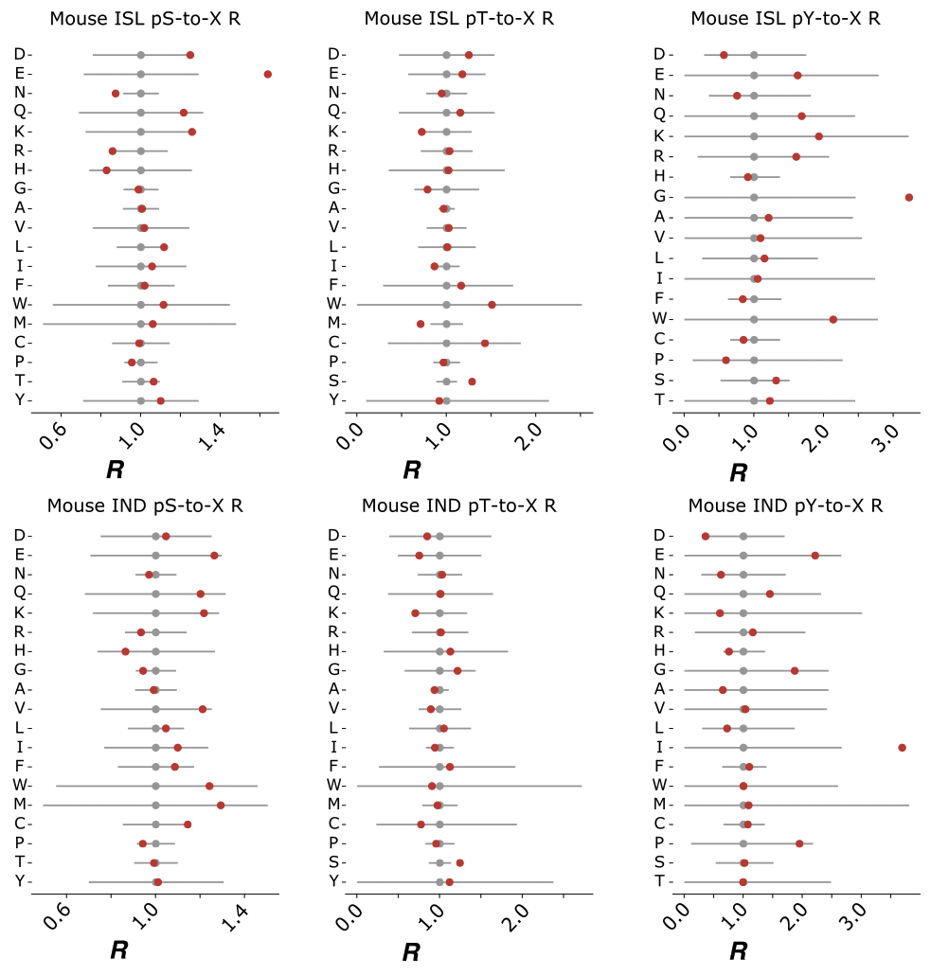
Supplementary Figure S6 | Comparison of the mutational patterns observed in mouse phosphosites located in phospho-islands vs. individual ones. Notation as in Suppl. Fig. S2.

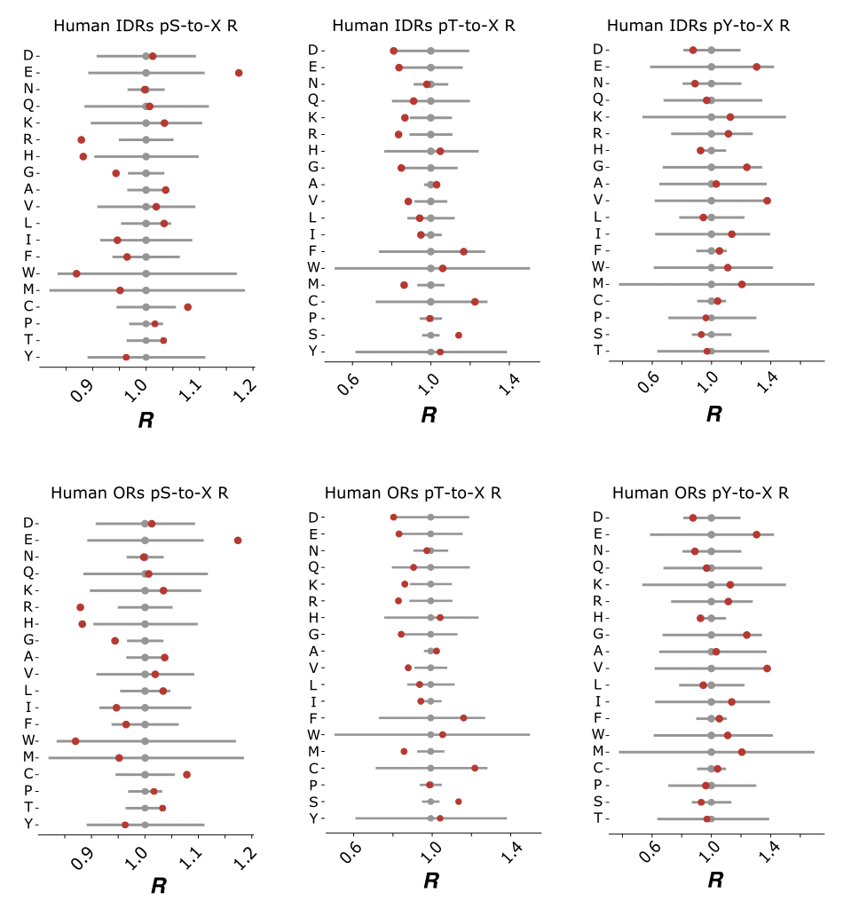
Supplementary Figure S7 | Comparison of the mutational patterns observed in human phosphosites located in intrinsically disordered and ordered regions. Notation as in Suppl. Fig. S2.

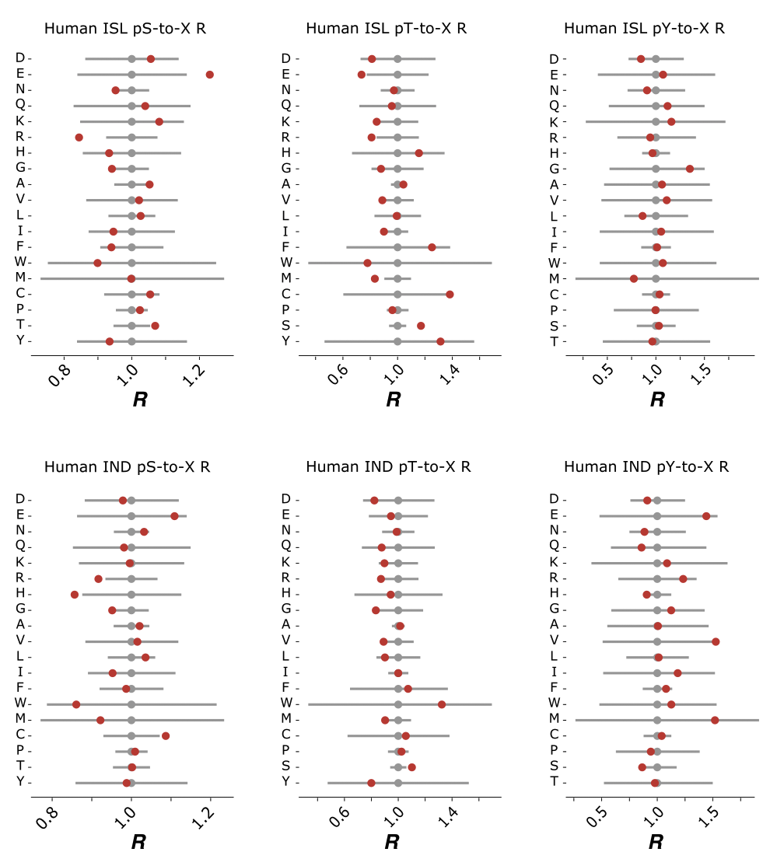
Supplementary Figure S8 | Comparison of the mutational patterns observed in human phosphosites located in phospho-islands vs. individual ones. Notation as in Suppl. Fig. S2.
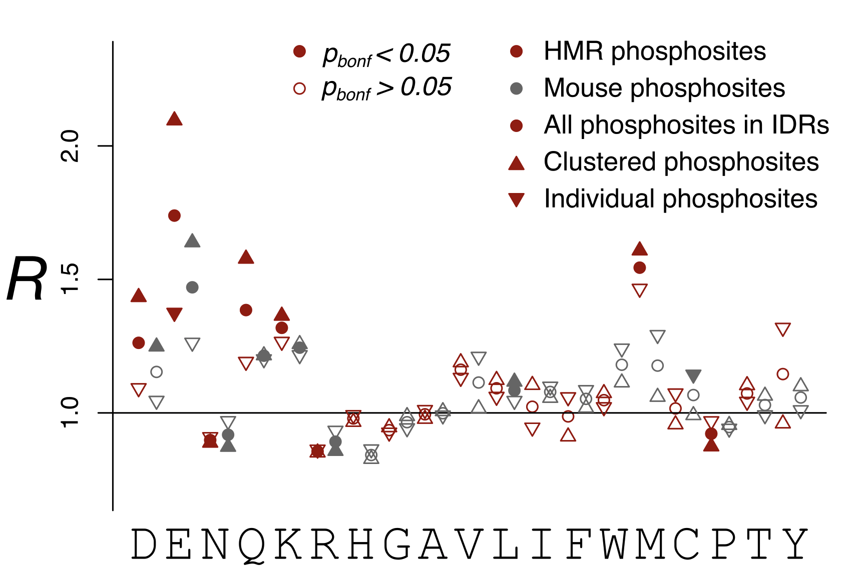
Supplementary Figure S9 | R values of the pS-to-X mutations for different phosphosite sets. Note the stronger effects observed for the HMR dataset compared to the mouse dataset and for clustered phosphoserines with respect to individual ones.

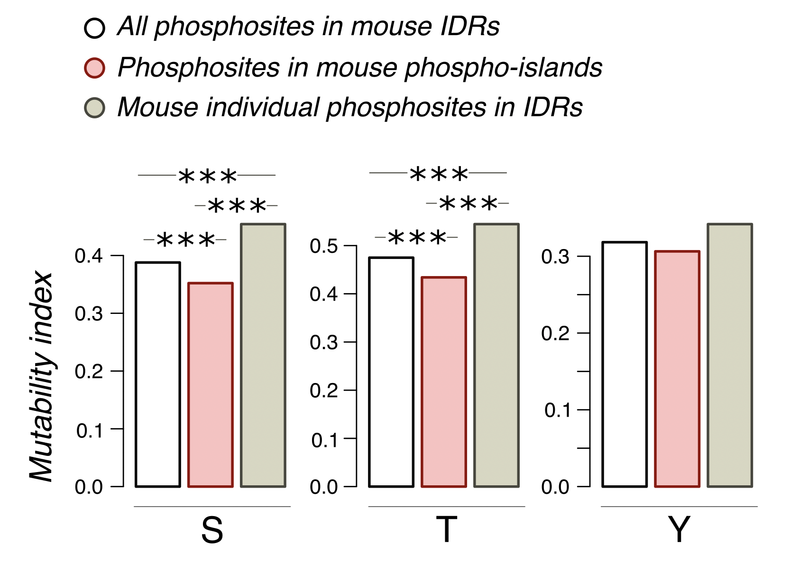
Supplementary Figure S10 | Conservation of phosphorylated amino acids for various mouse datasets. The mutability index is calculated for a phosphorylated amino acid with respect to its non-phosphorylated counterpart as the sum of probabilities of STY-to-X mutations calculated for all tree branches for the phosphorylated STY amino acid divided by the same sum for the respective non-phosphorylated amino acid. Three asterisks indicate statistically significant differences (p < 0.001, chi-squared contingency test).

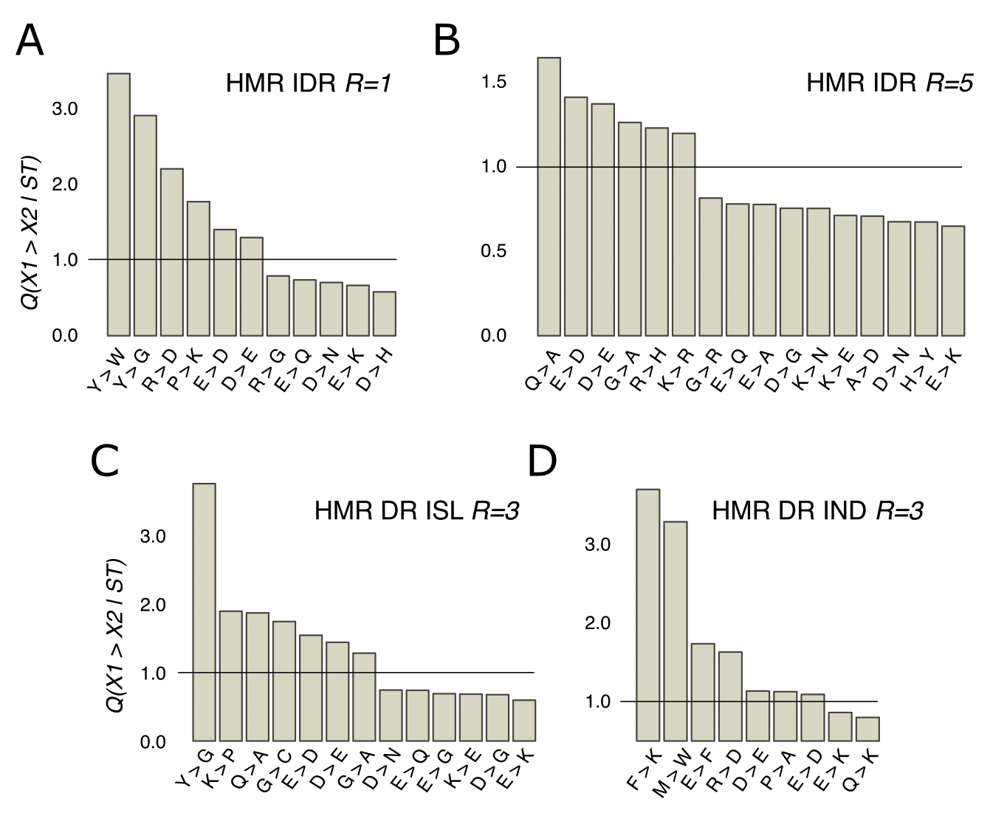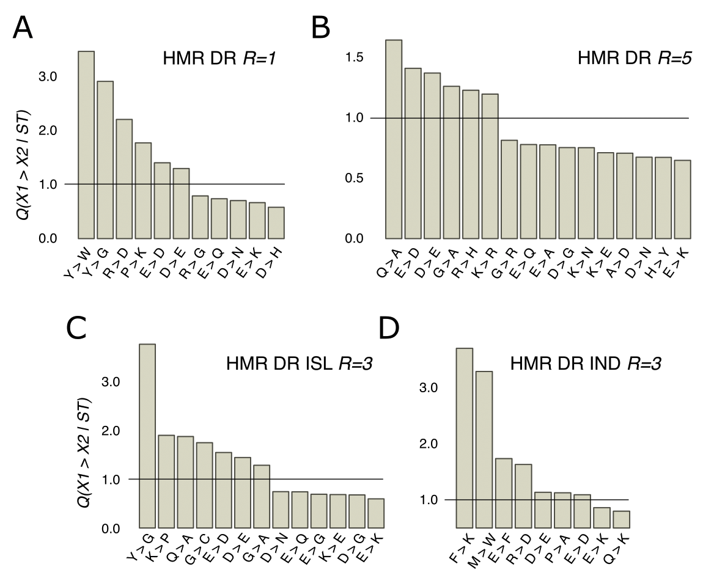
Supplementary Figure S11 | R values of mutations near ST phosphosites with probabilities significantly different from the expected ones for various HMR subsets. (A) HMR sites located in intrinsically disordered regions with the window radius 1. (B) HMR sites located in disordered regions with the window radius 3. (C) Clustered HMR sites with the window radius 3. (D) Individual HMR sites with the window radius 3.

2. Supplementary Tables

Supplementary tables are provided in the additional XLSX file.

/hmr_sites_list: List of all HMR-sites considered in the present study. Each site is marked as present in ordered/disordered region, having one of the five motif types, and being a part of a phosphosite cluster or individual. Phosphosites located in IDRs are considered as being neither clustered nor individual.
/mouse_site_list: List of mouse dataset phosphosites.
/hmr_psite_islands: List of HMR phosphor-islands.
/mouse_psite_islands: List of mouse phosphor-islands.
/R table: Table with R values and the respective corrected p-values for all considered phosphosite datasets. Fig. 3 and Suppl. Figs. S2-S6 correspond to this table.
/local_mutations: Q values of contextual mutations for different HMR phosphosite datasets and different window radius. Corresponds to Fig. 5 and Suppl. Fig. S9.
/phosphosite conservation: Mutability statistics for the mouse dataset. Corresponds to Suppl. Fig. S8.

