Figure S2 Detection the biofilm ability of uropathogenic Escherichia coli by Congo Red Agar.
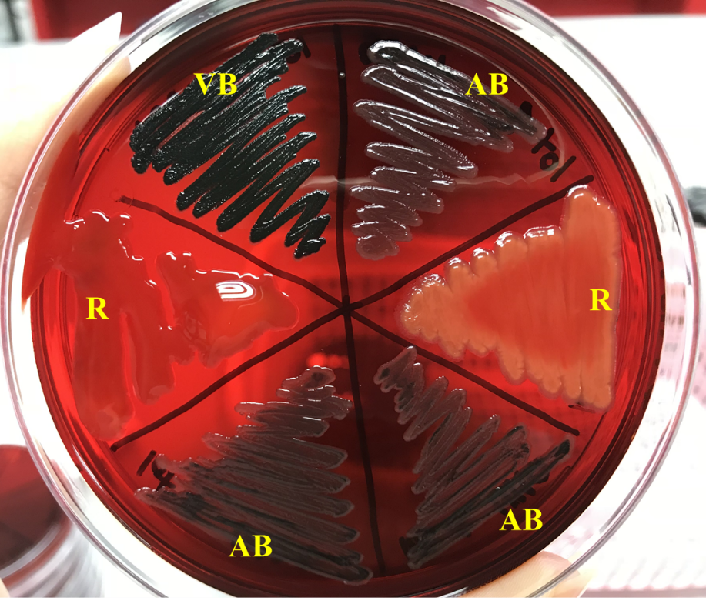
R, red; AB, almost black; VB, very black. The color tones of colonies were categorized as follows: very black, and almost black, which were interpreted as strong, and weak biofilm producers, respectively, and red reported as non-biofilm producers.

