Supplementary Methods

Retrieval of RdRP sequences
The sequences of RdRP were either retrieved from NCBI GenBank or GISAID (https://www.gisaid.org/). The accession numbers were AWH65952.1, P_828869 and YP_009725307 for MERS, SARS and SARS-2 CoVs, respectively.
Sequence alignment and multiple sequence comparisons
Sequences were analyzed by pairwise and multiple sequence comparisons. Alignment, sequence identity rates and the number of similarities and differences were analyzed in CLC genomics software (Qiagen Inc., USA).
Construction of phylogenetic tree
The neighbor-joining method was used to generate a phylogenetic tree. The tree was generated and edited by CLC genomics workbench software.
Sequence comparisons
A comparison between SARS and SARS-2 (COVID-19) CoVs is provided in Figure 1. The highlighted (non-conserved) residues (Fig. S1A) indicate that 34 different residues are present. The percentage identity was 96.35% (Fig. S1B), indicating a high homology rate between SARS and SARS-2 RdRP. In contrast, there was a low homology rate between SARS-2-CoV and MERS-CoV (Fig. S2). There were 267 amino acids that were different, and the percentage identity was lower at 71.44%.

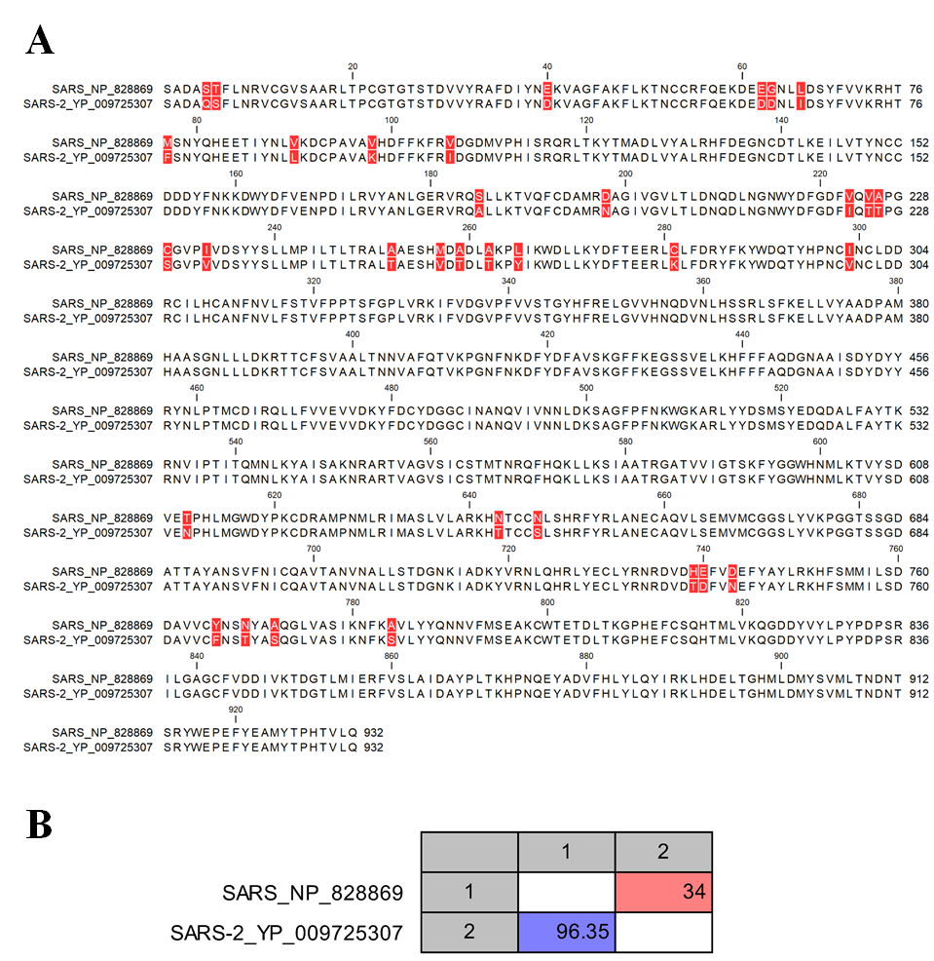

Fig. S1: Sequence alignment of RdRP from SARS CoV and SARS-CoV-2 (COVID-19). A) Pairwise sequence alignment of SARS CoV and SARS-CoV-2. Conserved residues are not highlighted and displayed in black colour. The different residues are displayed in white and highlighted by a red background colour B) Sequence comparison matrix of COVID-19 and SARS RdRP. The top right cell (in red) shows the number of amino acids differences. The lower left cell (blue) shows the identity%.

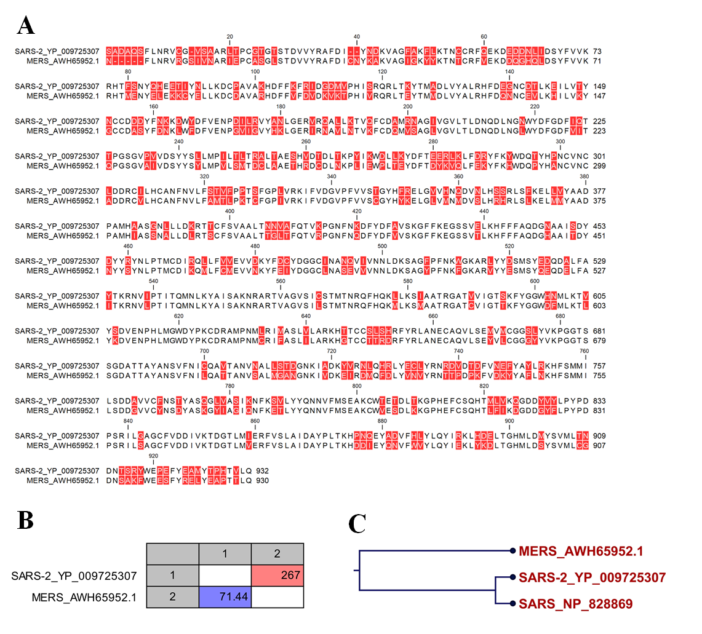
Fig. S2: Sequence alignment of RdRP from MERS CoV and SARS-CoV-2 (COVID-19). A) Pairwise sequence alignment of MERS CoV and SARS-CoV-2. Conserved residues are not highlighted and displayed in black colour. The different residues are displayed in white and highlighted by a red background colour B) Sequence comparison matrix of COVID-19 and MERS CoV RdRP. The top right cell (in red) shows the number of amino acids differences. The lower left cell (blue) shows the identity%.

