Supplementary information

Supplementary 1A: Information on the available hedgehog roadkill records used in this study. The information presented is grouped into data providers. Collection methods include: ONR – Online Recording, EAR – Effort Associated Sightings, SPA – Smart Phone App, OPS – Opportunist Sightings, EML – Email recording
Data provider | Start date | End date | Projects included | Collection methods
People Trust for Endangered Species (PTES) | 2011 | 2018 | Big Hedgehog Map, Mammals on Roads, Suffolk Wildlife Trust | OLR, EAR, SPA, OPS
Mammal Society (MS) | 2000 | 2017 | National Atlas Project, Mammal Mapper, Mammal Tracker | SPA, EAR, OPS, EML
Project Splatter (PS) | 1959 | 2018 | Project Splatter | SPA, OPS, OLR, EML

Supplementary 1B: Raw data of hedgehog roadkill records collected from different citizen science projects
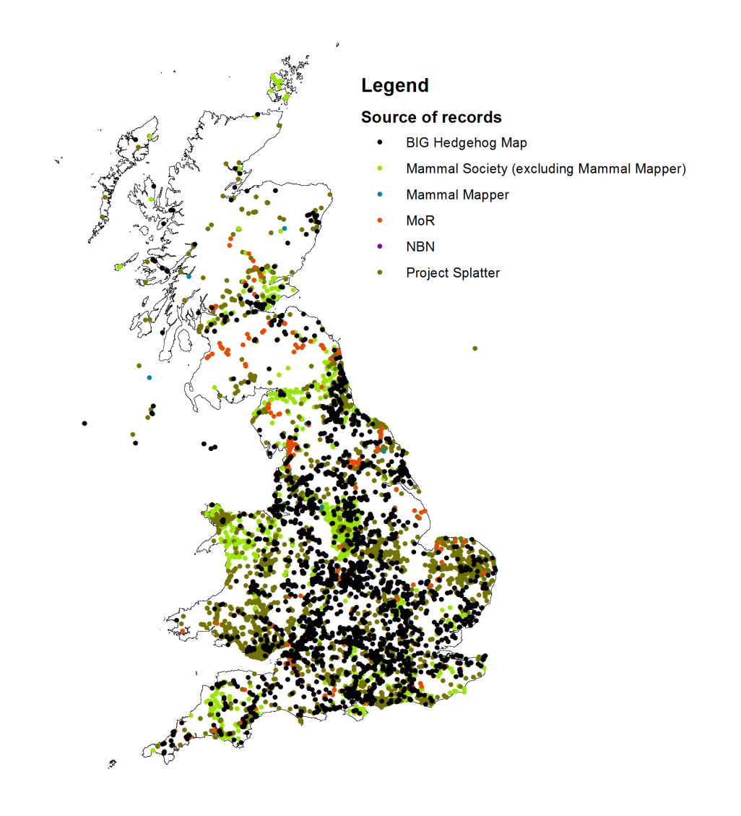

Supplementary 2: Additional information on the preparation of landscape variables for MaxEnt.
A suit of environmental variables were sourced from various datasets with the initial selection being based on the a priori expectation that they have an influence on the presence or impact of hedgehogs. The countrywide modelling framework was conducted at a 1-3 km resolution and focused primarily on habitat, road density and climatic variables. The percentage of habitat was calculated using the 2007 Land Cover Map (LCM: Morton et al., 2011) from the Centre for Ecology and Hydrology (CEH). The percentage area of each broad habitat classification was calculated for each 1 km² British National grid square. At 3 km resolution, the habitat percentages were amalgamated from the 1 km resolution grid. The full list of habitats is available in (Figure 1 and Supplementary 5). Road densities were calculated using ArcGIS (ESRI, 2011) by measuring the km of road from the OS road shapefile (https://www.ordnancesurvey.co.uk/opendatadownload/products.html) within a 1km grid. Road type specific analyses were calculated by dividing the shapefile into road classifications (minor roads, B roads, Major roads and all roads). The climatic data was sourced from WorldClim (https://www.worldclim.org/).

Supplementary 3: Road type classifications and distributions used in this project. Below are the road classifications for minor, B, Major and All road shapefiles used in the road-level models. These shapefiles are based on the OS Open Roads data from the Ordinance Survey (https://www.ordnancesurvey.co.uk/opendatadownload/products.html#OPROAD) and divided into types based on the class and function fields.
Major roads
All roads
B roads
Minor roads
Supplementary 4: Table representing the model performance of the final national scale (1 km) roadkill HSM using roadkill background data and the road HSM’s (100 m) for models using random background data and roadkill background data. Schoener’s D index scores represent the niche overlap between models using random and roadkill background data
Background data | Model type | Feature types | Regularisation multiplier | AICc | Full AUC
Rdkill | National | LQ | 1 | 138,246 | 0.72
 | National + Major road | LQ | 1 | 22,054 | 0.50
 | National + B road | LQH | 4 | 10,186 | 0.60
 | National + Minor road | LQH | 4 | 44,442 | 0.71
 | National + all roads | LQHPT | 4 | 79,724 | 0.74
Rdm | National | LQHPT | 1.5 | 135,071 | 0.75
 | National+ Major road | LQH | 4 | 22,353 | 0.65
 | National + B road | LQHPT | 4 | 9,593 | 0.60
 | National + Minor road | LQH | 4 | 43,025 | 0.65
 | National + all roads | LQ | 1 | 79,379 | 0.61

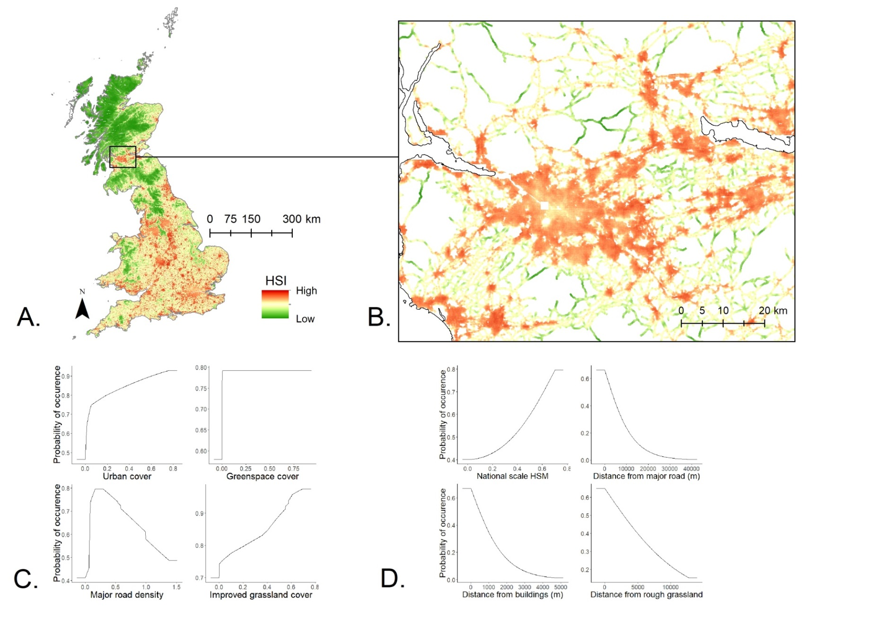
Supplementary 5: Mapped logistic habitat suitability indices (HSI) for E. europaeus roadkill at a national scale (A), then at a road level using all road data (B) according to the hierarchical, multi scale model using random background data. The response curves with the highest permutation importance are represented for the national scale (C) and the model using all road data (D).
Supplementary 6: Variable full names of raster files used for Maxent
Raster name | Variable full name
alltraff | All roads traffic
arable | Arable cover
broad_dens | B road densiy
broad | Broadleaved cover
conif | Coniferous woodland cover
disarable | Distance from arable
distbrd | Distance from B roads
eucdistbroa2 | Distance from broadleaved woodland
dis_build | Distance from buildings
eucdistconi2 | Distance from coniferous woodland
disfreshw | Distance from freshwater
disimpgra | Distance from improved grassland
dist_minor | Distance from Minor road
dist_mw | Distance from motorway
disrougra | Distance from rough grassland
dissuburb | Distance from suburban area
disurban | Distance from urban area
freshw | Freshwater cover
Greencover | Green space cover
HedgerowDensity | Hedgerow density
imp_grass | Improved grassland
mw_dens | Major road density
minorrd_tr | Minor road density
popdens | Population density
slope | slope
urban | urban cover

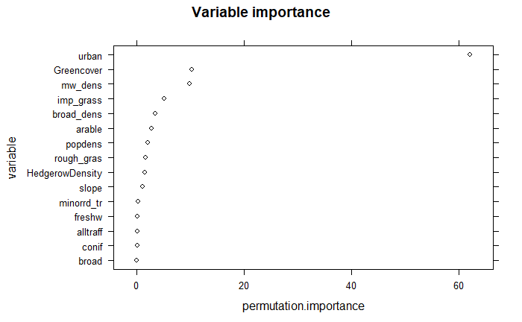
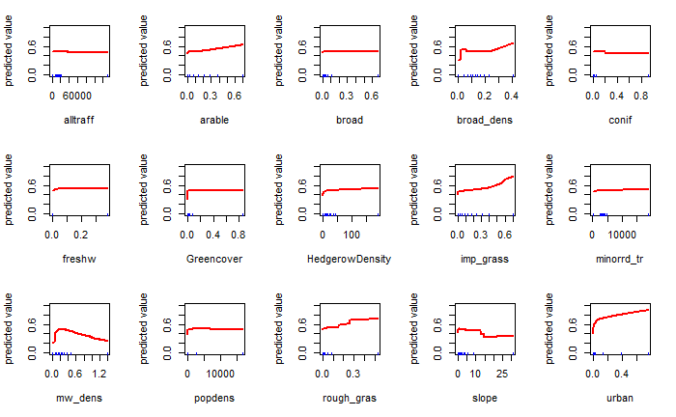
Supplementary 7: Summary of variable importance and response curves of the national model (random background data)

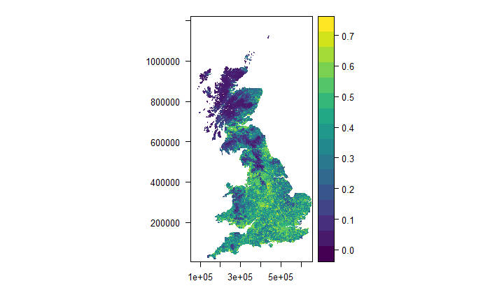
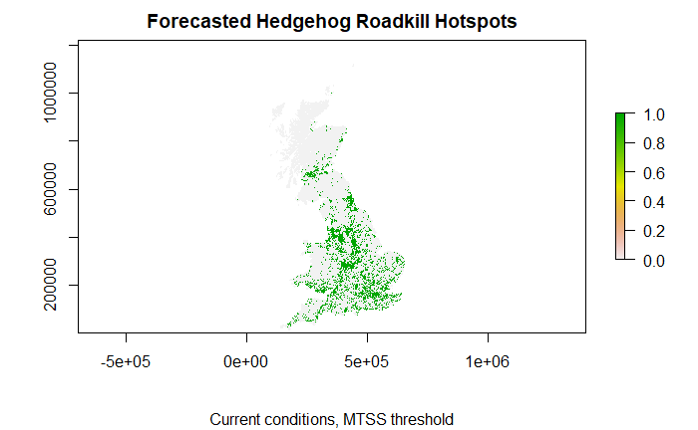
Supplementary 8: Mapped logistic habitat suitability indices (HSI) for hedgehog roadkill and forecasted high-risk of collision areas of the national model (random background data)

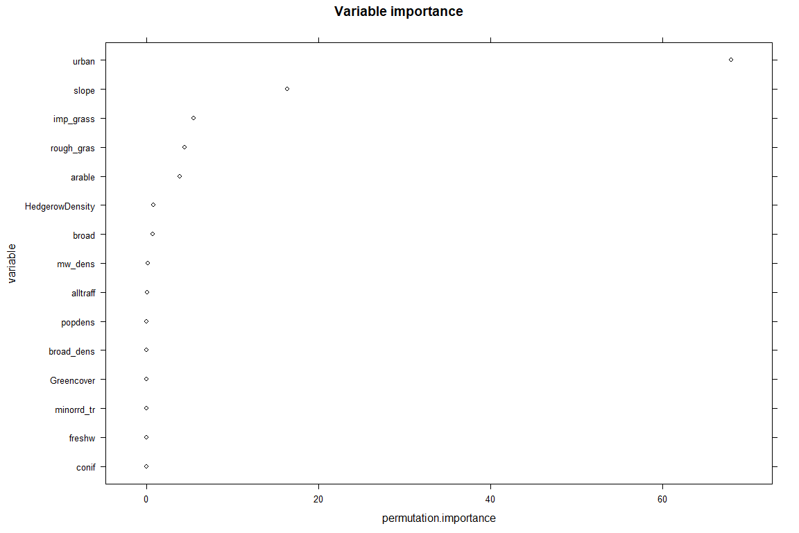
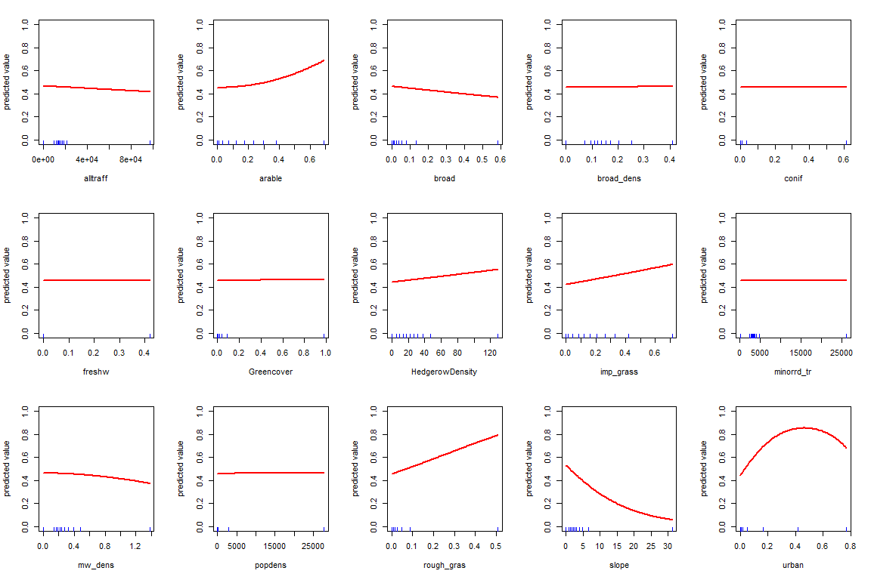
Supplementary 9: Summary of variable importance and response curves of the national model (roadkill background data).

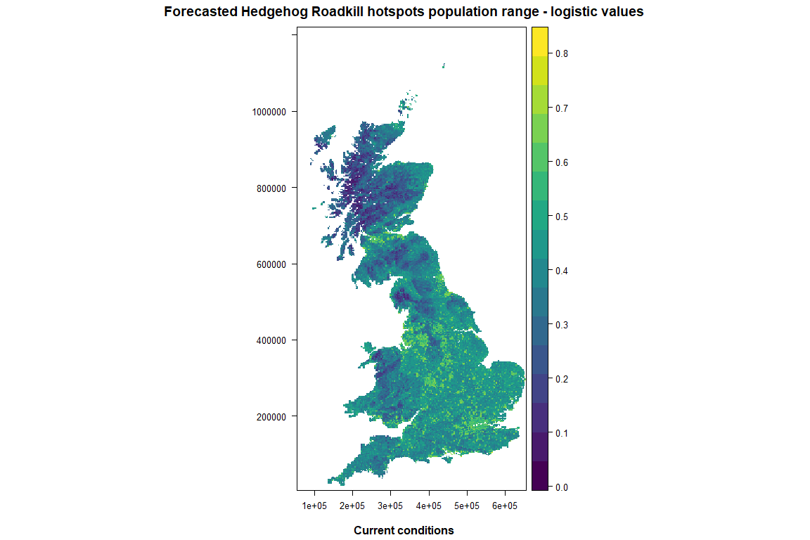
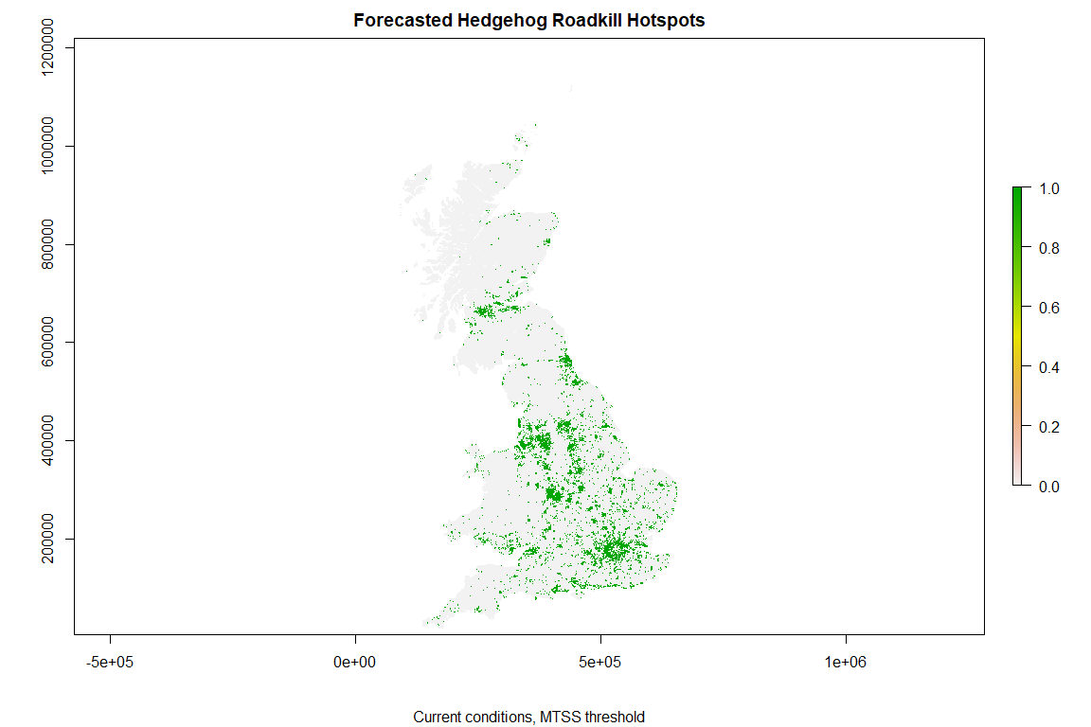
Supplementary 10: Mapped logistic habitat suitability indices (HSI) for hedgehog roadkill and forecasted high-risk of collision areas of the national model (roadkill background data).
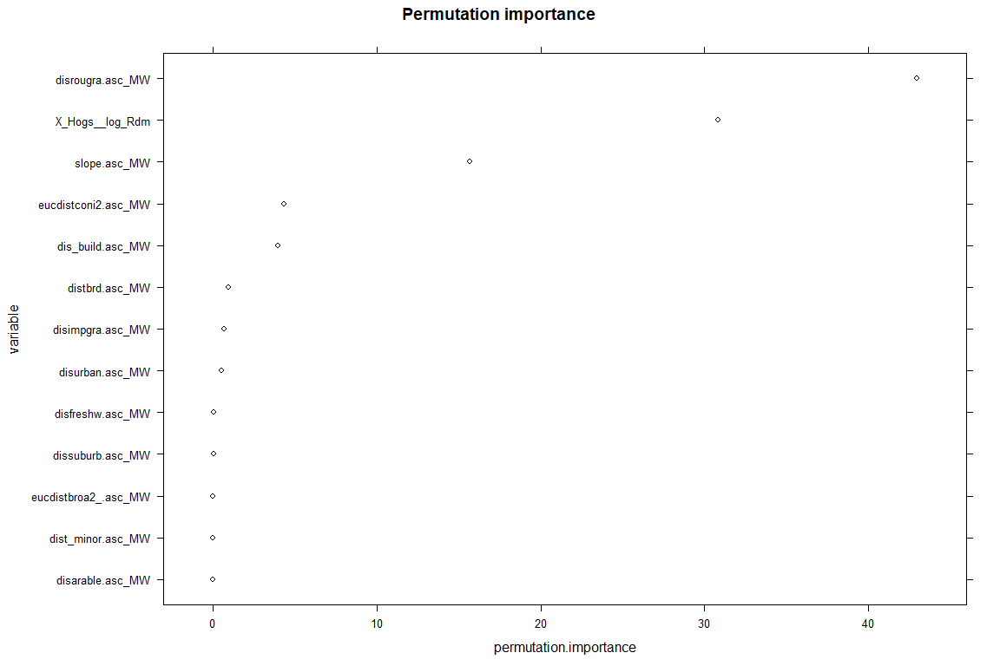
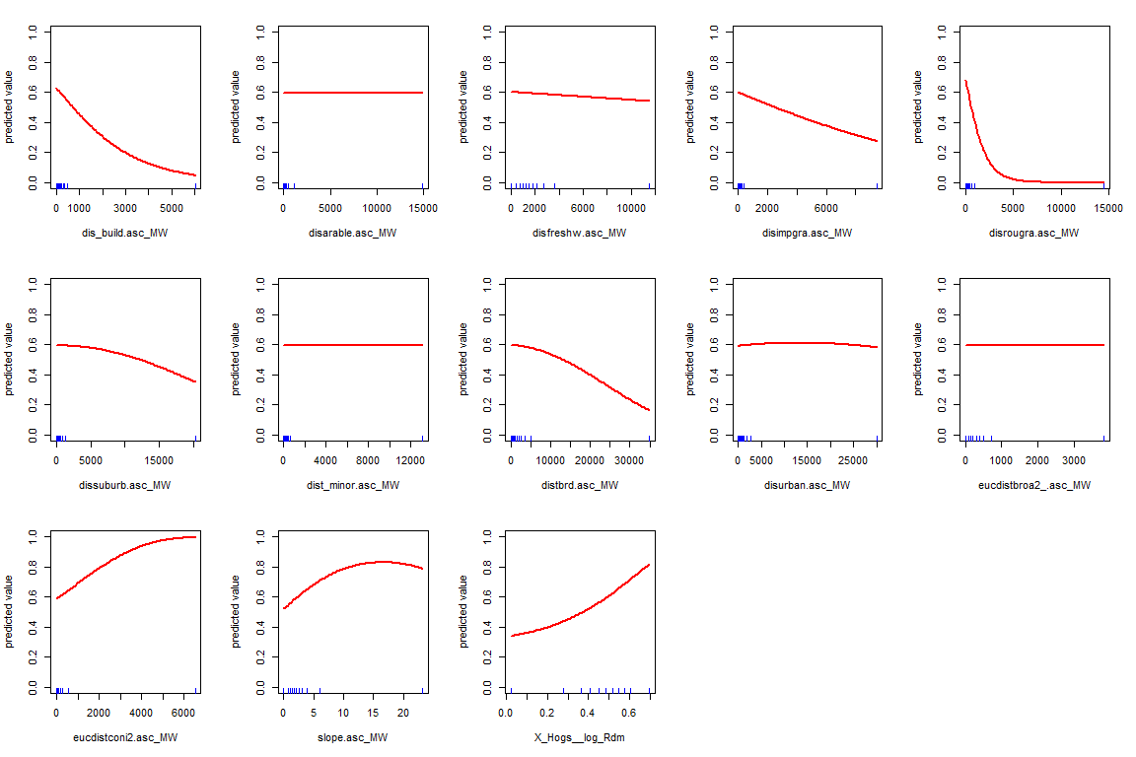
Supplementary 11: Summary of variable importance and response curves of the major road model (random background data)
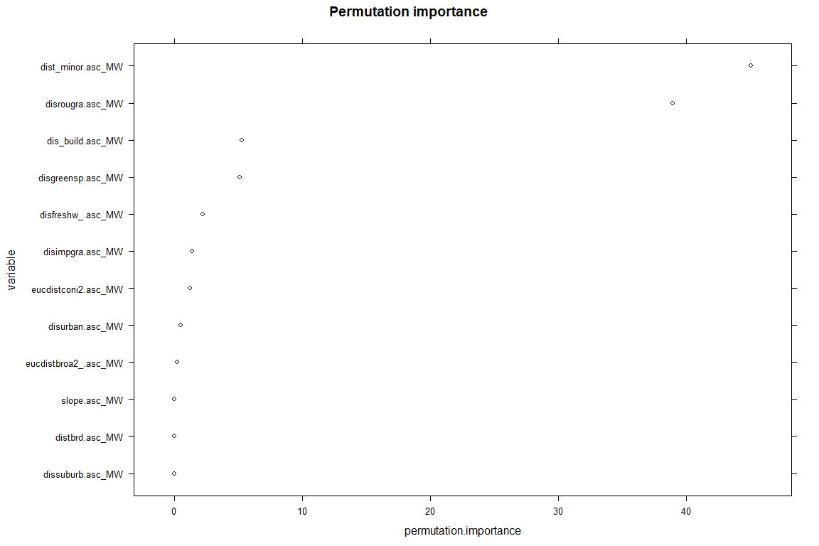
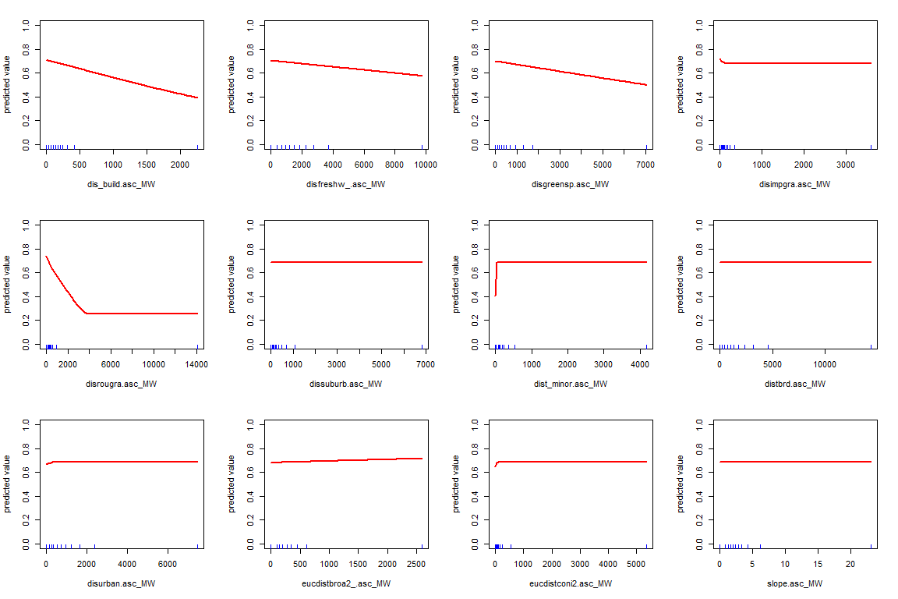
Supplementary 12: Summary of variable importance and response curves of the major road model (roadkill background data)

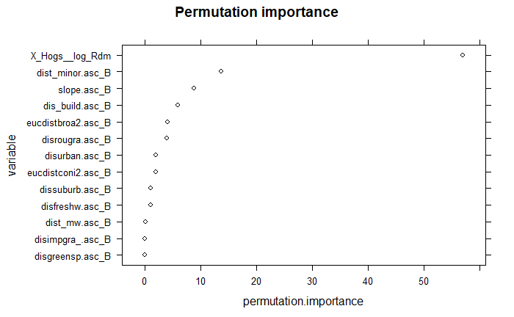
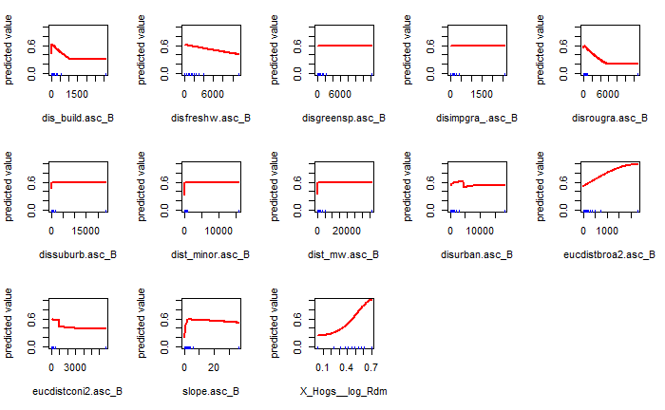

Supplementary 13: Summary of variable importance and response curves of the B road model (Random background data)

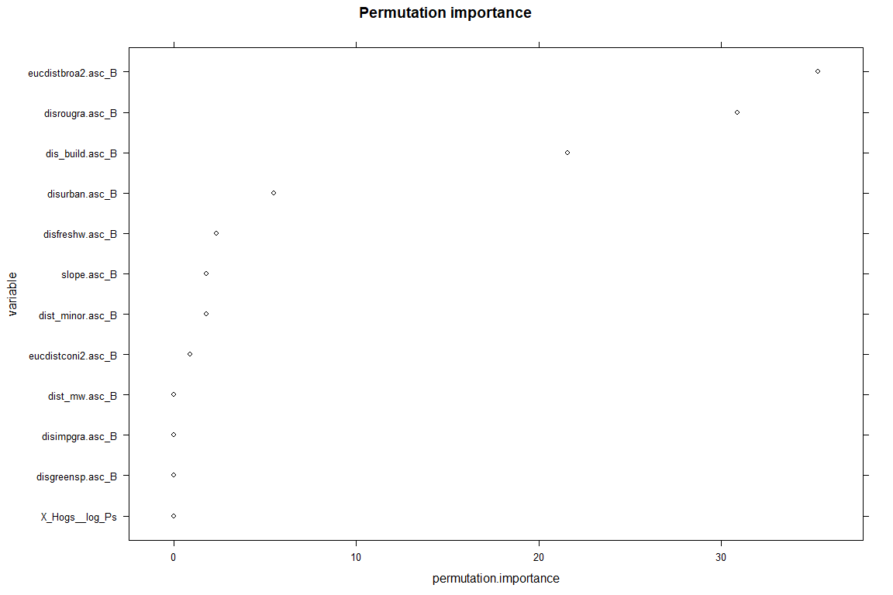
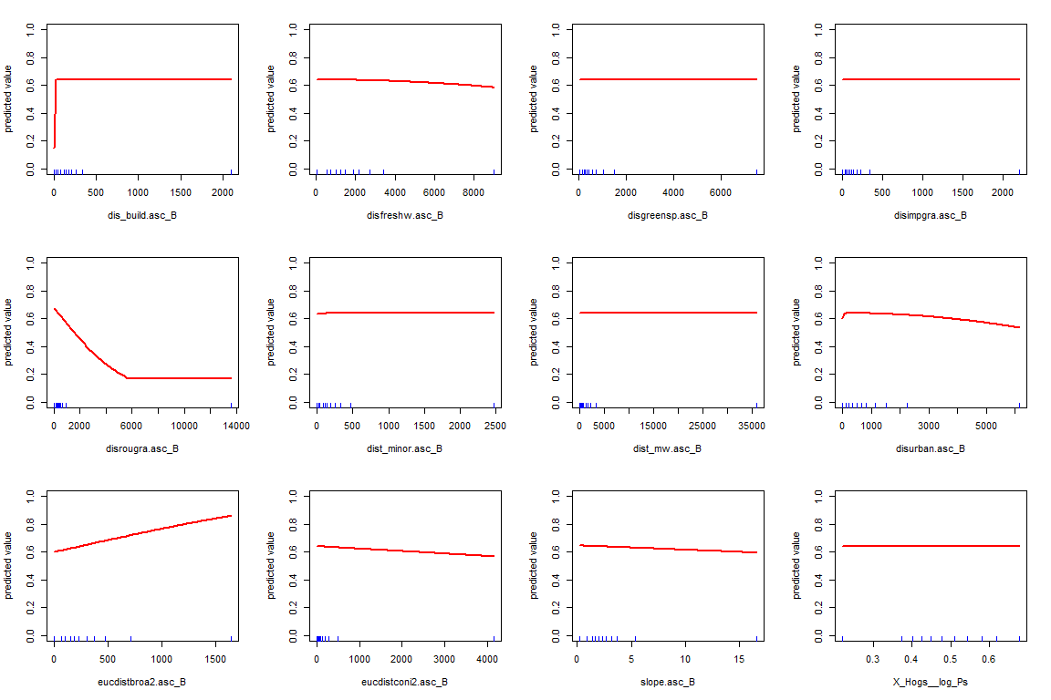
Supplementary 14: Summary of variable importance and response curves of the B road model (Roadkill background data)

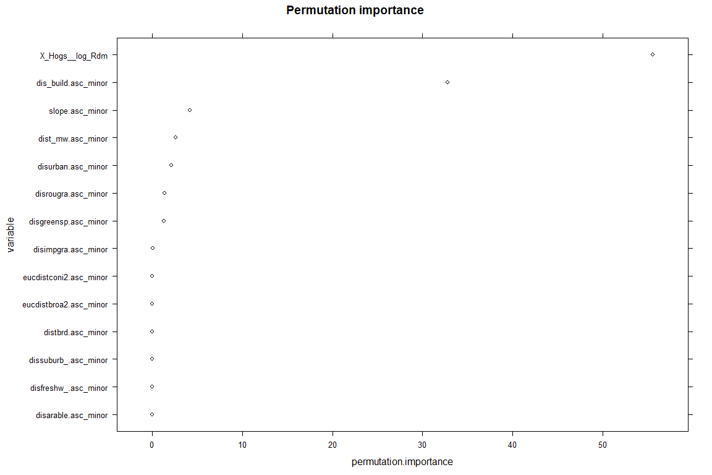
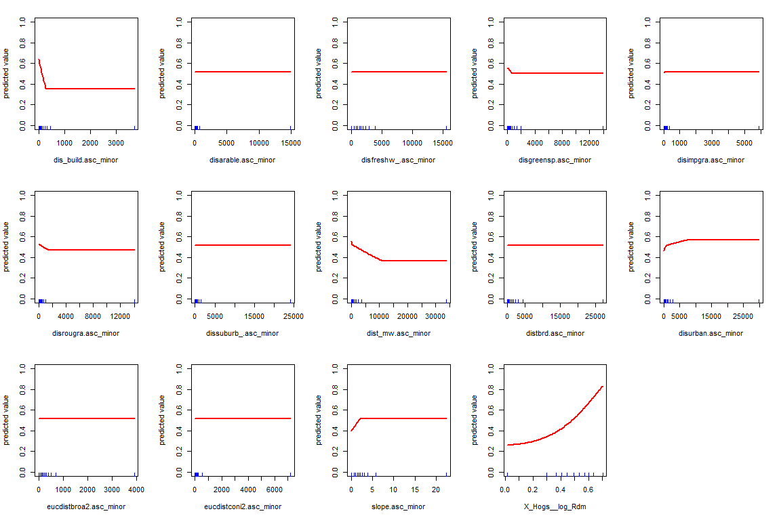
Supplementary 15: Summary of variable importance and response curves of the minor road model (Random background data)

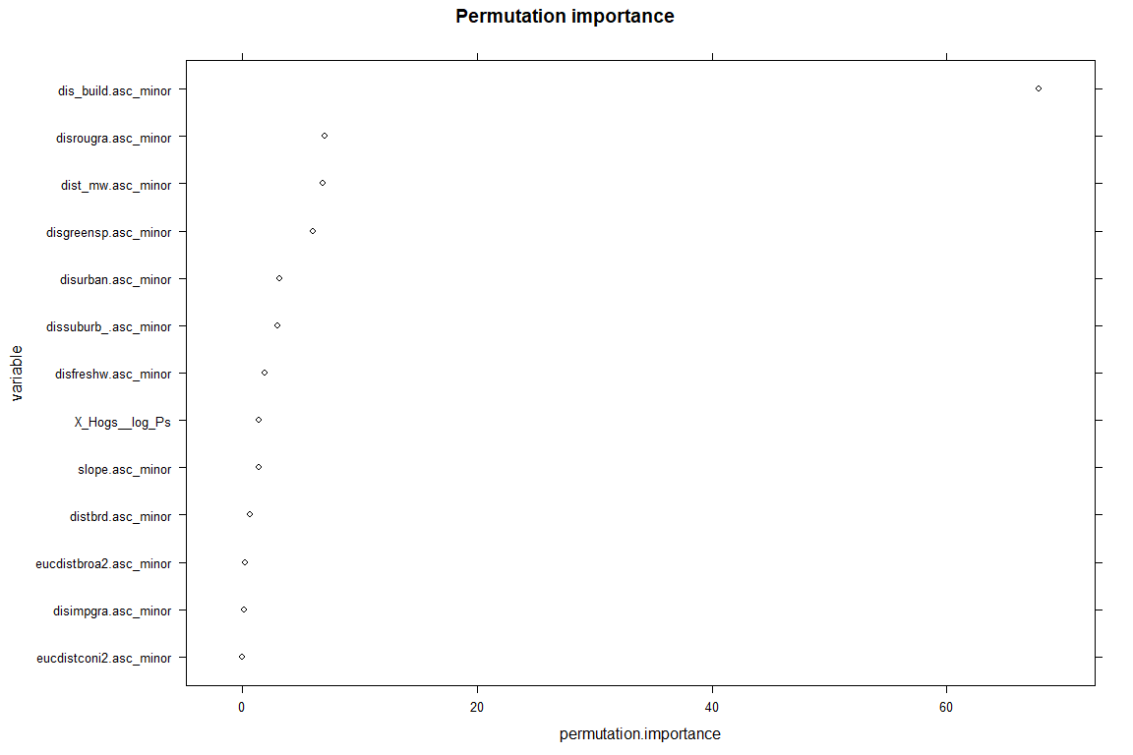
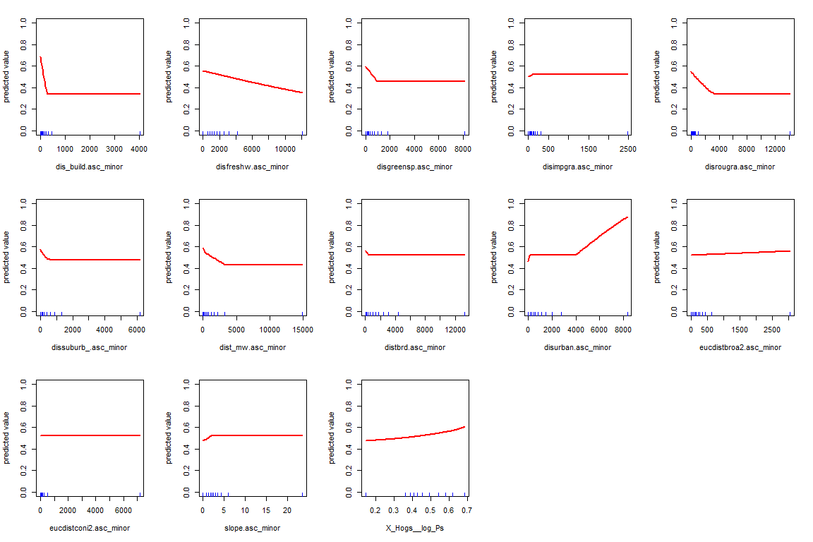
Supplementary 16: Summary of variable importance and response curves of the minor road model (Roadkill background data)

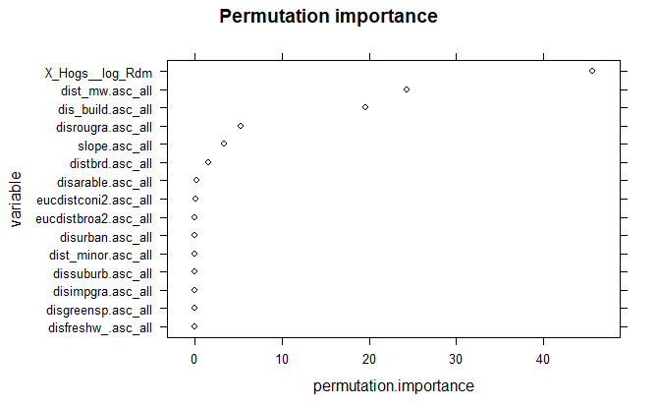
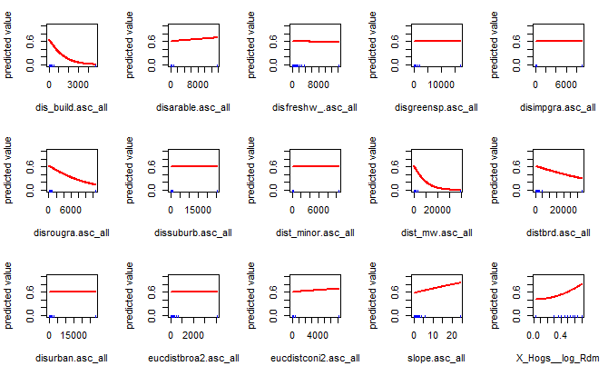
Supplementary 17: Summary of variable importance and response curves of the all roads model (Random background data)
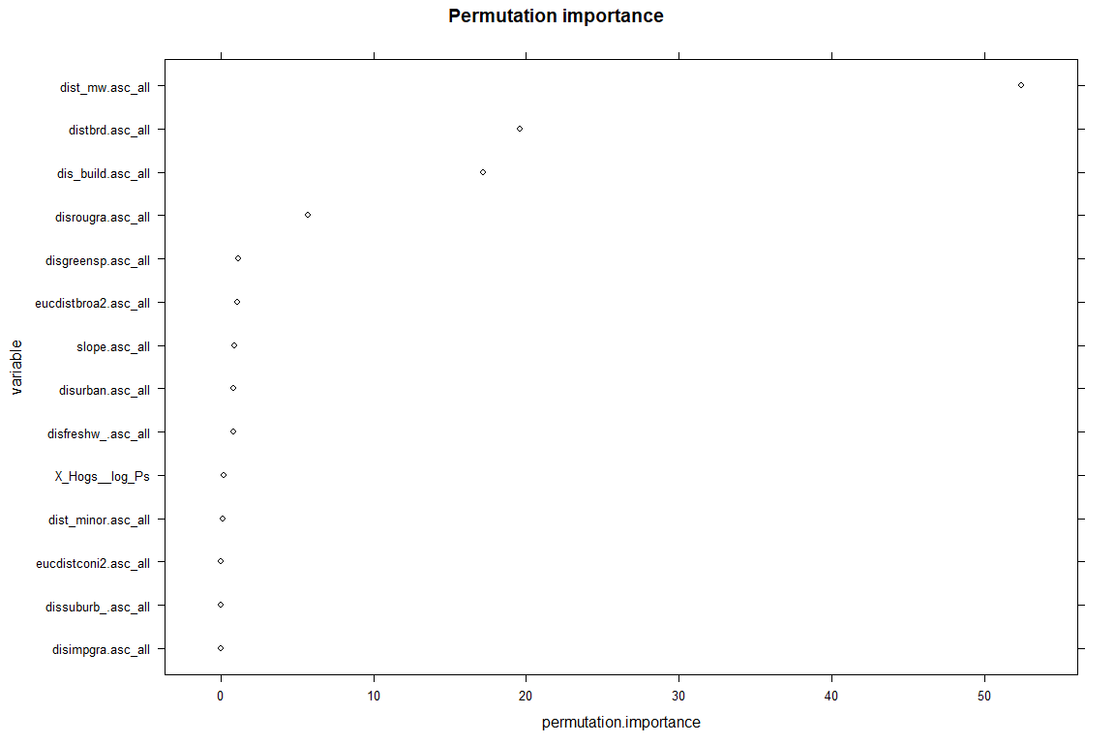
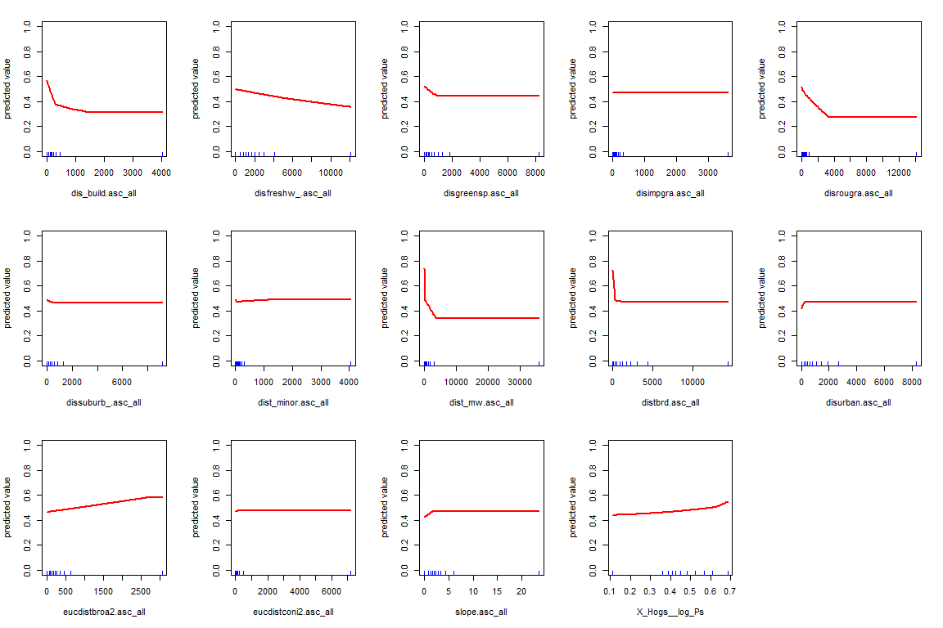

Supplementary 18: Summary of variable importance and response curves of the all roads model (Roadkill background data)
Supplementary 19: Using combined persistence data and predicted high-risk collision areas as a case study in Chesterfield to identify priority mitigation measures.

