Supporting Information

A new p-terphenyl derivative from the insect-derived fungus Aspergillus sp. Bdf-2 and the synergistic effects of terphenyllin

Tijiang Shan^{1†}, Yuyang Wang^{1†}, Song Wang¹, Yunying Xie², Zehua Cui³, Chunyin Wu¹, Jian Sun³, Jun Wang¹ and Ziling Mao^{1*}

¹ Guangdong Key Laboratory for Innovative Development and Utilization of Forest Plant Germplasm, College of Forestry and Landscape Architecture, South China Agricultural University, Guangzhou,Guangdong, China
² Institute of Medicinal Biotechnology, Chinese Academy of Medical Sciences & Peaking Union Medical College, Beijing, China
³ National Risk Assessment Laboratory for Antimicrobial Resistance of Animal Original Bacteria, South China Agricultural University, Guangzhou, Guangdong, China

Corresponding Author:
Ziling Mao¹
483 Wushan Road, Tianhe District, Guangzhou,Guangdong, 510642, China
Email address: zlmao@scau.edu.cn

†These authors contributed equally to this work.

Contents
Figure S1 Colony of Aspergillus candidus Bdf-2 4
Figure S2 Phylogenetic tree of Aspergillus candidus Bdf-2 based on the rDNA-ITS sequence 4
Figure S3 Phylogenetic tree of Aspergillus candidus Bdf-2 based on the beta-tubulin (tub2) gene sequence 5
Figure S4 Phylogenetic tree of Aspergillus candidus Bdf-2 based on the RNA polymerase II second largest subunit (RPB2) gene sequence 5
Figure S5 Phylogenetic tree of Aspergillus candidus Bdf-2 based on the large subunit ribosomal RNA gene sequence 6
Figure S6 UV spectrum of 4''-Dehydroxy-2'-methoxyterphenyllin (1) 6
Figure S7 IR spectrum of 4''-Dehydroxy-2'-methoxyterphenyllin (1) 7
Figure S8 HR-ESI-MS spectrum of 4''-Dehydroxy-2'-methoxyterphenyllin (1) 8
Figure S9 ¹H NMR spectrum of 4''-Dehydroxy-2'-methoxyterphenyllin (1) (Acetone-d₆, 600 MHz) 8
Figure S10 ¹³C NMR spectrum of 4''-Dehydroxy-2'-methoxyterphenyllin (1) (Acetone-d₆, 151 MHz) 9
Figure S11 HSQC spectrum of 4''-Dehydroxy-2'-methoxyterphenyllin (1) (Acetone-d₆) 9
Figure S12 HMBC spectrum of 4''-Dehydroxy-2'-methoxyterphenyllin (1) (Acetone-d₆) 10
Figure S13 ¹H-¹H COSY spectrum of 4''-Dehydroxy-2'-methoxyterphenyllin (1) (Acetone-d₆) 10
Figure S14 NOESY spectrum of 4''-Ddeoxy-2'-methoxyterphenyllin (1) (Acetone-d₆) 11
Figure S15 HR-ESI-MS spectrum of Terphenyllin (2) 11
Figure S16 ¹H NMR spectrum of Terphenyllin (2) (DMSO-d₆, 600 MHz) 12
Figure S17 ¹³C NMR spectrum of Terphenyllin (2) (DMSO-d₆, 151 MHz) 12
Figure S18 HR-ESI-MS spectrum of 4, 4''-Deoxyterphenyllin (3) 13
Figure S19 ¹H NMR spectrum of 4, 4''-Deoxyterphenyllin (3) (CDCl₃, 600 MHz) 13
Figure S20 ¹³C NMR spectrum of 4, 4''-Deoxyterphenyllin (3) (CDCl₃, 151 MHz) 14
Figure S21 HR-ESI-MS spectrum of 4″-Ddeoxyterphenyllin (4) 14
Figure S22 ¹H NMR spectrum of 4″-Ddeoxyterphenyllin (4) (Acetone-d₆, 600 MHz) 15
Figure S23 ¹³C NMR spectrum of 4″-Ddeoxyterphenyllin (4) (Acetone-d₆, 151 MHz) 15
Figure S24 HR-ESI-MS spectrum of 3''-Hydroxyterphenyllin (5) 16
Figure S25 ¹H NMR spectrum of 3''-Hydroxyterphenyllin (5) (CD₃OD, 600 MHz) 16
Figure S26 ¹³C NMR spectrum of 3''-Hydroxyterphenyllin (5) (CD₃OD, 151 MHz) 17
Figure S27 HR-ESI-MS spectrum of 3, 3''-Dihydroxyterphenyllin (6) 17
Figure S28 ¹H NMR spectrum of 3, 3''- Dihydroxyterphenyllin (6) (CD₃OD, 600 MHz) 18
Figure S29 ¹³C NMR spectrum of 3, 3''- Dihydroxyterphenyllin (6) (CD₃OD, 151 MHz) 18
Figure S30 HR-ESI-MS spectrum of Candidusin A (7) 19
Figure S31 ¹H NMR spectrum of Candidusin A (7) (CD₃OD, 600 MHz) 19
Figure S32 ¹³C NMR spectrum of Candidusin A (7) (CD₃OD, 151 MHz) 20
Figure S33 HR-ESI-MS spectrum of Dechlorochlorflavonin (8) 20
Figure S34 ¹H NMR spectrum of Dechlorochlorflavonin (8) (CDCl₃, 600 MHz) 21
Figure S35 ¹³C NMR spectrum of Dechlorochlorflavonin (8) (CDCl₃, 151 MHz) 21
Figure S36 HR-ESI-MS spectrum of Fellutanine A (9) 22
Figure S37 ¹H NMR spectrum of Fellutanine A (9) (CD₃OD, 600 MHz) 22
Figure S38 ¹³C NMR spectrum of Fellutanine A (9) (CD₃OD, 151 MHz) 23

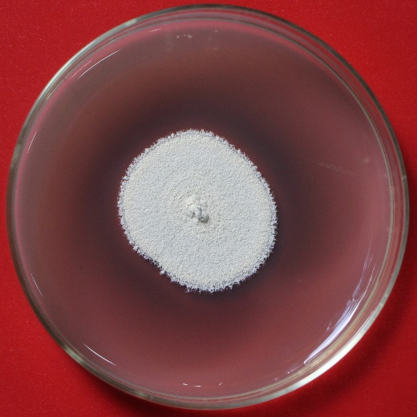

Figure S1 Colony of Aspergillus candidus Bdf-2

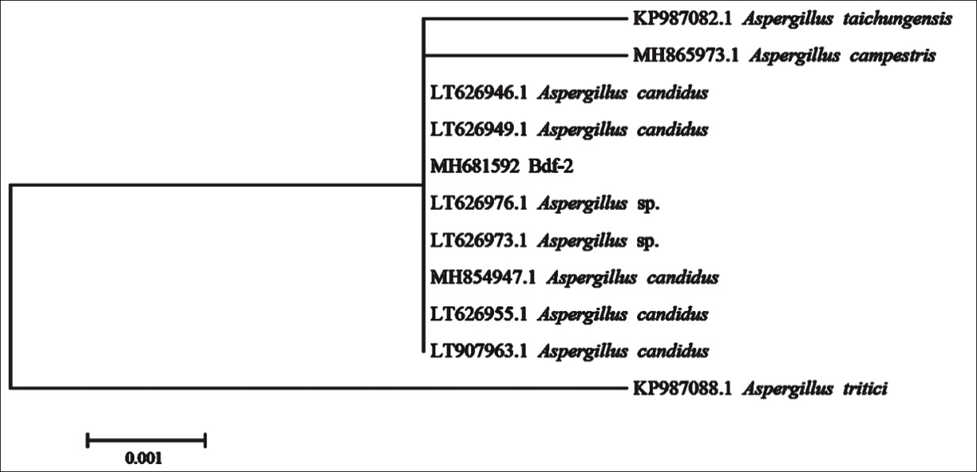

Figure S2 Phylogenetic tree of Aspergillus candidus Bdf-2 based on the rDNA-ITS sequence

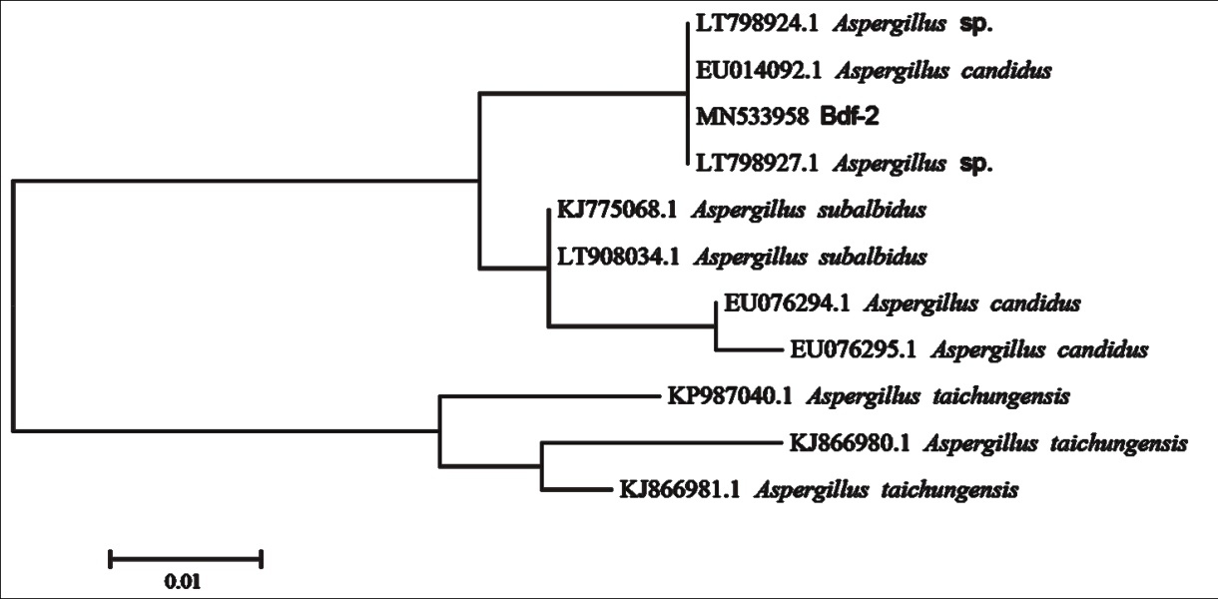

Figure S3 Phylogenetic tree of Aspergillus candidus Bdf-2 based on the beta-tubulin (tub2) gene sequence

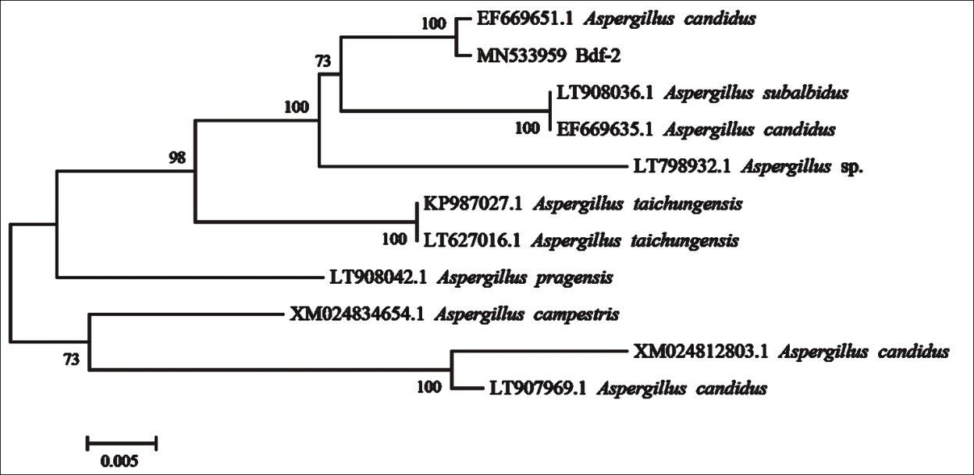

Figure S4 Phylogenetic tree of Aspergillus candidus Bdf-2 based on the RNA polymerase II second largest subunit (RPB2) gene sequence

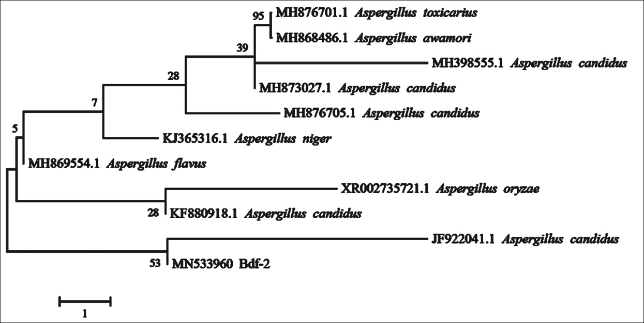

Figure S5 Phylogenetic tree of Aspergillus candidus Bdf-2 based on the large subunit ribosomal RNA gene sequence

Figure S6 UV spectrum of 4''-Dehydroxy-2'-methoxyterphenyllin (1)

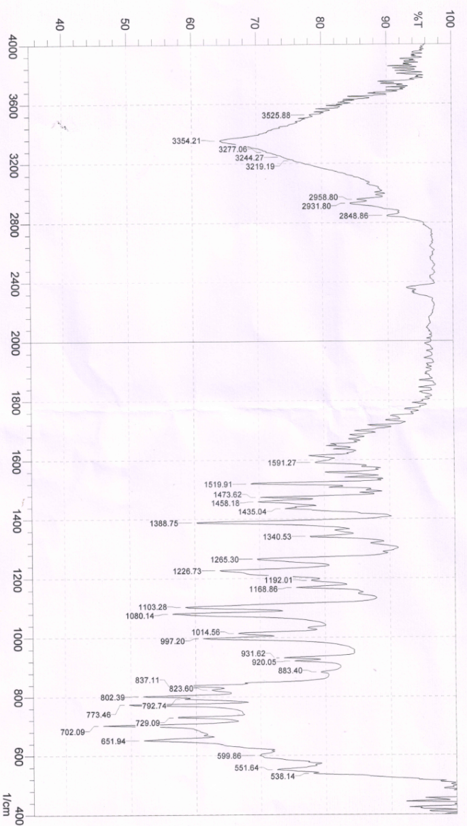

Figure S7 IR spectrum of 4''-Dehydroxy-2'-methoxyterphenyllin (1)

Figure S8 HR-ESI-MS spectrum of 4''-Dehydroxy-2'-methoxyterphenyllin (1)

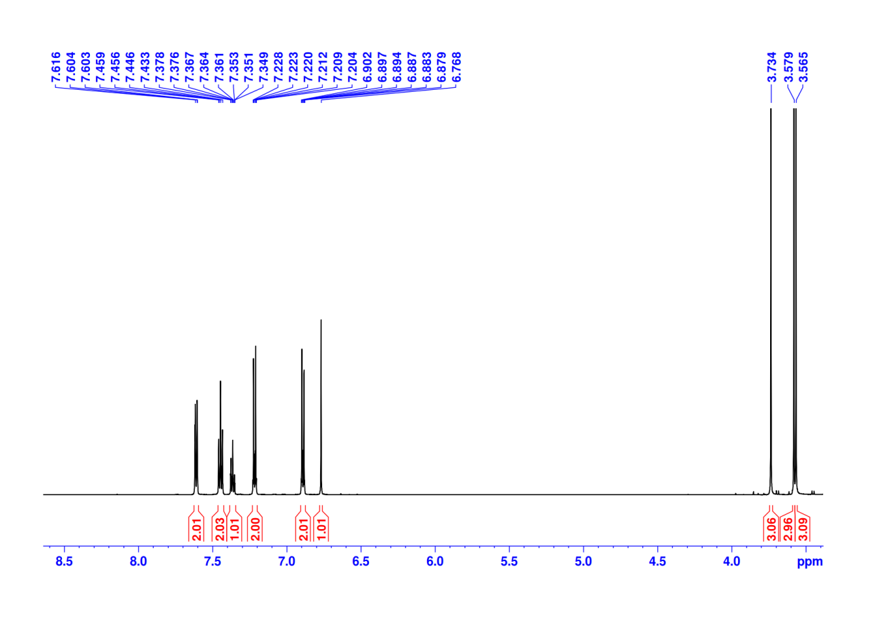

Figure S9 ¹H NMR spectrum of 4''-Dehydroxy-2'-methoxyterphenyllin (1) (Acetone-d₆, 600 MHz)

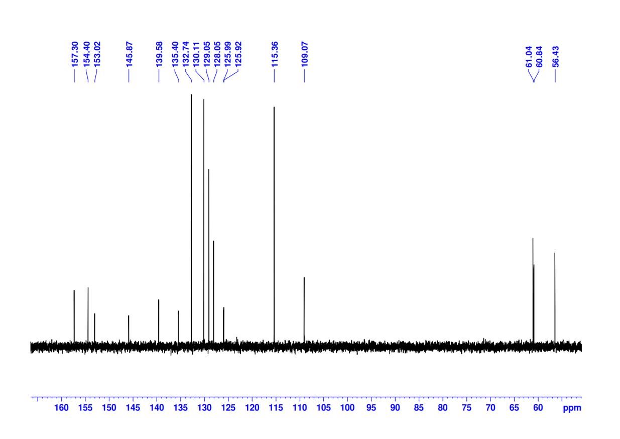

Figure S10 ¹³C NMR spectrum of 4''-Dehydroxy-2'-methoxyterphenyllin (1) (Acetone-d₆, 151 MHz)

Figure S11 HSQC spectrum of 4''-Dehydroxy-2'-methoxyterphenyllin (1) (Acetone-d₆)

Figure S12 HMBC spectrum of 4''-Dehydroxy-2'-methoxyterphenyllin (1) (Acetone-d₆)

Figure S13 ¹H-¹H COSY spectrum of 4''-Dehydroxy-2'-methoxyterphenyllin (1) (Acetone-d₆)

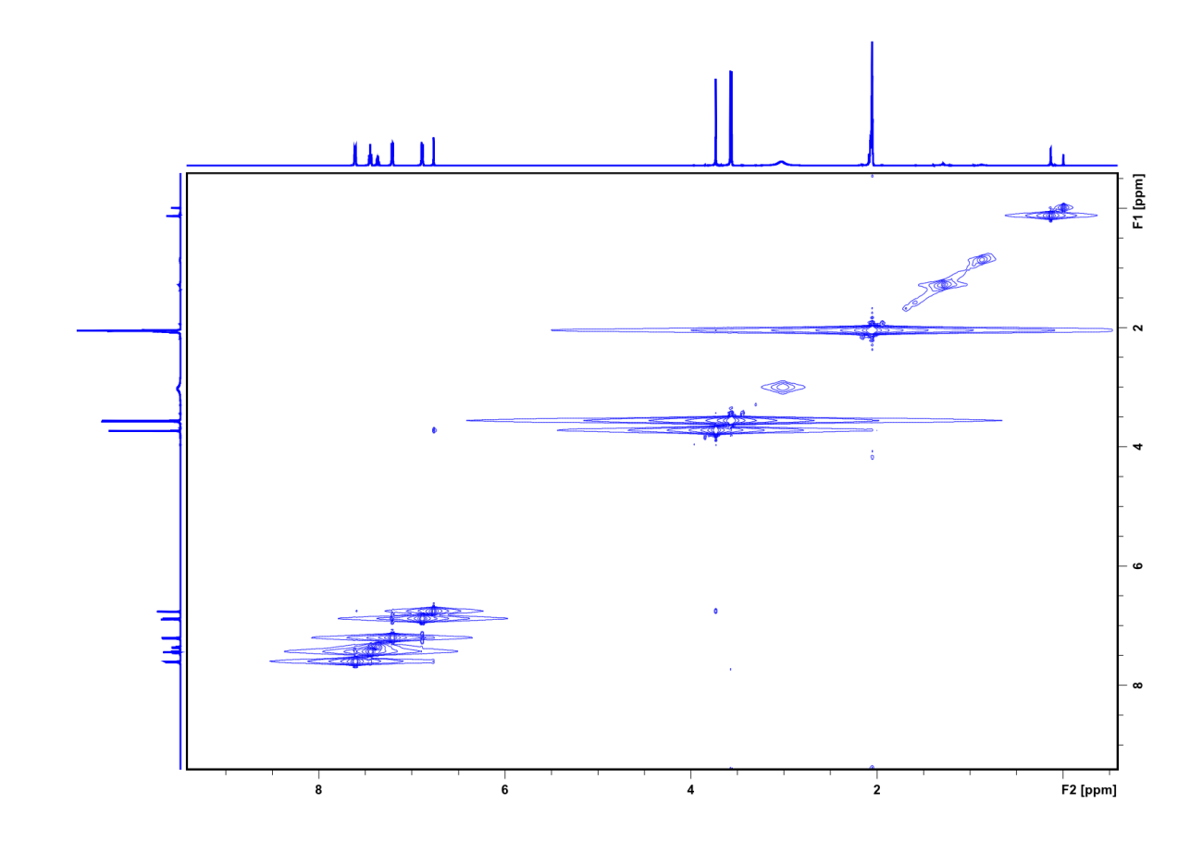

Figure S14 NOESY spectrum of 4''-Ddeoxy-2'-methoxyterphenyllin (1) (Acetone-d₆)

Figure S15 HR-ESI-MS spectrum of Terphenyllin (2)

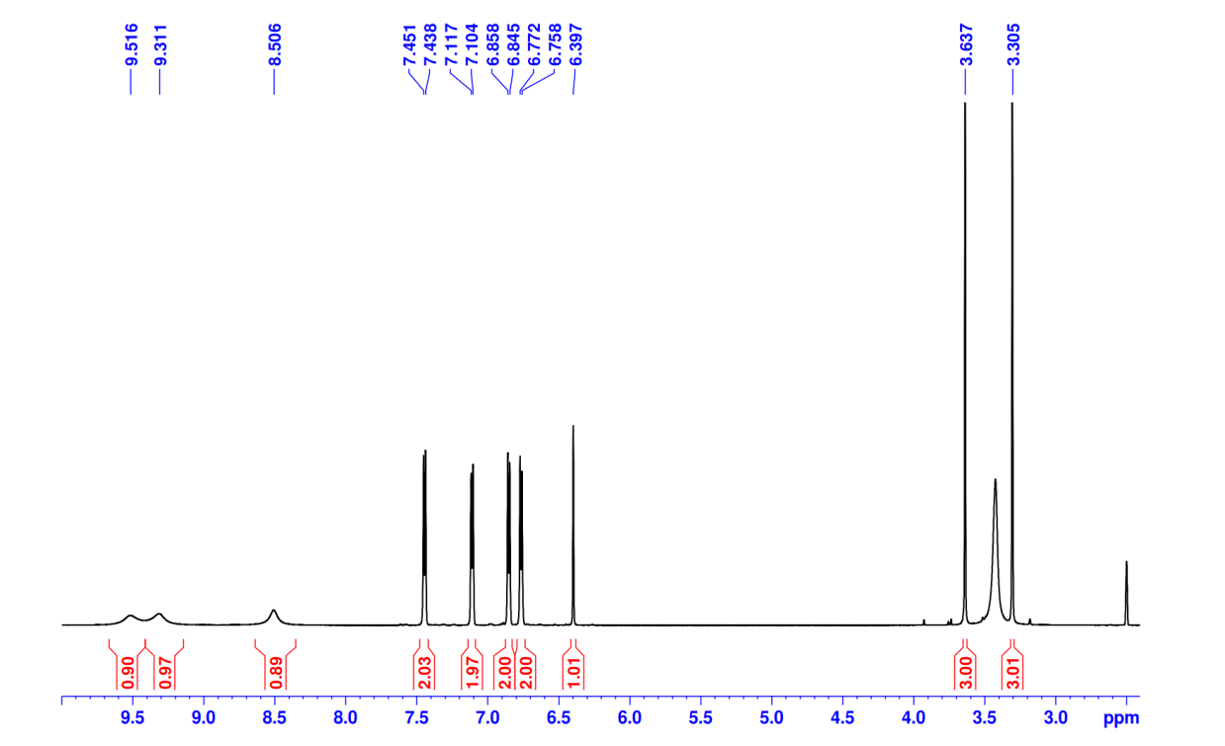

Figure S16 ¹H NMR spectrum of Terphenyllin (2) (DMSO-d₆, 600 MHz)

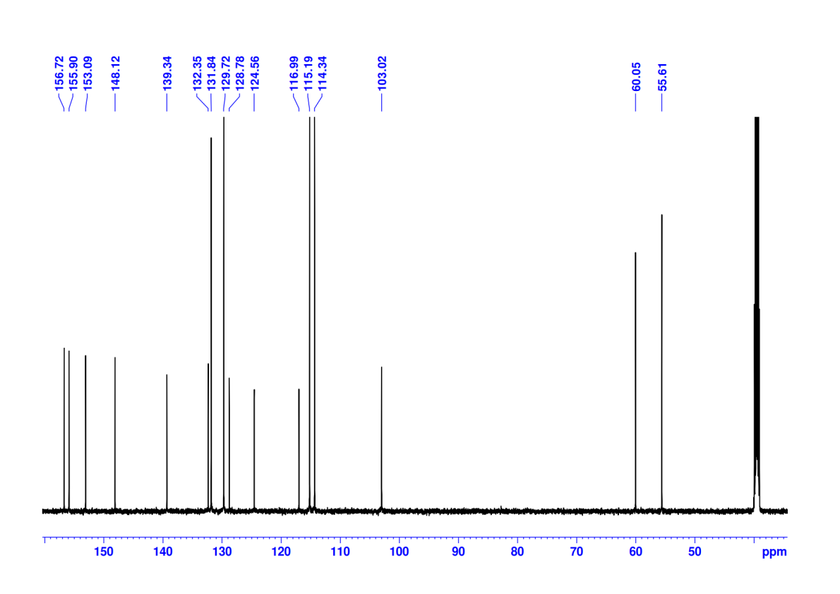

Figure S17 ¹³C NMR spectrum of Terphenyllin (2) (DMSO-d₆, 151 MHz)

Figure S18 HR-ESI-MS spectrum of 4, 4''-Deoxyterphenyllin (3)

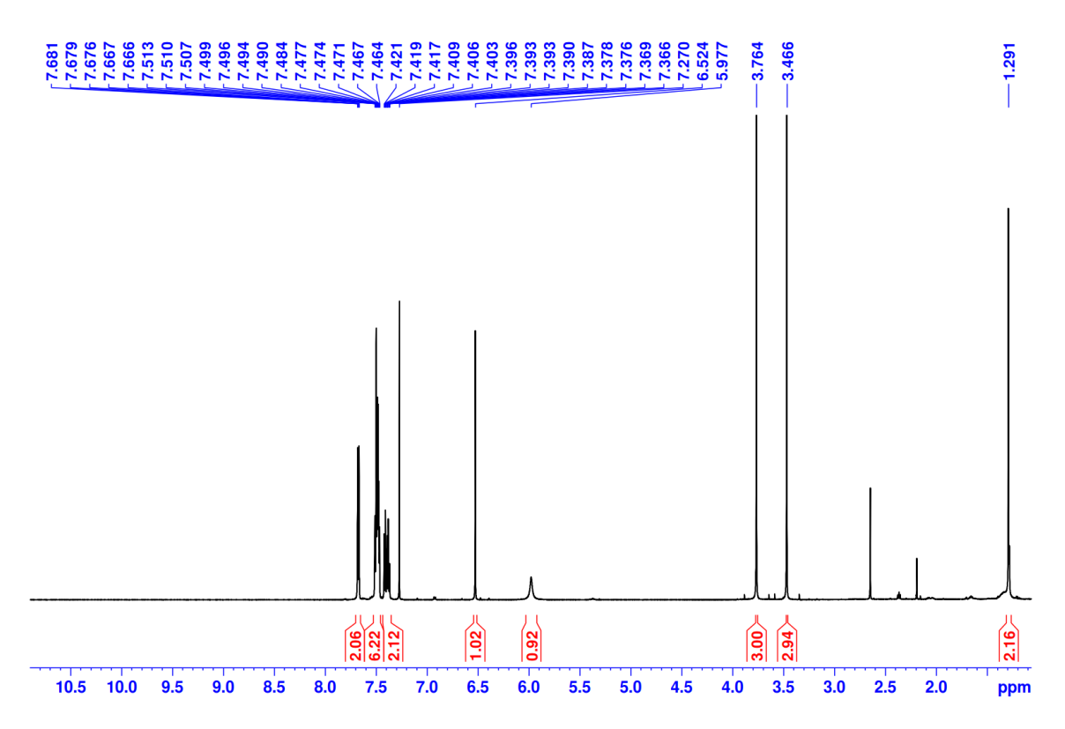

Figure S19 ¹H NMR spectrum of 4, 4''-Deoxyterphenyllin (3) (CDCl₃, 600 MHz)

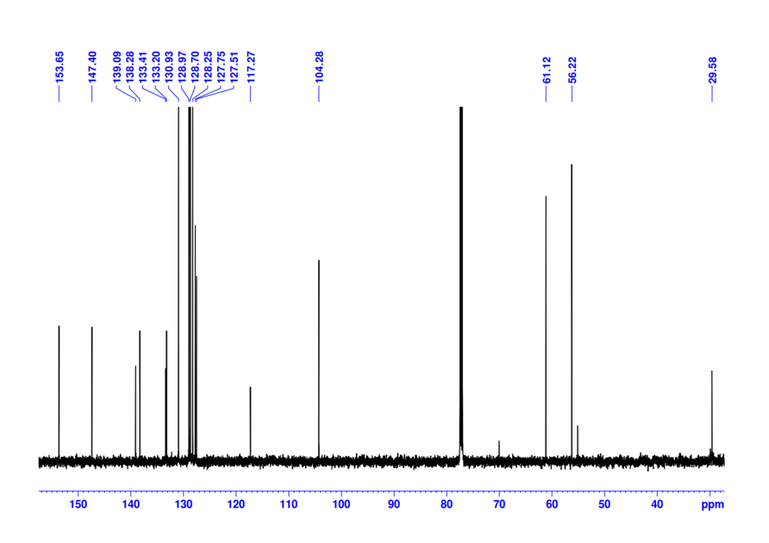

Figure S20 ¹³C NMR spectrum of 4, 4''-Deoxyterphenyllin (3) (CDCl₃, 151 MHz)

Figure S21 HR-ESI-MS spectrum of 4″-Ddeoxyterphenyllin (4)

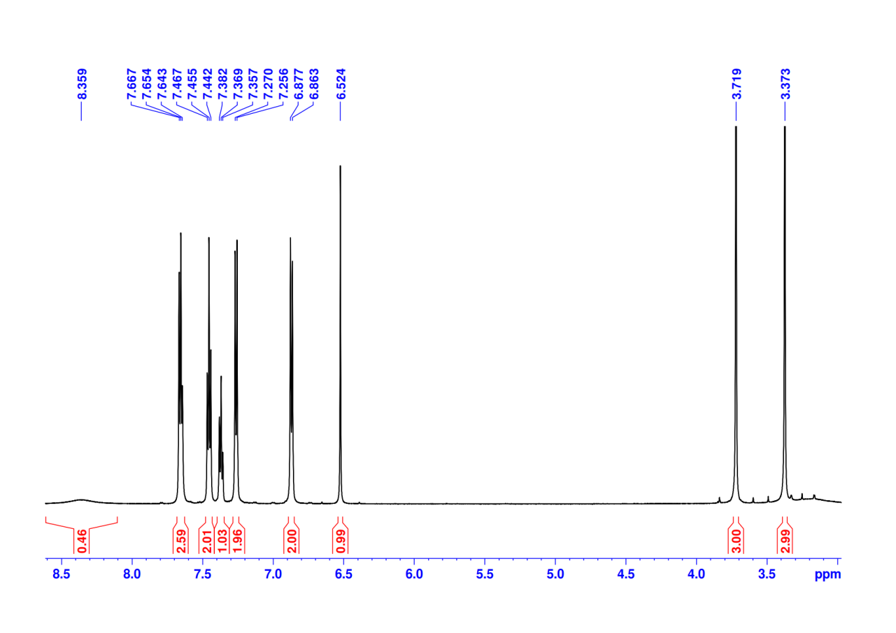

Figure S22 ¹H NMR spectrum of 4″-Ddeoxyterphenyllin (4) (Acetone-d₆, 600 MHz)

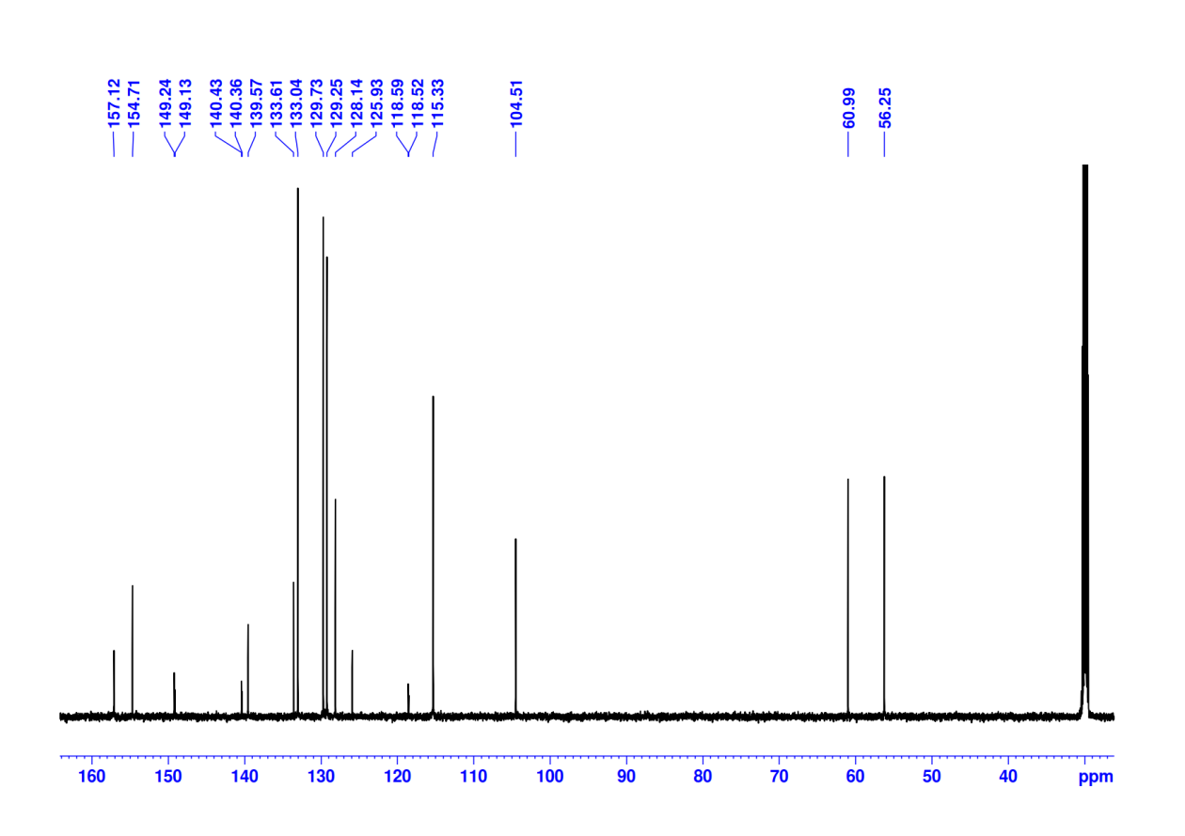

Figure S23 ¹³C NMR spectrum of 4″-Ddeoxyterphenyllin (4) (Acetone-d₆, 151 MHz)

Figure S24 HR-ESI-MS spectrum of 3''-Hydroxyterphenyllin (5)

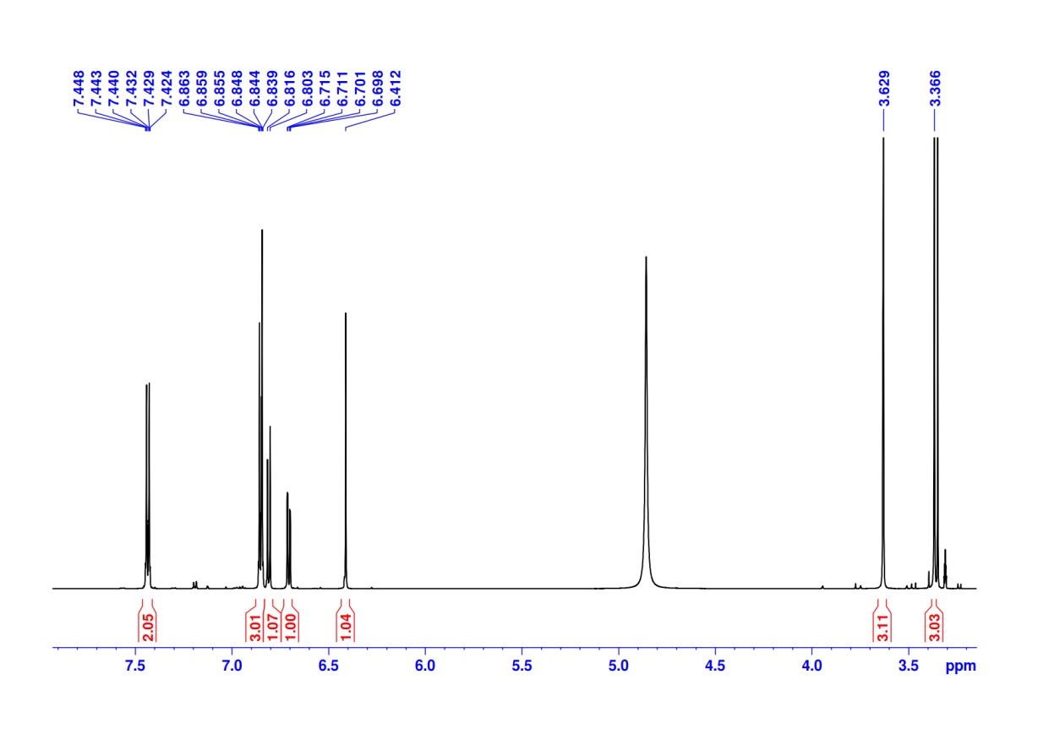

Figure S25 ¹H NMR spectrum of 3''-Hydroxyterphenyllin (5) (CD₃OD, 600 MHz)

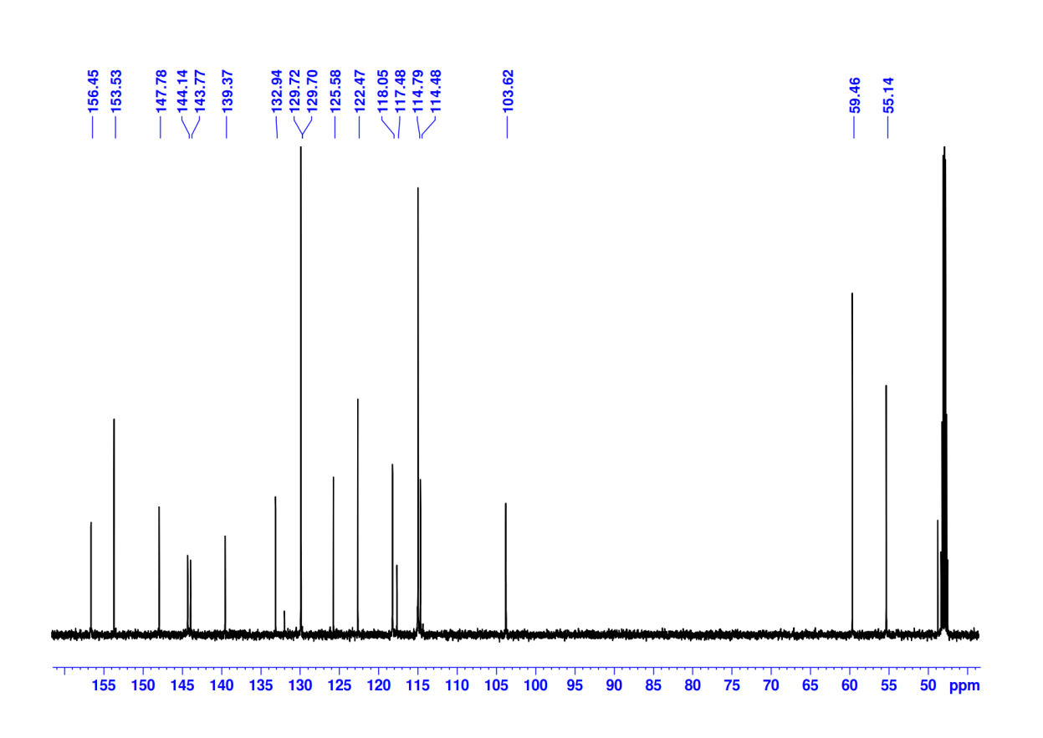

Figure S26 ¹³C NMR spectrum of 3''-Hydroxyterphenyllin (5) (CD₃OD, 151 MHz)

Figure S27 HR-ESI-MS spectrum of 3, 3''-Dihydroxyterphenyllin (6)

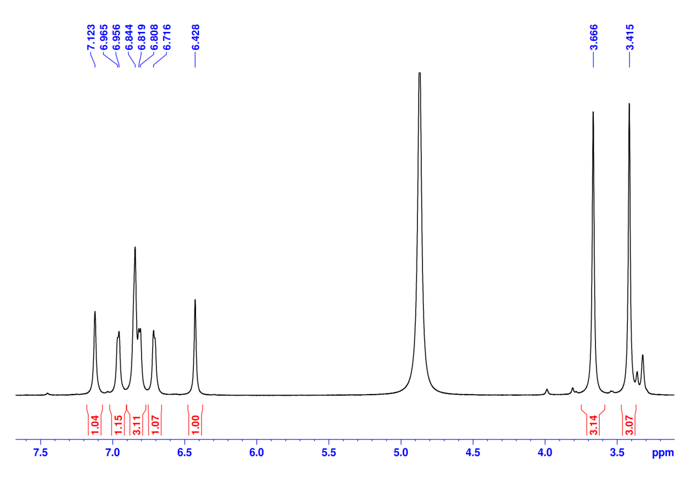

Figure S28 ¹H NMR spectrum of 3, 3''- Dihydroxyterphenyllin (6) (CD₃OD, 600 MHz)

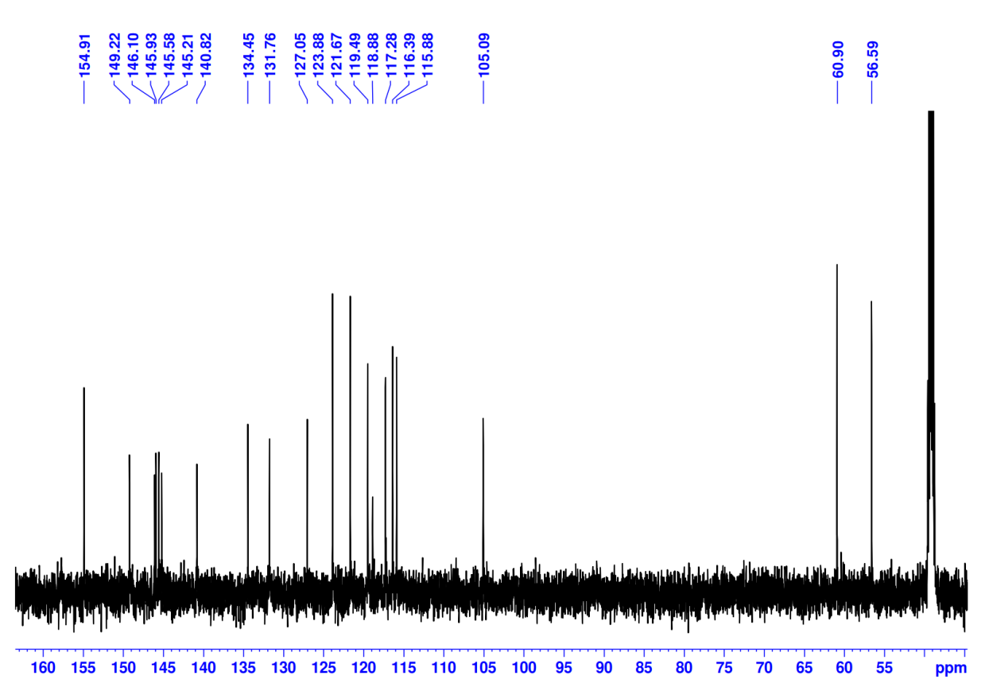

Figure S29 ¹³C NMR spectrum of 3, 3''- Dihydroxyterphenyllin (6) (CD₃OD, 151 MHz)

Figure S30 HR-ESI-MS spectrum of Candidusin A (7)

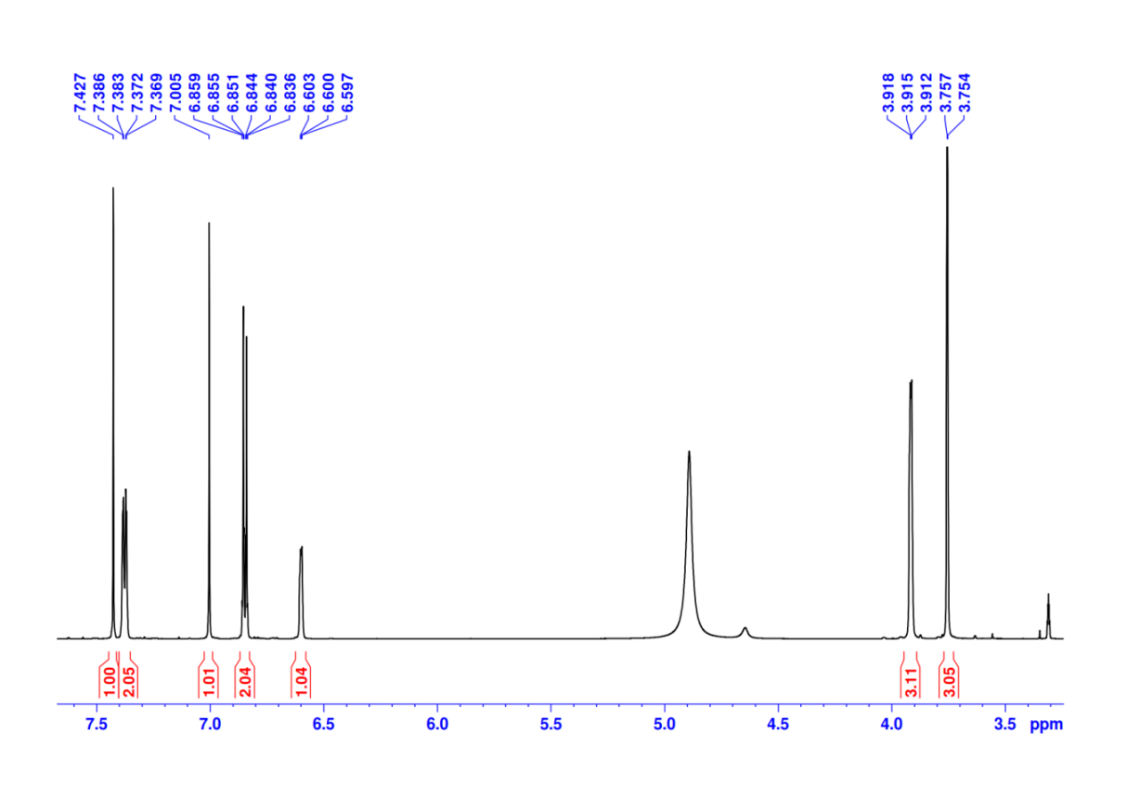

Figure S31 ¹H NMR spectrum of Candidusin A (7) (CD₃OD, 600 MHz)

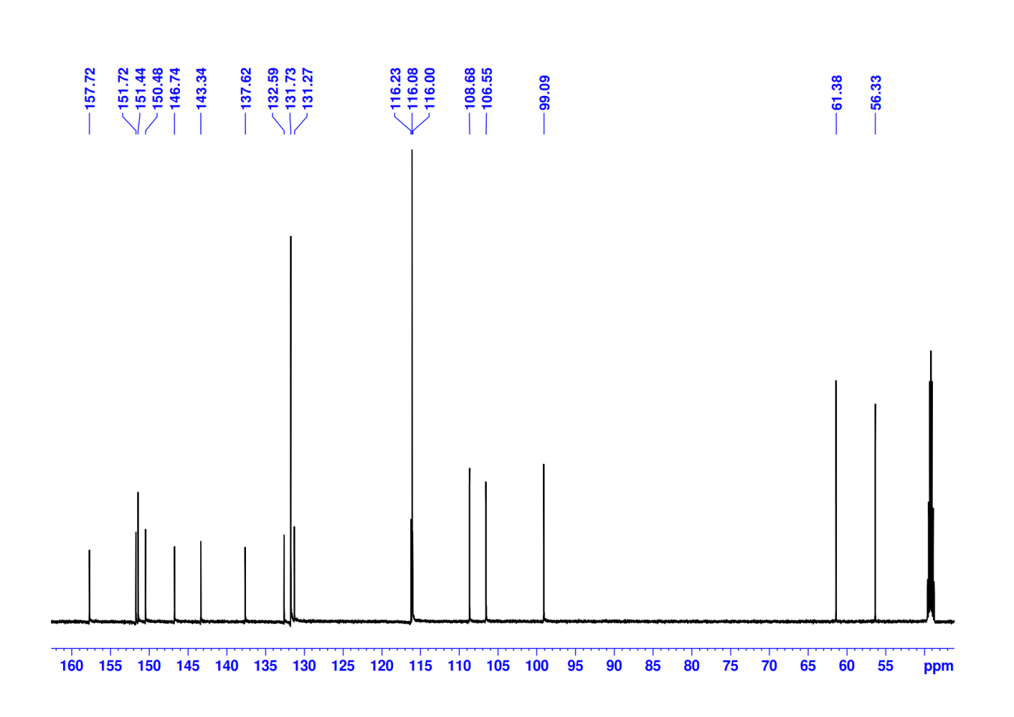

Figure S32 ¹³C NMR spectrum of Candidusin A (7) (CD₃OD, 151 MHz)

Figure S33 HR-ESI-MS spectrum of Dechlorochlorflavonin (8)

Figure S34 ¹H NMR spectrum of Dechlorochlorflavonin (8) (CDCl₃, 600 MHz)

Figure S35 ¹³C NMR spectrum of Dechlorochlorflavonin (8) (CDCl₃, 151 MHz)

Figure S36 HR-ESI-MS spectrum of Fellutanine A (9)

Figure S37 ¹H NMR spectrum of Fellutanine A (9) (CD₃OD, 600 MHz)

Figure S38 ¹³C NMR spectrum of Fellutanine A (9) (CD₃OD, 151 MHz)

