Post-hoc power analysis – VL Echo Intensity following two weeks of immobilization – left limb
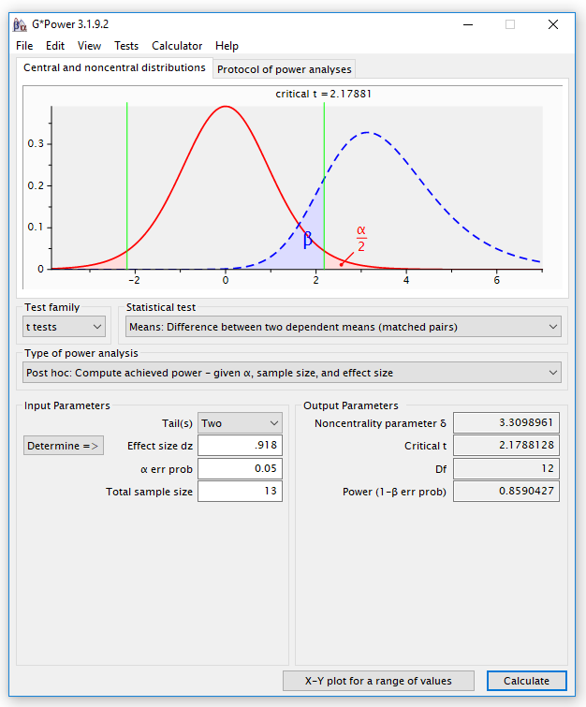

Post-hoc power analysis – VL CSA following two weeks of immobilization – left limb
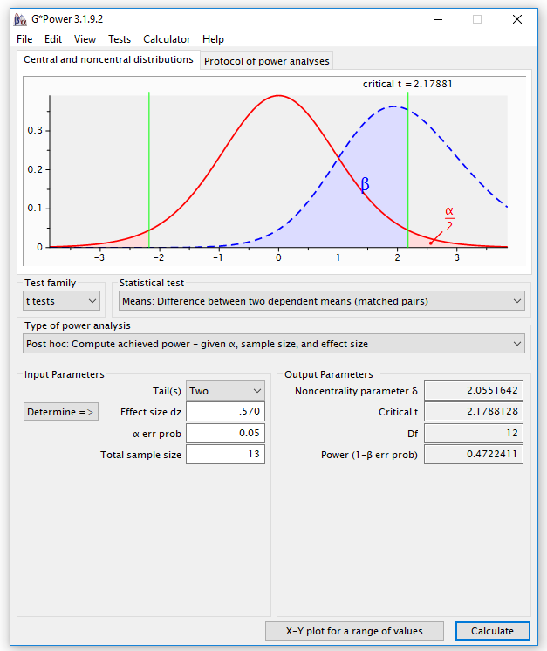

Post-hoc power analysis – RF Echo Intensity following two weeks of immobilization – left limb
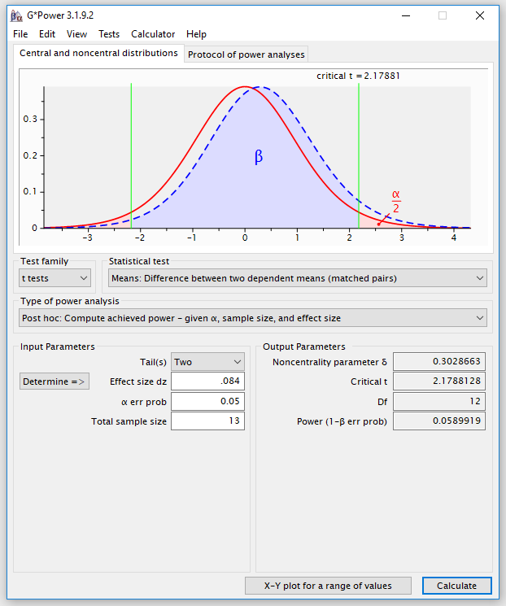

Post-hoc power analysis – RF CSA following two weeks of immobilization – left limb
