**Soil aggregate size influences the impact of** **inorganic nitrogen deposition on soil** **nitrification in an alpine meadow of the Qinghai-Tibet Plateau**

Jingjing Li1, Chao Yang2, Xiaoli Liu1, Hanzhong Ji3 and Xinqing Shao1,4,5*

1 College of Grassland Science and Technology, China Agricultural University, Beijing, China.

2 Grassland Agri-Husbandry Research Center, College of Grassland Science, Qingdao Agricultural University, Qingdao, China

3 Institute of Haibei Tibetan Autonomous Prefecture Animal Husbandry and Veterinary Science, Xining, China.

4 Technical Platform for Adaptive Management of Livestock System in Alpine Grassland, Xining, China.

5 Key Laboratory of Restoration Ecology of Cold Area in Qinghai province, Northwest Institute of Plateau Biology, Chinese Academy of Sciences, Xining, China.

*Corresponding Author:

Xinqing Shao

Email address: shaoxinqing@163.com

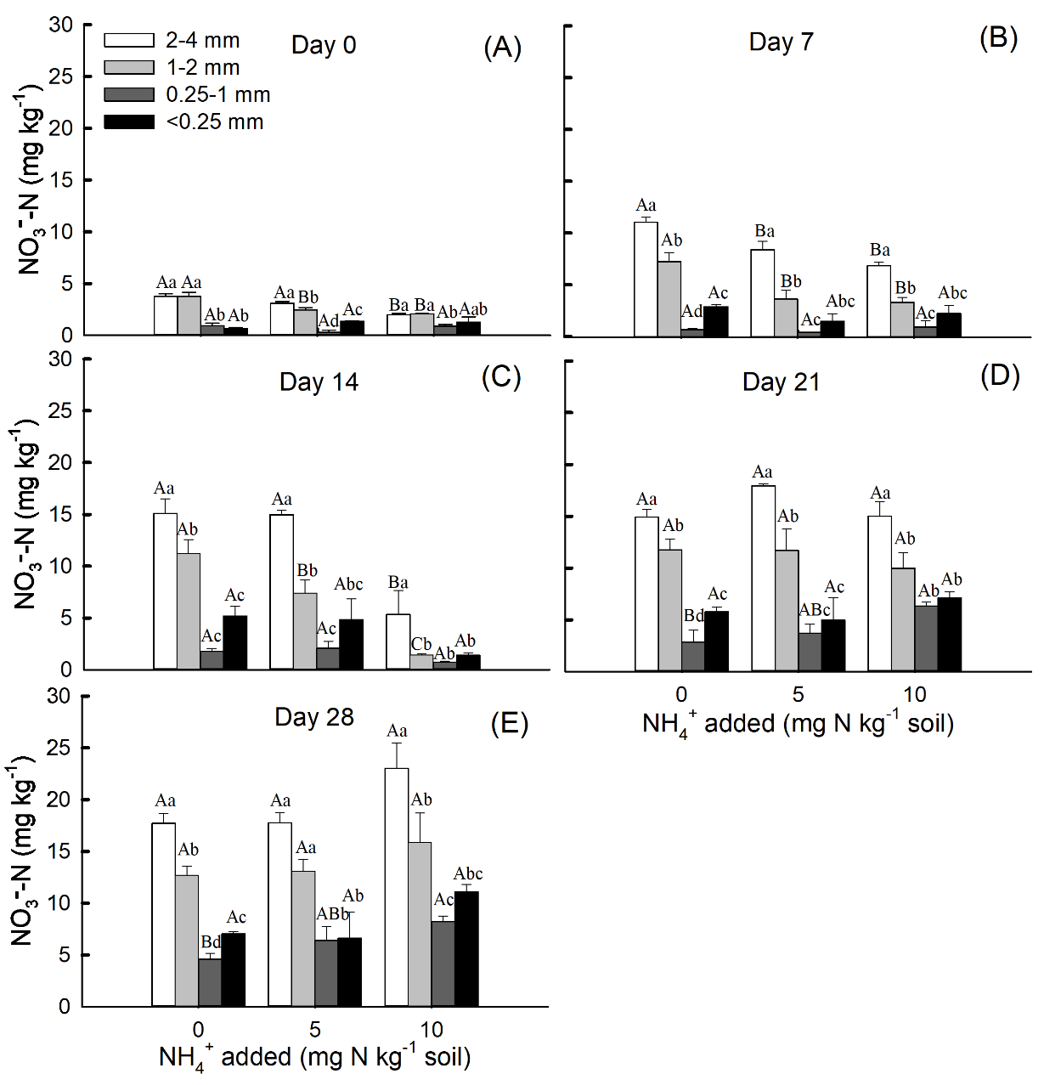

Figure S1. Effects of soil aggregate sizes on NO3--N concentrations (Mean ± SE, n=3) under NH4+-N addition treatment (A, day 0; B, day 7; C, day 14; D, day 21; E, day 28). Capital letters indicate significant differences among different NH4+-N concentrations for the same soil aggregate size on 5 sampling dates, and lowercase letters indicate significant differences among different soil aggregate sizes under the same NH4+-N concentration on 5 sampling dates (*P* < 0.05).

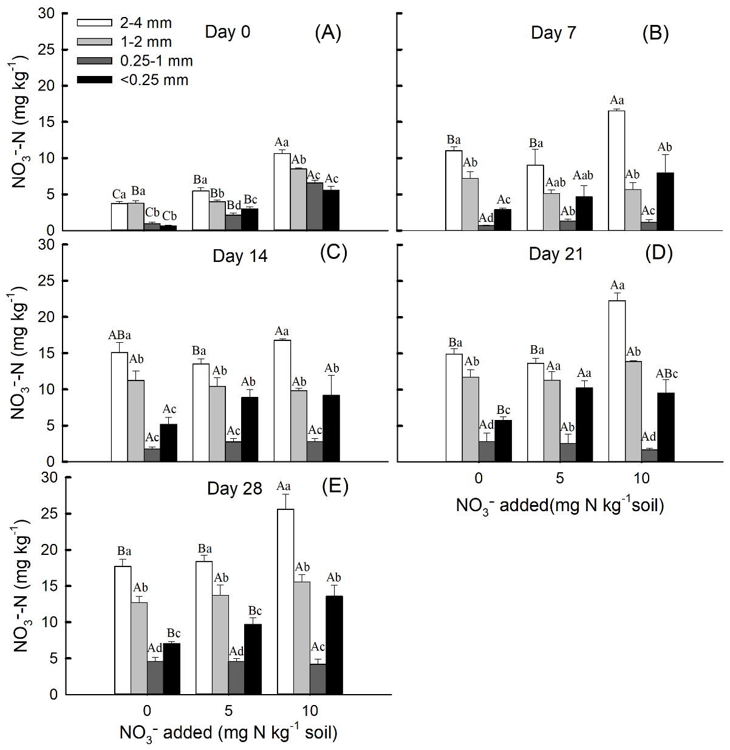

Figure S2. Effects of soil aggregate sizes on NO3--N concentrations (Mean ± SE, n=3) under NO3--N addition treatment (A, day 0; B, day 7; C, day 14; D, day 21; E, day 28). Capital letters indicate significant differences among different NO3--N concentrations for the same soil aggregate size on 5 sampling dates, and lowercase letters indicate significant differences among different soil aggregate sizes under the same NO3--N concentration on 5 sampling dates (*P* < 0.05).

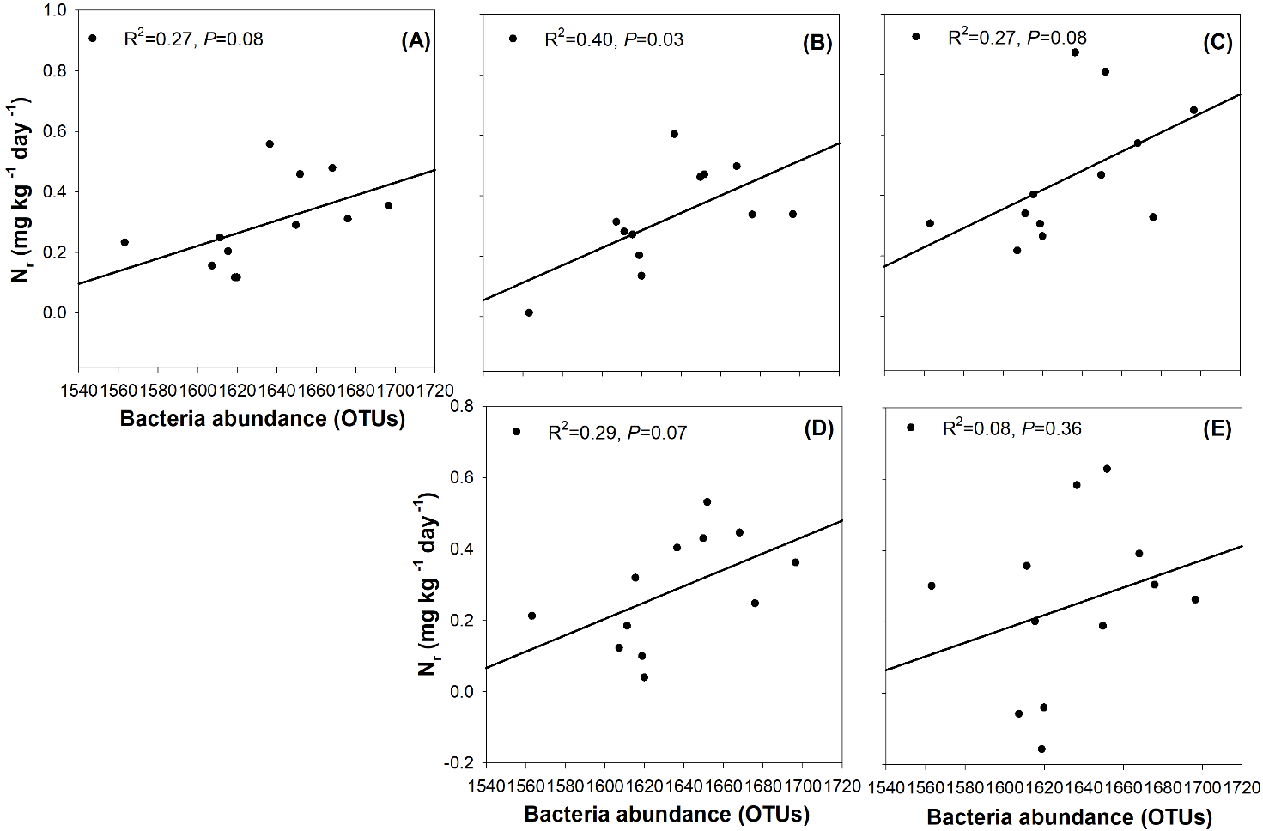

Figure S3. Correlations between the nitrification rate (Nr) in the fourth week and bacteria abundance (OTUs) of soil aggregate sizes. (A) no N addition, (B) addition of 5 mg NH4+-N kg-1 aggregate, (C) addition of 10 mg NH4+-N kg-1 aggregate, (D) addition of 5 mg NO3--N kg-1 aggregate, and (E) addition of 10 mg NO3--N kg-1 aggregate.

Table S1. The three-way ANOVA results for evaluating the 3 main factors (incubation period, soil aggregate size, and nitrogen addition) influencing the nitrification rate (Nr).

|  |  |  |  |
| --- | --- | --- | --- |
| Source | Nr (mg kg-1 day-1) | | |
| df | F | P | |
| Incubation period | 3 | 4.453 | 0.005 | |
| Aggregate size | 3 | 170.229 | < 0.0001 | |
| Nitrogen addition | 4 | 15.963 | < 0.0001 | |
| Incubation period * Aggregate size | 9 | 7.497 | < 0.0001 | |
| Incubation period * Nitrogen addition | 12 | 6.892 | < 0.0001 | |
| Aggregate size * Nitrogen addition | 12 | 7.478 | < 0.0001 | |
| Incubation period *Aggregate size *Nitrogen addition | 36 | 1.448 | 0.064 | |