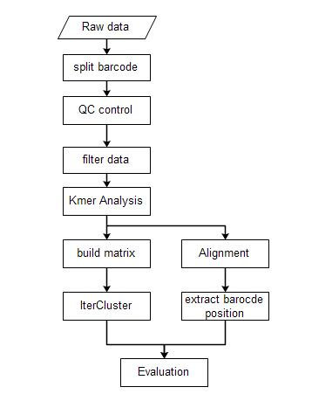
The workflow of IterCluster and its evaluation pipeline

The script used in each step:
 | stLFR data | 10x data
Split barcode | 01.split_barcode_stlfr.pl | Longranger, 01.split_10X_reads_new.pl
QC filter dup & adapter | 02.SOAPfilter_stlfr.sh | 02.SOAPfilter_10x.sh
Filter N and small barcode | 03.Reads_filter.pl | 03.Reads_filter.pl
Kmer Analysis | 04.kmer.sh | 04.kmer.sh
Alignment | 05.aln_run.sh | 05.aln_run.sh
Get barcode position | 06.get_barcode_position.pl | 06.get_barcode_position.pl
Build matrix | get_matrix_run.sh | get_matrix_run.sh
IterCluster | IterCluster-MCL.sh | IterCluster-MCL.sh
Evaluation | 07.Single_MclIterCuster_evaluate.pl | 07.Single_MclIterCuster_evaluate.pl
More detail can be found on IterCluster’s github page.

The adapter used in SOAPfilter:
The adapter1 is CTGTCTCTTATACACATCTTAGGAAGACAAGCACTGACGACATGA.
The adapter2 is TCTGCTGAGTCGAGAACGTCTCTGTGAGCCAAGGAGTTGCTCTGG.

