Supplementary Figure 1: The computational procedure of the HALO software for determining the H-score.

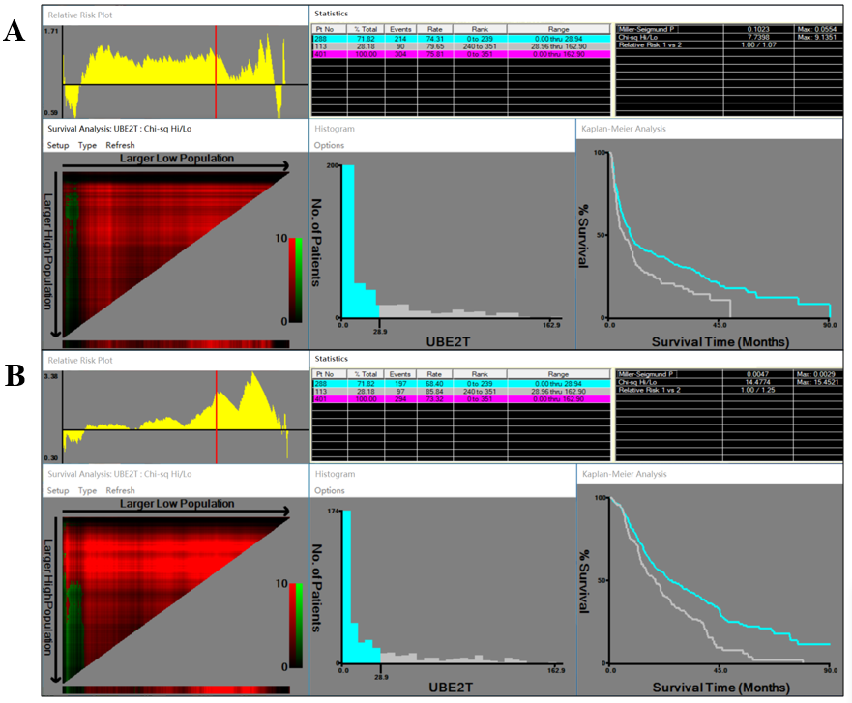
Supplementary Figure 2: X-tile analysis of prognosis based on the H-score. X-tile plots showing time to recurrence (A) and overall survival (B).

Supplementary Table 1 Baseline characteristics of patients with IHBD (N=13), BilIN-1/2 (N=23), and BilIN-3 (N=11).
Characteristics | IHBD | BilIN-1/2 | BilIN-3 | P value
Age, years | 43.61±8.98 | 56.00±11.36 | 54.82±14.38 | 0.010
Sex |  |  |  | 0.250
Male | 7(53.8%) | 6(26.1%) | 4(36.4%)
Female | 6(46.2%) | 17(73.9%) | 7(63.6%)
AFP, ng/mL | 61.98±201.29 | 6.68±10.79 | 28.17±86.15 | 0.378
CEA, ng/mL | 4.76±5.66 | 7.68±14.17 | 4.05±3.99 | 0.584
CA199, ng/mL | 62.77±126.62 | 119.47±281.32 | 131.79±293.36 | 0.771
TBIL, μmol/L | 18.68±15.62 | 19.84±18.08 | 29.97±61.88 | 0.652
ALB, g/L | 41.95±4.13 | 40.61±4.42 | 40.65±4.98 | 0.667
ALT, U/L | 45.68±63.81 | 38.44±30.50 | 51.58±59.99 | 0.753
GGT, U/L | 195.23±304.23 | 178.43±175.70 | 258.27±294.82 | 0.674
ALP, U/L | 93.28±102.65 | 80.94±76.41 | 178.97±117.94 | 0.022
HBsAg |  |  |  | 0.777
Positive | 4(30.8%) | 6(26.1%) | 2(18.2%)
Negative | 9(69.2%) | 17(73.9%) | 9(81.8%)
IHBD intrahepatic bile duct, BilIN biliary intraepithelial neoplasia, AFP alpha fetoprotein, CEA carcinoembryonic antigen, CA199 carbohydrate antigen 19-9, TBIL total bilirubin, ALB albumin, ALT alanine aminotransferase, GGT gamma glutamyltransferase, ALP alkaline phosphatase, HBsAg hepatitis B surface antigen.

