SUPPLEMENTARY MATERIAL

Unexpectedly high genetic diversity in a rare and Endangered seabird in the Hawaiian Archipelago
Carmen C. Antaky*, Emily E. Conklin, Robert J. Toonen, Ingrid S. Knapp, & Melissa R. Price
*Corresponding author: antaky@hawaii.edu
Supplementary Material S1: Estimates of F_{ST} from mtDNA data (light gray) and F_{ST} from nDNA (dark gray) for pairwise comparisons between Hydrobates castro grouped by sourced island across the Main Hawaiian Islands, where n = sample size.
Island | n | Kauaʻi | O‘ahu | Maui | Big Island
Kauaʻi | 9 | - | 0.1647 | 0.1654 | 0.0073
O‘ahu | 2 | 0.2068 | - | 0.3000 | 0.2720
Maui | 2 | 0.2244 | 0.0000 | - | 0.2625
Big Island | 11 | 0.0015 | 0.1295 | 0.1498 | -
*Due to small sample size, results should be interpreted with caution.

Supplementary Material S2: (A) F_{st} estimates, (B) structure plot, and (C) PCA plot, using nDNA and assigning the Maui and O‘ahu sourced individuals together as all belonging to the Maui island population.
A
Island | n | Kauaʻi | Maui/O‘ahu | Big Island
Kauaʻi | 9 | -
Maui | 4 | 0.3166 | -
Big Island | 11 | 0.0015 | 0.1588 | -

B

C

Supplementary Material S3: K statistics (Evanno et al. 2005) using (A) nDNA and (B) mtDNA of Hydrobates castro for STRUCTURE runs with the number of clusters (K) set between 1 and 4. Delta K statistic takes into account the change in the log probability of the data as K increases, but it cannot be calculated for K=1 which is also a potential answer. The highlighted row is the chosen K with the highest support from STRUCTURE HARVESTER.
K | Mean LnP(K) | StDevP(K) | Ln’ | |Ln”(K)| | Delta K
1 | -162182.19 | 56.51 | – | – | –
2 | -138540.84 | 147.71 | 23641.35 | 23119.61 | 156.52
3 | -138019.10 | 198.74 | 521.74 | 616.59 | 3.102
4 | -138113.95 | 189.11 | -94.85 | – | –
A

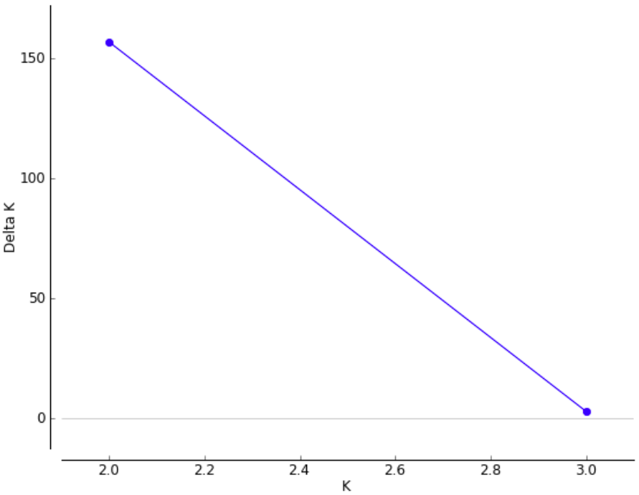
K | Mean LnP(K) | StDevP(K) | Ln’ | |Ln”(K)| | Delta K
1 | -923.03 | 0.58 | – | – | –
2 | -610.40 | 31.97 | 312.63 | 260.14 | 8.14
3 | -557.92 | 1.31 | 52.49 | 84.89 | 64.98
4 | -590.32 | 27.69 | -32.41 | – | –
B

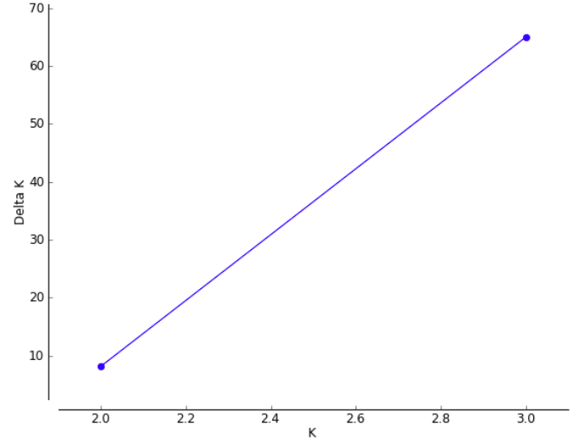
Supplementary Material S4: Bayesian Skyline Plot of Hydrobates castro based on the 67 mitochondrial SNPs from 20 samples collected in Kaua‘i and Big Island. The black line represents the median of the parameter N_{e}, proportional to the effective population size, while the purple shading is the 95 % CI.

*Due to small sample size, results should be interpreted with caution.

