Supplementary figures and tables

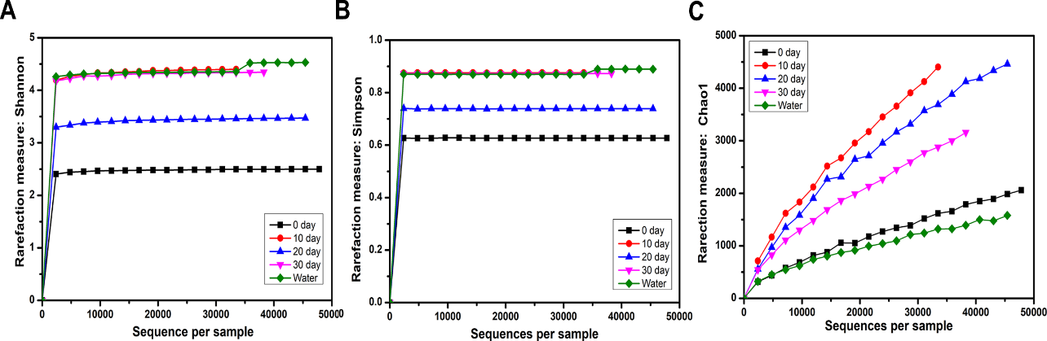
Figure S1. Alpha diversity analysis of microbiomes from turtle intestines at different growth stages and of the environmental water. (A) the Shannon index, (B) the Simpson index, (C) the Chao1 estimator.

Table S1. The distribution of dominant bacteria at the phylum level in turtle intestine at different growth stages and in the environmental water.
Dominate phylum | Mean of relative abundance (%)
 | 0-day | 10-day | 20-day | 30-day | Water
Actinobacteria | 0.03 | 1.06 | 0.00 | 0.29 | 4.45
Bacteroidetes | 0.32 | 0.31 | 27.17 | 22.55 | 23.24
Firmicutes | 58.23 | 92.94 | 67.08 | 56.46 | 1.90
Proteobacteria | 41.42 | 5.68 | 5.74 | 20.66 | 70.33
Cyanobacteria | 0 | 0 | 0 | 0 | 0.02

Table S2. The distribution of dominant bacteria at the family level in turtle intestine at different growth stages and in the environmental water.
Dominate Family | Mean of OTUs (%)
 | 0-day | 10-day | 20-day | 30-day | Water
Weeksellaceae | 0.12 | 0.21 | 0.01 | 0.04 | 8.95
Aeromonadaceae | 0.00 | 0.00 | 0.05 | 0.10 | 12.18
Alcaligenaceae | 10.76 | 0.11 | 0.00 | 0.00 | 1.09
Bacteroidaceae | 0.01 | 0.01 | 27.36 | 22.56 | 0.26
Clostridiaceae | 13.03 | 30.24 | 9.39 | 18.13 | 0.16
Comamonadaceae | 0.01 | 0.02 | 0.02 | 0.13 | 22.86
Cytophagaceae | 0.00 | 0.00 | 0.00 | 0.00 | 7.71
Enterobacteriaceae | 23.52 | 0.40 | 5.34 | 12.56 | 4.56
Lachnospiraceae | 0.74 | 33.75 | 27.74 | 8.18 | 0.14
Methylobacteriaceae | 0.73 | 0.13 | 0.04 | 2.85 | 3.63
Moraxellaceae | 0.02 | 3.75 | 0.01 | 2.30 | 7.78
Paenibacillaceae | 36.01 | 0.86 | 0.00 | 0.00 | 0.04
Peptostreptococcaceae | 0.57 | 19.94 | 23.43 | 17.60 | 0.07
Ruminococcaceae | 0.00 | 0.00 | 3.00 | 3.64 | 0.06
Staphylococcaceae | 0.01 | 4.07 | 0.00 | 0.02 | 0.43
Xanthomonadaceae | 0.37 | 1.27 | 0.01 | 0.03 | 7.84

Table S3. The distribution of dominant bacteria at the genus level at different growth stages of turtle intestine and in the environmental water.
Dominate Genus | Mean of OTUs (%)
 | 0-day | 10-day | 20-day | 30-day | Water
Achromobacter | 10.75 | 0.10 | 0.00 | 0.00 | 1.05
Acinetobacter | 0.02 | 3.75 | 0.01 | 2.29 | 7.69
Citrobacter | 20.78 | 0.24 | 5.17 | 11.77 | 3.40
Cloacibacterium | 0.00 | 0.00 | 0.00 | 0.02 | 6.94
Clostridium | 11.95 | 24.98 | 8.23 | 17.50 | 0.15
Comamonas | 0.01 | 0.00 | 0.01 | 0.08 | 17.95
Epulopiscium | 0.15 | 31.91 | 1.42 | 0.72 | 0.02
Flectobacillus | 0.00 | 0.00 | 0.00 | 0.00 | 6.66
Methylobacterium | 0.73 | 0.13 | 0.04 | 2.85 | 3.60
Paenibacillus | 36.01 | 0.86 | 0.00 | 0.00 | 0.04
Stenotrophomonas | 0.37 | 1.21 | 0.00 | 0.01 | 6.79

Table S4. The core OTUs existing in all the turtle intestinal samples
OTU ID | Taxonomy
OTU15730 | k__Bacteria; p__Firmicutes; c__Clostridia; o__Clostridiales; f__Clostridiaceae; g__; s__
OTU9929 | k__Bacteria; p__Firmicutes; c__Clostridia; o__Clostridiales; f__Clostridiaceae; g__; s__
OTU20347 | k__Bacteria; p__Firmicutes; c__Clostridia; o__Clostridiales; f__Peptostreptococcaceae; g__; s__
OTU23770 | k__Bacteria; p__Firmicutes; c__Clostridia; o__Clostridiales; f__Clostridiaceae; g__SMB53; s__
OTU16404 | k__Bacteria; p__Firmicutes; c__Clostridia; o__Clostridiales; f__Clostridiaceae; g__SMB53; s__
OTU4788 | k__Bacteria; p__Firmicutes; c__Clostridia; o__Clostridiales; f__Peptostreptococcaceae; g__; s__
OTU15234 | k__Bacteria; p__Firmicutes; c__Clostridia; o__Clostridiales; f__Peptostreptococcaceae; g__; s__
OTU15090 | k__Bacteria; p__Firmicutes; c__Clostridia; o__Clostridiales; f__Peptostreptococcaceae; g__; s__
OTU14103 | k__Bacteria; p__Firmicutes; c__Clostridia; o__Clostridiales; f__Clostridiaceae; g__; s__
OTU8288 | k__Bacteria; p__Firmicutes; c__Clostridia; o__Clostridiales; f__Peptostreptococcaceae; g__; s__
OTU13236 | k__Bacteria; p__Firmicutes; c__Clostridia; o__Clostridiales; f__Peptostreptococcaceae; g__; s__
OTU5062 | k__Bacteria; p__Firmicutes; c__Clostridia; o__Clostridiales; f__Peptostreptococcaceae; g__; s__
OTU23626 | k__Bacteria; p__Firmicutes; c__Clostridia; o__Clostridiales; f__Lachnospiraceae; g__; s__
OTU21165 | k__Bacteria; p__Firmicutes; c__Clostridia; o__Clostridiales; f__Clostridiaceae; g__Clostridium; s__perfringens
OTU15627 | k__Bacteria; p__Firmicutes; c__Clostridia; o__Clostridiales; f__Clostridiaceae; g__Clostridium; s__perfringens
OTU565 | k__Bacteria; p__Firmicutes; c__Clostridia; o__Clostridiales; f__Clostridiaceae; g__; s__
OTU12087 | k__Bacteria; p__Firmicutes; c__Clostridia; o__Clostridiales; f__Clostridiaceae; g__SMB53; s__
OTU110 | k__Bacteria; p__Firmicutes; c__Clostridia; o__Clostridiales; f__Peptostreptococcaceae; g__; s__
OTU22190 | k__Bacteria; p__Firmicutes; c__Clostridia; o__Clostridiales; f__Lachnospiraceae; g__Epulopiscium; s__
OTU204 | k__Bacteria; p__Firmicutes; c__Clostridia; o__Clostridiales; f__Clostridiaceae; g__; s__
OTU7060 | k__Bacteria; p__Firmicutes; c__Clostridia; o__Clostridiales; f__Clostridiaceae; g__; s__
OTU12011 | k__Bacteria; p__Firmicutes; c__Clostridia; o__Clostridiales; f__Clostridiaceae; g__; s__
OTU15421 | k__Bacteria; p__Firmicutes; c__Clostridia; o__Clostridiales; f__Clostridiaceae; g__Clostridium; s__perfringens
OTU11755 | k__Bacteria; p__Firmicutes; c__Clostridia; o__Clostridiales; f__Clostridiaceae; g__Sarcina; s__
OTU4315 | k__Bacteria; p__Firmicutes; c__Clostridia; o__Clostridiales; f__Clostridiaceae; g__Clostridium; s__perfringens
OTU10548 | k__Bacteria; p__Firmicutes; c__Clostridia; o__Clostridiales; f__Clostridiaceae; g__Sarcina; s__
OTU16273 | k__Bacteria; p__Firmicutes; c__Clostridia; o__Clostridiales; f__Clostridiaceae; g__Clostridium; s__perfringens
OTU17309 | k__Bacteria; p__Firmicutes; c__Clostridia; o__Clostridiales; f__Clostridiaceae; g__; s__
OTU4166 | k__Bacteria; p__Firmicutes; c__Clostridia; o__Clostridiales; f__Clostridiaceae; g__Clostridium; s__perfringens
OTU8421 | k__Bacteria; p__Firmicutes; c__Clostridia; o__Clostridiales; f__Clostridiaceae; g__SMB53; s__
OTU11871 | k__Bacteria; p__Firmicutes; c__Clostridia; o__Clostridiales; f__Clostridiaceae; g__; s__
OTU11506 | k__Bacteria; p__Firmicutes; c__Clostridia; o__Clostridiales; f__Peptostreptococcaceae; g__; s__
OTU13936 | k__Bacteria; p__Firmicutes; c__Clostridia; o__Clostridiales; f__Lachnospiraceae; g__Epulopiscium; s__
OTU13309 | k__Bacteria; p__Firmicutes; c__Clostridia; o__Clostridiales; f__Clostridiaceae; g__SMB53; s__
OTU3969 | k__Bacteria; p__Firmicutes; c__Clostridia; o__Clostridiales; f__Clostridiaceae; g__; s__
OTU6686 | k__Bacteria; p__Firmicutes; c__Clostridia; o__Clostridiales; f__Clostridiaceae
OTU23839 | k__Bacteria; p__Firmicutes; c__Clostridia; o__Clostridiales; f__Clostridiaceae; g__; s__
OTU15338 | k__Bacteria; p__Firmicutes; c__Clostridia; o__Clostridiales; f__Clostridiaceae; g__; s__
OTU12421 | k__Bacteria; p__Firmicutes; c__Clostridia; o__Clostridiales; f__Clostridiaceae
OTU15827 | k__Bacteria; p__Firmicutes; c__Clostridia; o__Clostridiales; f__Clostridiaceae; g__; s__
OTU946 | k__Bacteria; p__Firmicutes; c__Clostridia; o__Clostridiales; f__Lachnospiraceae; g__Epulopiscium; s__
OTU212 | k__Bacteria; p__Firmicutes; c__Clostridia; o__Clostridiales; f__Clostridiaceae; g__SMB53; s__
OTU19626 | k__Bacteria; p__Firmicutes; c__Clostridia; o__Clostridiales; f__Clostridiaceae; g__; s__
OTU21976 | k__Bacteria; p__Firmicutes; c__Clostridia; o__Clostridiales; f__Peptostreptococcaceae; g__; s__
OTU23987 | k__Bacteria; p__Firmicutes; c__Clostridia; o__Clostridiales; f__Peptostreptococcaceae; g__; s__
OTU12220 | k__Bacteria; p__Firmicutes; c__Clostridia; o__Clostridiales; f__Clostridiaceae; g__Clostridium; s__perfringens
OTU14227 | k__Bacteria; p__Firmicutes; c__Clostridia; o__Clostridiales; f__Clostridiaceae; g__Clostridium; s__perfringens

Table S5. LEfSe analysis of all the intestinal samples from turtles
Groups | Taxonomy | Highest Mean | LDA SCORE (log 10) | P-Value
0-day | Bacteria.Firmicutes.Bacilli.Bacillales.Paenibacillaceae | 5.556 | 5.265 | 0.017
 | Bacteria.Firmicutes.Bacilli | 5.568 | 5.257 | 0.029
 | Bacteria.Firmicutes.Bacilli.Bacillales.Paenibacillaceae.Paenibacillus | 5.541 | 5.247 | 0.017
 | Bacteria.Firmicutes.Bacilli.Bacillales.Paenibacillaceae.Paenibacillus.lautus | 5.567 | 5.244 | 0.014
 | Bacteria.Firmicutes.Bacilli.Bacillales | 5.504 | 5.233 | 0.030
 | Bacteria.Proteobacteria.Betaproteobacteria.Burkholderiales.Alcaligenaceae | 4.562 | 4.642 | 0.042
 | Bacteria.Proteobacteria.Betaproteobacteria.Burkholderiales.Alcaligenaceae.Achromobacter | 4.376 | 4.626 | 0.035
 | Bacteria.Proteobacteria.Alphaproteobacteria.Rhizobiales.Brucellaceae.Ochrobactrum | 2.432 | 3.879 | 0.048
 | Bacteria.Firmicutes.Bacilli.Bacillales.Bacillaceae.Bacillus | 3.700 | 3.749 | 0.028
 | Bacteria.Firmicutes.Bacilli.Bacillales.Bacillaceae.Bacillus.firmus | 2.991 | 3.433 | 0.042
 | Bacteria.Bacteroidetes.Sphingobacteriia.Sphingobacteriales.Sphingobacteriaceae.Sphingobacterium | 3.793 | 2.994 | 0.028
 | Bacteria.Bacteroidetes.Sphingobacteriia.Sphingobacteriales | 3.700 | 2.975 | 0.023
 | Bacteria.Bacteroidetes.Sphingobacteriia.Sphingobacteriales.Sphingobacteriaceae | 3.377 | 2.972 | 0.028
 | Bacteria.Bacteroidetes.Sphingobacteriia | 3.442 | 2.919 | 0.023
10-day | Bacteria.Firmicutes.Clostridia.Clostridiales | 5.934 | 5.515 | 0.050
 | Bacteria.Firmicutes.Clostridia | 5.934 | 5.499 | 0.050
 | Bacteria.Firmicutes.Clostridia.Clostridiales.Lachnospiraceae.Epulopiscium | 5.528 | 5.209 | 0.027
 | Bacteria.Firmicutes.Clostridia.Clostridiales.Lachnospiraceae | 5.447 | 5.195 | 0.050
 | Bacteria.Actinobacteria.Actinobacteria.Actinomycetales.Intrasporangiaceae.Janibacter | 3.120 | 3.500 | 0.042
 | Bacteria.Actinobacteria.Actinobacteria.Actinomycetales.Brevibacteriaceae | 5.447 | 3.288 | 0.042
 | Bacteria.Actinobacteria.Actinobacteria.Actinomycetales.Brevibacteriaceae.Brevibacterium | 5.031 | 3.263 | 0.042
 | Bacteria.Actinobacteria.Actinobacteria.Actinomycetales.Brevibacteriaceae.Brevibacterium.aureum | 4.710 | 3.263 | 0.042
 | Bacteria.Firmicutes.Bacilli.Bacillales.Planococcaceae.Kurthia.gibsonii | 3.793 | 3.005 | 0.013
 | Bacteria.Firmicutes.Bacilli.Bacillales.Planococcaceae | 3.626 | 2.988 | 0.025
 | Bacteria.Firmicutes.Bacilli.Bacillales.Planococcaceae.Kurthia | 3.045 | 2.954 | 0.013
20-day | Bacteria.Bacteroidetes | 5.437 | 5.153 | 0.040
 | Bacteria.Bacteroidetes.Bacteroidia | 5.436 | 5.152 | 0.038
 | Bacteria.Bacteroidetes.Bacteroidia.Bacteroidales.Bacteroidaceae | 5.032 | 5.148 | 0.038
 | Bacteria.Bacteroidetes.Bacteroidia.Bacteroidales | 4.777 | 5.128 | 0.038
 | Bacteria.Firmicutes.Clostridia.Clostridiales.Clostridiaceae.Clostridium.butyricum | 3.844 | 3.907 | 0.041
 | Bacteria.Firmicutes.Clostridia.Clostridiales.Lachnospiraceae.Coprococcus | 3.045 | 3.606 | 0.032
 | Bacteria.Firmicutes.Clostridia.Clostridiales.Lachnospiraceae.Dorea | 2.031 | 3.523 | 0.028
 | Bacteria.Firmicutes.Bacilli.Turicibacterales.Turicibacteraceae.Turicibacter | 3.176 | 3.522 | 0.034
 | Bacteria.Firmicutes.Bacilli.Turicibacterales | 2.653 | 3.504 | 0.034
 | Bacteria.Firmicutes.Bacilli.Turicibacterales.Turicibacteraceae | 3.040 | 3.468 | 0.034
 | Bacteria.Bacteroidetes.Bacteroidia.Bacteroidales.Odoribacteraceae.Odoribacter | 3.599 | 2.959 | 0.013
 | Bacteria.Firmicutes.Clostridia.Clostridiales.Ruminococcaceae.Faecalibacterium | 1.888 | 2.881 | 0.040
 | Bacteria.Bacteroidetes.Bacteroidia.Bacteroidales.Odoribacteraceae | 2.031 | 2.877 | 0.013
 | Bacteria.Firmicutes.Erysipelotrichi.Erysipelotrichales.Erysipelotrichaceae.Eubacterium | 2.975 | 2.731 | 0.022
 | Bacteria.Firmicutes.Erysipelotrichi.Erysipelotrichales.Erysipelotrichaceae.Eubacterium.dolichum | 2.975 | 2.721 | 0.022
30-day | Bacteria.Firmicutes.Clostridia.Clostridiales.Lachnospiraceae.Blautia | 4.211 | 4.077 | 0.017
 | Bacteria.Firmicutes.Erysipelotrichi.Erysipelotrichales | 4.101 | 4.049 | 0.014
 | Bacteria.Firmicutes.Erysipelotrichi.Erysipelotrichales.Erysipelotrichaceae | 4.101 | 4.044 | 0.014
 | Bacteria.Firmicutes.Erysipelotrichi | 3.956 | 4.025 | 0.014
 | Bacteria.Firmicutes.Clostridia.Clostridiales.Ruminococcaceae.Ruminococcus | 3.626 | 3.808 | 0.042
 | Bacteria.Bacteroidetes.Cytophagia.Cytophagales | 1.888 | 3.685 | 0.024
 | Bacteria.Bacteroidetes.Cytophagia | 3.377 | 3.677 | 0.024
 | Bacteria.Bacteroidetes.Cytophagia.Cytophagales.Cytophagaceae | 3.599 | 3.657 | 0.024
 | Bacteria.Tenericutes | 3.376 | 3.532 | 0.013
 | Bacteria.Tenericutes.Mollicutes.RF39 | 3.109 | 3.461 | 0.013
 | Bacteria.Firmicutes.Clostridia.Clostridiales.Ruminococcaceae.Anaerotruncus | 2.982 | 3.442 | 0.013
 | Bacteria.Proteobacteria.Alphaproteobacteria.Rhizobiales.Phyllobacteriaceae.Chelativorans | 2.493 | 3.372 | 0.040
 | Bacteria.Bacteroidetes.Bacteroidia.Bacteroidales.Porphyromonadaceae | 4.317 | 3.208 | 0.040
 | Bacteria.Tenericutes.Mollicutes | 4.317 | 3.173 | 0.013
 | Bacteria.Firmicutes.Clostridia.Clostridiales.Veillonellaceae | 4.233 | 3.167 | 0.017
 | Bacteria.Firmicutes.Clostridia.Clostridiales.Lachnospiraceae.Blautia.producta | 1.697 | 3.133 | 0.024
 | Bacteria.Firmicutes.Clostridia.Clostridiales.Peptococcaceae | 2.432 | 2.922 | 0.025
 | Bacteria.Firmicutes.Erysipelotrichi.Erysipelotrichales.Erysipelotrichaceae.Holdemania | 2.975 | 2.752 | 0.013
 | Bacteria.Actinobacteria.Actinobacteria.Actinomycetales.Microbacteriaceae.Clavibacter | 2.659 | 2.640 | 0.013
 | Bacteria.Firmicutes.Clostridia.Clostridiales.Lachnospiraceae.Ruminococcus | 2.493 | 2.611 | 0.040
 | Bacteria.Firmicutes.Clostridia.Clostridiales.Lachnospiraceae.Ruminococcus.gnavus | 2.686 | 2.605 | 0.040

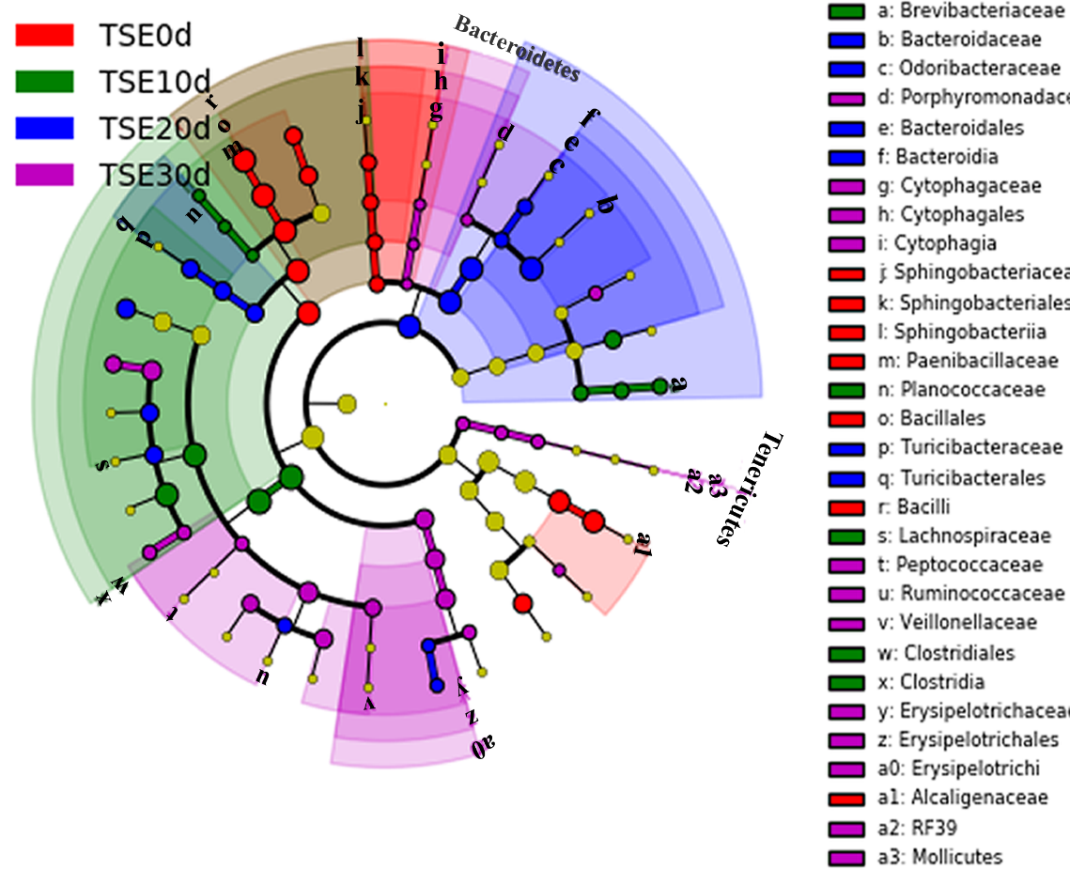
Figure S2. Taxonomic cladogram obtained from LEfSe analysis of 16S rRNA sequences (relative abundance ≥ 0.5%). The enriched taxa of TSE0d (Red), TSE10d (Green), TSE20d (Blue), and TSE30d (Purple) were shown. 0d, 10d, 20d, 30d indicate the intestine microbiome of turtles for growing 0 day, 10days, 20 days and 30 days. Only taxa meeting an LDA significant threshold >2 are shown.

Table S6. List of DNA sequence used in this study
Sequence number | Group | Sample ID
D1700911 | 0-day | TSE0d1
D1700912 |  | TSE0d2
D1700913 |  | TSE0d3
D1700917 | 10-day | TSE10d1
D1700918 |  | TSE10d2
D1700919 |  | TSE10d3
D1700923 | 20-day | TSE20d1
D1700924 |  | TSE20d2
D1700925 |  | TSE20d3
D1700935 | 30-day | TSE30d1
D1700936 |  | TSE30d2
D1700937 |  | TSE30d3
D1700947 | Water | TSEe1
D1700950 |  | TSEe2
D1700953 |  | TSEe3

