Note: Uncropped Figure 2 and Figure 5 were required to unload in submitting system. However, another requisition is the document should be the doc format. The uncropped figures are so many that we list them in this document for facilitate your reviewing.

Uncropped Figure 2 and Figure 5

Figure2A Line 1 -E2



Figure 2A Line 2- AIF1-CSFV SM-signficant results were obtained expelling influence of pig cells to antibodies

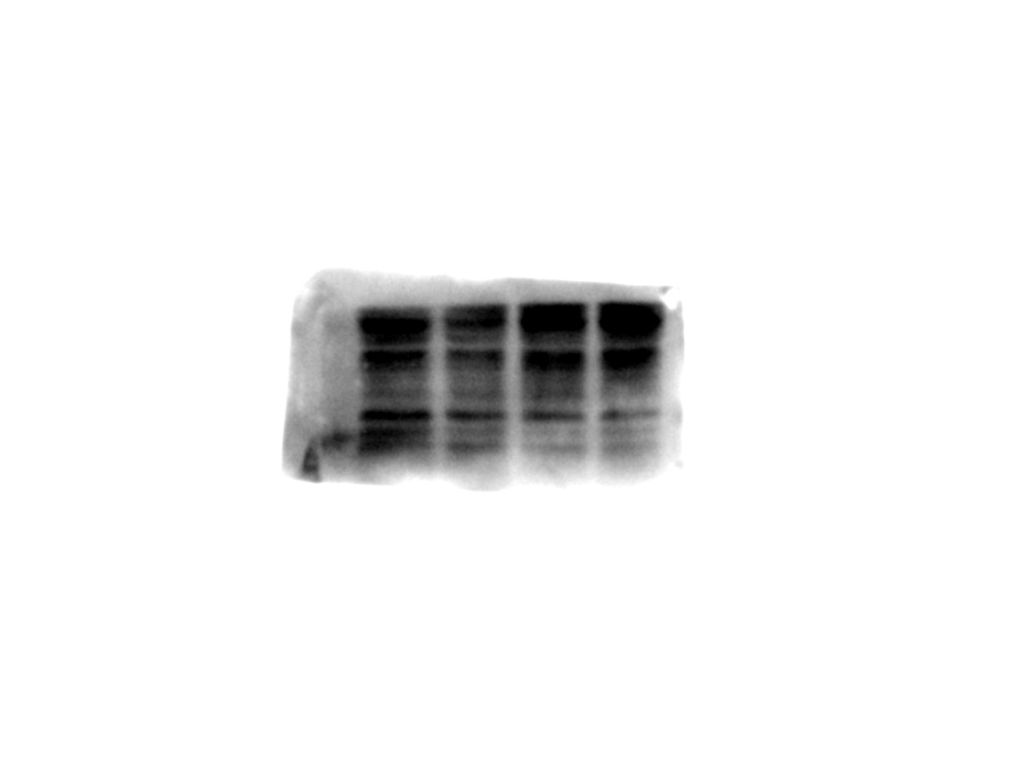

Figure2A line 3 -IL6 for CSFV（right）

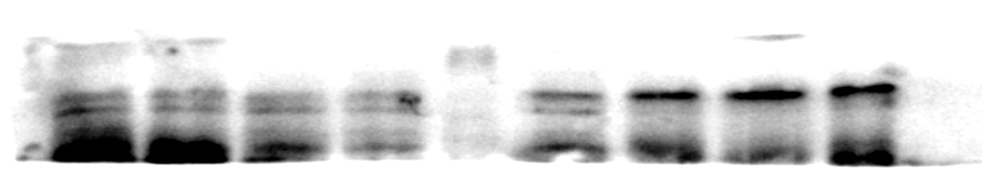

Figure2A line4 -actin –CSFV infection group

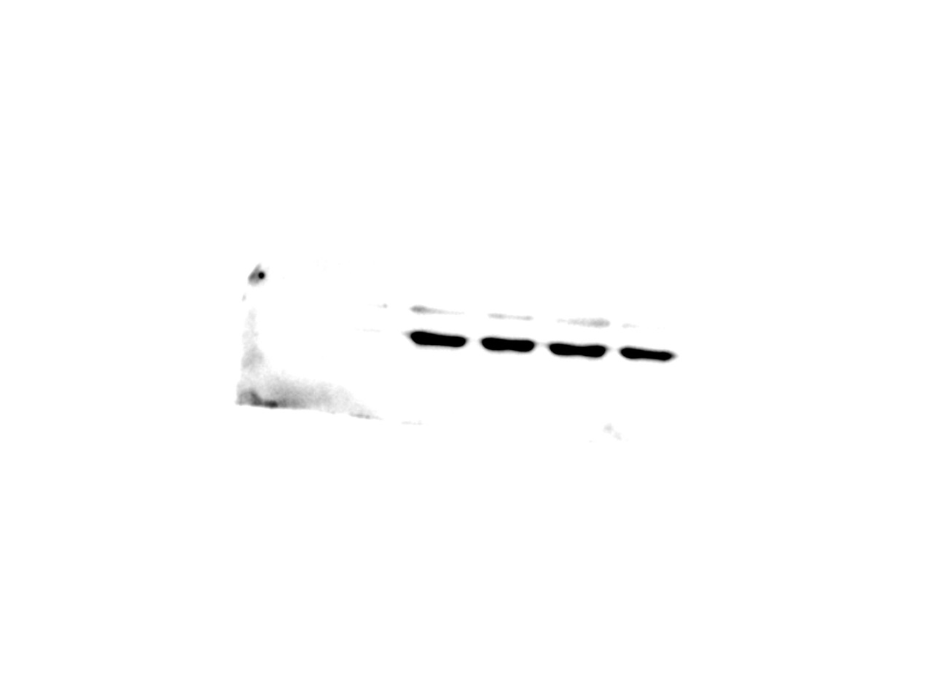

Figure2A line5 - E2-mock infection

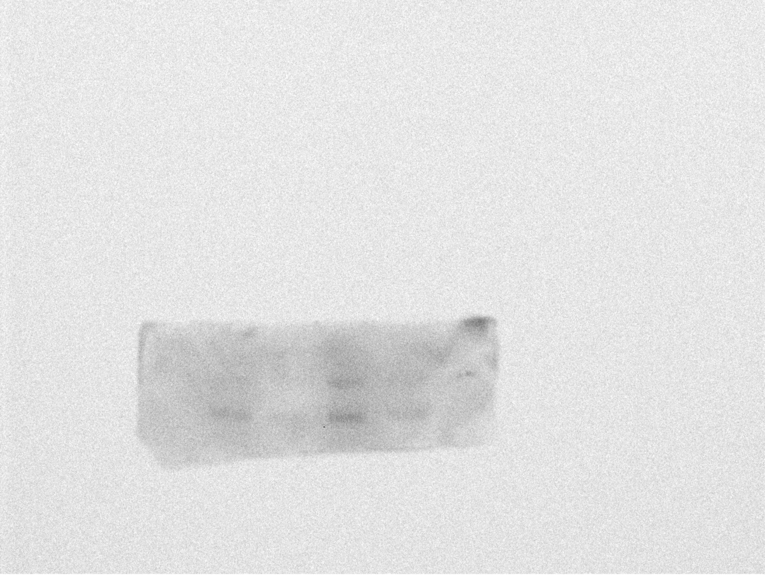

Figure2A line6 AIF-1 from mock infection group

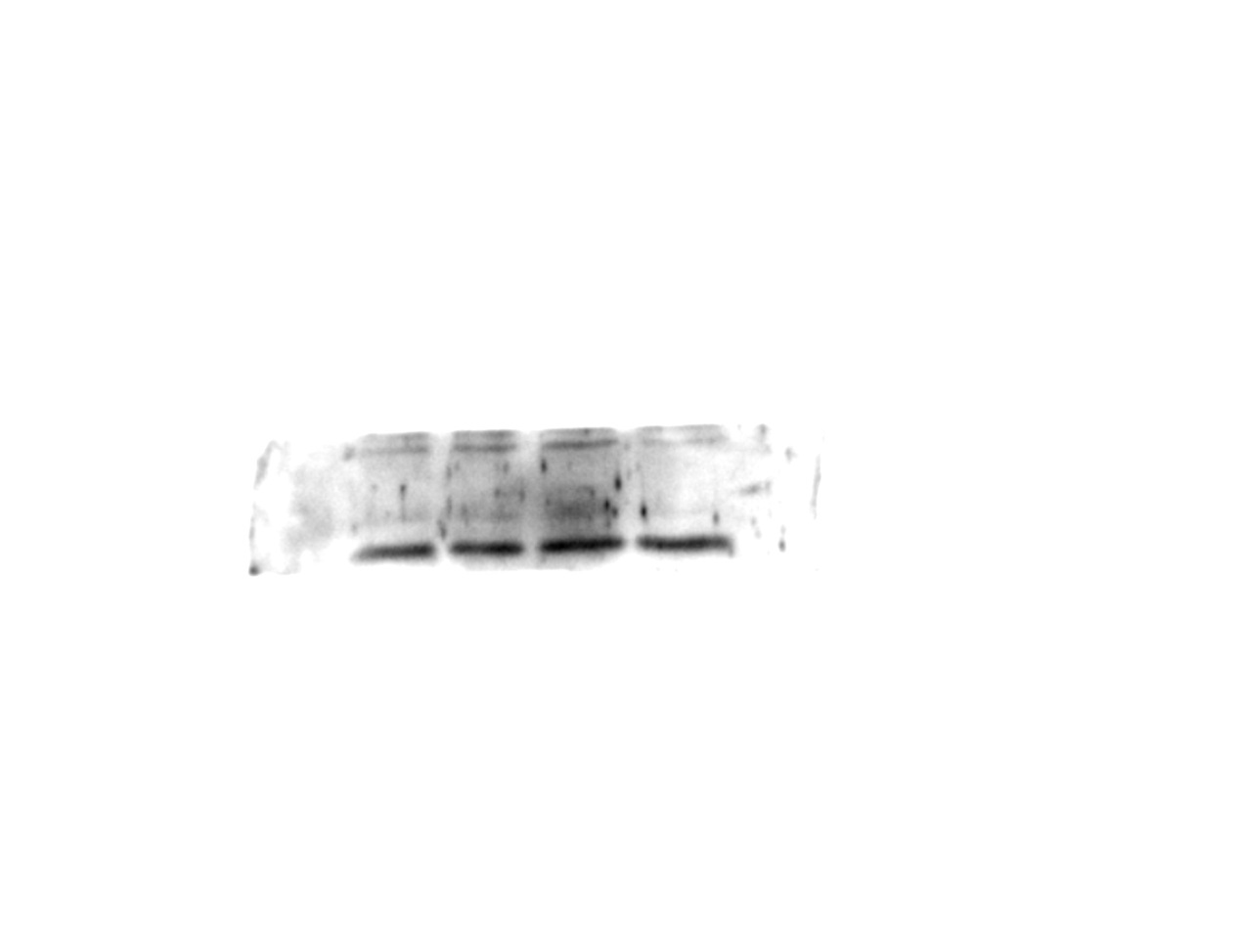

Figure 2A Line7 -IL6 for mock infection（left）

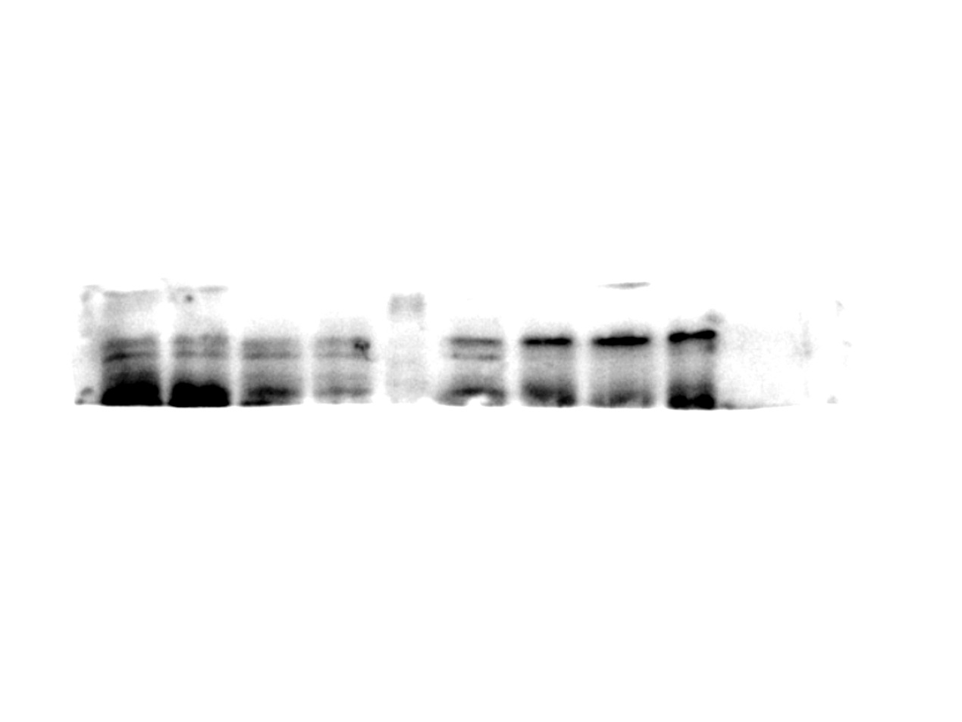

Figure2A line8 -actin –mock infection group

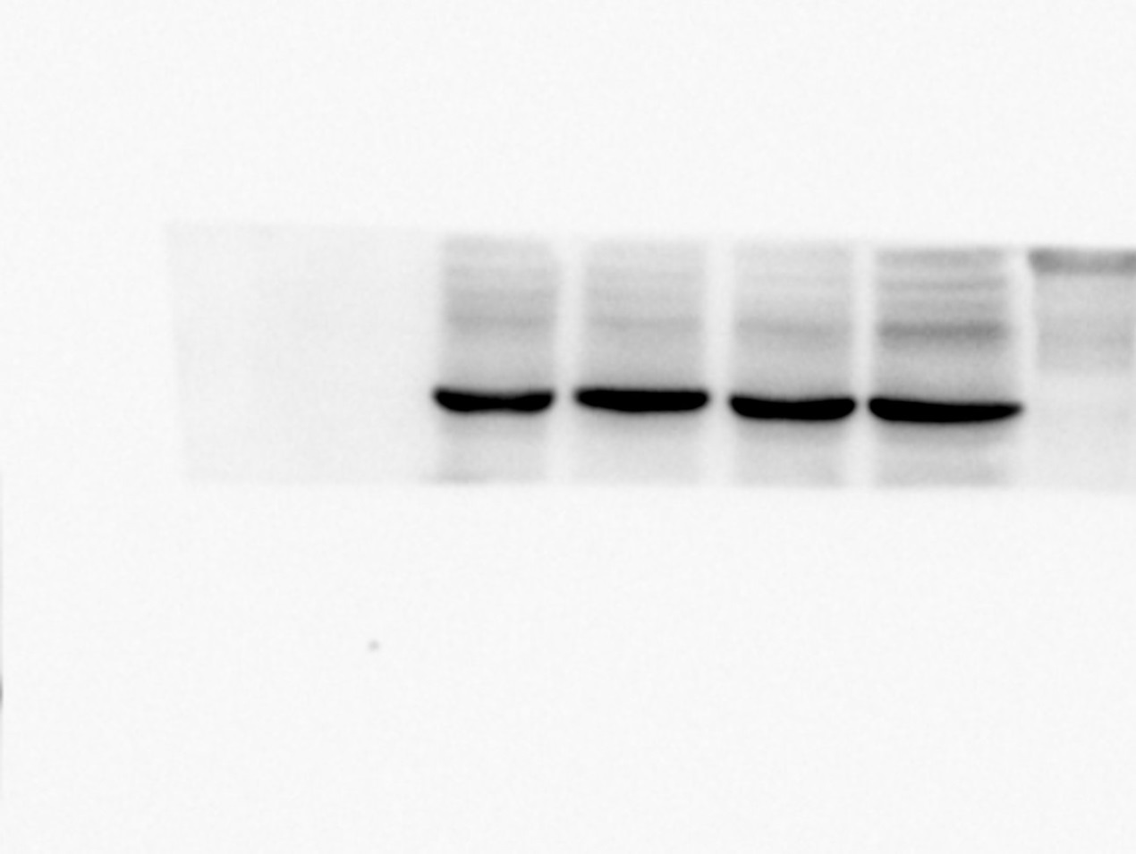

Figure5B line 1（left）actin



Figure5B line 1（right）actin



Figure5B line 2（left）E2 for AIF RNAi



Figure5B line 2（right）E2 for AIF overexpression

