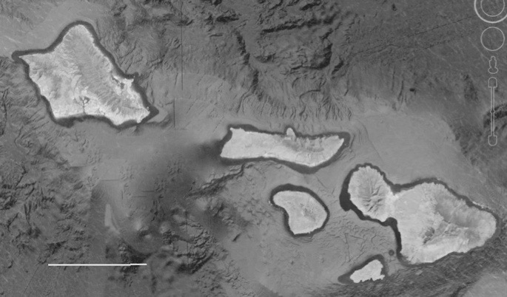
Supplemental Table 1: Genetic diversity comparison between the nearshore and offshore P. lobata populations from Oʻahu (Maunalua Bay) based on 17,850 single nucleotide polymorphic loci. The number of heterozygous sites per individual was obtained using VCFtools, and the total number of polymorphic loci was obtained using Arlequin (for the nearshore population, showing the average over two individuals).
 | SampleID | Heterozygous sites (HET)¹ | Ave. no. of polymorphic loci across 2 individuals²
Offshore  (O) | Coral1 (C6) | 7621
 | Coral2 (C16) | 7518
 | Average | 7569.5 | 11105
Nearshore  (N) | Coral6 (N1) | 7267
 | Coral7 (N3) | 6631
 | Coral8 (M2) | 7200
 | Coral9 (M7) | 7345
 | Coral10 (M12) | 7622
 | Average | 7213.0 | 10255.4 ± 43.3

¹ t-test: t = -2.0942, df = 4.6575, p-value = 0.09451
² no statistical test since n=1 for Offshore

Supplemental Table 2: AMOVA results of P. lobata. (A) Populations across islands, (B) populations across habitat types; nearshore vs offshore individuals from Oʻahu and Maui1 (B).

A | Source of Variation | Variance components | % Variance | Fixation indices
 | Among groups (islands) | 0.00135 | 0.03 | F_{CT} = 0.0003
 | Among populations within groups | 0.24897 | 6.35 | F_{SC} = 0.063***
 | Among individuals Within populations | 1.51485 | 38.62 | F_{IS} = 0.41***
 | Within individuals | 2.15769 | 55.00 | F_{IT} = 0.45***

B | Source of Variation | Variance components | % Variance | F_{ST}
 | Between sites | 0.2360 | 5.96 | 0.060***
 | Within sites | 1.3906 | 35.12
 | Within individuals | 2.3333 | 58.92

