SUPPLEMENTARY INFORMATION

TITLE: Prevalence of chronic obstructive pulmonary disease at high altitude: a systematic review and meta-analysis

Authors’ full names: Huaiyu Xiong

Authors’ affiliation(s): LanZhou Univesity

Figure S1- Plot for publication bias (Egger’s Test).

Figure S2- Funnel plot for the prevalence of COPD.

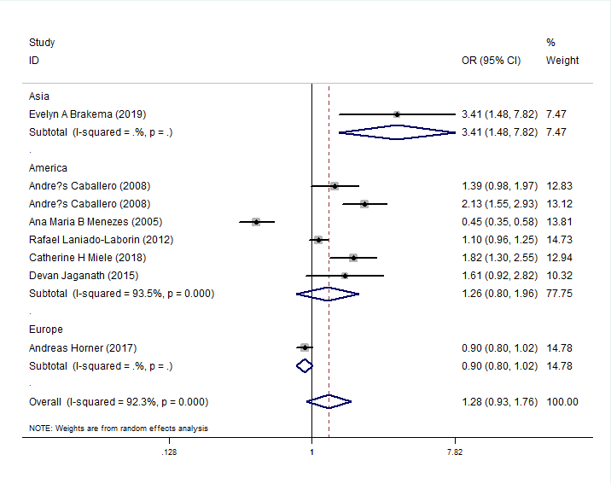

Figure S3- Forest plot for detecting whether altitude was a risk factor of COPD by regions.

