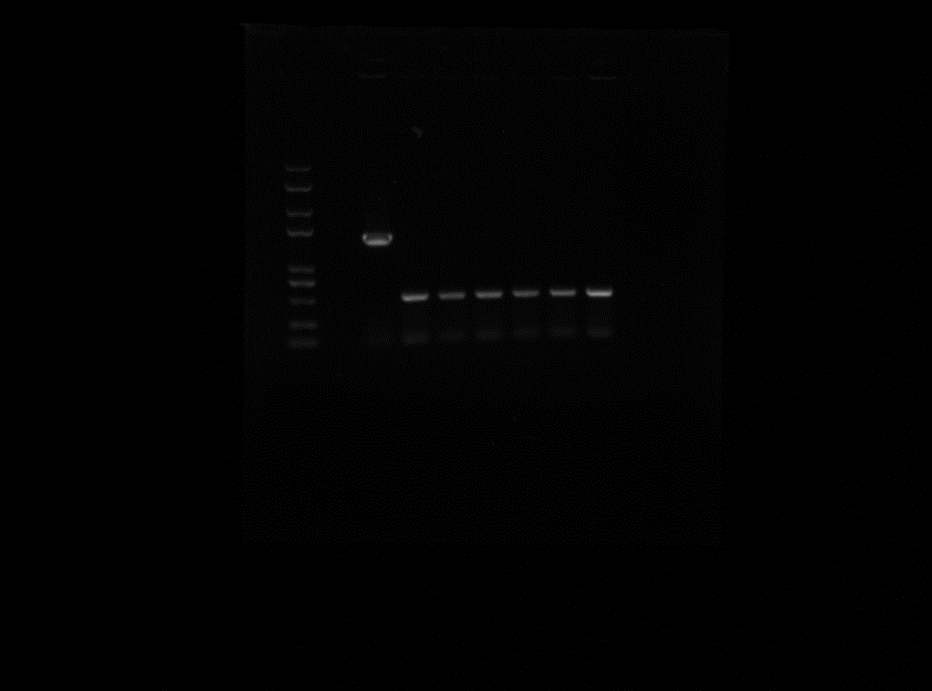

C83903 eltI knock off

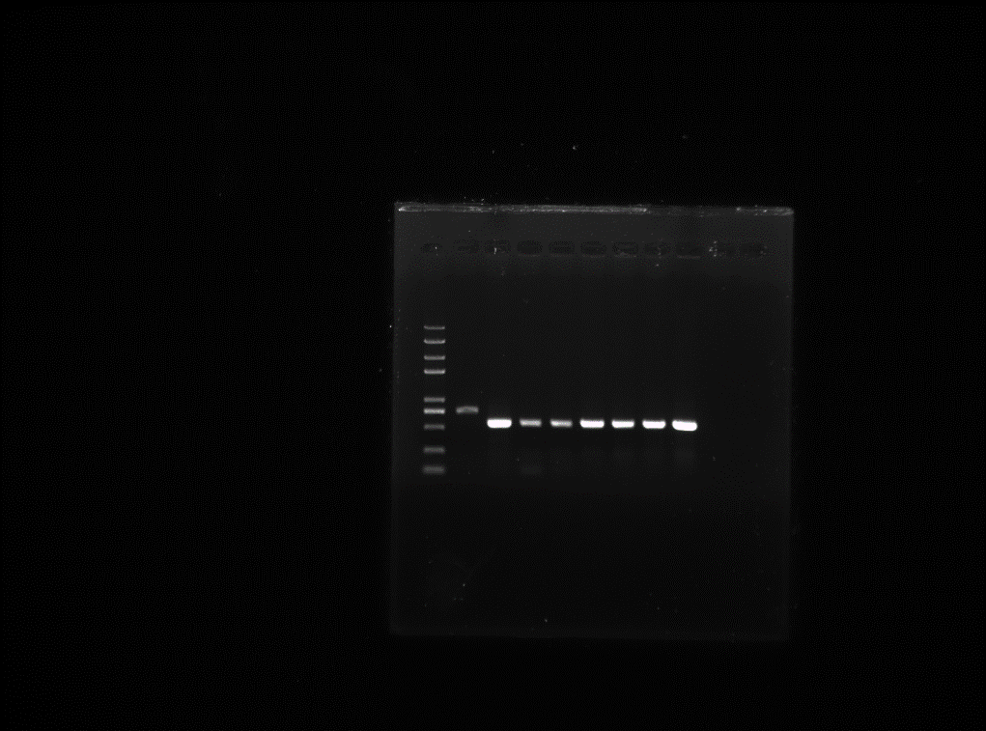

C83903 estb knock off

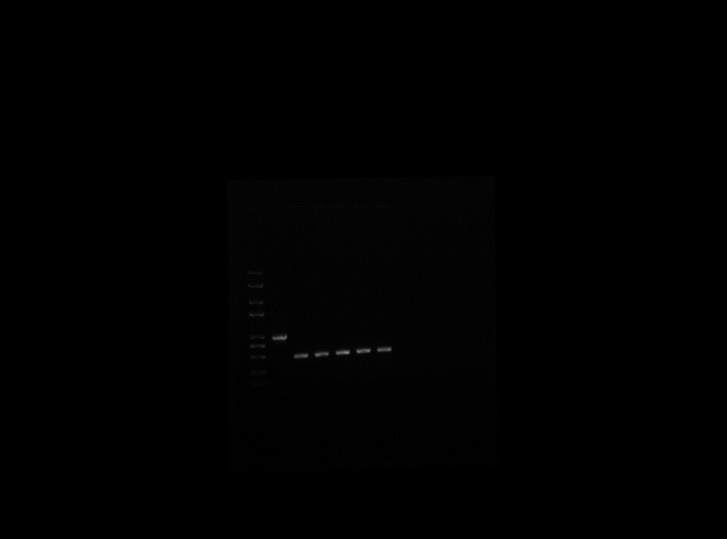

C83903 K88(faeG) knock off

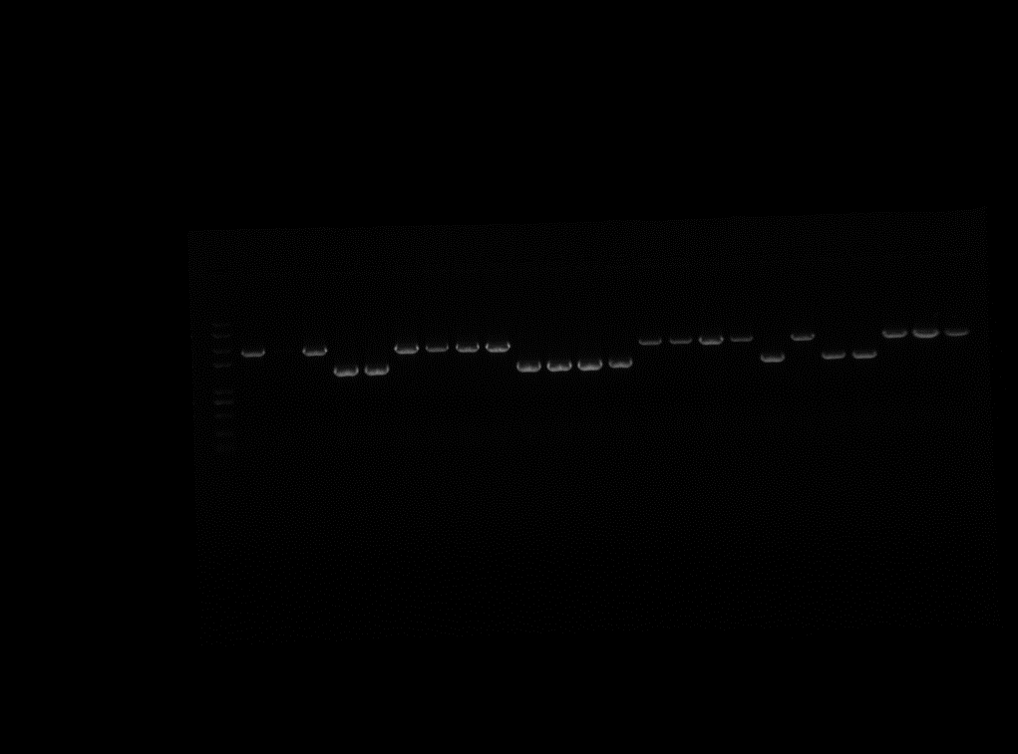

DN1502 eltII knock off

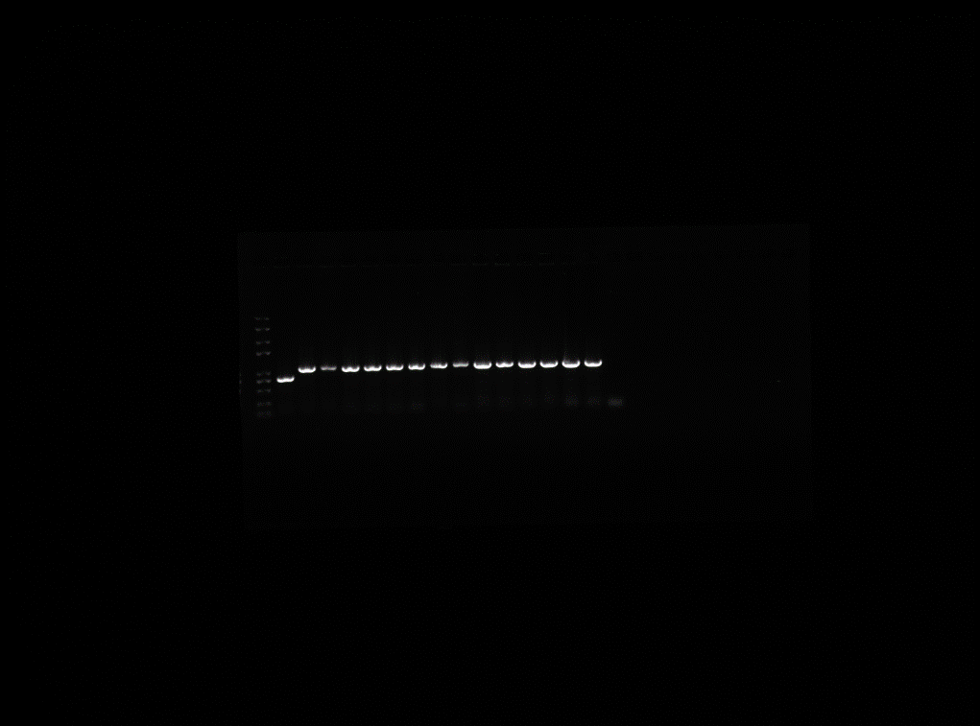

C83903 esta was inserted into estb

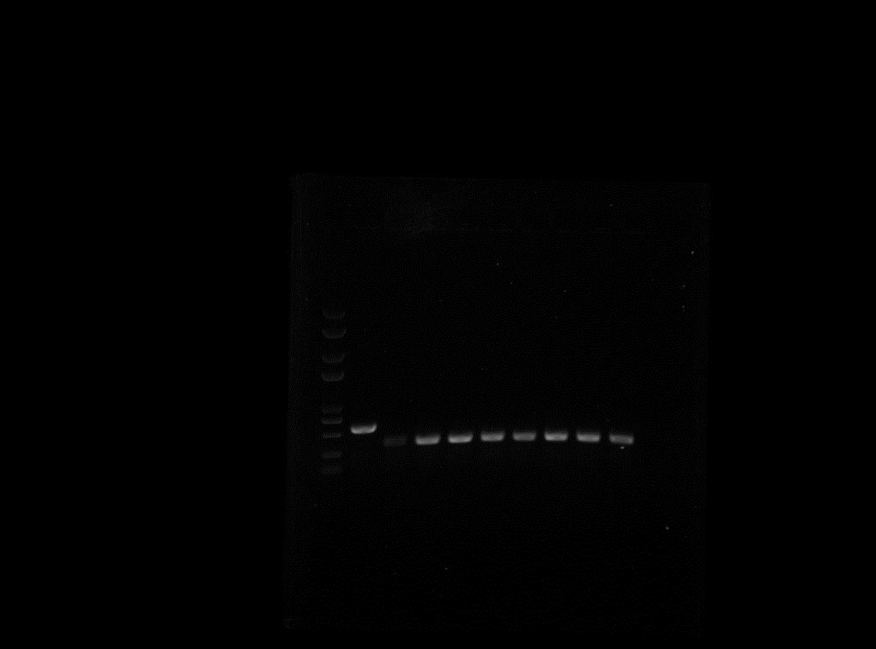

O142 esta knock off

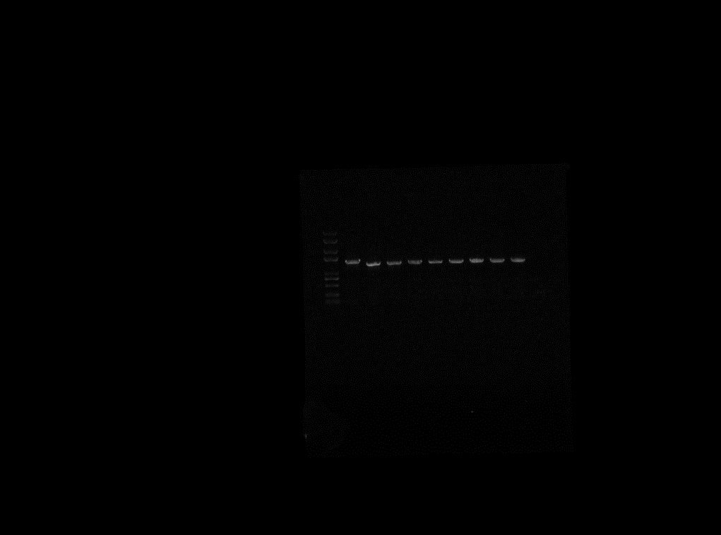

DN1502 the insertion(K88 faeG) of eltII

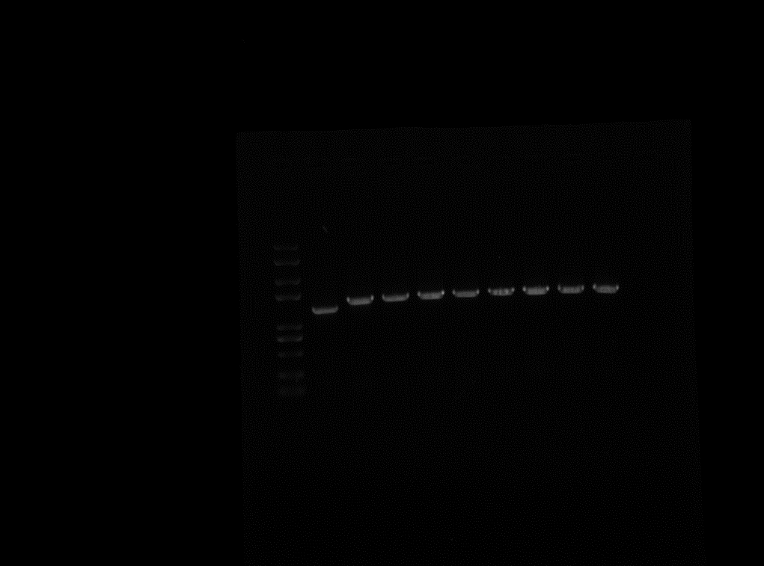

DN1502 the mutation of eltII

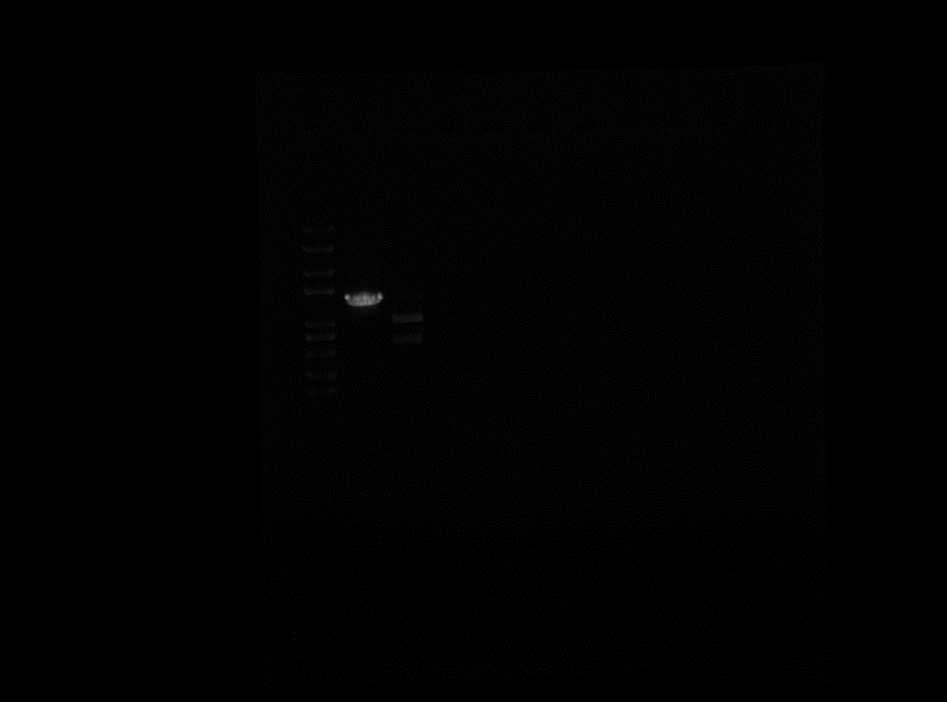

DN1502 the mutation and digestion of eltII

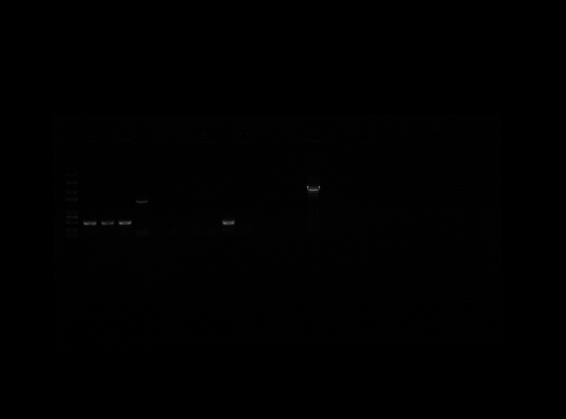

C83903 eltI knock off and cure plasmid

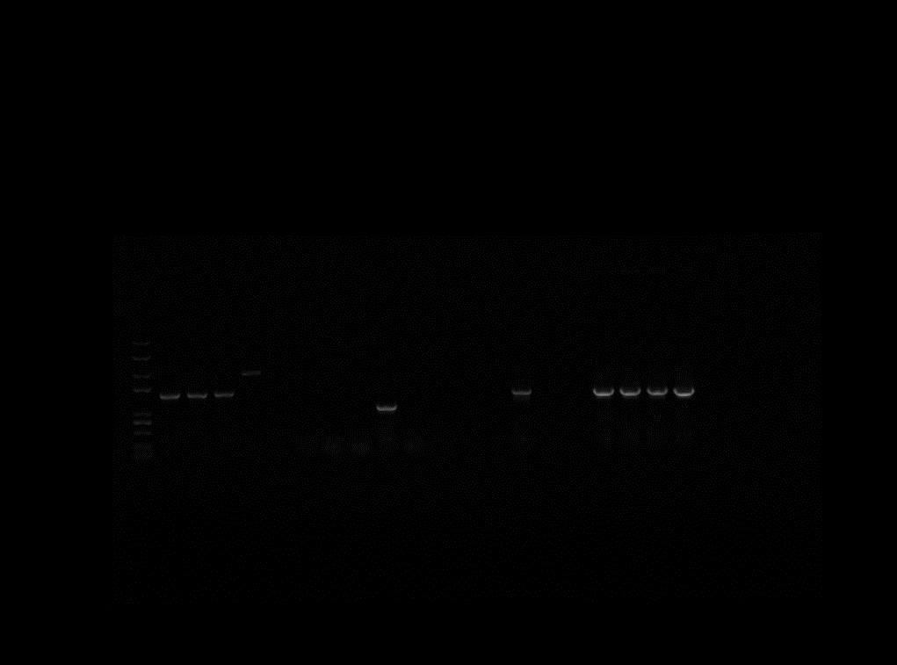

DN1502 after knocking off eltII, the plasmid cure

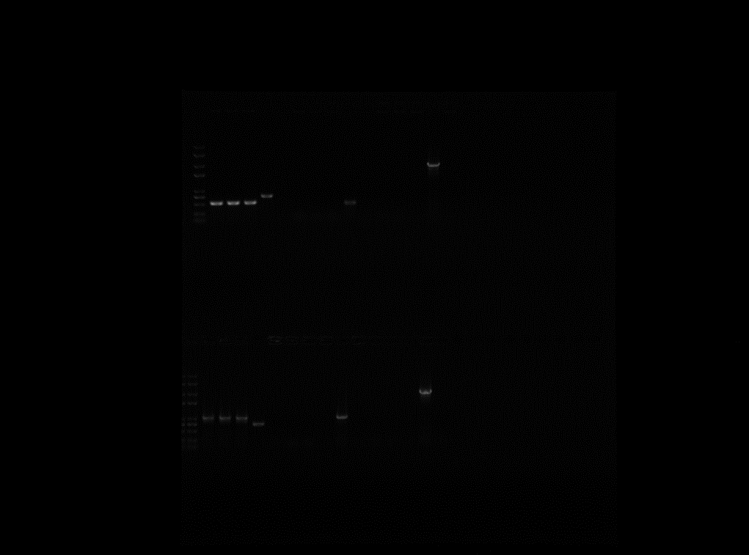

C83903 estb knock off and cure plasmid, estb inserted esta and plasmid cure

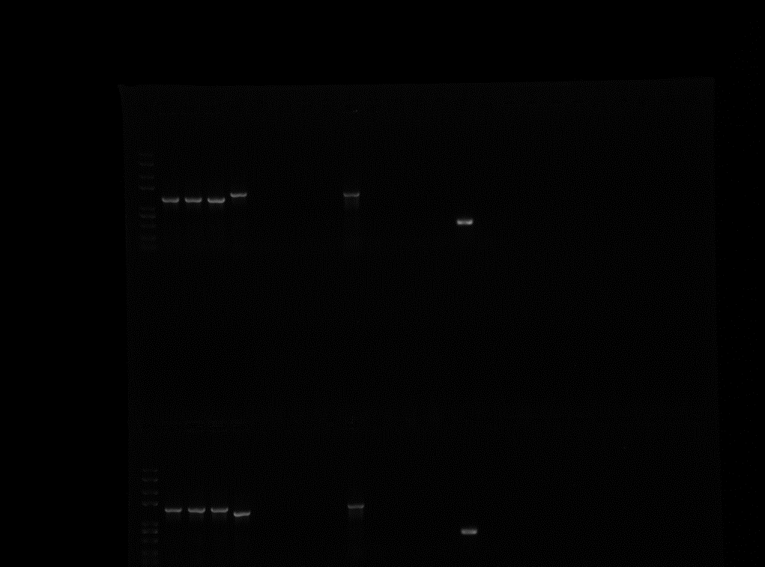

DN1502 the mutation and insertion(K88 faeG) of eltII and plasmid cure

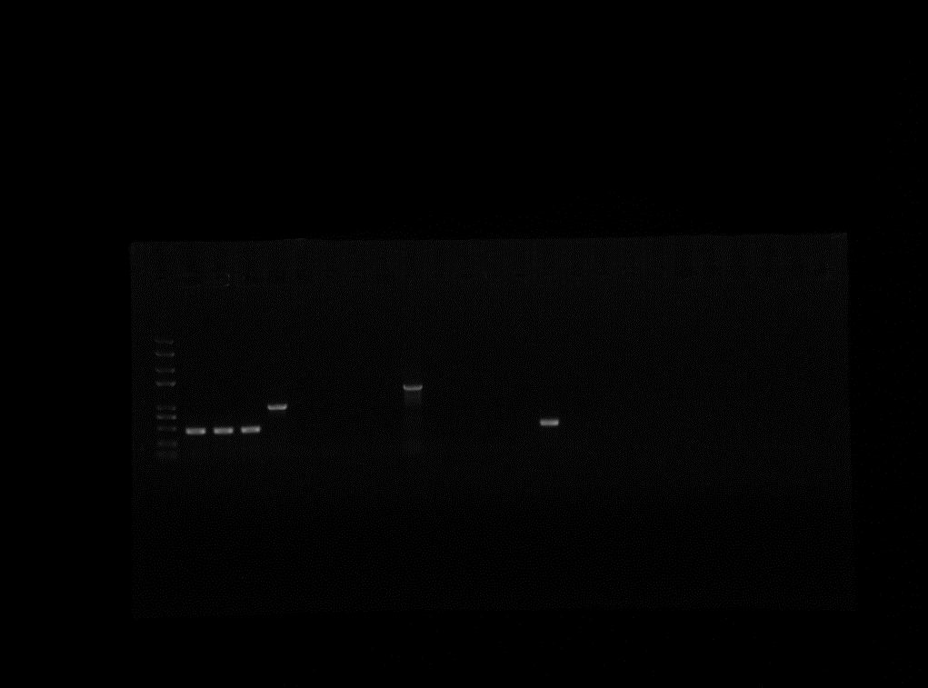

C83903 K88(faeG) knock off and plasmid cure

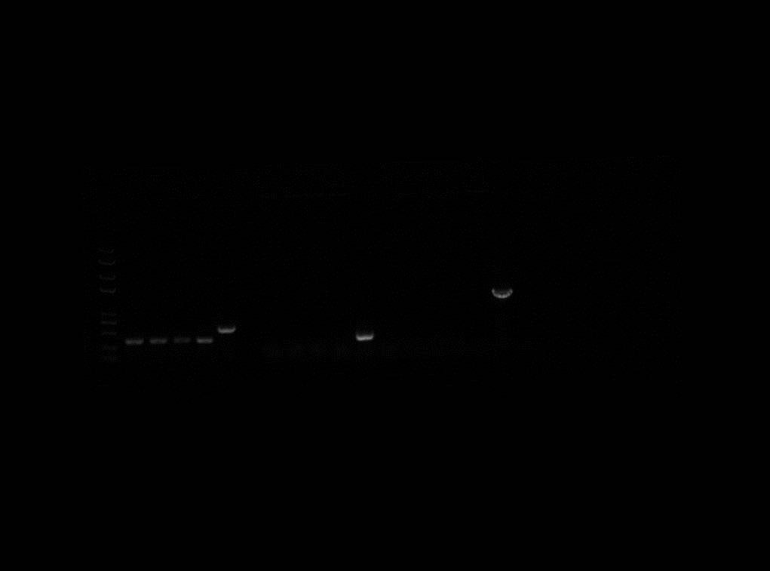

O142 esta knock off and cure plasmid

The raw figures were captured by alphamager HP.（Protein Simple, California, USA）

The figures appeared in manuscript was enhanced and clipped by photoshop CC 2018.