Supplemental Information from: Intraspecific variation in the cochleae of harbour porpoises (Phocoena phocoena) and its implications for comparative studies across odontocetes.

Maria Clara Iruzun Martins, Travis Park, Rachel Racicot and Natalie Cooper

Table S1. Specimen accession numbers and museum of origin. AMNH = American Museum of Natural History, New York, USA; IRSNB = Royal Belgian Institute of Natural Sciences; QMJM = Queensland Museum; NHMUK = Natural History Museum, London; NMVC = Museum Victoria, Melbourne, Australia; NMB= Naturhistorisches Museum, Basel, Switzerland. Side refers to the side of the head the cochlea came from.

Specimen number | Side | Taxon
NHMUK_CE1982.315 | Right | Berardius arnuxii
NHMUK_CE1952.6.20.4 | Right | Cephalorhynchus commersonii
NHMUK_CE1948.7.27.1 | Right | Cephalorhynchus heavisidii
NMBCIII1086 | Right | Delphinapterus leucas
NMB6679 | Right | Delphinus delphis
NHMUK_CE1874.11.25.1 | Right | Feresa attenuata
NHMUK_CE1947.12.31.4 | Right | Globicephala melas
NHMUK_CE1920.12.16.1 | Right | Grampus griseus
NHMUK_CE1862.12.2.2 | Right | Hyperoodon ampullatus
NHMUK1934.7.23.3 | Left | Hyperoodon planifrons
NMB7167 | Right | Inia geoffrensis
NMVC24976 | Left | Kogia breviceps
NHMUK_CE1952.8.28.1 | Right | Kogia sima
NHMUK_CE1895.5.9.1 | Right | Lagenodelphis hosei
NHMUK_CESW1928.19 | Right | Lagenorhynchus acutus
NHMUK_CE1848.7.12.12 | Right | Lagenorhynchus albirostris
NHMUK_CE1944.11.30.1 | Right | Lagenorhynchus australis
NHMUK_CE1960.8.24.1 | Right | Lagenorhynchus cruciger
NHMUK_CE1966.10.25.1 | Right | Lagenorhynchus obliquidens
NHMUK_CE1841.1733 | Left | Lagenorhynchus obscurus
AMNH57333 | Left | Lipotes vexillifer
IRSNB16232 | Right | Mesoplodon bidens
NMVC31378 | Left | Mesoplodon grayi
NHMUK_CE1876.2.16.3 | Right | Mesoplodon hectori
NHMUK_CE1920.5.20.1 | Right | Mesoplodon mirus
AMNH73315 | Left | Monodon monoceros
NHMUK_CE1903.9.12.3 | Right | Neophocaena phocaenoides
NHMUK_CE1883.11.20.2 | Right | Orcaella brevirostris
QMJM4700 | Right | Orcaella heinsohni
NHMUK_CESW1927.28 | Right | Orcinus orca
NHMUK_CE1992.100 | Right | Peponocephala electra
NHMUK_CE1939.9.30.1 | Right | Phocoena dioptrica
NHM_SW1954.15 | Left | Phocoena phocoena
NHMUK_1846.12.15.6 | Left | Phocoena phocoena
NHMUK_1873.6.3.45 | Left | Phocoena phocoena
NHMUK_92.265 | Left | Phocoena phocoena
NHMUK_1925.4.29.1 | Left | Phocoena phocoena
NHMUK_1933.15 | Left | Phocoena phocoena
NHMUK_1933.17 | Right | Phocoena phocoena
NHMUK_1934.45 | Left | Phocoena phocoena
NHMUK_1934.51 | Left | Phocoena phocoena
NHMUK_1965.3.30.1 | Left | Phocoena phocoena
NHMUK_1992.263 | Left | Phocoena phocoena
NHMUK_SW1926.29 | Right | Phocoena phocoena
NHMUK_SW1934.14 | Left | Phocoena phocoena
NHMUK_SW1934.31 | Left | Phocoena phocoena
NHMUK_SW1934.32 | Left | Phocoena phocoena
NHMUK_SW1937.24 | Left | Phocoena phocoena
NMB10131 | Right | Phocoena phocoena
NMVC27654 | Left | Phocoena phocoena
Phocoena_sinus | Right | Phocoena sinus
IRSNB_21219 | Right | Phocoena spinipinnis
NHMUK_CE1965.1.19.2 | Right | Phocoenoides dalli
NHMUK_CE893 | Left | Physeter macrocephalus
NMVC27417.2 | Right | Platanista gangetica
MNHN1934.375 | Right | Pontoporia blainvillei
NHMUK_CE1992.248 | Right | Pseudorca crassidens
NHMUK_CE1856.8.2.2 | Right | Sotalia fluviatilis
IRSNB_20137 | Left | Sotalia guianensis
NHMUK_CE1914.1.14.1 | Right | Sousa chinensis
NHMUK_CE1893.8.1.1 | Right | Sousa teuszii
NHMUK_CE1990.98 | Right | Stenella attenuata
NHMUK_CE1940.3.2.1 | Right | Stenella coeruleoalba
NHMUK_CE1990.104 | Right | Stenella longirostris
NMVC36961 | Left | Steno bredanensis
NMVC37967.6 | Right | Tasmacetus shepherdi
NHMUK CE1882.1.2.3 | Right | Tursiops aduncus
NHMUK_CE1866.8.7.1 | Right | Tursiops truncatus
NHMUK_CE1915.7.20.1 | Right | Ziphius cavirostris

Table S2. Scan Parameters of newly scanned specimens of Phocoena phocoena at the NHM. NHMUK = Natural History Museum, London. All specimens used a scan power (kV) of 100 and 1999 slices. Details for all other specimens can be found in Park et al. 2019.
Specimen number | Voxel Size (μm)
NHMUK_1846.12.15.6 | 53.40
NHMUK_1873.6.3.45 | 49.38
NHMUK_1925.4.29.1 | 48.73
NHMUK_SW1926.29 | 49.69
NHMUK_1992.265 | 49.69
NHMUK_SW1954.15 | 49.38
NHMUK_1965.3.30.1 | 48.73
NHMUK_1992.263 | 48.31
NHMUK_SW1934.32 | 48.73
NHMUK_SW1933.17 | 45.97
NHMUK_1934.31 | 53.40
NHMUK_SW1934.14 | 48.83
NHMUK_SW1934.45 | 48.31
NHMUK_SW1933.15 | 45.97
NHMUK_SW1934.51 | 48.83
NHMUK_SW1937.24 | 48.73

Table S3. Additional information on Phocoena phocoena specimens. Side refers to the side of the head the cochlea came from. CBL is condylobasal length (skull length) recorded in mm. Note that not all cochleae had a corresponding skull in the collections.

Specimen number | Side | Sex | Origin | CBL
NHMUK_1846.12.15.6 | Left | - | UK | 241
NHMUK_1873.6.3.45 | Left | - | USA | -
NHMUK_1892.265 | Left | - | UK | -
NHMUK_1925.4.29.1 | Left | Male | UK | -
NHMUK_1933.15 | Left | - | UK | 245
NHMUK_1933.17 | Right | Male | UK | -
NHMUK_1934.45 | Left | Male | UK | -
NHMUK_1934.51 | Left | - | UK | 251
NHMUK_1965.3.30.1 | Left | Female | UK | 259
NHMUK_1992.263 | Left | - | UK | -
NHMUK_SW1926.29 | Right | Female | UK | 271
NHMUK_SW1934.14 | Left | Female | UK | 254
NHMUK_SW1934.31 | Left | Male | UK | -
NHMUK_SW1934.32 | Left | Male | UK | 235
NHMUK_SW1937.24 | Left | Female | UK | 251
NHMUK_SW1954.15 | Left | - | UK | -
NMB10131 | Right | - | UK | -
NMVC27654 | Left | - | UK | 251

Tables S4 and S5 are too large to include here so can be found as a separate Excel file. These tables include ecological data on each species and a reference list for where these data came from.
Table S6. Summary of coefficients of variation (CV) found in other studies of odontocete cochlea. Where these studies contained right and left cochleae from one individual we first took the mean for the individual, then calculated CV across individuals. W2 = Width of basal turn perpendicular to cochlear width; ITD = Inter-turn distance, maximum distance between turns; FC = area of fenestra cochlearis. *This value is based on measurements from right and left cochlea of 12 individuals (i.e. 24 cochlea) rather than the mean value for each individual because only overall means are published in the paper.
Reference | Species | Number of individuals | Number of cochleae | Measurement | CV (%)
Costeur et al, 2018 | Pontoporia blainvillei | 4 | 4 | Number of turns | 0.00
Costeur et al, 2018 | Pontoporia blainvillei | 4 | 4 | Cochlear height | 3.35
Costeur et al, 2018 | Pontoporia blainvillei | 4 | 4 | Axial pitch | 3.52
Costeur et al, 2018 | Pontoportia sp | 4 | 4 | Number of turns | 0.00
Costeur et al, 2018 | Pontoportia sp | 4 | 4 | Cochlear height | 2.04
Costeur et al, 2018 | Pontoportia sp | 4 | 4 | Axial pitch | 2.04
Costeur et al, 2018 | Ziphiidae sp | 2 | 2 | Number of turns | 9.43
Costeur et al, 2018 | Ziphiidae sp | 2 | 2 | Cochlear height | 13.99
Costeur et al, 2018 | Ziphiidae sp | 2 | 2 | Axial pitch | 23.33
Costeur et al, 2018 | Inia geoffrensis | 2 | 2 | Number of turns | 0.00
Costeur et al, 2018 | Inia geoffrensis | 2 | 2 | Cochlear height | 10.88
Costeur et al, 2018 | Inia geoffrensis | 2 | 2 | Axial pitch | 10.95
Schnitzler et al, 2017 | Physeter macrocephalus | 12 | 24 | Cochlear height | 4.01*
Schnitzler et al, 2017 | Physeter macrocephalus | 12 | 24 | Cochlear width | 3.50*
Schnitzler et al, 2017 | Physeter macrocephalus | 12 | 24 | Cochlear canal length | 4.39*
Racicot et al, 2016 | Phocoena sinus | 2 | 2 | Cochlear volume | 10.23
Racicot et al, 2016 | Phocoena sinus | 2 | 2 | Cochlear canal length | 1.55
Racicot et al, 2016 | Phocoena sinus | 2 | 2 | Number of turns | 0.39
Racicot et al, 2016 | Phocoena sinus | 2 | 2 | Basal ratio | 0.00
Racicot et al, 2016 | Phocoena sinus | 2 | 2 | Cochlear height | 3.48
Racicot et al, 2016 | Phocoena sinus | 2 | 2 | Cochlear width | 3.91
Racicot et al, 2016 | Phocoena sinus | 2 | 2 | Axial pitch | 3.84
Racicot et al, 2018 | Delphinapterus leucas | 2 | 3 | Cochlear canal length | 2.39
Racicot et al, 2018 | Delphinapterus leucas | 2 | 3 | Cochlear width | 2.88
Racicot et al, 2018 | Delphinapterus leucas | 2 | 3 | Cochlear height | 10.52
Racicot et al, 2018 | Delphinapterus leucas | 2 | 3 | W2 | 3.67
Racicot et al, 2018 | Delphinapterus leucas | 2 | 3 | ITD | 13.95
Racicot et al, 2018 | Delphinapterus leucas | 2 | 3 | FC | 3.65
Racicot et al, 2018 | Delphinapterus leucas | 2 | 3 | Number of turns | 5.59
Racicot et al, 2018 | Monodon monocerus | 5 | 9 | Cochlear canal length | 5.28
Racicot et al, 2018 | Monodon monocerus | 5 | 9 | Cochlear width | 3.16
Racicot et al, 2018 | Monodon monocerus | 5 | 9 | Cochlear height | 6.08
Racicot et al, 2018 | Monodon monocerus | 5 | 9 | W2 | 1.42
Racicot et al, 2018 | Monodon monocerus | 5 | 9 | ITD | 11.30
Racicot et al, 2018 | Monodon monocerus | 5 | 9 | FC | 16.03
Racicot et al, 2018 | Monodon monocerus | 5 | 9 | Number of turns | 1.95

Table S7: Results of ANOVAs using principal components (PCs) accounting for 95% of the variance as response variables, and whether a specimen was Phocoena phocoena or another odontocete species as the explanatory variable. 3D shape data analyses used PCs 1 to 26; linear measurements analyses used PCs 1 to 6. Significant p values (p < 0.05) are in bold.

3D shape data
PC | df | F | p value | Bonferroni corrected p value
PC1 | 1,67 | 10.44 | 0.002 | 0.050
PC2 | 1,67 | 0.316 | 0.576 | -
PC3 | 1,67 | 27.44 | < 0.001 | < 0.001
PC4 | 1,67 | 2.151 | 0.147 | -
PC5 | 1,67 | 2.582 | 0.113 | -
PC6 | 1,67 | 2.225 | 0.140 | -
PC7 | 1,67 | 0.617 | 0.435 | -
PC8 | 1,67 | 0.057 | 0.812 | -
PC9 | 1,67 | 1.546 | 0.218 | -
PC10 | 1,67 | 4.209 | 0.044 | -
PC11 | 1,67 | 2.819 | 0.098 | -
PC12 | 1,67 | 1.723 | 0.194 | -
PC13 | 1,67 | 0.319 | 0.574 | -
PC14 | 1,67 | 1.327 | 0.253 | -
PC15 | 1,67 | 0.094 | 0.760 | -
PC16 | 1,67 | 2.989 | 0.088 | -
PC17 | 1,67 | 0.046 | 0.830 | -
PC18 | 1,67 | 0.408 | 0.525 | -
PC19 | 1,67 | 0.202 | 0.655 | -
PC20 | 1,67 | 0.850 | 0.360 | -
PC21 | 1,67 | 3.345 | 0.072 | -
PC22 | 1,67 | 0.235 | 0.629 | -
PC23 | 1,67 | 0.446 | 0.506 | -
PC24 | 1,67 | 0.077 | 0.782 | -
PC25 | 1,67 | 0.074 | 0.786 | -
PC26 | 1,67 | 0.286 | 0.594 | -
Linear measurements
PC | df | F | p value | Bonferroni corrected p value
PC1 | 1,67 | 24.303 | < 0.001 | < 0.001
PC2 | 1,67 | 8.237 | 0.005 | 0.033
PC3 | 1,67 | 0.088 | 0.767 | -
PC4 | 1,67 | 5.139 | 0.027 | 0.16
PC5 | 1,67 | 1.117 | 0.294 | -
PC6 | 1,67 | 0.229 | 0.634 | -

Table S8. Results of MANOVA analyses using principal components (PCs 1 to 26) that account for 95% of the variance in 3D shape as the response variable, and whether a specimen was Phocoena phocoena or another odontocete species (group), and additional taxonomic or ecological variables (various) as the explanatory variables.

analysis | variable | df | F/approx F | Pillai | p
Family | group | 1,58 | 5.964 | 0.921 | < 0.001
 | family | 9,58 | 1.671 | 2.923 | < 0.001
Habitat | group | 1,59 | 6.171 | 0.920 | < 0.001
 | habitat | 4,59 | 1.671 | 2.923 | 0.003
Diet | group | 1,60 | 6.433 | 0.919 | < 0.001
 | diet | 3,60 | 1.714 | 2.207 | 0.007
Feeding mode | group | 1,60 | 6.357 | 0.918 | < 0.001
 | feeding | 3,60 | 0.927 | 1.803 | 0.647
Dive type | group | 1,60 | 6.768 | 0.923 | < 0.001
 | dive type | 3,60 | 1.822 | 2.242 | 0.003
Hearing type | group | 1,66 | 6.309 | 0.898 | < 0.001
 | hearing type | 1,66 | 3.572 | 0.833 | < 0.001

Table S9. Results of Procrustes MANOVA and standard MANOVA analyses using either Procrustes aligned coordinates or principal components (PCs) accounting for 95% of the variance as the response variable, and whether a specimen was Phocoena phocoena or another phocoenid species as the explanatory variable. 3D shape data analyses used PCs 1 to 14; linear measurements analyses used PCs 1 to 7. Significant p values (< 0.05) are in bold.
3D shape data
test | df | F/approx F | Pillai | p
Procrustes ANOVA | 1,19 | 2.958 | NA | 0.026
MANOVA | 1,19 | 3.398 | 0.888 | 0.070
Linear measurements
MANOVA | 1,19 | 3.155 | 0.629 | 0.035

Table S10. Possible correlates of intraspecific variation in the cochleae of Phocoena phocoena specimens. Results are from MANOVAs using principal components (PCs) accounting for 95% of the variance in the cochleae shape as the response variable, and either the side of the head the cochlea came from, the sex, origin (UK or USA), or log skull length (condylobasal length in mm) of the specimens, as the predictor variables. 3D shape data analyses used PCs 1 to 16; linear measurements analyses used PCs 1 to 7.
3D shape data
predictor | df | approx F | Pillai | p | bonferroni
side | 1,16 | 1.837 | 0.896 | 0.340 | 1.000
sex† | 1,7 | 1.114 | 0.770 | 0.544 | 1.000
origin | 1,16 | 10.69 | 0.980 | 0.038 | 0.152
skull length† | 1,7 | 19.41 | 0.983 | 0.050 | 1.000
Linear measurements
side | 1,16 | 0.571 | 0.285 | 0.765 | 1.000
sex | 1,7 | 6.613 | 0.979 | 0.291 | 1.000
origin | 1,16 | 0.376 | 0.861 | 0.566 | 1.000
skull length | 1,7 | 4.226 | 0.967 | 0.359 | 1.000

†For sex and condylobasal length we have fewer specimens with data (n = 9 for each) so there are not enough observations to fit MANOVAs of all 16 PCs. In these analyses we therefore use only PC1 to PC6, which accounted for 75% of the variance in the cochlear shape.

Table S11. Results of Procrustes MANOVA and standard MANOVA analyses using either Procrustes aligned coordinates or principal components (PCs) accounting for 95% of the variance as the response variable, and whether a specimen was Phocoena phocoena or another odontocete species as the explanatory variable, but excluding the USA P.phocoena specimen (NHMUK_1873.6.3.45). 3D shape data analyses used PCs 1 to 26; linear measurements analyses used PCs 1 to 6. Significant p values (< 0.05) are in bold.
3D shape data
test | df | F/approx F | Pillai | p
Procrustes ANOVA | 1,66 | 5.374 | NA | 0.001
MANOVA | 1,66 | 8.376 | 0.842 | < 0.001
Linear measurements
MANOVA | 1,66 | 8.570 | 0.457 | < 0.001

Supplemental Figures

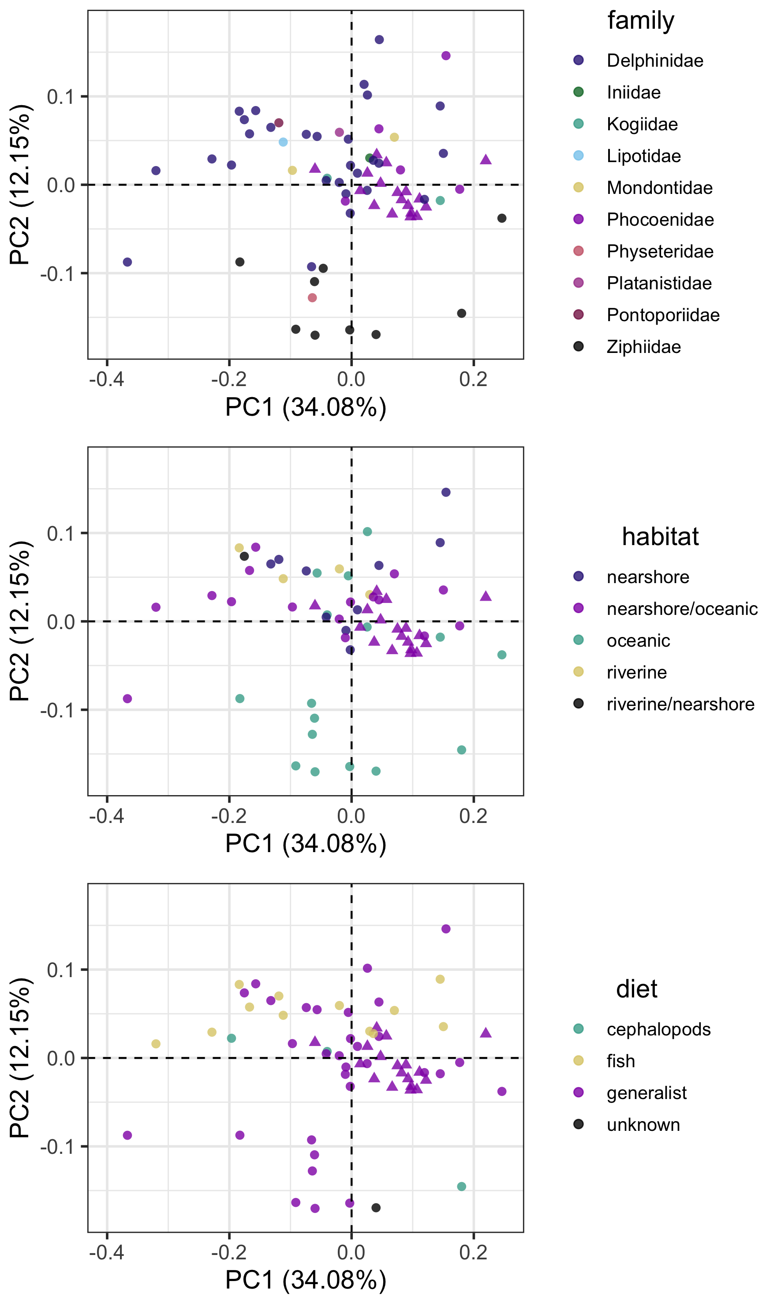

Figure S1: Principal components plots of PC1 and PC2 for 3D cochlea shape data, coloured according to taxonomic family, habitat or diet. Triangles are Phocoena phocoena specimens; circles are all other odontocete species. numbers in brackets show the percentage variance explained for each PC.

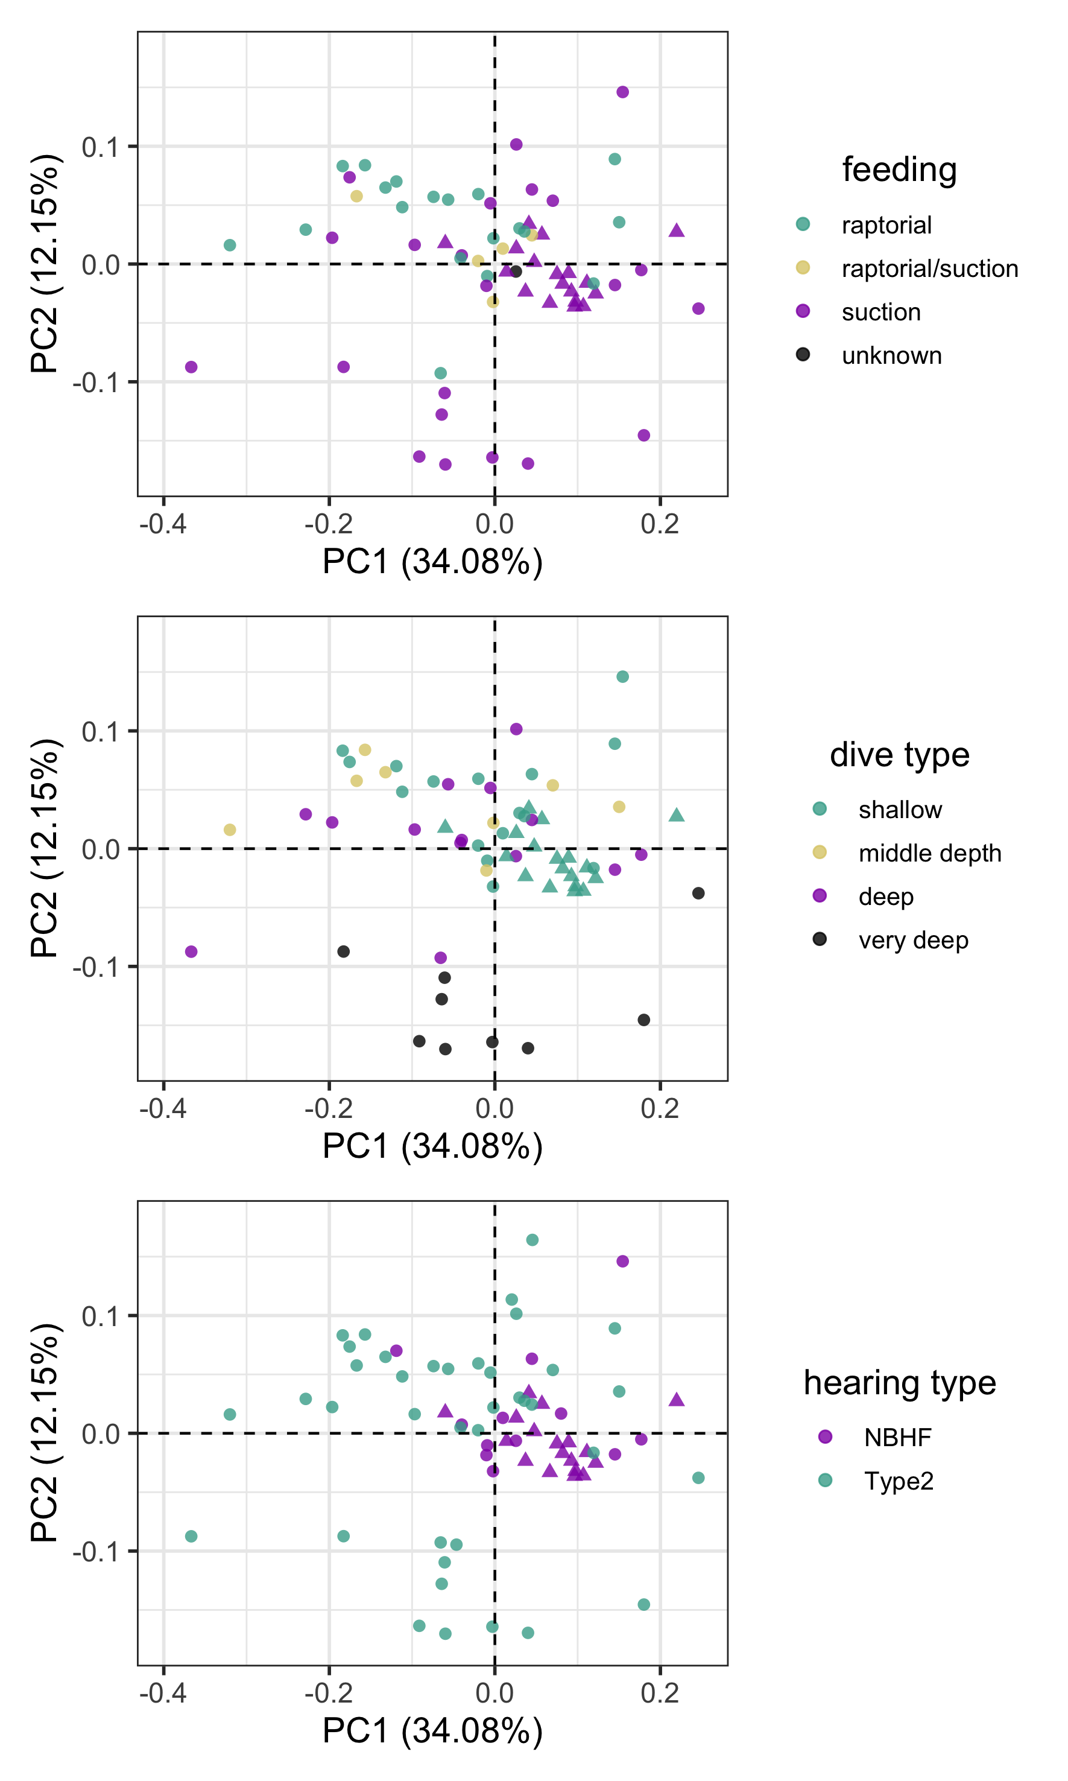
Figure S2: Principal components plots of PC1 and PC2 for 3D cochlea shape data, coloured according to taxonomic feeding mode, dive type or hearing type. Triangles are Phocoena phocoena specimens; circles are all other odontocete species. numbers in brackets show the percentage variance explained for each PC.

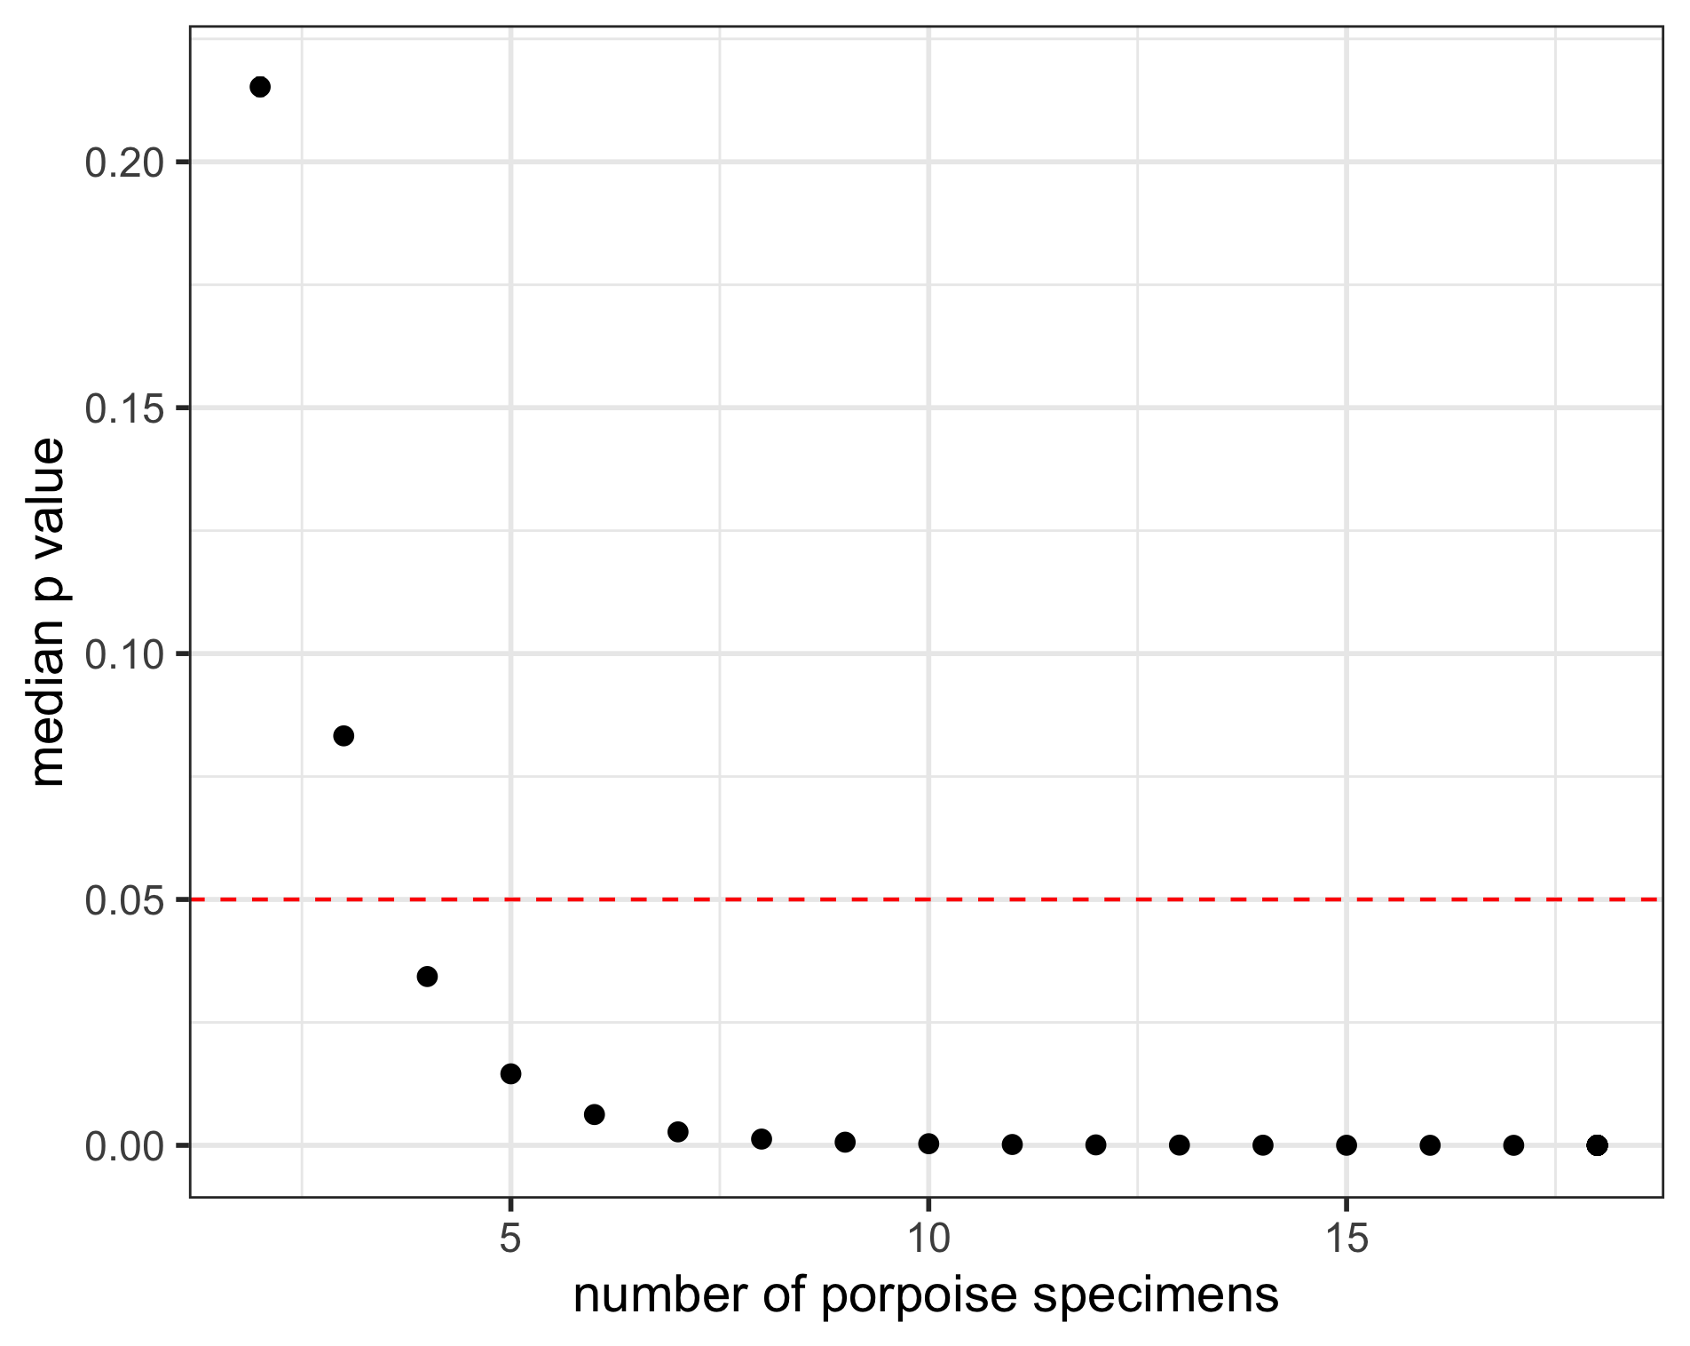
Figure S3: Median p values from multivariate analyses of variance (MANOVA) on principal components (PCs) of 3D cochlea shape data with varying numbers of Phocoena phocoena specimens included. For each number of Phocoena phocoena specimens we ran the analyses for each possible combination of specimens. Significance at p < 0.05 is indicated by the red dashed line.

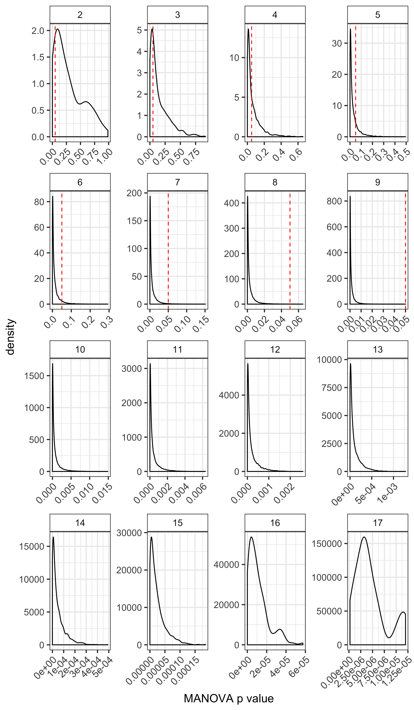
Figure S4: Kernal density plots showing p values from multivariate analyses of variance (MANOVA) on principal components (PCs) of 3D cochlea shape data with varying numbers of Phocoena phocoena specimens included. For each number of Phocoena phocoena specimens we ran the analyses for each possible combination of specimens. Significance at p < 0.05 is indicated by the red dashed line, which is not visible for n > 9.
References
Park, T., Mennecart, B., Costeur, L., Grohé., and Cooper, N. 2019. Convergent evolution in toothed whale cochleae. BMC Evolutionary Biology. 9, 195.

