Step of click SPSS (version 26)
1.file → open → data
Analyze → Tables → Custom Tables（Chi-square test was used to compare the clinicopathological characteristics between the training set and the validation set）
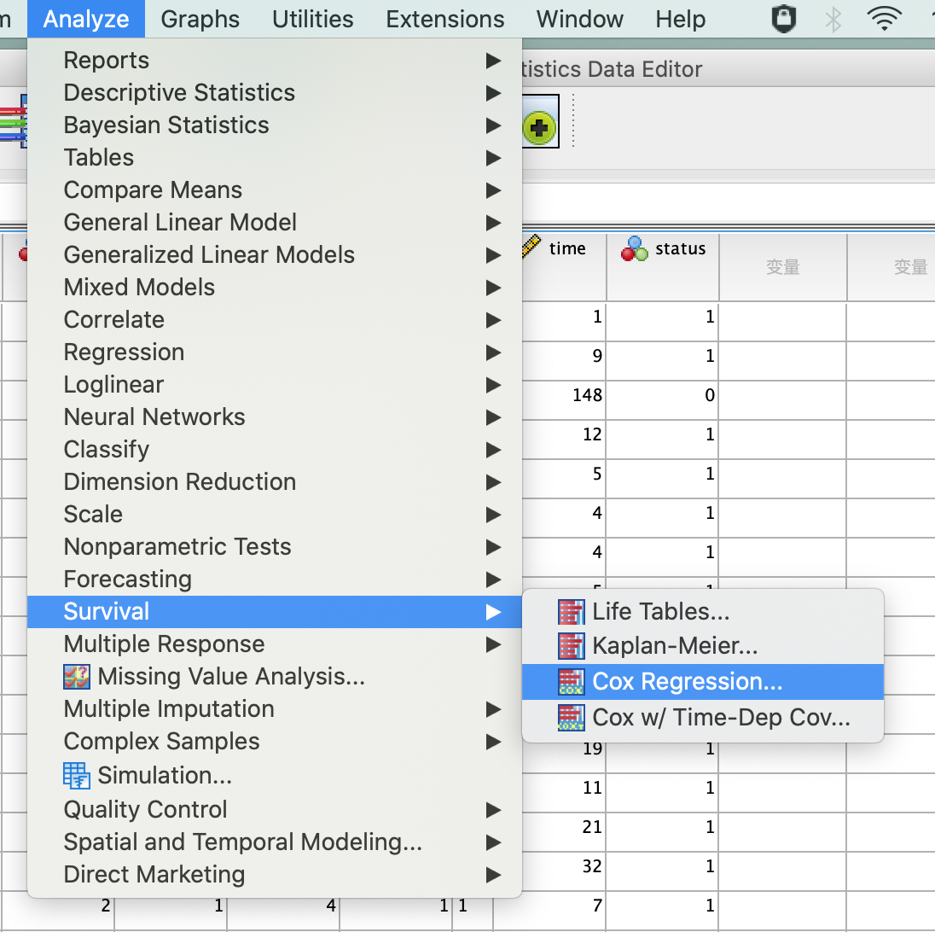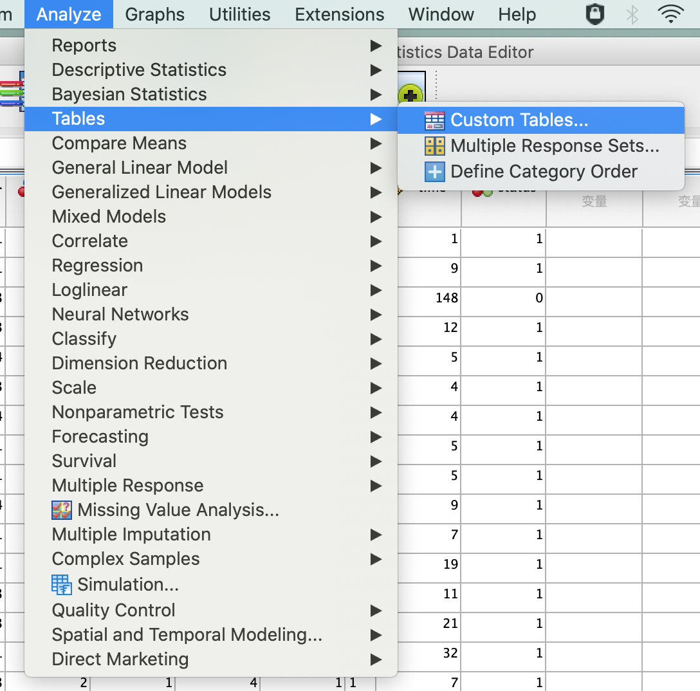
2. file → open → data
Analyze → survival → Cox regression (Univariate and forward stepwise multivariate Cox analysis was used to determine the independent factors affecting OS
)
