Spot | SORBIDRAFT | Protein name | Protein functional category | Accumulation level
 |  |  |  | 1 2 3 4
*299 | sb08g020860 | Thiosulfate/3 mercaptopyruvate sulfurtransferase 2 isoform X1 | Sulfur metabolism | 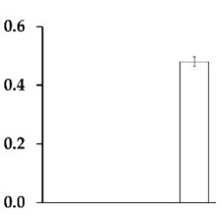
*298 | sb04g002620 | Probable ATP synthase 24 kDa subunit | Energy metabolism | 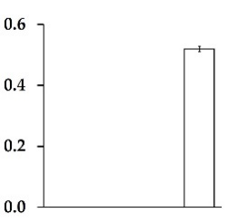
*300 | sb04g020180 | Sucrose-phosphatase 1 | Carbohydrate metabolism | 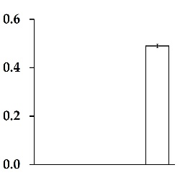
291 | sb01g043060 | Mitochondrial-processing peptidase subunit β | Transport | 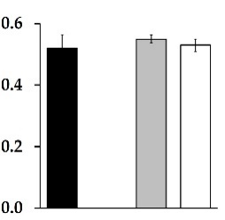
204 | sb04g005040 | V-type proton ATPase catalytic subunit A | Transport | 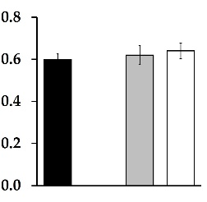
72 | sb02g031030 | Triosephosphate isomerase | Carbohydrate metabolism | 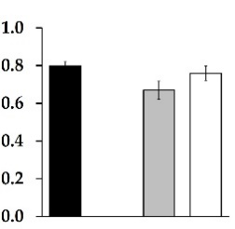
176 | sb09g000730 | Actin-97 isoform X2,  Zea mays  (GI: 103629276) | Cell structure | 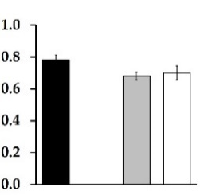
*189 | sb03g031470 | ATP synthase β subunit | Energy metabolism | 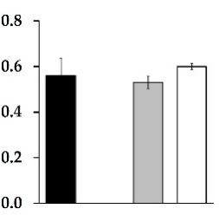
*269 | sb03g003550 | 1aminocyclopropane-1-carboxylate oxidase | Ethylene biosynthesis | 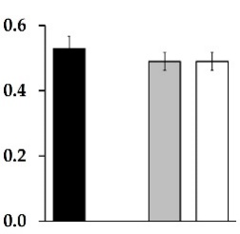
*114 | sb02g042550 | Stress-related protein | Stress response | 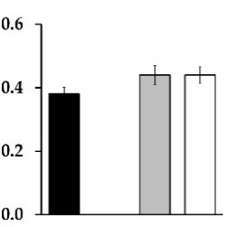
*142 | sb10g001900 | Probable aldo-keto reductase 2 | Stress response | 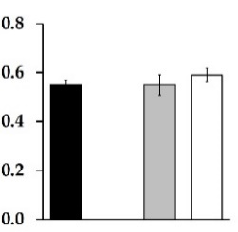
*131 | sb03g046030 | Protein MEMO 1 | Cell motility | 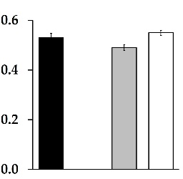
*162 | sb09g021360 | Bifunctional aspartate aminotransferase and glutamate/aspartate-prephenate aminotransferase | Amino acid Biosynthesis | 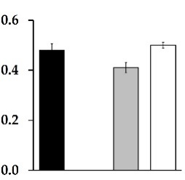
144 | sb03g029570 | Malate dehydrogenase | Carbohydrate metabolism | 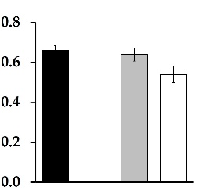
*65 | sb08g019790 | Adenine phosphoribosyl transferase 1 | Cytokinin metabolism | 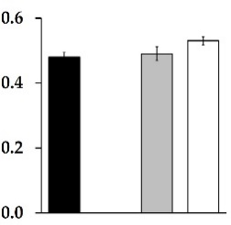
239 | sb02g044060 | Ascorbate peroxidase 2 | Antioxidant metabolism | 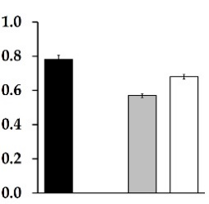
263 | sb02g042150 | Momilactone A synthase | Antioxidant metabolism | 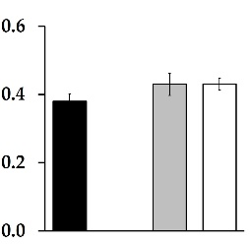
34 | sb01g040030 | 17.9 kDa class I heat shock protein | Stress response | 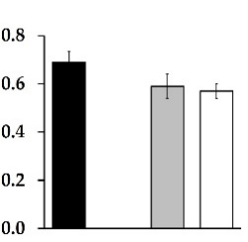
259 | sb09g004470 | Universal stress protein PHOS32 | Stress response | 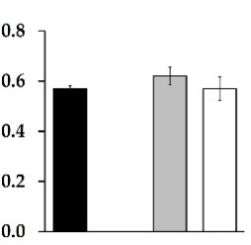
*143 | sb01g039930 | Serine/threonine-protein phosphatase PP1 isoform X1,  Zea mays  (GI: 103634267) | Transcription | 