Spot | SORBIDRAFT | Protein name | Protein functional category | Accumulation level
 |  |  |  | 1 2 3 4
113 | sb05g023220 | Plastid-lipid-associated protein 6/fibrillin | Stress response | 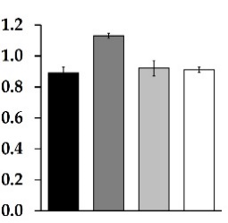
*172 | sb06g022050 | NADP-Isocitrate dehydrogenase | Carbohydrate metabolism | 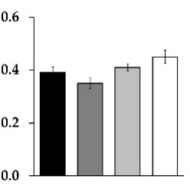
*266 | sb04g026360 | Succinyl-CoA ligase subunit beta | Carbohydrate metabolism | 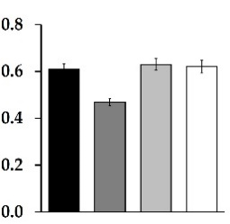
244 | sb08g004880 | Probable L-ascorbate peroxidase 6 | Antioxidant metabolism | 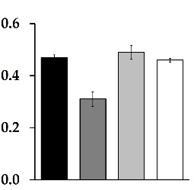
91 | sb03g002090 | Heme-binding  protein 2 | Antioxidant metabolism | 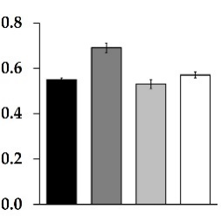
6 | sb08g005260 | Thioredoxin M-type | Antioxidant metabolism | 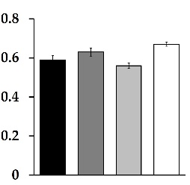
*147 | sb08g000220 | Glucuronokinase 1 | Biosynthetic Process | 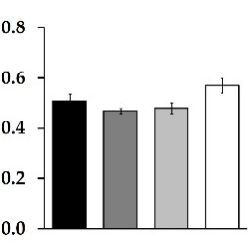
*108 | sb07g025680 | 14-3-3-like protein GF14-C | Signal  transduction | 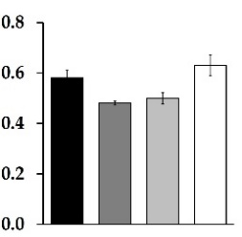
47 | sb07g027960 | Thylakoid lumenal 19 kDa protein | Photosynthesis | 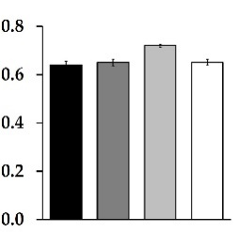
104 | sb03g042550 | Probable membrane-associated 30 kDa protein | Photosynthesis | 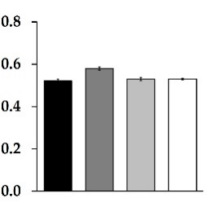
111 | sb04g034340 | Inorganic pyrophosphatase 6 | Energy metabolism | 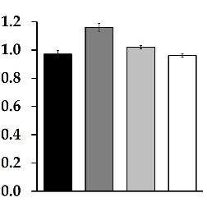
*191 | sb03g009490 | T-complex protein 1 subunit β | Signal transduction | 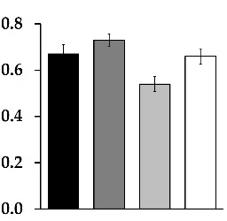
243 | sb06g023900 | NAD(P)H-quinone oxidoreductase subunit M | Antioxidant metabolism | 