Spot | SORBIDRAFT | Protein name | Protein functional category | Accumulation level
 |  |  |  | 1 2 3 4
*307 | sb01g017050 | Heat shock 70 kDa protein  Panicum miliaceum,  (GI: RNL19808.1) | Stress response | 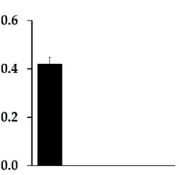
*308 | sb10g004540 | Caffeoyl-CoA O-methyltransferase 1 isoform X2 | Biosynthesis  Flavonoids | 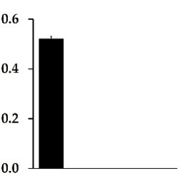
138 | sb03g009260 | Cysteine synthase 1 | Sulfur metabolism | 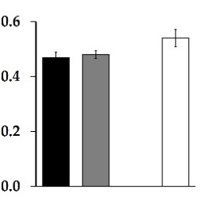
240 | sb10g005960 | Splicing factor RSZ21 arginine/serine-rich | RNA processing | 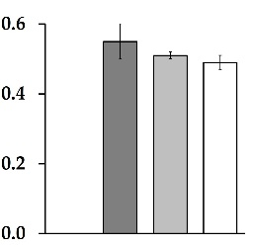
271 | sb02g038200 | MFP 1 attachment factor | Unknown function | 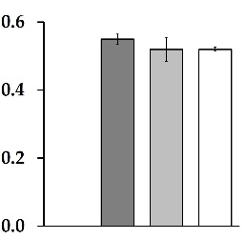
*274 | sb04g002770 | Proteasome subunit α type-1 | Protein metabolism | 