Table S1. Genetic data used (cytb) in phylogenetic analyses. Shown are locations of samples and major river drainage with GenBank accession numbers. Samples labeled “E. raneyi A” and “E. raneyi B” are from Near et al. (2011); Y.R. = Yocona River drainage, L.T.R. = Little Tallahatchie River drainage; U.T. = unnamed tributary; see Table S3 for outgroup data.
Sample | Drainage | Stream | Latitude | Longitude | GenBank
SP5_Yocona | Y.R. | Splinter Creek | 34.251 | -89.642 | MT296596
SP4_Yocona | Y.R. | Splinter Creek | 34.251 | -89.642 | MT296597
SP10_Yocona | Y.R. | Splinter Creek | 34.251 | -89.642 | MT296598
YL1_Yocona | Y.R. | Yellow Leaf Creek | 34.348 | -89.455 | MT296599
9_Yocona | Y.R. | Yellow Leaf Creek | 34.348 | -89.455 | MT296600
2_Yocona | Y.R. | Pumpkin Creek | 34.327 | -89.398 | MT296601
10_Yocona | Y.R. | Pumpkin Creek | 34.327 | -89.398 | MT296602
14_Yocona | Y.R. | Pumpkin Creek | 34.327 | -89.398 | MT296603
E. raneyi_B | Y.R. | Pumpkin Creek | 34.327 | -89.398 | HQ128214
TC2_Yocona | Y.R. | Taylor Creek | 34.293 | -89.589 | MT296604
TC1_Yocona | Y.R. | Taylor Creek | 34.293 | -89.589 | MT296605
X3_Yocona | Y.R. | Taylor Creek | 34.293 | -89.589 | MT296606
X10_Yocona | Y.R. | Taylor Creek | 34.293 | -89.589 | MT296607
X12_Yocona | Y.R. | Taylor Creek | 34.293 | -89.589 | MT296608
M1_Yocona | Y.R. | Morris Creek | 34.283 | -89.544 | MT296609
M3_Yocona | Y.R. | Morris Creek | 34.283 | -89.544 | MT296610
M7_Yocona | Y.R. | Morris Creek | 34.283 | -89.544 | MT296611
M5_Yocona | Y.R. | Morris Creek | 34.283 | -89.544 | MT296612
LUT1_Otouc | Y.R. | U.T. Otoucalofa Creek | 34.125 | -89611 | MT296613
U44_Otouc | Y.R. | U.T. Otoucalofa Creek | 34.125 | -89611 | MT296614
U42_Otouc | Y.R. | U.T. Otoucalofa Creek | 34.125 | -89611 | MT296615
U41_Otouc | Y.R. | U.T. Otoucalofa Creek | 34.125 | -89611 | MT296616
GB1_Otouc | Y.R. | Gordon Branch | 34.14 | -89.549 | MT296617
GB2_Otouc | Y.R. | Gordon Branch | 34.14 | -89.549 | MT296618
GB4_Outoc | Y.R. | Gordon Branch | 34.14 | -89.549 | MT296619
M14_Otouc | Y.R. | Mill Creek | 34.167 | -89.52 | MT296620
M17_Otouc | Y.R. | Mill Creek | 34.167 | -89.52 | MT296621
M20_Otouc | Y.R. | Mill Creek | 34.167 | -89.52 | MT296622
M27_Otouc | Y.R. | Mill Creek | 34.167 | -89.52 | MT296623
M29_Otouc | Y.R. | Mill Creek | 34.167 | -89.52 | MT296624
M24_Otouc | Y.R. | Mill Creek | 34.167 | -89.52 | MT296625
LJ37_Otouc | Y.R. | Johnston Creek | 34.124 | -89.641 | MT296626
LJ36_Otouc | Y.R. | Johnston Creek | 34.124 | -89.641 | MT296627
LJ35_Otouc | Y.R. | Johnston Creek | 34.124 | -89.641 | MT296628
LJ34_Otouc | Y.R. | Johnston Creek | 34.124 | -89.641 | MT296629
LJ33_Otouc | Y.R. | Johnston Creek | 34.124 | -89.641 | MT296630
LJ32_Otouc | Y.R. | Johnston Creek | 34.124 | -89.641 | MT296631
E. raneyi_A | L.T.R. | Big Spring Creek | 34.664 | -89.413 | HQ 128213
T69_Talla | L.T.R. | Big Spring Creek | 34.664 | -89.413 | MT296632
T68_Talla | L.T.R. | Big Spring Creek | 34.664 | -89.413 | MT296633
T63-1_Talla | L.T.R. | Big Spring Creek | 34.664 | -89.413 | MT296634
T61_Talla | L.T.R. | Big Spring Creek | 34.664 | -89.413 | MT296635
T60_Talla | L.T.R. | Big Spring Creek | 34.664 | -89.413 | MT296636
T57_Talla | L.T.R. | Big Spring Creek | 34.664 | -89.413 | MT296637
T53_Talla | L.T.R. | Big Spring Creek | 34.664 | -89.413 | MT296638
K5_Talla | L.T.R. | Big Spring Creek | 34.664 | -89.413 | MT296639
K7_Talla | L.T.R. | Big Spring Creek | 34.664 | -89.413 | MT296640
DC4_Talla | L.T.R. | Deer Creek | 34.316 | -89.785 | MT296641
DC5_Talla | L.T.R. | Deer Creek | 34.316 | -89.785 | MT296642
DC6_Talla | L.T.R. | Deer Creek | 34.316 | -89.785 | MT296643
DC2_Talla | L.T.R. | Deer Creek | 34.316 | -89.785 | MT296644
DC1_Talla | L.T.R. | Deer Creek | 34.316 | -89.785 | MT296645
DC3_Talla | L.T.R. | Deer Creek | 34.316 | -89.785 | MT296646
Hu13_Talla | L.T.R. | Hurricane Creek | 34.425 | -89.496 | MT296647
Hu17_Talla | L.T.R. | Hurricane Creek | 34.425 | -89.496 | MT296648
GM4_Talla | L.T.R. | Graham Mill Creek | 34.503 | -89.491 | MT296649
GM3_Talla | L.T.R. | Graham Mill Creek | 34.503 | -89.491 | MT296650
GM2_Talla | L.T.R. | Graham Mill Creek | 34.503 | -89.491 | MT296651
LC80_Tippah | L.T.R. | Chewalla Creek | 34.725 | -89.305 | MT296652
LC79_Tippah | L.T.R. | Chewalla Creek | 34.725 | -89.305 | MT296653
UC2-5_Tippah | L.T.R. | Chewalla Creek | 34.725 | -89.305 | MT296654
UC2-4_Tippah | L.T.R. | Chewalla Creek | 34.725 | -89.305 | MT296655
T1_Tippah | L.T.R. | U.T. Tippah River | 34.709 | -89.256 | MT296656
T2_Tippah | L.T.R. | U.T. Tippah River | 34.709 | -89.256 | MT296657
CH9_Tippah | L.T.R. | Chilli Creek | 34.682 | -89.173 | MT296658
CH6_Tippah | L.T.R. | Chilli Creek | 34.682 | -89.173 | MT296659
CH5_Tippah | L.T.R. | Chilli Creek | 34.682 | -89.173 | MT296660
CH4_Tippah | L.T.R. | Chilli Creek | 34.682 | -89.173 | MT296661
CH1_Tippah | L.T.R. | Chilli Creek | 34.682 | -89.173 | MT296662
YC9_Tippah | L.T.R. | Yellow Rabbit Creek | 34.819 | -89.106 | MT296663
YC10_Tippah | L.T.R. | Yellow Rabbit Creek | 34.819 | -89.106 | MT296664
YC13_Tippah | L.T.R. | Yellow Rabbit Creek | 34.819 | -89.106 | MT296665
YY7_Tippah | L.T.R. | Yellow Rabbit Creek | 34.819 | -89.106 | MT296666
YY25_Tippah | L.T.R. | Yellow Rabbit Creek | 34.819 | -89.106 | MT296667
H62_Cypress | L.T.R. | Bay Springs Branch | 34.429 | -89.396 | MT296668
H45_Cypress | L.T.R. | Bay Springs Branch | 34.429 | -89.396 | MT296669
A25_Cypress | L.T.R. | Puskus Creek | 34.443 | -89.341 | MT296670
A24_Cypress | L.T.R. | Puskus Creek | 34.443 | -89.341 | MT296671
G42_Cypress | L.T.R. | Puskus Creek | 34.443 | -89.341 | MT296672
G32_Cypress | L.T.R. | Puskus Creek | 34.443 | -89.341 | MT296673
D39_Cypress | L.T.R. | Puskus Creek | 34.443 | -89.341 | MT296674
D38_Cypress | L.T.R. | Puskus Creek | 34.443 | -89.341 | MT296675
42_Cypress | L.T.R. | Puskus Creek | 34.443 | -89.341 | MT296676
31_Cypress | L.T.R. | Puskus Creek | 34.443 | -89.341 | MT296677
30_Cypress | L.T.R. | Puskus Creek | 34.443 | -89.341 | MT296678
17_Cypress | L.T.R. | Puskus Creek | 34.443 | -89.341 | MT296679
16_Cypress | L.T.R. | Puskus Creek | 34.443 | -89.341 | MT296680
15_Cypress | L.T.R. | Puskus Creek | 34.443 | -89.341 | MT296681
F40_Cypress | L.T.R. | Cypress Creek | 34.382 | -89.298 | MT296682
C27_Cypress | L.T.R. | Cypress Creek | 34.382 | -89.298 | MT296683
B33_Cypress | L.T.R. | Cypress Creek | 34.382 | -89.298 | MT296684
28_Cypress | L.T.R. | Cypress Creek | 34.382 | -89.298 | MT296685
27_Cypress | L.T.R. | Cypress Creek | 34.382 | -89.298 | MT296686
26_Cypress | L.T.R. | Cypress Creek | 34.382 | -89.298 | MT296687
24_Cypress | L.T.R. | Cypress Creek | 34.382 | -89.298 | MT296688

Table S2. Genetic data (S7) used in phylogenetic analyses. Shown are locations of samples and major river drainage with GenBank accession numbers. Samples labeled “E. raneyi A” and “E. raneyi B” are from Near et al. (2011); Y.R. = Yocona River drainage, L.T.R. = Little Tallahatchie River drainage; U.T. = unnamed tributary; see Table S3 for outgroup data.
Sample | Drainage | Stream | Latitude | Longitude | GenBank
LJ32_Otouc | Y.R. | Johnston Creek | 34.124 | -89.641 | MT296689
LJ33_Otouc | Y.R. | Johnston Creek | 34.124 | -89.641 | MT296690
LJ34_Otouc | Y.R. | Johnston Creek | 34.124 | -89.641 | MT296691
LJ35_Otouc | Y.R. | Johnston Creek | 34.124 | -89.641 | MT296692
LJ36_Otouc | Y.R. | Johnston Creek | 34.124 | -89.641 | MT296693
LJ37_Otouc | Y.R. | Johnston Creek | 34.124 | -89.641 | MT296694
M18_Otouc | Y.R. | Mill Creek | 34.167 | -89.52 | MT296695
M19_Otouc | Y.R. | Mill Creek | 34.167 | -89.52 | MT296696
M20_Otouc | Y.R. | Mill Creek | 34.167 | -89.52 | MT296697
M21_Otouc | Y.R. | Mill Creek | 34.167 | -89.52 | MT296698
M24_Otouc | Y.R. | Mill Creek | 34.167 | -89.52 | MT296699
M29_Otouc | Y.R. | Mill Creek | 34.167 | -89.52 | MT296700
U41_Otouc | Y.R. | U.T. Otoucalofa Creek | 34.125 | -89611 | MT296701
U42_Otouc | Y.R. | U.T. Otoucalofa Creek | 34.125 | -89611 | MT296702
U44_Otouc | Y.R. | U.T. Otoucalofa Creek | 34.125 | -89611 | MT296703
GB1_Otouc | Y.R. | Gordon Branch | 34.14 | -89.549 | MT296704
GB2_Otouc | Y.R. | Gordon Branch | 34.14 | -89.549 | MT296705
M3_Yocona | Y.R. | Morris Creek | 34.283 | -89.544 | MT296706
M4_Yocona | Y.R. | Morris Creek | 34.283 | -89.544 | MT296707
M5_Yocona | Y.R. | Morris Creek | 34.283 | -89.544 | MT296708
M6_Yocona | Y.R. | Morris Creek | 34.283 | -89.544 | MT296709
YL1_Yocona | Y.R. | Yellow Leaf Creek | 34.348 | -89.455 | MT296710
SL2_Yocona | Y.R. | Splinter Creek | 34.251 | -89.642 | MT296711
SL4_Yocona | Y.R. | Splinter Creek | 34.251 | -89.642 | MT296712
SL5_Yocona | Y.R. | Splinter Creek | 34.251 | -89.642 | MT296713
Sp10_Yocona | Y.R. | Splinter Creek | 34.251 | -89.642 | MT296714
TC1_Yocona | Y.R. | Taylor Creek | 34.293 | -89.589 | MT296715
TC2_Yocona | Y.R. | Taylor Creek | 34.293 | -89.589 | MT296716
X12_Yocona | Y.R. | Taylor Creek | 34.293 | -89.589 | MT296717
X3_Yocona | Y.R. | Taylor Creek | 34.293 | -89.589 | MT296718
X10_Yocona | Y.R. | Taylor Creek | 34.293 | -89.589 | MT296719
E. raneyi B | Y.R. | Pumpkin Creek | 34.327 | -89.398 | HQ128451
16_Cypress | L.T.R. | Puskus Creek | 34.443 | -89.341 | MT296720
17_Cypress | L.T.R. | Puskus Creek | 34.443 | -89.341 | MT296721
31_Cypress | L.T.R. | Puskus Creek | 34.443 | -89.341 | MT296722
42_Cypress | L.T.R. | Puskus Creek | 34.443 | -89.341 | MT296723
22_Cypress | L.T.R. | Puskus Creek | 34.443 | -89.341 | MT296724
15_Cypress | L.T.R. | Puskus Creek | 34.443 | -89.341 | MT296725
C27_Cypress | L.T.R. | Cypress Creek | 34.382 | -89.298 | MT296726
H62_Cypress | L.T.R. | Bay Springs Branch | 34.429 | -89.396 | MT296727
26_Cypress | L.T.R. | Cypress Creek | 34.382 | -89.298 | MT296728
24_Cypress | L.T.R. | Cypress Creek | 34.382 | -89.298 | MT296729
27_Cypress | L.T.R. | Cypress Creek | 34.382 | -89.298 | MT296730
F49_Cypress | L.T.R. | Cypress Creek | 34.382 | -89.298 | MT296731
B33_Cypress | L.T.R. | Cypress Creek | 34.382 | -89.298 | MT296732
E. raneyi A | L.T.R. | Big Spring Creek | 34.664 | -89.413 | HQ128450
T52_Talla | L.T.R. | Big Spring Creek | 34.664 | -89.413 | MT296733
T53_Talla | L.T.R. | Big Spring Creek | 34.664 | -89.413 | MT296734
T54_Talla | L.T.R. | Big Spring Creek | 34.664 | -89.413 | MT296735
T55_Talla | L.T.R. | Big Spring Creek | 34.664 | -89.413 | MT296736
T57_Talla | L.T.R. | Big Spring Creek | 34.664 | -89.413 | MT296737
T58_Talla | L.T.R. | Big Spring Creek | 34.664 | -89.413 | MT296738
T59_Talla | L.T.R. | Big Spring Creek | 34.664 | -89.413 | MT296739
T61_Talla | L.T.R. | Big Spring Creek | 34.664 | -89.413 | MT296740
T68_Talla | L.T.R. | Big Spring Creek | 34.664 | -89.413 | MT296741
T69_Talla | L.T.R. | Big Spring Creek | 34.664 | -89.413 | MT296742
K5_Talla | L.T.R. | Big Spring Creek | 34.664 | -89.413 | MT296743
K2_Talla | L.T.R. | Big Spring Creek | 34.664 | -89.413 | MT296744
DC3_Talla | L.T.R. | Deer Creek | 34.316 | -89.785 | MT296745
DC1_Talla | L.T.R. | Deer Creek | 34.316 | -89.785 | MT296746
DC2_Talla | L.T.R. | Deer Creek | 34.316 | -89.785 | MT296747
DC6_Talla | L.T.R. | Deer Creek | 34.316 | -89.785 | MT296748
DC5_Talla | L.T.R. | Deer Creek | 34.316 | -89.785 | MT296749
DC4_Talla | L.T.R. | Deer Creek | 34.316 | -89.785 | MT296750
GM2_Talla | L.T.R. | Graham Mill Creek | 34.503 | -89.491 | MT296751
GM3_Talla | L.T.R. | Graham Mill Creek | 34.503 | -89.491 | MT296752
GM4_Talla | L.T.R. | Graham Mill Creek | 34.503 | -89.491 | MT296753
Hu13_Talla | L.T.R. | Hurricane Creek | 34.425 | -89.496 | MT296754
Hu15_Talla | L.T.R. | Hurricane Creek | 34.425 | -89.496 | MT296755
HU17_Talla | L.T.R. | Hurricane Creek | 34.425 | -89.496 | MT296756
LC80_Tippah | L.T.R. | Chewalla Creek | 34.725 | -89.305 | MT296757
UC2-4_Tippah | L.T.R. | Chewalla Creek | 34.725 | -89.305 | MT296758
UC2-5_Tippah | L.T.R. | Chewalla Creek | 34.725 | -89.305 | MT296759
CH2_Tippah | L.T.R. | Chilli Creek | 34.682 | -89.173 | MT296760
CH6_Tippah | L.T.R. | Chilli Creek | 34.682 | -89.173 | MT296761
CH9_Tippah | L.T.R. | Chilli Creek | 34.682 | -89.173 | MT296762
CH1_Tippah | L.T.R. | Chilli Creek | 34.682 | -89.173 | MT296763
T6_Tippah | L.T.R. | U.T. Tippah River | 34.709 | -89.256 | MT296764
T9a_Tippah | L.T.R. | U.T. Tippah River | 34.709 | -89.256 | MT296765
YY7_Tippah | L.T.R. | Yellow Rabbit Creek | 34.819 | -89.106 | MT296766
YY25_Tippah | L.T.R. | Yellow Rabbit Creek | 34.819 | -89.106 | MT296767
YY24_Tippah | L.T.R. | Yellow Rabbit Creek | 34.819 | -89.106 | MT296768
YY20_Tippah | L.T.R. | Yellow Rabbit Creek | 34.819 | -89.106 | MT296769

Table S3. GenBank accession numbers for outgroup sequences used in phylogenetic analyses.
Sample | GenBank
Etheostoma zonistium A | HQ128255
E. zonistium B | HQ128256
E. cyanoprosopum | HQ128100
E. cervus | HQ128102
E. pyrrhogaster | HQ128207
E. nigrum | AF 183945
Percina sciera | HQ 128270

Table S4. Genetic sequence data (cytb) used for estimating uncorrected pairwise genetic distances among snubnose darters. GenBank accession numbers are given for all sources except data stored on Dryad (https://datadryad.org/) from Kozal et al. (2017); these sequences are labeled as in Kozal et al. (2017). This data set was added to the Yazoo Darter sequences from Table S1 for estimating genetic distances.
Species | Citation | GenBank/Dryad
Etheostoma bellator | Near et al., 2011 | HQ128088
E. bellator | Porterfield 1998 | AF288425
E. cf. bellator | Near et al., 2011 | HQ128087
E. cf. bellator | Near et al., 2011 | HQ128086
E. cf. bellator | Near et al., 2011 | JF742808
E. cf. bellator | Near et al., 2011 | JF742807
E. brevirostrum | Porterfield 1998 | AF288428
E. cf. brevirostrum | Near et al., 2011 | HQ128097
E. cf. brevirostrum | Near et al., 2011 | HQ128096
E. cervus | Near et al., 2011 | HQ128101.1
E. cervus | Near et al., 2011 | HQ128102
E. cervus | Powers & Warren 2009 | FJ423444
E. cervus | Powers & Warren 2009 | FJ423443
E. cervus | Powers & Warren 2009 | FJ423442
E. cervus | Powers & Warren 2009 | FJ423441
E. cervus | Kozal et al., 2017 | A
E. cervus | Kozal et al., 2017 | B
E. cervus | Kozal et al., 2017 | E
E. chermocki | Near et al., 2011 | HQ128103
E. chermocki | Porterfield 1998 | AF288429
E. colorosum | Near et al., 2011 | HQ128113
E. colorosum | Near et al., 2011 | HQ128112
E. colorosum | Porterfield 1998 | AF288430
E. coosae | Near et al., 2011 | HQ128115
E. coosae | Near et al., 2011 | HQ128114
E. coosae | Porterfield 1998 | AF288431
E. cyanoprosopum | Near et al., 2011 | HQ128100
E. cyanoprosopum | Kozal et al., 2017 | CL
E. cyanoprosopum | Kozal et al., 2017 | AF
E. cyanoprosopum | Kozal et al., 2017 | AD
E. cyanoprosopum | Kozal et al., 2017 | X
E. cyanoprosopum | Kozal et al., 2017 | Z
E. cyanoprosopum | Kozal et al., 2017 | AB
E. duryi | Near et al., 2011 | HQ128124
E. duryi | Near et al., 2011 | HQ128123
E. duryi | Porterfield 1998 | AF288432
E. etnieri | Near et al., 2011 | HQ128128
E. etnieri | Porterfield 1998 | AF288433
E. flavum | Near et al., 2011 | HQ128133
E. flavum | Near et al., 2011 | HQ128132
E. flavum | Porterfield 1998 | AF288434
E. flavum | Switzer 2004 | AY964714
E. lachneri | Near et al., 2011 | HQ128155.1
E. lachneri | Near et al., 2011 | HQ128154.1
E. lachneri | Porterfield 1998 | AF288436
E. lachneri | Powers & Warren 2009 | FJ423445
E. pyrrhogaster | Near et al., 2011 | HQ128206.1
E. pyrrhogaster | Near et al., 2011 | HQ128207
E. pyrrhogaster | Porterfield 1998 | AF288438
E. pyrrhogaster | Powers & Warren 2009 | FJ423440
E. pyrrhogaster | Powers & Warren 2009 | FJ423439
E. pyrrhogaster | Powers & Warren 2009 | FJ423438
E. pyrrhogaster | Powers & Warren 2009 | FJ423437
E. pyrrhogaster | Kozal et al., 2017 | A
E. pyrrhogaster | Kozal et al., 2017 | B
E. pyrrhogaster | Kozal et al., 2017 | E
E. ramseyi | Near et al., 2011 | HQ128212
E. ramseyi | Near et al., 2011 | HQ128211
E. ramseyi | Porterfield 1998 | AF288440
E. scotti | Near et al., 2011 | HQ128218
E. scotti | Porterfield 1998 | AF288443
E. tallapoosae | Near et al., 2011 | HQ128242
E. tallapoosae | Near et al., 2011 | HQ128241
E. zonistium | Near et al., 2011 | HQ128255
E. zonistium | Near et al., 2011 | HQ128256
E. zonistium | Kozal et al., 2017 | AD
E. zonistium | Kozal et al., 2017 | AE
E. zonistium | Kozal et al., 2017 | AF
E. zonistium | Kozal et al., 2017 | AA
E. zonistium | Kozal et al., 2017 | AB
E. zonistium | Kozal et al., 2017 | S
E. zonistium | Kozal et al., 2017 | T
E. zonistium | Kozal et al., 2017 | BU
E. zonistium | Kozal et al., 2017 | BW
E. zonistium | Kozal et al., 2017 | CL
E. zonistium | Kozal et al., 2017 | AQ
E. zonistium | Kozal et al., 2017 | AT
E. zonistium | Kozal et al., 2017 | AW
E. zonistium | Kozal et al., 2017 | AX
E. zonistium | Kozal et al., 2017 | AY
E. zonistium | Kozal et al., 2017 | AZ
E. zonistium | Kozal et al., 2017 | BC
E. zonistium | Kozal et al., 2017 | BD
E. zonistium | Kozal et al., 2017 | BE
E. zonistium | Kozal et al., 2017 | BG
E. zonistium | Kozal et al., 2017 | BH
E. zonistium | Kozal et al., 2017 | BI
E. zonistium | Kozal et al., 2017 | B
E. zonistium | Kozal et al., 2017 | G
E. zonistium | Kozal et al., 2017 | K
E. zonistium | Kozal et al., 2017 | L
E. zonistium | Kozal et al., 2017 | DJ
E. zonistium | Kozal et al., 2017 | DK
E. zonistium | Kozal et al., 2017 | DL
E. zonistium | Kozal et al., 2017 | O
E. zonistium | Kozal et al., 2017 | P
E. zonistium | Kozal et al., 2017 | Q
E. zonistium | Kozal et al., 2017 | R
E. cf. zonistium | Porterfield 1998 | AF288450
E. cf. zonistium | Kozal et al., 2017 | DU
E. cf. zonistium | Kozal et al., 2017 | DX
E. cf. zonistium | Kozal et al., 2017 | EB
E. cf. zonistium | Kozal et al., 2017 | ED
E. cf. zonistium | Kozal et al., 2017 | EE
E. cf. zonistium | Kozal et al., 2017 | EG
E. cf. zonistium | Kozal et al., 2017 | EH
E. cf. zonistium | Kozal et al., 2017 | EI
E. cf. zonistium | Kozal et al., 2017 | EJ
E. cf. zonistium | Kozal et al., 2017 | EK
E. simoterum | Near et al., 2011 | HQ128226
E. zonale | Near et al., 2011 | HQ128252
E. nigrum | Near, Porterfield & Page 2000 | AF183945
Percina sciera | Near et al., 2011 | HQ 128270

Table S5. Uncorrected pairwise genetic distances (cytb) among snubnose darters (MEGA analyses) are shown. The number of base differences per site from averaging over all sequence pairs between groups are shown. All positions containing gaps and missing data were eliminated yielding a total of 1047 of 1140 bp used for estimates. Labels for undescribed species follows Jelks et al. (2008), Y.R. = Yocona River drainage, L.T.R. = Little Tallahatchie River drainage.
 | Y.R. | L.T.R. | E. cyanoprosopum |  | E. cervus
Yazoo Darter, Y.R.
Yazoo Darter, L.T.R. | 0.75
E. cyanoprosopum | 8.84 | 9.24
E. cervus | 8.45 | 8.97 | 4.86
E. pyrrhogaster | 8.61 | 9.04 | 4.84 |  | 0.86
E. nigrum | 14.90 | 15.05 | 15.17 |  | 15.20
Percina sciera | 16.91 | 16.81 | 17.11 |  | 17.46
E. lachneri | 8.60 | 9.18 | 9.16 |  | 9.11
E. cf. bellator, Sipsey | 10.29 | 10.40 | 11.02 |  | 10.99
E. cf. brevirostrum, Conasauga | 8.79 | 8.71 | 9.51 |  | 9.41
E. cf. brevirostrum, Amicalola | 7.84 | 7.95 | 8.20 |  | 8.17
E. ramseyi | 8.53 | 8.83 | 9.54 |  | 9.17
E. bellator | 8.50 | 8.99 | 9.84 |  | 9.48
E. cf. bellator, Locust Fork | 9.70 | 10.18 | 10.24 |  | 9.80
E. colorosum | 7.20 | 7.37 | 8.97 |  | 9.25
E. etnieri | 9.94 | 10.47 | 10.06 |  | 9.69
E. chermocki | 8.22 | 8.71 | 9.62 |  | 9.29
E. tallapoosae | 8.22 | 8.26 | 8.77 |  | 8.21
E. flavum | 13.52 | 13.62 | 13.33 |  | 14.55
E. duryi | 13.38 | 13.57 | 11.97 |  | 13.90
E. coosae | 12.52 | 12.96 | 13.44 |  | 14.54
E. scotti | 12.80 | 13.00 | 12.55 |  | 14.01
E. brevirostrum, Shoal Creek | 8.79 | 8.71 | 9.78 |  | 9.60
E. cf. zonistium, Hatchie River | 8.33 | 8.64 | 4.75 |  | 0.50
E. simoterum | 14.33 | 14.24 | 15.01 |  | 15.04
E. zonistium | 7.61 | 8.07 | 4.25 |  | 1.42
E. zonale | 15.00 | 15.09 | 15.15 |  | 15.00
 | E. pyrrhogaster | E. nigrum | Percina sciera |  | E. lachneri
E. pyrrhogaster
E. nigrum | 15.19
Percina sciera | 17.47 | 16.33
E. lachneri | 9.10 | 15.26 | 15.71
E. cf. bellator, Sipsey | 10.84 | 15.98 | 17.03 |  | 6.15
E. cf. brevirostrum, Conasauga | 9.46 | 15.09 | 17.77 |  | 8.05
E. cf. brevirostrum, Amicalola | 8.41 | 13.94 | 17.00 |  | 6.33
E. ramseyi | 9.37 | 14.84 | 17.00 |  | 7.89
E. bellator | 9.39 | 15.38 | 15.85 |  | 5.73
E. cf. bellator, Locust Fork | 9.81 | 15.43 | 15.62 |  | 5.56
E. colorosum | 8.99 | 14.61 | 16.49 |  | 5.35
E. etnieri | 9.82 | 15.09 | 15.76 |  | 8.95
E. chermocki | 9.20 | 15.00 | 15.57 |  | 5.16
E. tallapoosae | 8.22 | 14.14 | 16.71 |  | 7.88
E. flavum | 14.48 | 15.74 | 16.64 |  | 13.96
E. duryi | 14.20 | 16.27 | 17.00 |  | 13.28
E. coosae | 14.53 | 15.57 | 16.91 |  | 13.58
E. scotti | 14.01 | 16.14 | 16.76 |  | 12.56
E. brevirostrum, Shoal Creek | 9.68 | 15.47 | 17.86 |  | 8.52
E. cf. zonistium, Hatchie River | 0.72 | 14.86 | 17.30 |  | 9.04
E. simoterum | 15.42 | 16.81 | 17.10 |  | 14.18
E. zonistium | 1.44 | 14.71 | 16.81 |  | 8.61
E. zonale | 14.56 | 16.71 | 17.48 |  | 15.02
 | Sipsey | Conasauga | Amicalola |  | E. ramseyi
E. cf. bellator, Sipsey
E. cf. brevirostrum, Conasauga | 9.84
E. cf. brevirostrum, Amicalola | 8.21 | 3.15
E. ramseyi | 9.39 | 7.20 | 6.62
E. bellator | 6.24 | 8.79 | 7.45 |  | 8.63
E. cf. brevirostrum, Locust Fork | 6.57 | 9.22 | 7.69 |  | 8.96
E. colorosum | 6.75 | 7.70 | 6.21 |  | 7.64
E. etnieri | 10.22 | 10.51 | 8.98 |  | 10.16
E. chermocki | 6.05 | 8.60 | 7.07 |  | 8.25
E. tallapoosae | 9.42 | 7.26 | 5.54 |  | 7.26
E. flavum | 14.96 | 14.04 | 13.49 |  | 13.55
E. duryi | 14.04 | 12.83 | 12.13 |  | 13.79
E. coosae | 13.53 | 13.85 | 13.21 |  | 14.04
E. scotti | 13.36 | 13.47 | 12.89 |  | 12.97
E. brevirostrum, Shoal Creek | 10.12 | 1.05 | 3.63 |  | 7.67
E. cf. zonistium, Hatchie River | 11.02 | 9.32 | 8.08 |  | 9.06
E. simoterum | 14.52 | 14.90 | 13.94 |  | 14.55
E. zonistium | 10.69 | 9.03 | 7.78 |  | 8.95
E. zonale | 15.28 | 14.23 | 15.00 |  | 14.45
 | E. bellator | Locust Fork | E. colorosum |  | E. etnieri
E. bellator
E. cf. bellator, Locust Fork | 5.11
E. colorosum | 5.83 | 6.03
E. etnieri | 9.26 | 8.83 | 7.99
E. chermocki | 0.57 | 4.92 | 5.64 |  | 9.07
E. tallapoosae | 8.31 | 8.93 | 7.13 |  | 9.84
E. flavum | 13.92 | 13.42 | 13.37 |  | 14.23
E. duryi | 13.79 | 13.51 | 13.91 |  | 13.79
E. coosae | 14.07 | 12.94 | 13.27 |  | 13.50
E. scotti | 13.32 | 12.61 | 12.46 |  | 14.09
E. brevirostrum, Shoal Creek | 8.88 | 9.89 | 7.86 |  | 11.08
E. cf. zonistium, Hatchie River | 9.38 | 9.81 | 9.15 |  | 9.62
E. simoterum | 14.33 | 13.90 | 14.29 |  | 14.52
E. zonistium | 8.93 | 9.64 | 8.45 |  | 9.07
E. zonale | 15.28 | 15.81 | 14.84 |  | 15.28
 | E. chermocki | E. tallapoosae |  | E. flavum | E. duryi
E. chermocki
E. tallapoosae | 7.93
E. flavum | 13.59 | 13.54
E. duryi | 13.40 | 13.09 | 8.13
E. coosae | 13.72 | 12.73 | 12.88 |  | 13.31
E. scotti | 12.89 | 12.27 | 13.49 |  | 12.56
E. brevirostrum, Shoal Creek | 8.69 | 7.26 | 14.30 |  | 13.18
E. cf. zonistium, Hatchie River | 9.19 | 7.91 | 14.37 |  | 13.96
E. simoterum | 14.14 | 13.47 | 14.83 |  | 13.94
E. zonistium | 8.74 | 7.61 | 14.10 |  | 13.80
E. zonale | 14.80 | 14.14 | 15.14 |  | 15.66
 | E. coosae | E. scotti | E. brevirostrum |  | Hatchie River
E. scotti | 9.54
E. brevirostrum, Shoal Creek | 14.10 | 13.37
E. cf. zonistium, Hatchie River | 14.49 | 13.91 | 9.51
E. simoterum | 15.44 | 15.19 | 14.71 |  | 15.01
E. zonistium | 14.01 | 13.43 | 9.22 |  | 1.29
E. zonale | 16.17 | 16.38 | 14.52 |  | 14.73
 | E. simoterum | E. zonistium
E. simoterum
E. zonistium | 15.03
E. zonale | 12.80 | 14.76

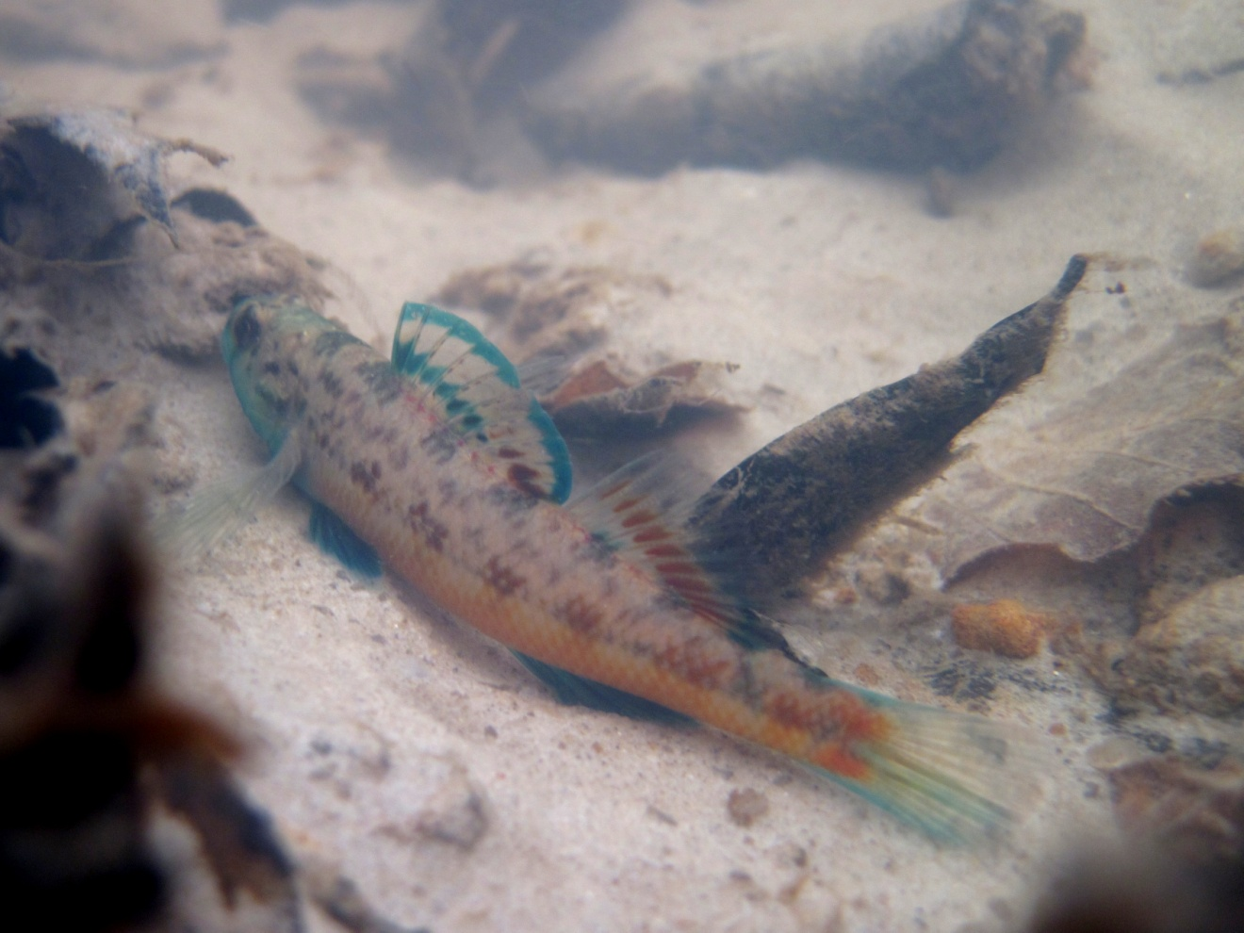
Figure S1. Male Yazoo Darter in Puskus Creek, Little Tallahatchie River drainage. Photo credit: Ken Sterling.

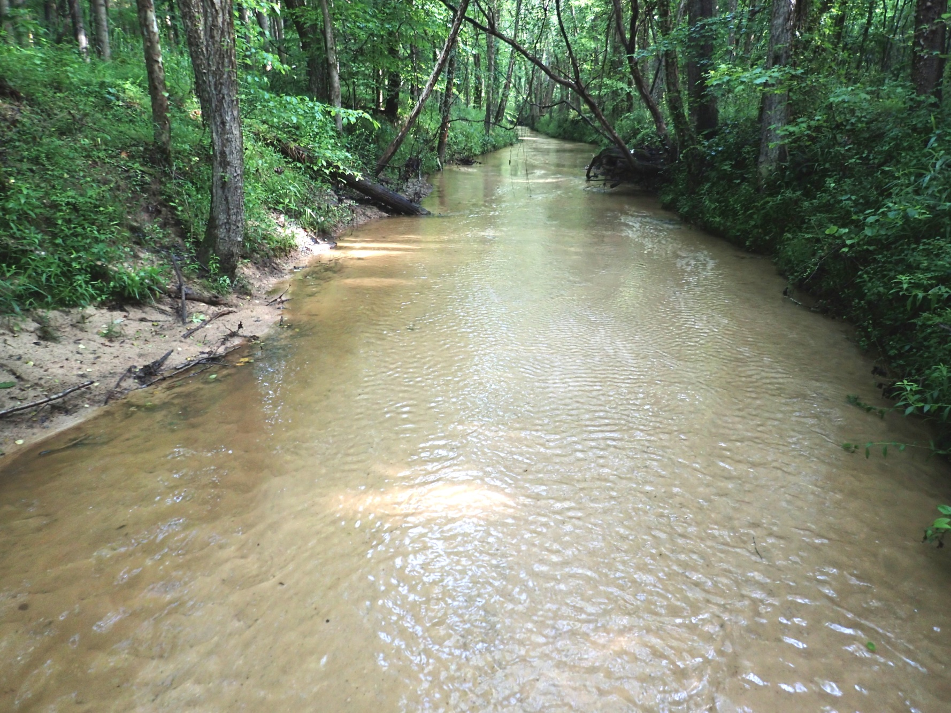
Figure S2. Photograph of Puskus Creek (Little Tallahatchie River drainage) showing typical stream habitat within the distribution of the Yazoo Darter; the stream reach pictured once ran through agricultural fields and is now recovering from channelization and incisement but still lacks stable structure (i.e., wood) used by aquatic organisms including the Yazoo Darter. Photo credit: Ken Sterling.

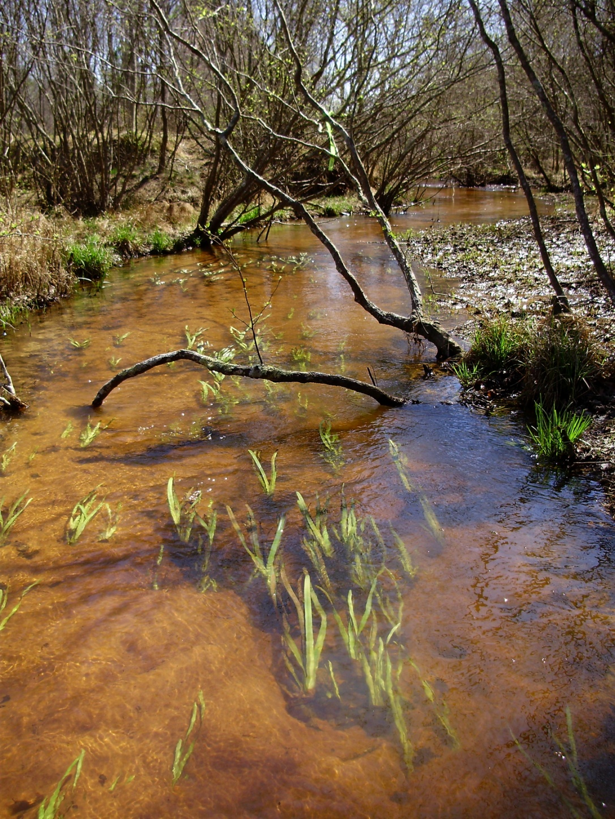
Figure S3. Photograph of a spring run tributary of Puskus Creek showing better quality habitat for Yazoo Darters; such habitat is limited, especially in the Yocona River drainage. Photo credit: Ken Sterling.

Figure S4. Phylogenetic tree of the partitioned cytb dataset using Bayesian estimation (MrBayes ver. 3.2.6) showing Bayesian posterior probabilities at the nodes (see Tables S1 and S2 for sequence data); red bar = Yocona River drainage, blue bar = Little Tallahatchie River drainage.
Figure S5. Phylogenetic tree of the partitioned cytb dataset using maximum likelihood estimation (RAxML-HPC ver. 8.0) showing bootstrap values at the nodes (see Tables S1 and S2 for sequence data); red bar = Yocona River drainage, blue bar = Little Tallahatchie River drainage.
Figure S6. Phylogenetic tree of the partitioned S7 dataset using Bayesian estimation (MrBayes ver. 3.2.6) showing Bayesian posterior probabilities at the nodes (see Tables S1 and S2 for sequence data); red bar = Yocona River drainage, blue bar = Little Tallahatchie River drainage.
Figure S7. Phylogenetic tree of the partitioned S7 dataset using maximum likelihood estimation (RAxML-HPC ver. 8.0) showing bootstrap values at the nodes (see Tables S1 and S2 for sequence data); red bar = Yocona River drainage, blue bar = Little Tallahatchie River drainage.

Literature Cited
Kozal, L.C., J.W. Simmons, J.M. Mollish, D.J. MacGuigan, E. Benavides, B.P. Keck, and T.J. Near. 2017. Phylogenetic and morphological diversity of the Etheostoma zonistium species complex with the description of a new species endemic to the Cumberland Plateau of Alabama. Bulletin of the Peabody Museum of Natural History 58:263-286.
Near, T.J., J.C. Porterfield, and L.M. Page. 2000. Evolution of cytochrome b and the molecular systematics of Ammocrypta (Percidae: Etheostomatinae). Copeia 2000:701-711.
Near, T.J., C.M. Bossu, G.S. Bradburd, R.L. Carlson, R.C. Harrington, P.R. Hollingsworth, B.P. Keck, and D.A. Etnier. 2011. Phylogeny and temporal diversification of darters (Percidae: Etheostomatinae). Systematic Biology 60:565-595.
Porterfield, J.C. 1998. Phylogenetic systematics of snubnose darters (Percidae: Etheostoma), with discussions of reproductive behavior, sexual selection, and the evolution of male breeding color. PhD Thesis, University of Illinois at Urbana-Champaign, Urbana, IL 154 pp.
Powers, S.L., and M.L. Warren Jr. 2009. Phylogeography of three snubnose darters (Percidae: Subgenus Ulocentra) endemic to the southeastern US Coastal Plain. Copeia 2009:523-528.
Switzer, J.F. 2004. Molecular systematics and phylogeography of the Etheostoma variatum species group (Actinopterygii: Percidae). PhD Dissertation. St. Louis University, St. Louis MO.

