Supplementary Information

SI1: Model spatial random fields
The random fields below plot the spatial autocorrelation that is estimated to remain after accounting for the covariates and monad random effect. Therefore the estimates are dependent on the locations of the sites and plots that are in the model and on the fixed and random independent variables in each model. Note the different scales across the maps of both the means and standard deviations. White crosses indicate site locations.
Figure A1.1. MEA10 model (vascular plant richness only). Mean and standard deviation of spatial random fields.

Figure A1.2. MEA10 model (vascular plant and bryophyte richness combined). Mean and standard deviation of spatial random fields.

Figure A1.3. SEA04 model 1 (vascular plant richness only). Mean and standard deviation of spatial random fields.

Figure A1.4. SEA04 model 1 (vascular plant and bryophyte richness combined). Mean and standard deviation of spatial random fields.
Figure A1.5. SEA04 model 2 (vascular plant richness only). Mean and standard deviation of spatial random fields.
Figure A1.6. SEA04 model 2 (vascular plant and bryophyte richness combined). Mean and standard deviation of spatial random fields.

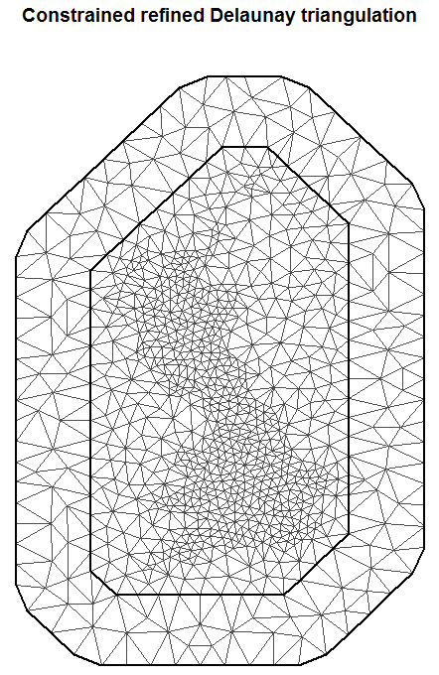
Figure A1.7. Constrained refined Delaunay triangulation of Britain over which the SPDE solution to the zero mean Matern Gaussian Markov random field (GMRF) is estimated.

