- Endosymbiotic adaptations in three new bacterial species associated with Dictyostelium discoideum: Paraburkholderia agricolaris sp. nov., Paraburkholderia hayleyella sp. nov., and Paraburkholderia bonniea sp. nov.
Debra A. Brock^{1*+}, Suegene Noh^{2*}, Alicia N.M. Hubert¹, Tamara S. Haselkorn³, Susanne DiSalvo⁴, Melanie K. Suess⁵, Alexander S. Bradley^{5,6}, Mahboubeh Tavakoli-Nezhad¹, Katherine S. Geist¹, David C. Queller¹, Joan E. Strassmann¹

¹Department of Biology, Washington University in St. Louis, Saint Louis, MO USA

²Department of Biology, Colby College, Waterville, ME USA
³Department of Biology, University of Central Arkansas, Conway, AK USA
⁴Department of Biology, Southern Illinois University Edwardsville, Edwardsville, IL USA
⁵Department of Earth and Planetary Sciences, Washington University in St. Louis, Saint Louis MO USA
⁶Division of Biology and Biomedical Sciences, Washington University in St. Louis, Saint Louis MO 63130

* These authors contributed equally to this work.
⁺Corresponding author

Supplementary Files

Figure S1
Figure S1. The Hadamard matrix representing ANI multiplied by alignment length between proposed type strains of Paraburkholderia sp. nov. isolated associated with D. discoideum and closely related Paraburkholderia. These scores indicate that our type strains are significantly different from the comparison strains. (a) P. agricolaris is a separate species from P. fungorum and P. insulsa. (b) P. hayleyella and P. bonniea are separate from each other and from P. megapolitana and P. phenoliruptrix.

Figure S2

Figure S2. Full-length 16S ribosomal RNA phylogeny including three new non-pathogenic Paraburkholderia species found in association with D. discoideum and Burkholderia sensu lato species. We aligned all 16S copies found in these new species with high quality 16S copies of type strains of Burkholderia sensu lato species, with a focus on the genera Paraburkholderia and Caballeronia. Ralstonia pickettii was used as the outgroup. All sequences other than those for the new species were downloaded from the SILVA database and aligned in a rRNA secondary structure aware manner. This tree is an approximately-Maximum Likelihood tree based on this alignment.

Table S1
D. discoideum clone | Bacteria name/species | Location | GPS Coordinates | Paraburkholderia sp. nov,  Type Strain
QS31 | BaQS31  P. agricolaris | Texas- Houston Arboretum | N 29° 46’, W 95° 27’
QS70 | BaQS70  P. agricolaris | Texas- Houston Arboretum | N 29° 46’, W 95° 27’
QS159 | BaQS159  P. agricolaris | Virginia- Mountain Lake Biological Station | N 37° 21’, W 80° 31’ | BaQS159
QS175 | BaQS175  P. agricolaris | Texas- Houston Arboretum | N 29° 46’, W 95° 27’
QS317 | BaQS317  P. agricolaris | Texas- Houston Arboretum | N 29° 46’, W 95° 27’
QS983 | BaQS983  P. agricolaris | Virginia- Mountain Lake Biological Station | N 37° 21’, W 80° 31’
QS1007 | BaQS1007  P. agricolaris | Virginia- Mountain Lake Biological Station | N 37° 21’, W 80° 31’
QS11 | BhQS11  P. hayleyella | Virginia- Mountain Lake Biological Station | N 37° 21’, W 80° 31’ | BhQS11
QS21 | BhQS21  P. hayleyella | Virginia- Mountain Lake Biological Station | N 37° 21’, W 80° 31’
QS22 | BhQS22  P. hayleyella | Virginia- Mountain Lake Biological Station | N 37° 21’, W 80° 31’
QS46 | BhQS46  P. hayleyella | Arkansas- Forest City | N 34˚ 50.1’, W 91˚28.1’
QS115 | BhQS115  P. hayleyella | Indiana- Bloomington (Lobelia) | N 39° 13.2’, W 86° 20.5’
QS155 | BhQS155  P. hayleyella | Virginia- Mountain Lake Biological Station | N 37° 21’, W 80° 31’
QS530 | BhQS530  P. hayleyella | Indiana- Bloomington (Lobelia) | N 39° 13.2’, W 86° 20.5’
QS433 | BbQS433  P. bonniea | Virginia- Mountain Lake Biological Station | N 37° 21’, W 80° 31’
QS859 | BbQS859  P. bonniea | Virginia- Mountain Lake Biological Station | N 37° 37.6’, W 80° 51.9’ | BbQS859
Table S1. List of Dictyostelium discoideum clones, bacteria name and species identity isolated from each D. discoideum farmer, location collected along with GPS coordinates, and Paraburkholderia sp. nov. type strains. We used all Paraburkholderia sp. nov strains in experimental assays to determine carbon source utilization, D. discoideum spore length, and optimal temperature. Raw data for specific isolates can be found in supplementary data files. We used Paraburkholderia sp. nov. type strains in experimental assays to determine fatty acid composition, catalase activity, nitrate reduction, oxidase activity, and antibiotic sensitivity.

Table S2
Genome name | NCBI Genomes | JGI Integrated Microbial Genomes
B. mallei NCTC10247 |  | x
B. pseudomallei ATCC15682 |  | x
B. pseudomallei ATCC23343 |  | x
C. choica LMG22940 | x
C. concitans LMG29315 | x
C. cordobensis LMG27620 | x
C. glathei DSM50014 | x
C. grimmiae R27 | x
C. humi LMG22934 | x
C. jiangsuensis MP1 | x
C. megalochromosomata JC2949 | x
C. sordidicola S170 | x
C. telluris LMG22936 | x
C. terrestris LMG22937 | x
C. udeis LMG27134 | x
C. zhejiangensis OP1 | x
M. endofungorum HKI465 |  | x
M. rhizoxinica HKI454 | x
P. acidipaludis NBRC101816 | x
P. aromaticivorans BN5 |  | x
P. aspalathi LMG27731 |  | x
P. bannensis NBRC103871 | x
P. bryophila 376MFSha3_1 | x
P. caballeronis LMG26416 |  | x
P. caledonica NBRC102488 | x
P. caribensis MWAP64 | x
P. diazotrophica LMG26031 |  | x
P. dilworthii WSM3556 | x
P. dipogonis ICMP19430 | x
P. eburnea LMG29537 |  | x
P. ferrariae NBRC106233 | x
P. fungorum ATCC BAA-463 | x
P. fungorum FDAARGOS245 |  | x
P. ginsengisoli NBRC100965 | x
P. ginsengiterrae DCY85 |  | x
P. graminis C4D1M | x
P. heleia NBRC101817 | x
P. hospita LMG20598 |  | x
P. insulsa LMG28183 |  | x
P. kirstenboschensis KB15 |  | x
P. kururiensis thiooxydans NBRC107107 | x
P. megapolitana LMG23650 |  | x
P. mimosarum LMG23256 | x
P. monticola JC2948 |  | x
P. nodosa DSM21604 | x
P. oxyphila NBRC105797 | x
B. phenazium LMG2247 |  | x
P. phenoliruptrix BR3459a | x
P. phymatum STM815 | x
P. phytofirmans PsJn | x
P. piptadeniae STM7183 |  | x
P. rhizosphaerae LMG29544 |  | x
P. ribeironis STM7296 |  | x
P. sacchari LMG19450 |  | x
P. sartisoli LMG24000 |  | x
P. sediminicola LMG24238 |  | x
P. silvatlantica SRCL-319 | x
P. sprentiae WSM5005 | x
P. susongensis LMG29540 |  | x
P. terrae NBRC100964 |  | x
P. terricola LMG20594 |  | x
P. tropica LMG22274 |  | x
P. tuberum DU833 | x
P. unamae MTI-641 | x
P. xenovorans LB400 | x
R. pickettii 12J | x
T. caryophylli Ballard720 |  | x
T. soli GP25-8 | x
T. symbiotica JPY-345 |  | x

Table S2. Sources of 70 additional Paraburkholderia genomes and draft assemblies downloaded for phylogenomic analyses.

Table S3.
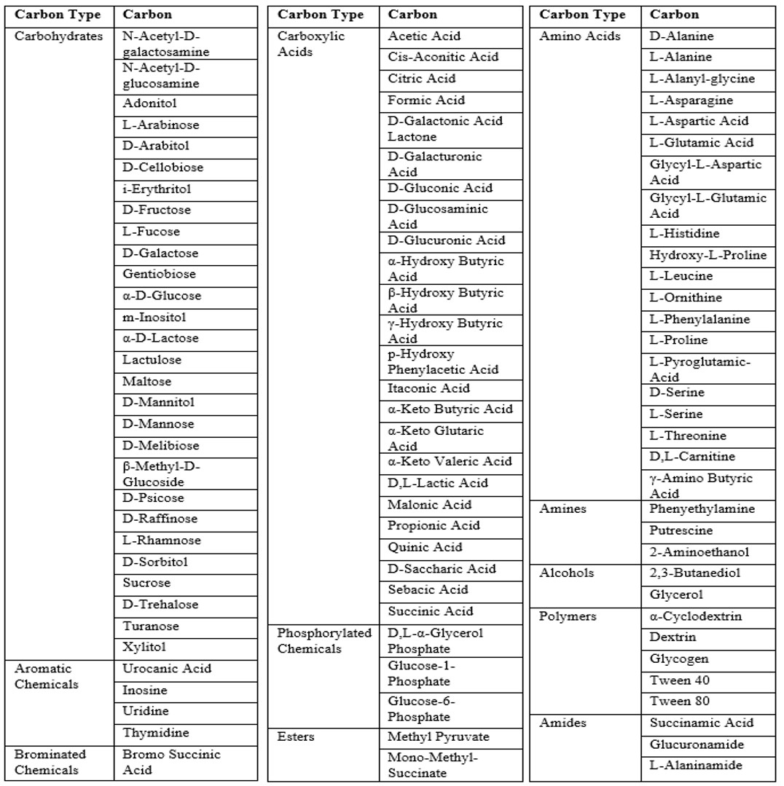
Table S3. Table of 95 test carbons from Biolog GN2 Microplates (Biolog Inc., Hayward, CA) arranged into groups of similar types.

Table S4
Characteristic |  | P. fungorum | P. xenovorans | P. phymatum | P. agricolaris  sp. nov | P. hayleyella sp. nov | P. bonniea sp. nov
n (# strains) |  | 1 | 1 | 1 | 7 | 7 | 2
Lab specific strain IDs |  | N/A | N/A | N/A | BaQS31, BaQS1007 BaQS70 BaQS175 BaQS159 BaQS317 BaQS983 | BhQS11 BhQS21 BhQS22 BhQS46 BhQS115BhQS155BhQS530 | BbQS433 BbQS859
Utilization of:
Polymers | α-Cyclodextrin | - | - | - | - | - | -
 | Dextrin | - | - | - | 14% | - | -
 | Glycogen | - | + | - | 71% | - | -
 | Tween 40 | + | + | + | + | + | +
 | Tween 80 | + | + | + | + | + | +
Carbohydrates | N-Acetyl-D-galactosamine | + | + | + | + | - | -
 | N-Acetyl-D-glucosamine | + | + | + | + | - | +
 | Adonitol | + | - | + | + | - | -
 | L-Arabinose | + | + | + | + | - | -
 | D-Arabitol | + | + | + | + | - | -
 | D-Cellobiose | - | - | - | 71% | - | -
 | i-Erythritol | - | - | - | - | - | -
 | D-Fructose | + | + | + | + | 14% | +
 | L-Fucose | + | + | + | + | 29% | -
 | D-Galactose | + | + | + | + | - | 50%
 | Gentiobiose | + | + | - | 57% | - | 50%
 | α-D-Glucose | + | + | + | + | + | +
 | m-Inositol | + | + | + | + | - | -
 | α-D-Lactose | - | - | - | 71% | - | -
 | Lactulose | - | - | - | 29% | - | -
 | Maltose | - | - | - | 43% | - | -
 | D-Mannitol | + | + | + | + | - | -
 | D-Mannose | + | + | + | + | 86% | +
 | D-Melibiose | + | - | - | - | - | -
 | β-Methyl-D-Glucoside | - | - | - | - | - | -
 | D-Psicose | - | - | - | - | - | -
 | D-Raffinose | - | - | + | - | - | -
 | L-Rhamnose | + | + | + | + | - | -
 | D-Sorbitol | + | + | + | + | - | -
 | Sucrose | - | - | + | - | - | -
 | D-Trehalose | - | - | + | - | - | -
 | Turanose | - | - | - | - | - | -
 | Xylitol | + | - | + | 57% | - | -
Esters | Methyl Pyruvate | + | + | + | + | + | +
 | Mono-Methyl-Succinate | + | + | + | + | - | 50%
Carboxylic Acids | Acetic Acid | + | + | + | + | + | +
 | Cis-Aconitic Acid | + | + | + | + | - | +
 | Citric Acid | + | + | + | + | - | +
 | Formic Acid | + | + | + | + | - | -
 | D-Galactonic Acid Lactone | + | + | + | + | - | -
 | D-Galacturonic Acid | + | + | + | 86% | - | -
 | D-Gluconic Acid | + | + | + | + | + | +
 | D-Glucosaminic Acid | + | + | + | + | 57% | +
 | D-Glucuronic Acid | + | + | + | + | - | -
 | α-Hydroxy Butyric Acid | + | + | + | + | + | +
 | β-Hydroxy Butyric Acid | + | + | + | + | + | +
 | γ-Hydroxy Butyric Acid | - | + | - | 57% | - | -
 | p-Hydroxy Phenylacetic Acid | + | + | + | + | - | -
 | Itaconic Acid | - | + | - | 14% | - | -
 | α-Keto Butyric Acid | + | + | + | + | + | +
 | α-Keto Glutaric Acid | + | + | + | + | + | 50%
 | α-Keto Valeric Acid | + | + | + | 71% | - | -
 | D,L-Lactic Acid | + | + | + | + | + | +
 | Malonic Acid | + | + | + | + | - | -
 | Propionic Acid | + | + | + | + | + | +
 | Quinic Acid | + | + | + | + | - | -
 | D-Saccharic Acid | + | + | + | + | - | -
 | Sebacic Acid | + | + | + | + | - | -
 | Succinic Acid | + | + | + | + | + | +
Brominated Chemicals | Bromo Succinic Acid | + | + | + | + | + | +
Amides | Succinamic Acid | + | + | + | + | 14% | +
 | Glucuronamide | + | + | + | 57% | - | -
 | L-Alaninamide | + | + | + | + | 43% | +
Amino Acids | D-Alanine | + | + | + | + | 43% | +
 | L-Alanine | + | + | + | + | 71% | +
 | L-Alanyl-glycine | + | + | + | + | + | +
 | L-Asparagine | + | + | + | + | + | +
 | L-Aspartic Acid | + | + | + | + | + | +
 | L-Glutamic Acid | + | + | + | + | + | +
 | Glycyl-L-Aspartic Acid | + | + | - | 71% | - | -
 | Glycyl-L-Glutamic Acid | + | + | + | + | + | +
 | L-Histidine | + | + | + | + | - | 50%
 | Hydroxy-L-Proline | - | + | + | + | - | -
 | L-Leucine | + | + | + | + | - | +
 | L-Ornithine | - | + | + | 86% | - | -
 | L-Phenylalanine | + | + | + | + | - | -
 | L-Proline | + | + | + | + | + | +
 | L-Pyroglutamic Acid | + | + | + | + | - | -
 | D-Serine | + | + | + | + | 43% | 50%
 | L-Serine | + | + | + | + | + | +
 | L-Threonine | + | + | + | + | 86% | +
 | D,L-Carnitine | + | + | + | 71% | - | -
 | γ-Amino Butyric Acid | + | + | + | + | 29% | 50%
Aromatic Chemicals | Urocanic Acid | + | + | + | + | - | 50%
 | Inosine | - | - | - | 86% | - | +
 | Uridine | + | + | - | + | - | -
 | Thymidine | - | - | - | - | - | -
Amines | Phenyethylamine | - | - | + | 29% | - | -
 | Putrescine | - | - | - | 29% | - | -
 | 2-Aminoethanol | + | + | + | 71% | - | -
Alcohols | 2,3-Butanediol | - | - | - | - | - | -
 | Glycerol | + | + | + | + | - | -
Phosphorylated Chemicals | D,L-α-Glycerol Phosphate | - | + | - | 57% | - | -
 | Glucose-1-Phosphate | - | - | - | - | - | -
 | Glucose-6-Phosphate | - | + | - | 71% | - | -

Table S4. Summary table of carbon source utilization for all species grouped by carbon type. A plus symbol indicates all isolates were able to use a specific carbon type and a minus symbol indicates no utilization. A number value indicates the percentage of isolates in a specific group that can utilize that particular carbon type. P. agricolaris and P. bonniea are able to utilize some carbon sources that their close Paraburkholderia relatives cannot. Specific information for all Paraburkholderia sp. nov. isolates can be found in the raw data files in the supplementary information.

Table S5
 | Pairwise Species Comparisons
 |  | P. agricolaris vs. Non-symbionts | P. hayleyella vs. Non-symbionts | P. bonniea vs. Non-symbionts | P. agricolaris vs. P. hayleyella | P. agricolaris vs. P. bonniea | P. hayleyella vs. P. bonniea
Carbon Source | Alcohols
 | Amides |  |  |  | 0.0001 |  | 0.0381
 | Amines
 | Amino Acids |  | < 0.001 | 0.0003 | < 0.001 | < 0.001
 | Aromatic Chemicals | 0.0817 |  |  | 0.0285 | 0.0899
 | Brominated Chemicals
 | Carbohydrates |  | < 0.001 | < 0.001 | < 0.001 | < 0.001 | 0.0401
 | Carboxylic Acids |  | < 0.001 | < 0.001 | < 0.001 | < 0.001
 | Esters
 | Phosphorylated Chemicals
 | Polymers
 |  | > 0.10 | Levels of Significant Difference Between Carbon Use for Paraburkholderia outgroup species
 | . | < 0.10
 | * | < 0.05
 | ** | < 0.01
 | *** | < 0.001
Table S5. Pairwise species comparisons of Paraburkholderia sp. nov. with each other and with three control outgroup Paraburkholderia. P. hayleyella and P. bonniea have diverged in carbon usage for amino acids, carbohydrates, and carboxylic acids compared to the outgroup species. The three Paraburkholderia sp. nov. have diverged from each other in pairwise carbon usage.

Table S6
Paraburkholderia | Isolate | Number of bacteria measured
P. agricolaris | BaQS31 | 110
 | BaQS1007 | 126
 | BaQS70 | 103
 | BaQS175 | 114
 | BaQS159 | 112
 | BaQS317 | 128
 | BaQS983 | 104
P. hayleyella | BhQS11 | 95
 | BhQS21 | 104
 | BhQS22 | 105
 | BhQS46 | 154
 | BhQS115 | 125
 | BhQS155 | 104
 | BhQS530 | 111
P. bonniea | BbQS433 | 110
 | BbQS859 | 133
Controls | P. phymatum | 104
 | P. fungorum | 100
 | P. xenovorans | 102

Table S6. Summary table of bacteria isolates used for length measurements and number measured for each isolate. Raw data for specific isolates can be found in supplementary information.

Table S7

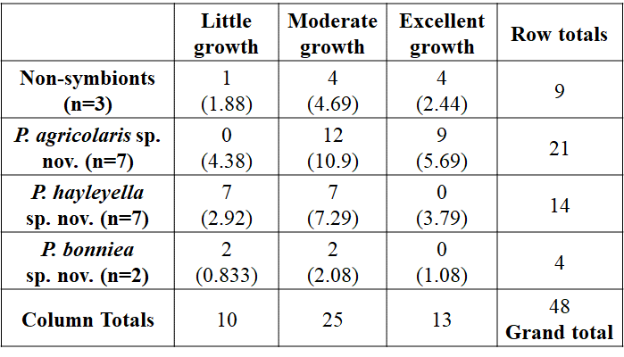
Table S7. Fisher’s Exact Contingency Table. Each cell of this contingency table provides the following information for the growth data: the observed cell total for each growth category, and the expected cell total for growth category is below in parentheses. The given table has a probability of 1.1 E-07; the sum of the probabilities finds p < 0.001. Our hypothesis that growth rates are the same for all four groups is false.

Table S8

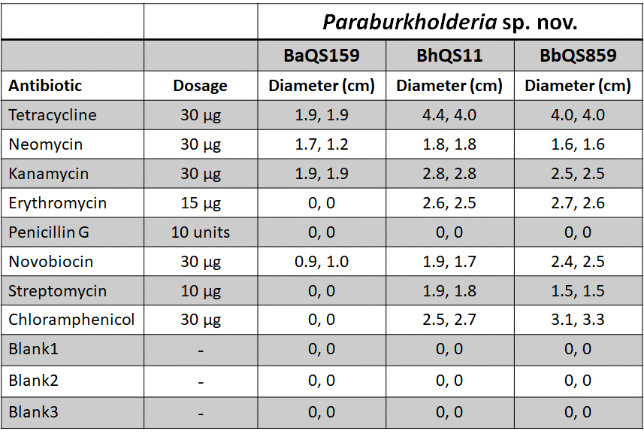
Table S8. Antibiotic susceptibility test. Paraburkholderia sp. nov. type strains were tested against eight antibiotics for susceptibility. We plated the bacteria on nutrient agar plates and measured the diameter of any zones of inhibition after 48 hours of bacterial growth at 22°C. Antibiotic and blank disk diameters equal 0.7cm.

Table S9.
 | Estimated genome size | Scaffold count | GC content | N50 contig length | Mean sequencing coverage
P. agricolaris (BaQS159) | 8,762,141 | 2 | 0.62 | 4,840,882 | 122
P. hayleyella (BhQS11) | 4,165,087 | 2 | 0.59 | 3,312,599 | 243
P. bonniea (BbQS859) | 4,131,982 | 2 | 0.59 | 3,195,827 | 162

Table S9. Summary genome characteristics of draft genome assemblies for the three type strains. PacBio sequencing and assembly resulted in the resolution of these genomes into two scaffolds each.

Table S10.
Type Strain Genome Server
Query strain | Subject strain | dDDH (%) | C.I. (%) | ∆GC (%)
BaQS159 | Paraburkholderia insulsa LMG 28183 | 65.1 | [62.2 - 67.9] | 0.02
BaQS159 | Paraburkholderia fungorum NBRC 102489 | 64.8 | [61.9 - 67.7] | 0.23
BaQS159 | Paraburkholderia aspalathi LMG 27731 | 37 | [34.5 - 39.5] | 0.52
BaQS159 | Paraburkholderia xenovorans LB400 | 30.1 | [27.7 - 32.6] | 1.02
BaQS159 | Paraburkholderia phytofirmans PsJN | 30 | [27.6 - 32.5] | 0.68
BaQS159 | Paraburkholderia aromaticivorans BN5 | 30 | [27.6 - 32.5] | 1.33
BaQS159 | Paraburkholderia dipogonis ICMP 19430 | 29.9 | [27.5 - 32.4] | 0.04
BaQS159 | Paraburkholderia ribeironis STM 7296 | 29.2 | [26.8 - 31.7] | 0.87
BaQS159 | Paraburkholderia panaciterrae DCY85-1 | 29 | [26.6 - 31.5] | 0.75
BaQS159 | Paraburkholderia ginsengiterrae DCY85 | 29 | [26.6 - 31.5] | 0.89
BaQS159 | Paraburkholderia rhynchosiae WSM3937 | 28 | [25.6 - 30.5] | 0.1
BaQS159 | Paraburkholderia sartisoli LMG 24000 | 24.8 | [22.4 - 27.2] | 1.91
BaQS159 | Paraburkholderia caribensis MWAP64 | 23.7 | [21.4 - 26.2] | 0.96
BbQS859 | BhQS11 | 23.6 | [21.3 - 26.1] | 0.65
BaQS159 | Paraburkholderia terrae NBRC 100964 | 23.5 | [21.2 - 26.0] | 0.35
BaQS159 | Paraburkholderia megapolitana LMG 23650 | 23.5 | [21.2 - 26.0] | 0.46
BaQS159 | Caballeronia telluris LMG 22936 | 22.9 | [20.6 - 25.3] | 2.41
BaQS159 | Caballeronia udeis LMG 27134 | 22.5 | [20.2 - 24.9] | 1.57
BhQS11 | Paraburkholderia dipogonis ICMP 19430 | 22.1 | [19.8 - 24.5] | 2.27
BhQS11 | Paraburkholderia ribeironis STM 7296 | 21.9 | [19.7 - 24.4] | 3.18
BbQS859 | BaQS159 | 21.9 | [19.6 - 24.3] | 2.96
BhQS11 | Paraburkholderia fungorum NBRC 102489 | 21.9 | [19.6 - 24.3] | 2.54
BbQS859 | Paraburkholderia aromaticivorans BN5 | 21.9 | [19.7 - 24.4] | 4.29
BhQS11 | Paraburkholderia phytofirmans PsJN | 21.8 | [19.5 - 24.2] | 2.99
BaQS159 | BhQS11 | 21.8 | [19.5 - 24.2] | 2.31
BhQS11 | Paraburkholderia insulsa LMG 28183 | 21.8 | [19.6 - 24.3] | 2.33
BhQS11 | Paraburkholderia xenovorans LB400 | 21.8 | [19.6 - 24.3] | 3.33
BaQS159 | Caballeronia sordidicola LMG 22029 | 21.8 | [19.6 - 24.3] | 1.46
BbQS859 | Paraburkholderia xenovorans LB400 | 21.8 | [19.6 - 24.3] | 3.98
BhQS11 | Paraburkholderia aromaticivorans BN5 | 21.7 | [19.5 - 24.2] | 3.64
BhQS11 | Paraburkholderia panaciterrae DCY85-1 | 21.7 | [19.5 - 24.2] | 3.06
BhQS11 | Paraburkholderia ginsengiterrae DCY85 | 21.7 | [19.5 - 24.2] | 3.2
BbQS859 | Paraburkholderia ginsengiterrae DCY85 | 21.6 | [19.4 - 24.0] | 3.85
BbQS859 | Paraburkholderia panaciterrae DCY85-1 | 21.6 | [19.4 - 24.1] | 3.71
BbQS859 | Paraburkholderia phytofirmans PsJN | 21.6 | [19.4 - 24.0] | 3.64
BhQS11 | Paraburkholderia sartisoli LMG 24000 | 21.6 | [19.4 - 24.1] | 4.23
BbQS859 | Paraburkholderia dipogonis ICMP 19430 | 21.6 | [19.3 - 24.0] | 2.92
BbQS859 | Paraburkholderia ribeironis STM 7296 | 21.5 | [19.3 - 24.0] | 3.83
BhQS11 | Paraburkholderia aspalathi LMG 27731 | 21.5 | [19.3 - 24.0] | 1.8
BbQS859 | Paraburkholderia aspalathi LMG 27731 | 21.5 | [19.3 - 23.9] | 2.45
BbQS859 | Paraburkholderia rhynchosiae WSM3937 | 21.5 | [19.2 - 23.9] | 3.07
BhQS11 | Paraburkholderia megapolitana LMG 23650 | 21.5 | [19.2 - 23.9] | 2.77
BbQS859 | Paraburkholderia insulsa LMG 28183 | 21.4 | [19.1 - 23.8] | 2.98
BhQS11 | Paraburkholderia rhynchosiae WSM3937 | 21.4 | [19.1 - 23.8] | 2.42
BbQS859 | Paraburkholderia fungorum NBRC 102489 | 21.4 | [19.2 - 23.9] | 3.19
BhQS11 | Paraburkholderia caribensis MWAP64 | 21.4 | [19.2 - 23.9] | 3.28
BhQS11 | Caballeronia telluris LMG 22936 | 21.4 | [19.1 - 23.8] | 4.72
BhQS11 | Paraburkholderia terrae NBRC 100964 | 21.3 | [19.0 - 23.7] | 2.66
BbQS859 | Paraburkholderia sartisoli LMG 24000 | 21.2 | [19.0 - 23.7] | 4.88
BbQS859 | Paraburkholderia caribensis MWAP64 | 21.2 | [19.0 - 23.7] | 3.93
BbQS859 | Caballeronia telluris LMG 22936 | 21.1 | [18.8 - 23.5] | 5.37
BbQS859 | Paraburkholderia megapolitana LMG 23650 | 21.1 | [18.8 - 23.5] | 3.42
BbQS859 | Paraburkholderia terrae NBRC 100964 | 20.9 | [18.7 - 23.4] | 3.31
BbQS859 | Caballeronia sordidicola LMG 22029 | 20.7 | [18.4 - 23.1] | 1.5
BbQS859 | Caballeronia udeis LMG 27134 | 20.7 | [18.5 - 23.1] | 1.39
BhQS11 | Caballeronia udeis LMG 27134 | 20.5 | [18.3 - 23.0] | 0.74
BhQS11 | Caballeronia sordidicola LMG 22029 | 20.4 | [18.2 - 22.8] | 0.85

Table S10. DNA-DNA hybridization value prediction, with confidence intervals and GC% comparison, from Type (Strain) Genome Server version 2.1 (https://tygs.dsmz.de; accessed May 2019). The three new species of Paraburkholderia endosymbionts were compared against their closely related type strains, Paraburkholderia and Caballeronia, present on the server.

