Supplementary figure 1) Anatomy of the pacific oyster with labels for all major tissues visible. Digestive gland (not visible) is found enveloped by gonadal tissue. Top (right) layer of mantle has been removed.

Heart

Gonad

Adductor striated muscle

Adductor smooth muscle

Gill

Mantle

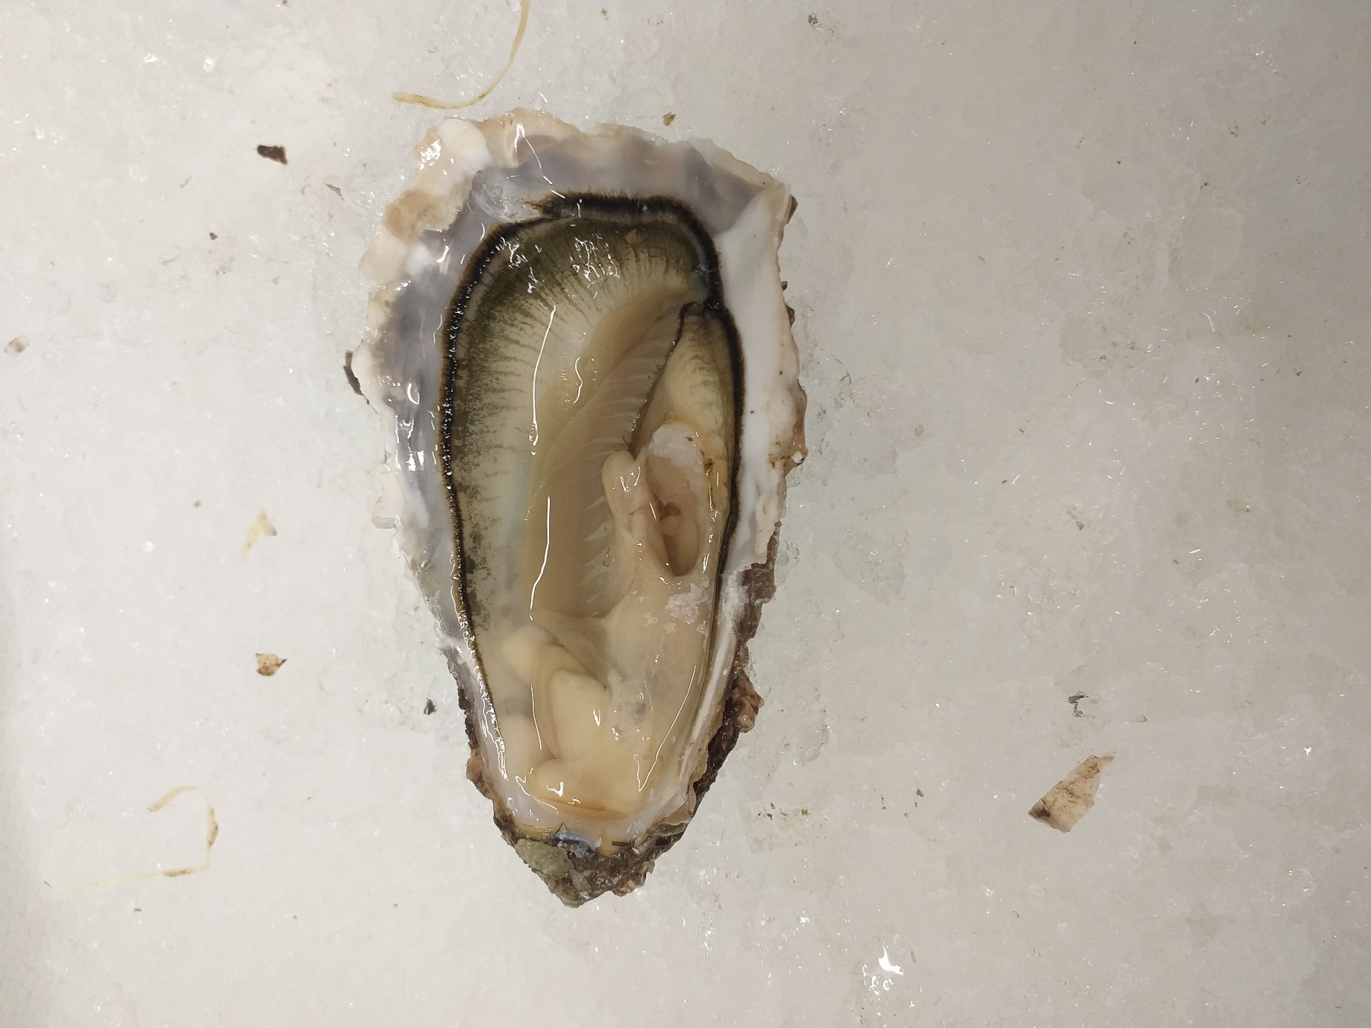

R Potts