Supplementary data 1

Mathematical algorithm for IP-HPLC analysis

- IP-HPLC peak area (mAU*s) contains antigen peak ({Ag}), antibody peak ({Ab}), and antigen-antibody complex peak ({Ag-Ab}).

A _{(mAU*s)} = {Ag₁} + {Ab₁} + {Ag₂-Ab₂}

- UV spectrum shows relatively proportional value (α) between ({Ag} + {Ab}) and {Ag-Ab}; {Ag-Ab} = α({Ag} + {Ab})

A _{(mAU*s)} = {Ag₁} + {Ab₁} + α({Ag₂} + {Ab₂})
A _{(mAU*s)} = ({Ag₁} + α({Ag₂}) +({Ab₁} + α{Ab₂})

{Ag₁} + α({Ag₂} _{(mAU*s)} = A - ({Ab₁} + α{Ab₂})

- When the antibody was monospecific or monoclonal to antigen, Ag1/Ag2 = Ab1/Ab2 = β.

{Ag₁} + $\frac{α}{β}$({Ag₂} _{(mAU*s)} = A - ({Ab₁} + α{Ab₂})
{Ag₁} (1 + $\frac{α}{β}$) _{(mAU*s)} = A - ({Ab₁} + α{Ab₂})
{Ag₁} _{(mAU*s)} = $\frac{β(A - \left(\left\{Ab1\right\}+ α\left\{Ab2\right\}\right))}{α+β}$

And
{Ag₁} + α({Ag₂} _{(mAU*s)} = A - ({Ab₁} + α{Ab₂})
β({Ag₂} + α({Ag₂} _{(mAU*s)} = A - ({Ab₁} + α{Ab₂})
β({Ag₂} + α({Ag₂} _{(mAU*s)} = A - ({Ab₁} + α{Ab₂})
{Ag₂}(α + β) _{(mAU*s)} = A - ({Ab₁} + α{Ab₂})
{Ag₂}(α + β) _{(mAU*s)} = $\frac{A - (\{Ab1\} + α\{Ab2\})}{α + β}$

- And then, the objective antigen expression was {Ag₁} + {Ag₂}.
{Ag₁} + {Ag₂} _{(mAU*s)} = $\frac{\left(1+β\right)A-2(\left\{Ab1\right\}+ α\left\{Ab1\right\})}{α + β}$

- {Ag_{1c}} + {Ag_{2c}} _{(mAU*s)} is an objective antigen expression of control group, while {Ag_{1e}} + {Ag_{2e}} _{(mAU*s)} is an objective antigen expression of experimental group.
- The ratio compared between experiment and control objective antigen expression is ({Ag_{1e}} + {Ag_{2e}})/({Ag_{1c}} + {Ag_{2c}}).

$\frac{\{Ag1e\} + \{Ag2e\}}{\{Ag1c\} + \{Ag2c\}}$ = $\frac{Ae\left(1+β\right) - 2(\left\{Ab1e\right\} + α\left\{Ab2e\right\})}{Ac\left(1+β\right) - 2(\left\{Ab1c\right\} + α\left\{Ab2c\right\})}$
= $\frac{Ae - \frac{2(\left\{Ab1e\right\} + α\left\{Ab2e\right\}}{1 + β}}{Ac - \frac{2(\left\{Ab1c\right\} + α\left\{Ab2c\right\}}{1 + β}}$

- $\frac{2(\left\{Ab1e\right\} + α\left\{Ab2e\right\}}{1 + β}$ and $\frac{2(\left\{Ab1c\right\} + α\left\{Ab2c\right\}}{1 + β}$ are replaceable with γA_{ave} (A_{ave} is average of A_{c} and A_{e}).

- Therefore,
$\frac{\{Ag1e\} + \{Ag2e\}}{\{Ag1c\} + \{Ag2c\}}$ = $\frac{Ae - γAave}{Ac - γAave}$

- Because ({Ag_{1e}} + {Ag_{2e}}) and ({Ag_{1c}} + {Ag_{2c}}) are mathematically hypothetical value (mAU*s), their square root value may approximate the comparable expression level (mAU).

$\sqrt{\frac{\{Ag1e\} + \{Ag2e\}}{\{Ag1c\} + \{Ag2c\}}}$ = $\sqrt{\frac{Ae - γAave}{Ac - γAave}}$

$\frac{Experiment antigen expression level}{Control antigen expression level}$ = $\sqrt{\frac{Ae - γAave}{Ac - γAave}}$ x 100 (%)

- γ can be determined by experimental IP-HPLC. If 15%-reduced amount of objective protein sample was applied to Protein A/G bead column compared to control group. The IP-HPLC results were as follow;

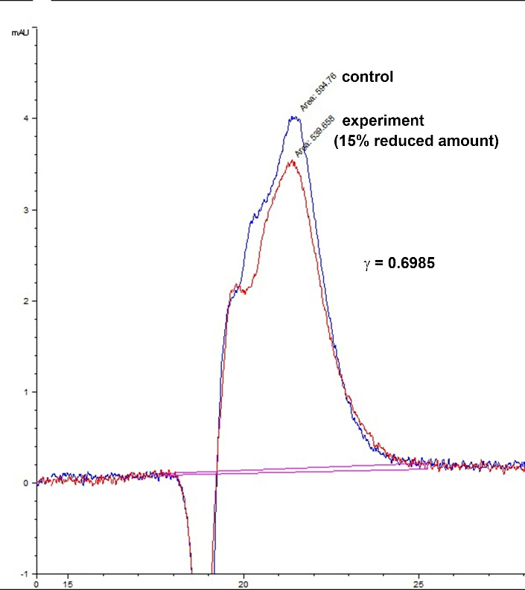
When the eluted proteins containing antibody were analyzed with 30 cm long column at low running speed (0.3 mL/min), the proteins were slightly separated but still appeared much overlapped in chromatography.

- And then,
$\frac{Experiment antigen expression level}{Control antigen expression level}$ = $\sqrt{\frac{Ae - γAave}{Ac - γAave}}$ x 100 = 85 (%)
$\sqrt{\frac{Ae - γAave}{Ac - γAave}}$ x 100 = 85 (%)
$\sqrt{\frac{539.658 - 567.209γ}{594.76 - 567.209γ}}$ x 100 = 85 (%)

Therefore, constant γ can be calculated as 0.6985, and used to subtract other elements besides objective protein.

From this algorithm, the relative ratio (%) between objective protein level and control protein level can be obtained, albeit it is impossible to get the concentration of objective protein through IP-HPLC.

