Supplementary data 2

Representative chromatography through IP-HPLC analysis

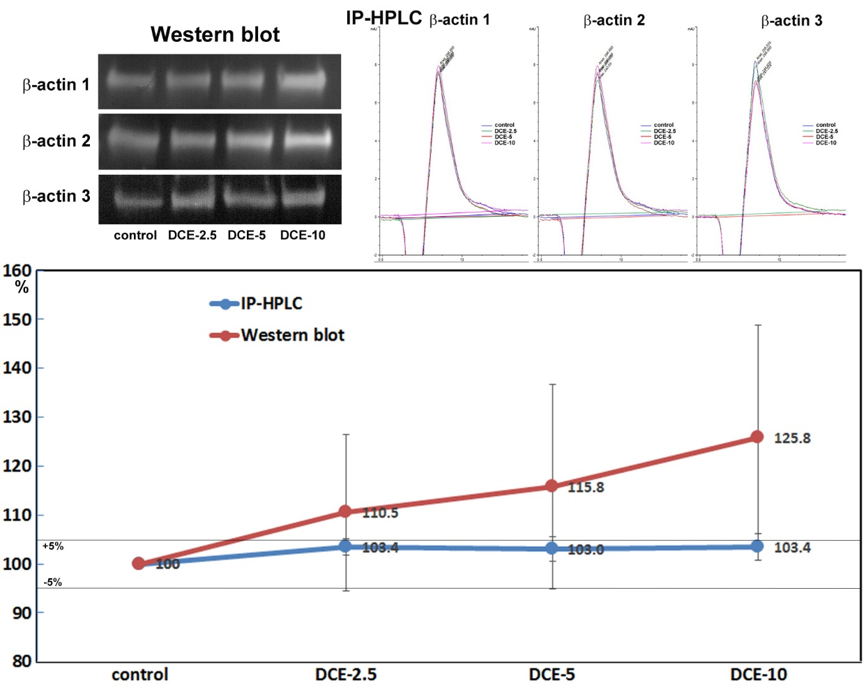
Supplementary Figure 2. β-Actin expression in DCE-treated RAW 264.7 cells was explored through western blot and IP-HPLC. Densitometry data of triplicated western blot (red line) showed big standard deviation (16.1 – 23.2 %), while triplicated IP-HPLC data (blue line) showed relatively small standard deviation (1.7 – 2.7%). Therefore, the latter was available to perform statistical analysis contrary to the former. These data were obtained from the previous study (Yoon, C.S., Kim, M.K., Kim, Y.S. & Lee, S.K. In vitro protein expression changes in RAW 264.7 cells and HUVECs treated with dialyzed coffee extract by immunoprecipitation high performance liquid chromatography. Scientific reports 8, 13841 (2018))

