Supplementary Material
Table S1: Reproductive success in nest boxes containing a BFDV-positive parent or nestling. ‘Hatching success’ was calculated as percentage of eggs laid that hatched; ‘fledging success’ is percentage of hatched nestlings that left the nest; ‘breeding success’ is percentage of eggs laid that produced fledglings. Shading and order of cells, and numbering of nest boxes, are the same as in Appendix Table 2 (white background indicates nests with BFDV-positive nest swabs; grey background indicates nests with BFDV-negative nest swabs).
year | nest box | species | BFDV+  nest swab | no. eggs  laid | no.  eggs hatched | no. fledglings | hatching  success (%) | fledging  success (%) | breeding  success (%)
2016 | 1 | P. elegans | + | 6 | 6 | 4 | 100 | 67 | 67
2016 | 2 | P. elegans | + | 7 | 7 | 6 | 100 | 86 | 86
2017 | 3 | P. elegans | + | 6 | 6 | 4 | 100 | 67 | 67
2017 | 4 | P. elegans | + | 6 | 5 | 0 | 83 | 0 | 0
2016 | 5 | P. elegans | - | 6 | 5 | 0 | 83 | 0 | 0
2016 | 6 | P. eximius | - | 5 | 4 | 4 | 80 | 100 | 80
2016 | 7 | P. elegans | - | 7 | 7 | 4 | 100 | 57 | 57
2017 | 8 | P. elegans | - | 6 | 6 | 6 | 100 | 100 | 100
2017 | 9 | P. elegans | - | 4 | 3 | 3 | 75 | 100 | 75
2017 | 10 | P. eximius | - | 6 | 6 | 6 | 100 | 100 | 100
2017 | 11 | P. eximius | - | 6 | 6 | 6 | 100 | 100 | 100
 |  |  | MEAN | 5.9 | 5.6 | 3.9 | 92.9 | 70.6 | 66.5
 |  |  | SD | 0.8 | 1.2 | 2.1 | 9.6 | 36.6 | 34.3

Table S2: Data on nest boxes with BFDV-negative birds which we used as control group. ‘Hatching success’ was calculated as percentage of eggs laid that hatched; ‘fledging success’ is the percentage of hatched nestlings that fledged; ‘breeding success’ is the percentage of eggs laid that produced fledglings. Abbreviations used are: for field sites: Bellbrae (BB), Meredith (ME), Steiglitz (ST) and Gundrys Road (GR); No. (number), BFDV+ (BFDV-positive), blood+ (BFDV-positive blood sample), blood- (BFDV-negative blood sample), cloacal+ (BFDV-positive cloacal swab), cloacal- (BFDV-negative cloacal swab), adult ♀ (female parent), adult ♂ (male parent).
year | site | nest | species | BFDV+  nest swab | no. eggs | no. eggs hatched | no. fledglings | hatching  success (%) | fledging  success (%) | breeding  success (%) | no. adults tested | BFDV status  adult ♀ | BFDV status  adult ♂ | BFDV status  nestlings
2016 | ST | W8 | P. elegans | 0 | 9 | 9 | 9 | 100 | 100 | 100 | 2 | blood-, cloacal- | blood-, cloacal- | blood-
2016 | ME | E10 | P. elegans | 0 | 6 | 6 | 6 | 100 | 100 | 100 | 2 | blood-, cloacal- | blood-, cloacal- | blood-
2016 | ME | E4 | P. elegans | 0 | 6 | 4 | 0 | 67 | 0 | 0 | 2 | blood-, cloacal- | blood-, cloacal- | blood-
2016 | BB | C11 | P. elegans | 0 | 5 | 5 | 5 | 100 | 100 | 100 | 2 | blood-, cloacal- | blood-, cloacal- | blood-
2016 | ME | W4 | P. elegans | 0 | 6 | 6 | 6 | 100 | 100 | 100 | 2 | blood-, cloacal- | blood-, cloacal- | blood-
2017 | BB | C15 | P. elegans | 0 | 7 | 7 | 7 | 100 | 100 | 100 | 2 | blood-, cloacal- | blood-, cloacal- | blood-
2017 | ST | W7 | P. eximius | 0 | 6 | 5 | 5 | 83 | 100 | 83 | 2 | blood-, cloacal? | blood-, cloacal? | blood-
2017 | GR | P29 | P. elegans | 0 | 6 | 4 | 4 | 67 | 100 | 67 | 2 | blood-, cloacal- | blood-, cloacal- | blood-
2017 | ST | S16 | P. elegans | 0 | 4 | 3 | 3 | 75 | 100 | 75 | 2 | blood-, cloacal- | blood-, cloacal- | blood-
2017 | ST | S20 | P. elegans | 0 | 6 | 6 | 6 | 100 | 100 | 100 | 2 | blood-, cloacal- | blood-, cloacal- | blood-
2017 | BB | N7 | P. elegans | 0 | 6 | 4 | 3 | 67 | 75 | 50 | 2 | blood-, cloacal- | blood-, cloacal- | blood-
 |  |  |  | MEAN | 6.09 | 5.36 | 4.91 | 87.12 | 88.64 | 79.55
 |  |  |  | SD | 1.16 | 1.61 | 2.27 | 14.81 | 28.93 | 30.02

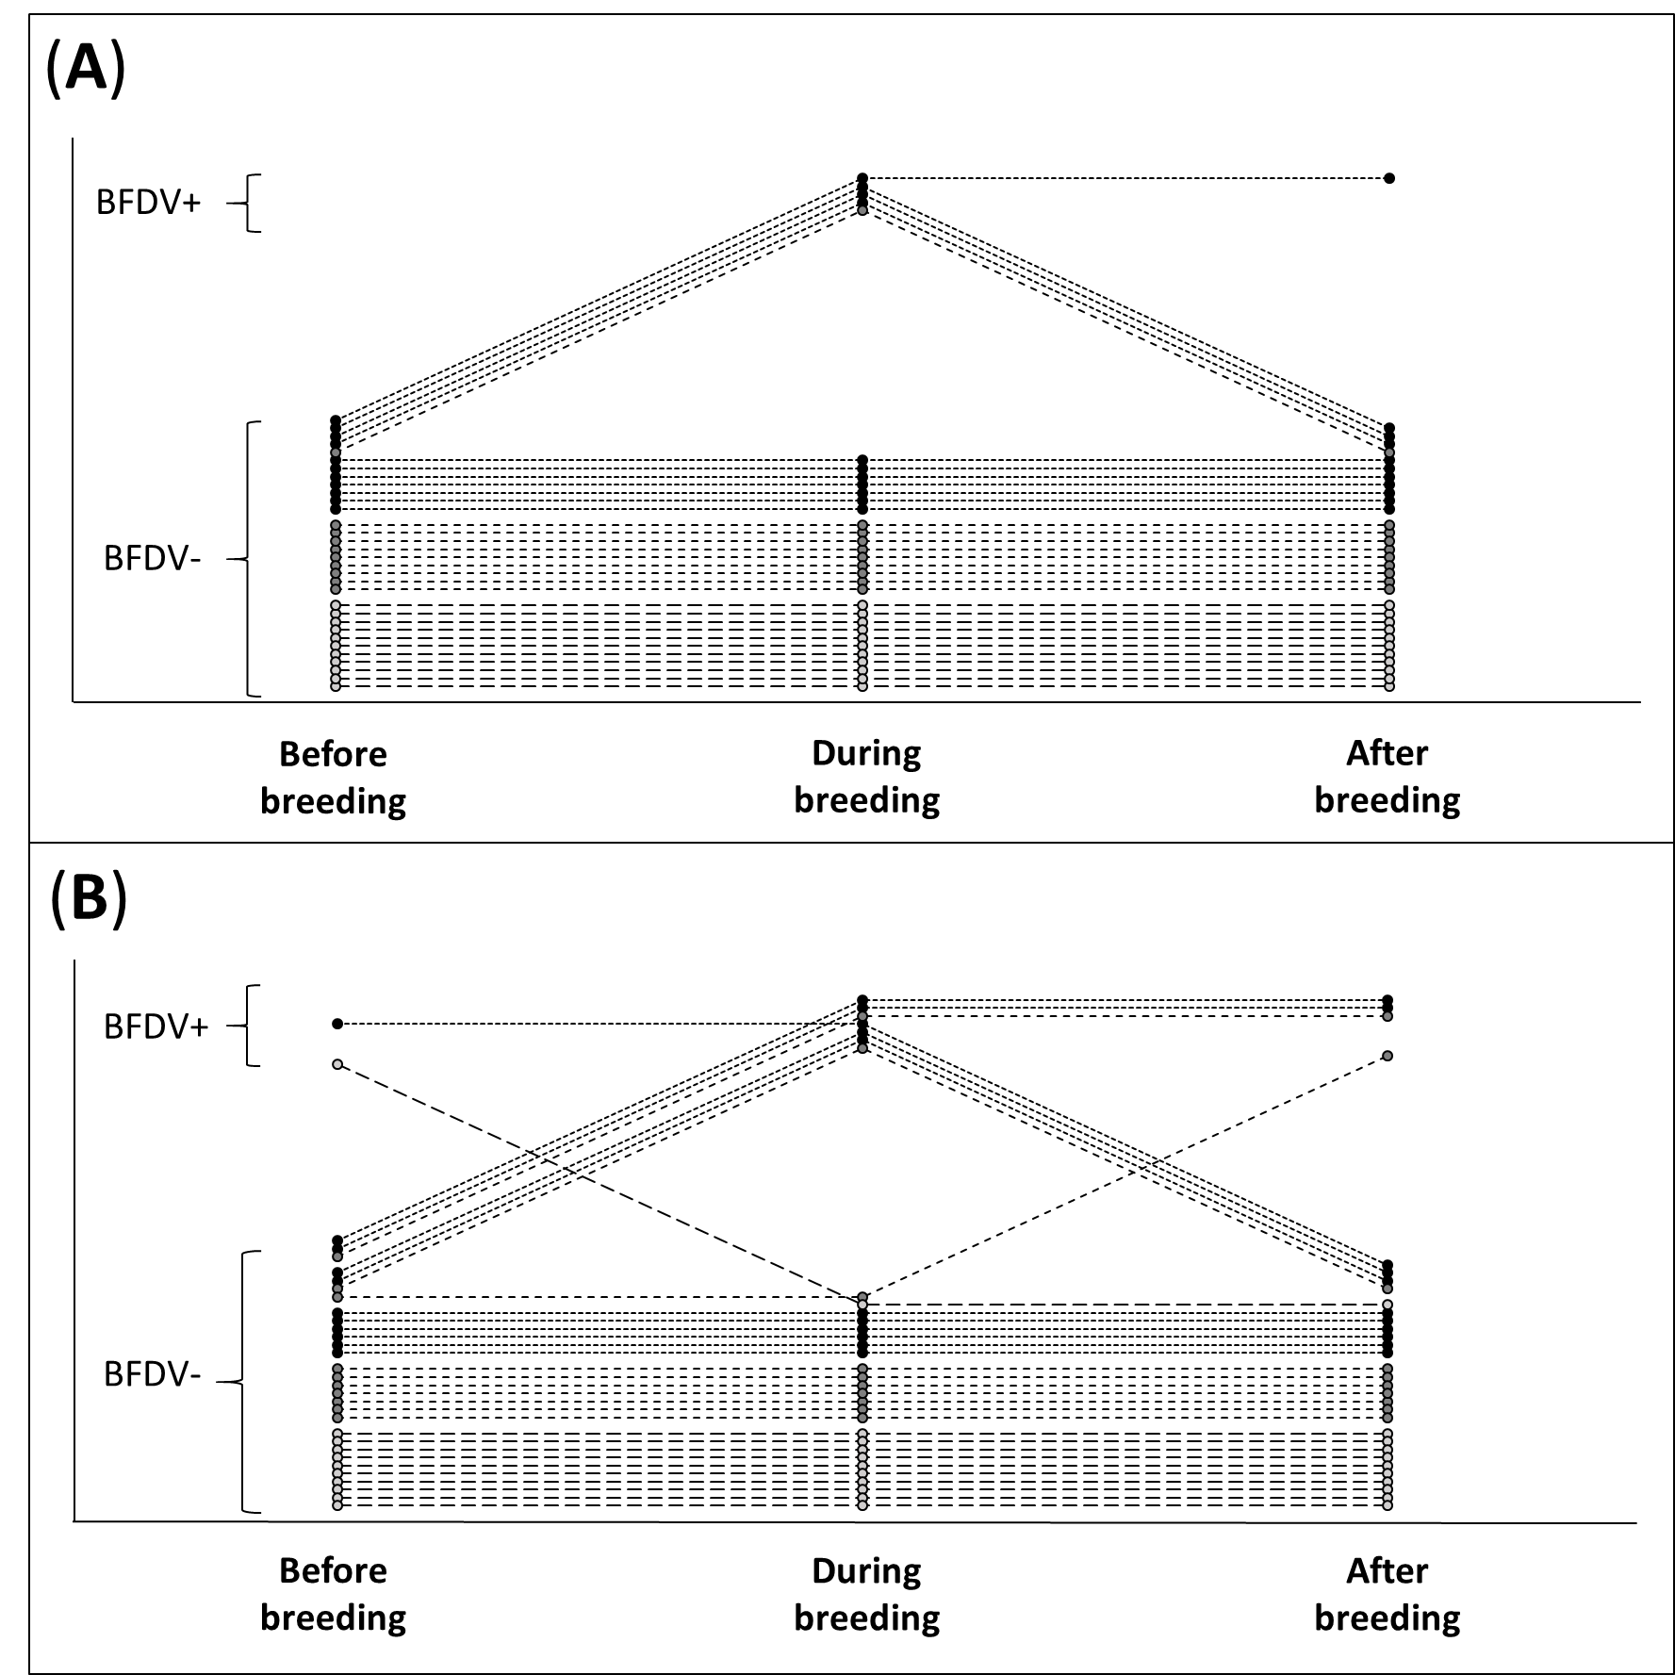
Figure S1: BFDV presence in the nest box before, during and after the breeding season for every nest, as detected with nest box swabs. Panel A shows results with a detection threshold of Cq < 36, panel B shows the same nest, with a detection threshold of Cq < 38. Black dots with dotted lines show nests which contained BFDV-positive birds, dark grey dots with short-dashed lines show empty nest boxes which were used as paired controls, and light grey dots with long-dashed lines show nest boxes with BFDV-negative birds. Dots have been spread out along the y-axis for better visibility.
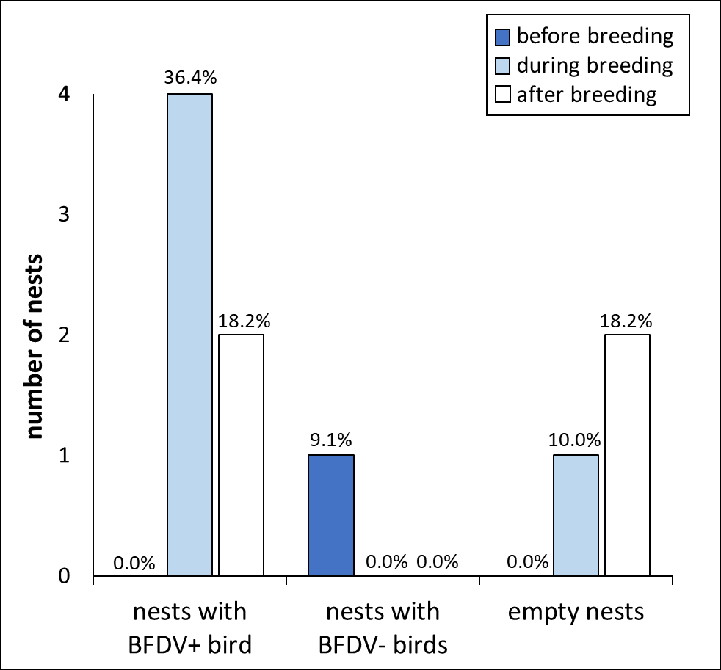
Figure S2: Number of nest boxes (out of total of 33 for the three test groups, 11 per group) with BFDV-positive nest box swabs before, during and after the breeding season, and analysed with the higher qPCR threshold₃₈. Using this threshold leads to inclusion of samples with weaker qPCR signals as positive and thus to a higher total number of BFDV-positive samples. For unoccupied nest boxes during the breeding season, the sample size was 10 unoccupied nest boxes instead of 11.

