Supplementary Table 1. GEPIA box plots of the mRNA expression profiles of PI3K/AKT/mTOR signaling pathway proteins in 523 clear cell renal cell carcinoma (T) and 72 normal kidney tissues (N), which was downloaded from TCGA database. 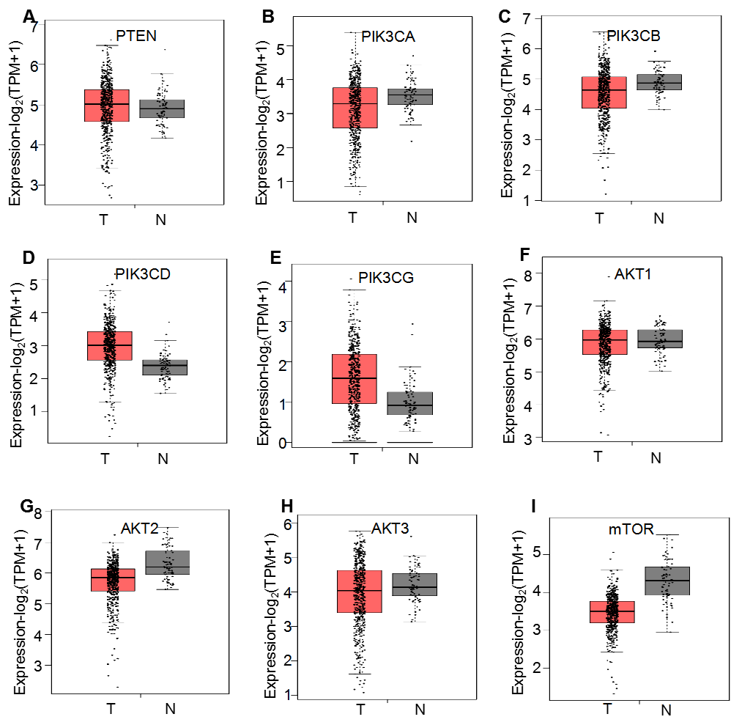
(A-I) Box plots demonstrate the relative mRNA expression levels (log2 (TPM+1)) of (A) PTEN, (B) PIK3CA, (C) PIK3CB, (D) PIK3CD, (E) PIK3CG, (F) AKT1, (G) AKT2, (H) AKT3 and (I) mTOR, which were not significantly altered between the tissues (P>0.05).

