Supplementary Table 2. Oncomine box plots of the mRNA expression profiles of PI3K/AKT/mTOR pathway members in 10 clear cell renal cell carcinoma (T) and 10 matched normal kidney tissues (N).
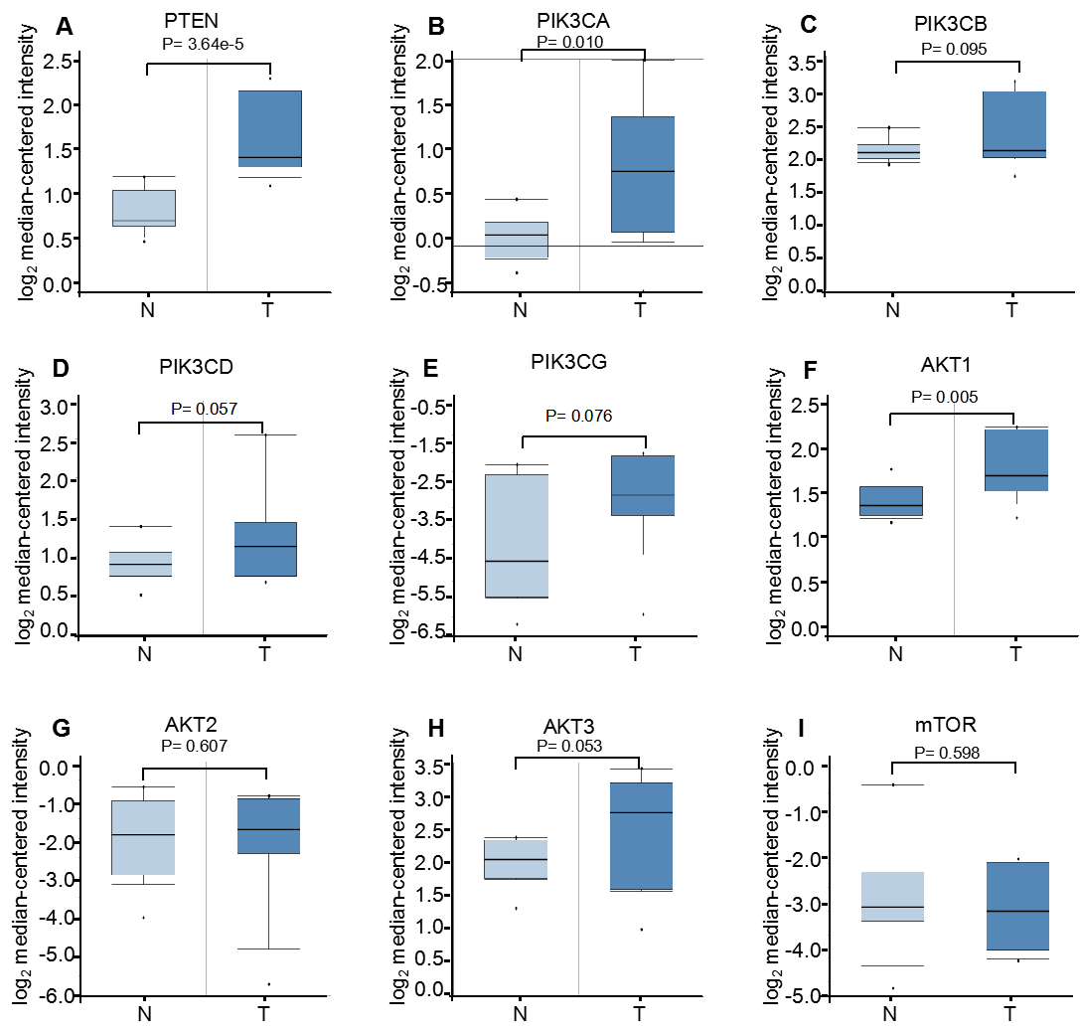
- I) Box plots demonstrate the relative mRNA expression levels of (A) PTEN, (B) PIK3CA, (C) PIK3CB, (D) PIK3CD, (E) PIK3CG, (F) AKT1, (G) AKT2, (H) AKT3 and (I) mTOR, which showed that only PTEN (1.77-fold), PIK3CA (1.56-fold) and AKT1 (1.27-fold) were increased in ccRCC, while the other six genes were not significantly altered between the tissues (P>0.05).

