Supplementary Material
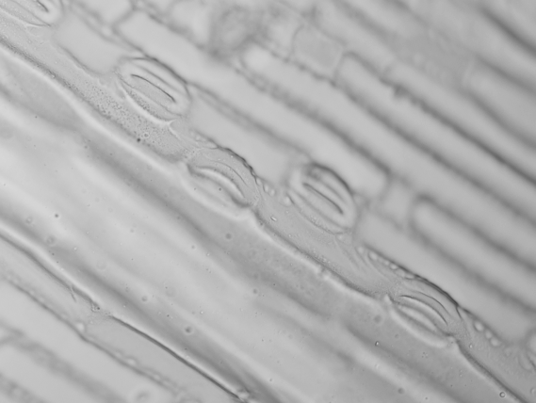
stoma
stoma
- （B）
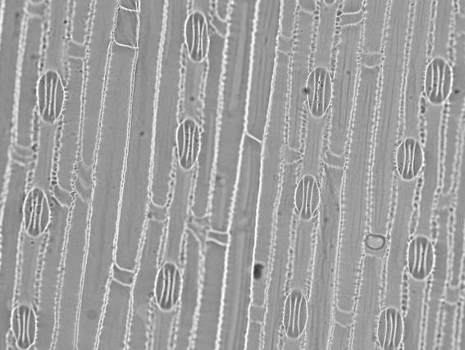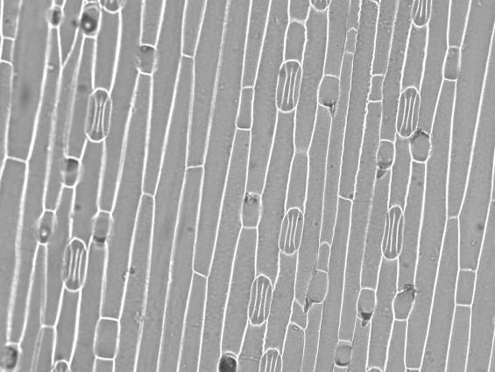
stoma
stoma
（C） （D）
Supplementary Figure S1: The stomatal characteristics (20×) in progeny plants. (A) and (B), the adaxial leaf surfaces in enclosure and overgrazing Leymus chinensis respectively. (C) and (D), the abaxial leaf surfaces in enclosure and overgrazing Leymus chinensis respectively.

