Journal guidelines - Journal of Comparative Neurology (JCN)
The leading journal when it comes to reporting on antibodies in scientific articles is the Journal of Comparative Neurology. This journal was the first one to generate attention for the problems related to antibodies and antibody reporting and it is responsible for what some people call the ‘one-journal revolution’ on antibody reporting (Baker 2015).
On 25 August 2003, JCN published an editorial explaining the minimal types of validation that should be carried out with antibodies used in immunohistochemistry. In this editorial, JCN also informed its authors that scientific articles with antibodies in which the antigen is not reported would no longer be published. It also encourages authors to provide full information on the antibodies used; authors need to provide both the catalog number and information on which batch was used. This editorial mostly created awareness of the problems that can arise when using antibodies. It did not provide strict guidelines on antibody reporting in JCN (Saper & Sawchenko 2003).
Two years later, on 22 November 2005, Clifford Saper, the editor in chief of JCN from 1994 to 2011, published another editorial commenting on the use of antibodies in research. The editors of JCN had become aware of retractions caused by problems with antibodies. This editorial describes a set of rules that should from then onwards be applied to every paper using antibodies (Saper 2005).
After that editorial, JCN implemented antibody reporting guidelines, which can be found under the instructions for authors section on the journal’s website. With regard to antibodies, they require authors to add an ‘Antibody Characterization’ section to the methods section of a paper. They also state that they support the Resource Identification Initiative (RRID). Information retrieved from the Author Guidelines section of website Journal Comparative Neurology on 04-05-2018.
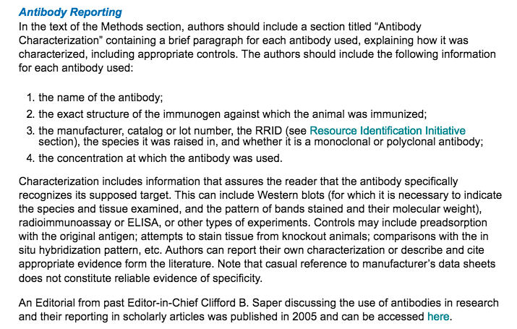
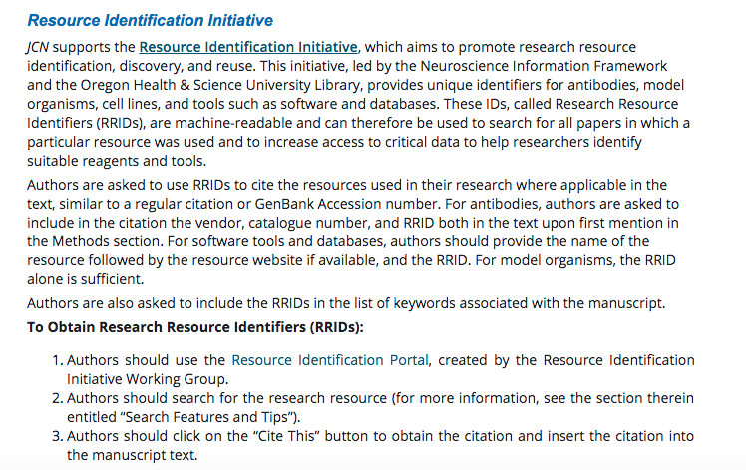
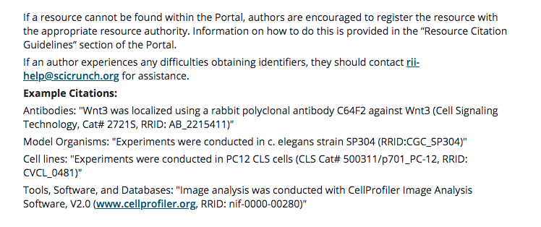

When authors want to submit a manuscript to JCN, they need to check a box that states that their publication provides full information on all antibodies used. Submission process tested on 09-05-2018).

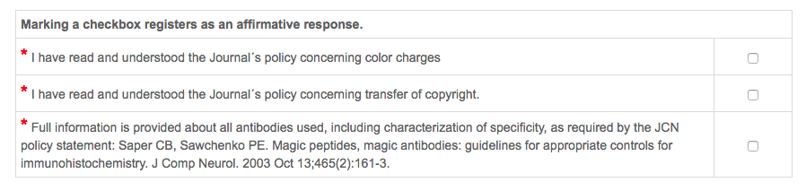

Journal guidelines - Nature
In an effort to reduce the irreproducibility of the research published in their journal, Nature implemented a Reporting Checklist for Life Science Articles in May 2013. This checklist should improve reporting of a few crucial experimental and analytical design elements of research. From that moment onwards, authors were required to fill out this checklist at submission of their paper. At the same time, Nature also abolished space restrictions on the methods section (Nature 2013).

Antibody section of Reporting Checklist for Life Sciences Articles 2013:
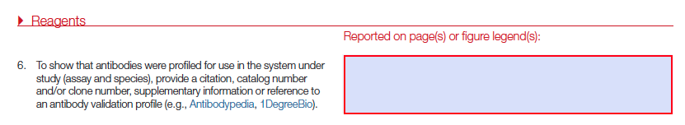

On 1 June 2017, Nature published another announcement stating that the journal would go one step further in trying to improve the quality of reporting. From then onwards, authors in the life science field are required to fill out a Life Science Reporting Summary that will be published as supplementary information alongside the article. This document contains details about the experimental design, analysis and reagents (Nature 2017).

Antibody section of Reporting Summary for Life Sciences Articles June 2017:

Antibody section of Reporting Summary for Life Sciences Articles March 2018
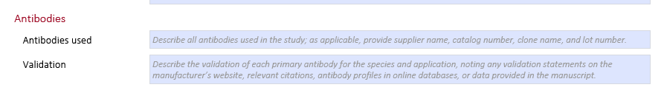

During the submission process, Nature asks its authors to upload the reporting summary at the same moment as the manuscript. The journal warns its authors that failure to hand it in at submission may delay the handling of the submission since the form needs to be provided to reviewers if the paper is sent for peer-review (submission process tested on 09-05-2018).

References
Baker M. 2015. Antibody anarchy: A call to order. Nature 527:545. 10.1038/527545a
Nature. 2013. Reducing our irreproducibility. Nature 496:398-398.
Nature. 2017. Towards greater reproducibility. Nature 546. 10.1038/546008a
Saper CB. 2005. An open letter to our readers on the use of antibodies. The Journal of Comparative Neurology 493:477-478. 10.1002/cne.20839
Saper CB, and Sawchenko PE. 2003. Magic peptides, magic antibodies: guidelines for appropriate controls for immunohistochemistry. Journal of Comparative Neurology 465:161-163.

