Supplementary Information for

Adsorption and bonding strength of chromium species by ferrihydrite from acidic aqueous solutions

Agnieszka Dzieniszewska, Joanna Kyziol-Komosinska, Magdalena Pająk

Institute of Environmental Engineering Polish Academy of Sciences,   
34 M. Skłodowska-Curie St., 41-819 Zabrze, Poland;

Submitted to PeerJ

**This supporting information has 5 pages, including 3 tables and 2 figures**

**Table S1:**

**List of adsorption isotherm models.**

|  |  |  |  |  |
| --- | --- | --- | --- | --- |
| Adsorption isotherms models | | | | |
| Isotherm | Isotherm form | Equation number | Parameters | Ref. |
| Freundlich | Nonlinear $q=K_{F}∙{C_{eq}}^{1/{n_{F}}}$   Linear $logq=logK_{F}∙1/nlogC_{eq}$ | (S1.1)  (S1.2) | *KF* – Freundlich equilibrium constant related to the adsorption capacity and adsorption intensity of the system (mg g-1(L mg-1)1/*nF*),  *1/nF* – expresses favorability of adsorption (dimensionless) | *Freundlich, 1906* |
| Langmuir | Nonlinear $q=\frac{q_{max}K_{L}C_{eq}}{1+K_{L}C_{eq}}$   Linear $\frac{C_{eq}}{q}=\frac{C_{eq}}{q_{max}}+\frac{1}{K_{L}q_{max}}$ | (S2.1)  (S2.2) | *qmax* – maximum adsorption capacity  (mg g-1),  *KL* – Langmuir constant related to the affinity of the binding sites and the energy of adsorption (L mg-1) | *Langmuir, 1916* |
| Dubinin-Radushkevich | Nonlinear $q=q_{D}∙exp⁡\left(–βε^{2}\right)$   Linear $lnq=lnq_{D}-βε^{2}$ | (S3.1)  (S3.2) | *qD*– theoretical saturation capacity  (mmol g-1),  *β* – constant related to the adsorption energy (mol2 kJ-2),  *ε* – Polanyi potential, $ε=RTln\left(1+1/{C_{eq}}\right)$ (S4), *R* – gas constant (J mol-1 K-1), *T* – temperature (K) | *Dubinin, 1960* |
| Sips | Nonlinear $q=\frac{q_{max}K_{S}{C_{eq}}^{1/{n_{S}}}}{1+K_{S}{C_{eq}}^{1/{n_{S}}}}$ | (S5) | *KS* – Sips constant related with affinity constant ((L mg-1)1/*nS*),  1/*nS* – Sips exponent which represents the surface heterogeneity (dimensionless) | *Sips, 1948* |

**Table S2:**

**List of error functions.**

|  |  |  |  |  |
| --- | --- | --- | --- | --- |
| Error functions | | | | |
| Abbreviation | Definition/expression | Equation number | Parameters | Ref. |
| SSE | $\sum_{i=1}^{n}{{\left(q_{e,cal}-q_{e,exp}\right)}_{i}^{2}}$ | (S6) | *qe,cal* – calculated value of the adsorption capacity,  *qe,exp* – experimental value of the adsorption capacity,  *n* – number of observations in the experimental data | *Foo & Hameed, 2010* |
| *RMSE* | $\sqrt{\frac{1}{n}\sum_{i=1}^{n}{{\left(q_{e,exp}-q_{e,cal}\right)}_{i}^{2}}}$ | (S7) | *Terdputtakun et al., 2017* |
| *χ2* |  | (S8) | *Terdputtakun et al., 2017* |

**Table S3:**

**Modified BCR sequential extraction scheme.**

|  |  |  |  |
| --- | --- | --- | --- |
| Stage of extraction | Fraction | Extractant | Conditions |
| E0 | Soluble in water | Double distilled H2O | S:L = 1:40, 2 h, T = 20 °C |
| E1 | (Acid soluble/  Exchangeable) – bound to carbonates | 0.11 M CH3COOH(pH 2.85) | S:L = 1:40, 16 h, T = 20 °C |
| E2 | Reducible – bound to Mn  and Fe oxides | 0.5 M NH2OH·HCl (pH 1.5) | S:L = 1:40, 16 h, T = 20 °C |
| E3 | Oxidizable – bound to  organic matter and sulfides | 8.8 M H2O2,  then 1 M CH3COONH4 (pH 2.0) | S:L = 1:10, 1 h, T = 80 °C  S:L = 1:50, 16 h, T = 20 °C |
| E4 | Residual | Aqua regia (HCl/HNO3 3/1),  then 0.1 M HNO3 | S:L = 1:25, T = 80 °C  S:L = 1:50 |

Diagram of chromium speciation for Cr(III) from chloride and sulfate solution as well as for Cr(VI) at *C*0 = 1000 mg L-1 was generated using the software Visual MINTEQ version 3.1 [http://vminteq.lwr.kth.se/download/].

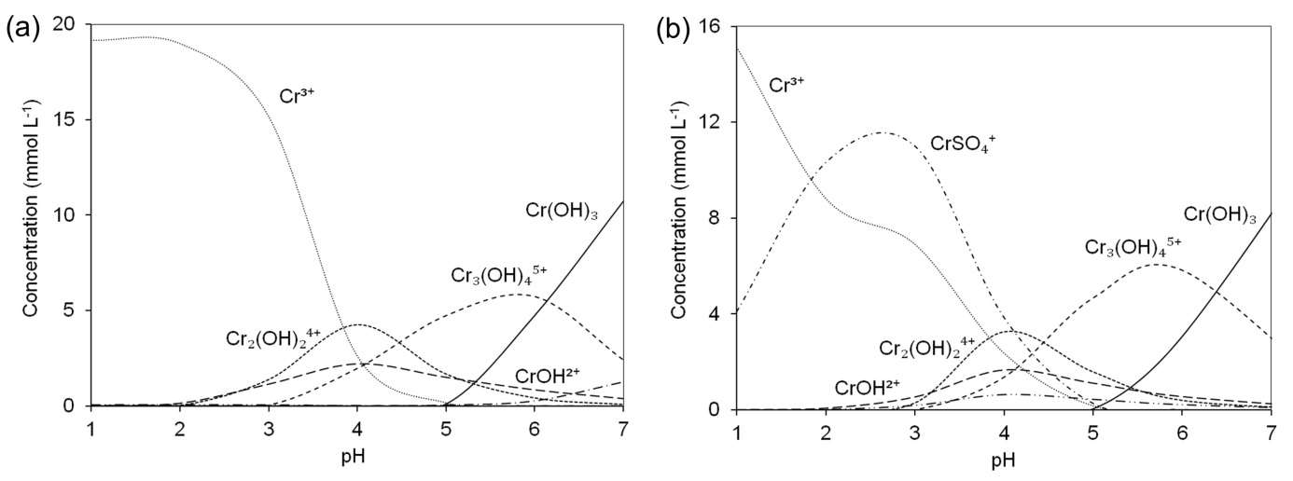

**Figure S1: Cr(III) speciation in chloride (A) and sulfate (B) solutions at *C*0 = 1000 mgCr L-1 as a function of pH.**

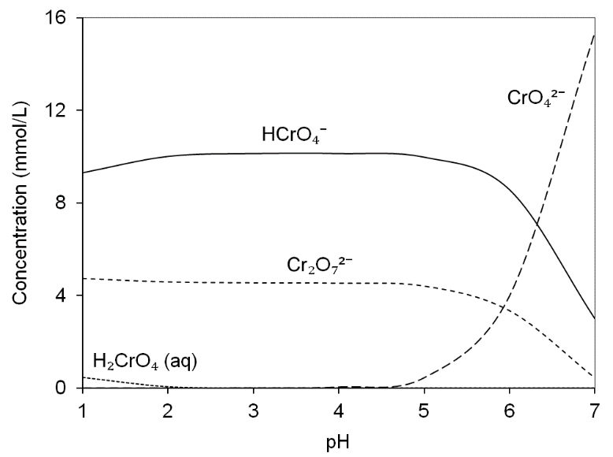

**Figure S2: Cr(VI) speciation depending on the pH in the solution at *C*0 = 1000 mgCr L-1.**