Appendix A
Demonstrations of the diagnostics for linearity of relationship

Figure 1: For sugar consumption (with the UAE data in both cases but changing the scale to focus on the bulk of data)
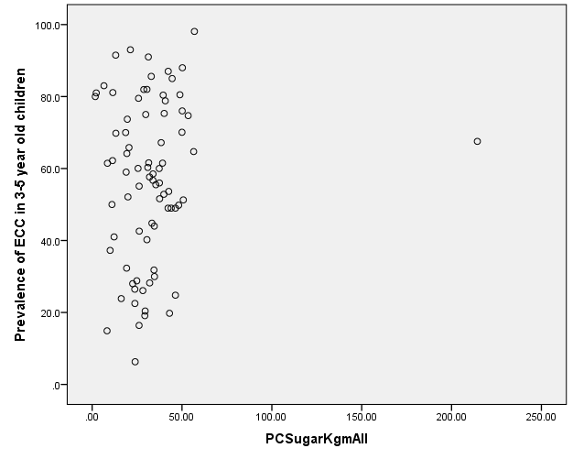 | 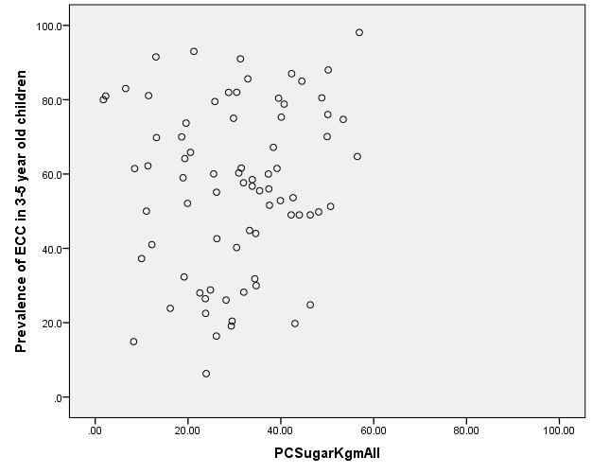

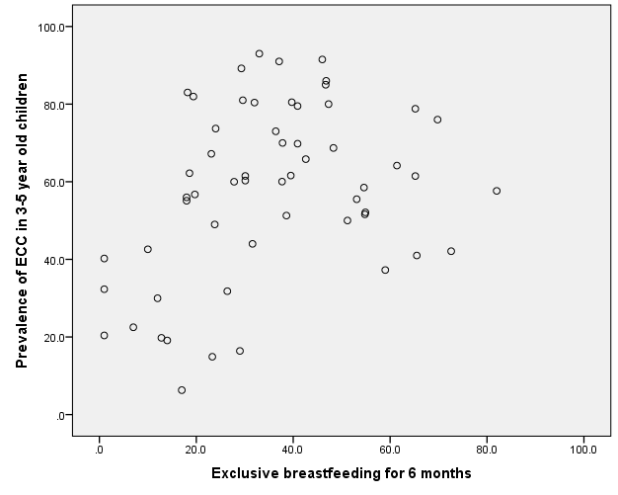

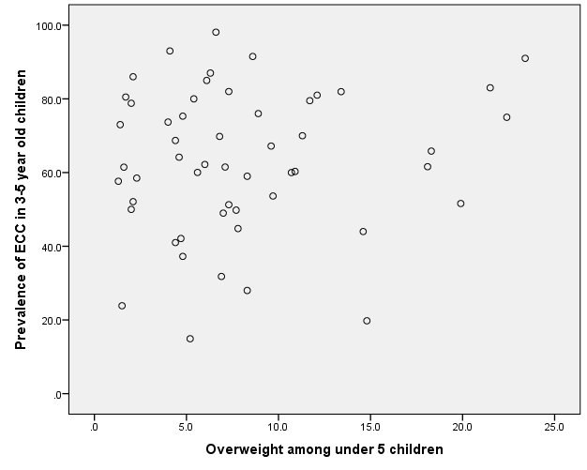

Figure 1: Normal distribution of residuals in the models for sugar consumption

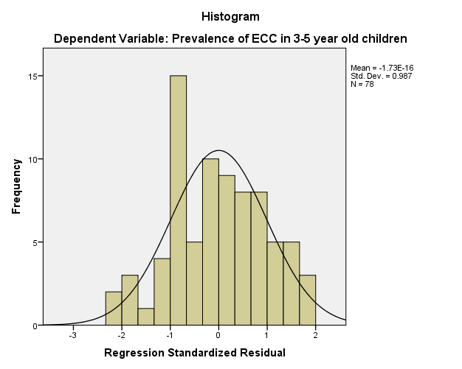 | 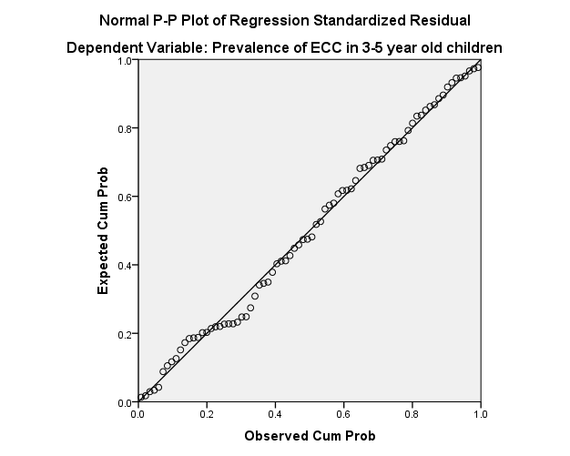

Figure 3: Normal distribution of residuals in the models for exclusive breastfeeding

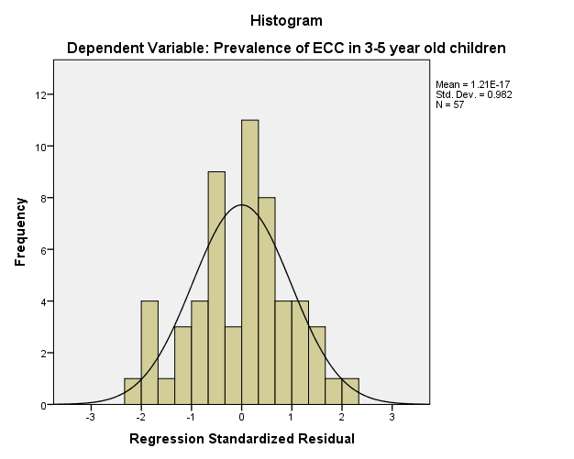 | 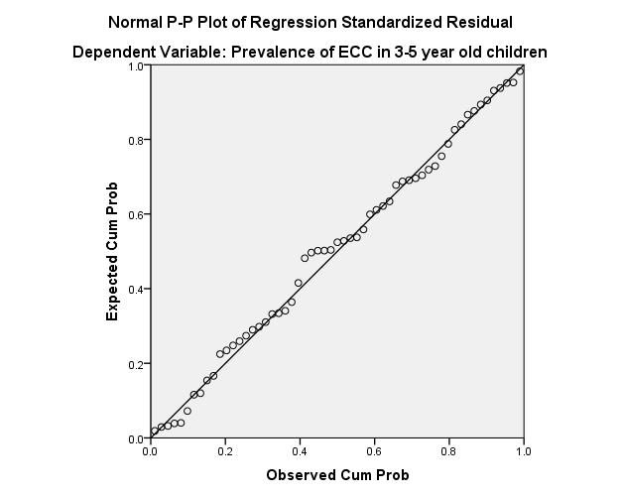

Figure 4: Normal distribution of residuals in the models for overweight
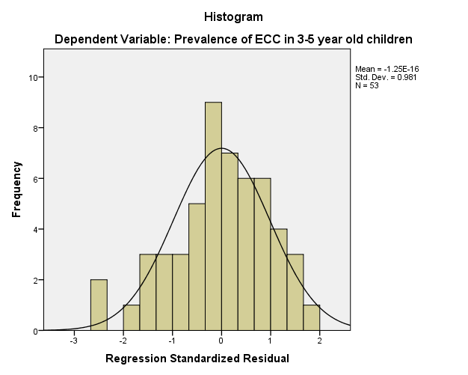 | 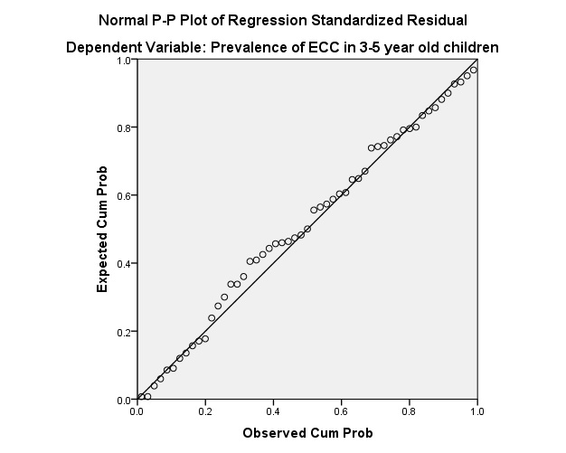

Figure 5: Constant variance of residuals for per capita sugar consumption
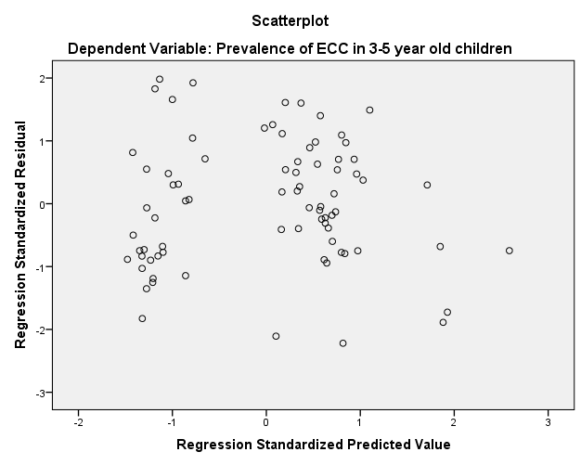

Figure 6: Constant variance of residuals for exclusive breastfeeding
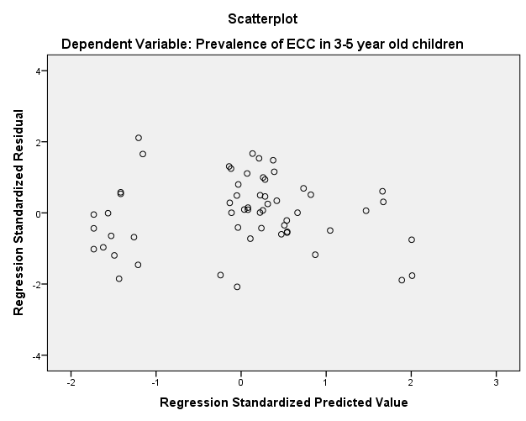

Figure 7: Constant variance of residuals for overweight

