28S
Model selected:
Model = HKY+I
partition = 010010
-lnL = 1481.2745
K = 99
freqA = 0.2535
freqC = 0.2502
freqG = 0.3087
freqT = 0.1876
kappa = 2.6142 (ti/tv = 1.3297)
p-inv = 0.9290

--
PAUP* Commands Block:
If you want to load the selected model and associated estimates in PAUP*,
attach the next block of commands after the data in your PAUP file:

[!
Likelihood settings from best-fit model (HKY+I) selected by AIC
with jModeltest 2.1.10 v20160303 on Thu Jul 19 18:52:01 PDT 2018]

BEGIN PAUP;
Lset base=(0.2535 0.2502 0.3087 ) nst=2 tratio=1.3297 rates=equal pinvar=0.9290;
END;
--

16S
Model selected:
Model = GTR+I+G
partition = 012345
-lnL = 4998.0343
K = 140
freqA = 0.4141
freqC = 0.1074
freqG = 0.1197
freqT = 0.3587
R(a) [AC] = 0.6729
R(b) [AG] = 6.6843
R(c) [AT] = 2.4115
R(d) [CG] = 0.5637
R(e) [CT] = 3.5806
R(f) [GT] = 1.0000
p-inv = 0.1900
gamma shape = 0.3390

--
PAUP* Commands Block:
If you want to load the selected model and associated estimates in PAUP*,
attach the next block of commands after the data in your PAUP file:

[!
Likelihood settings from best-fit model (GTR+I+G) selected by AIC
with jModeltest 2.1.10 v20160303 on Thu Jul 19 18:56:49 PDT 2018]

BEGIN PAUP;
Lset base=(0.4141 0.1074 0.1197 ) nst=6 rmat=(0.6729 6.6843 2.4115 0.5637 3.5806) rates=gamma shape=0.3390 ncat=4 pinvar=0.1900;
END;

COI123
PAUP* Commands Block:
If you want to load the selected model and associated estimates in PAUP*,
attach the next block of commands after the data in your PAUP file:

[!
Likelihood settings from best-fit model (HKY+I+G) selected by BIC
with jModeltest 2.1.10 v20160303 on Wed Jun 27 17:40:02 PDT 2018]

BEGIN PAUP;
Lset base=(0.3016 0.0842 0.1386 ) nst=2 tratio=4.2721 rates=gamma shape=0.6090 ncat=4 pinvar=0.5130;
END;

COI1--
Model selected:
Model = TrN+I+G
partition = 010020
-lnL = 903.1276
K = 145
freqA = 0.2759
freqC = 0.1287
freqG = 0.2989
freqT = 0.2964
R(a) [AC] = 1.0000
R(b) [AG] = 2.1743
R(c) [AT] = 1.0000
R(d) [CG] = 1.0000
R(e) [CT] = 56.5968
R(f) [GT] = 1.0000
p-inv = 0.4590
gamma shape = 0.6000

--
PAUP* Commands Block:
If you want to load the selected model and associated estimates in PAUP*,
attach the next block of commands after the data in your PAUP file:

[!
Likelihood settings from best-fit model (TrN+I+G) selected by AIC
with jModeltest 2.1.10 v20160303 on Thu Jul 19 18:54:37 PDT 2018]

BEGIN PAUP;
Lset base=(0.2759 0.1287 0.2989 ) nst=6 rmat=(1.0000 2.1743 1.0000 1.0000 56.5968) rates=gamma shape=0.6000 ncat=4 pinvar=0.4590;
END;

COI2
Model selected:
Model = TVM+I
partition = 012314
-lnL = 339.9084
K = 146
freqA = 0.1200
freqC = 0.2429
freqG = 0.1844
freqT = 0.4527
R(a) [AC] = 2035.9781
R(b) [AG] = 562.3539
R(c) [AT] = 780.4383
R(d) [CG] = 1227.7834
R(e) [CT] = 562.3539
R(f) [GT] = 1.0000
p-inv = 0.7750

--
PAUP* Commands Block:
If you want to load the selected model and associated estimates in PAUP*,
attach the next block of commands after the data in your PAUP file:

[!
Likelihood settings from best-fit model (TVM+I) selected by AIC
with jModeltest 2.1.10 v20160303 on Thu Jul 19 18:56:38 PDT 2018]

BEGIN PAUP;
Lset base=(0.1200 0.2429 0.1844 ) nst=6 rmat=(2035.9781 562.3539 780.4383 1227.7834 562.3539) rates=equal pinvar=0.7750;
END;
--

COI12
Model selected:
Model = TIM1+I+G
partition = 012230
-lnL = 1335.4470
K = 146
freqA = 0.2037
freqC = 0.1965
freqG = 0.2403
freqT = 0.3594
R(a) [AC] = 1.0000
R(b) [AG] = 3.8131
R(c) [AT] = 2.2129
R(d) [CG] = 2.2129
R(e) [CT] = 27.8670
R(f) [GT] = 1.0000
p-inv = 0.6370
gamma shape = 0.4090

--
PAUP* Commands Block:
If you want to load the selected model and associated estimates in PAUP*,
attach the next block of commands after the data in your PAUP file:

[!
Likelihood settings from best-fit model (TIM1+I+G) selected by AIC
with jModeltest 2.1.10 v20160303 on Thu Jul 19 18:58:12 PDT 2018]

BEGIN PAUP;
Lset base=(0.2037 0.1965 0.2403 ) nst=6 rmat=(1.0000 3.8131 2.2129 2.2129 27.8670) rates=gamma shape=0.4090 ncat=4 pinvar=0.6370;
END;
--

COI3
Model selected:
Model = TIM1+G
partition = 012230
-lnL = 5129.3146
K = 145
freqA = 0.3283
freqC = 0.0534
freqG = 0.1072
freqT = 0.5110
R(a) [AC] = 1.0000
R(b) [AG] = 8.8964
R(c) [AT] = 0.2994
R(d) [CG] = 0.2994
R(e) [CT] = 9.2786
R(f) [GT] = 1.0000
gamma shape = 1.3690

--
PAUP* Commands Block:
If you want to load the selected model and associated estimates in PAUP*,
attach the next block of commands after the data in your PAUP file:

[!
Likelihood settings from best-fit model (TIM1+G) selected by AIC
with jModeltest 2.1.10 v20160303 on Thu Jul 19 19:01:06 PDT 2018]

BEGIN PAUP;
Lset base=(0.3283 0.0534 0.1072 ) nst=6 rmat=(1.0000 8.8964 0.2994 0.2994 9.2786) rates=gamma shape=1.3690 ncat=4 pinvar=0;
END;

ITS
Model selected:
Model = GTR+G
partition = 012345
-lnL = 7397.5640
K = 141
freqA = 0.2135
freqC = 0.2455
freqG = 0.2629
freqT = 0.2781
R(a) [AC] = 1.6179
R(b) [AG] = 2.4575
R(c) [AT] = 1.5632
R(d) [CG] = 0.6692
R(e) [CT] = 1.9475
R(f) [GT] = 1.0000
gamma shape = 0.5400

--
PAUP* Commands Block:
If you want to load the selected model and associated estimates in PAUP*,
attach the next block of commands after the data in your PAUP file:

[!
Likelihood settings from best-fit model (GTR+G) selected by AIC
with jModeltest 2.1.10 v20160303 on Thu Jul 19 19:00:52 PDT 2018]

BEGIN PAUP;
Lset base=(0.2135 0.2455 0.2629 ) nst=6 rmat=(1.6179 2.4575 1.5632 0.6692 1.9475) rates=gamma shape=0.5400 ncat=4 pinvar=0;
END;

(1) SeqALL_BEAST_exc_meratus_2.xml = Normal

(2) SeqALL_BEAST_exc_meratus_2.xml = clock model unlink – mtDNA & nrDNA

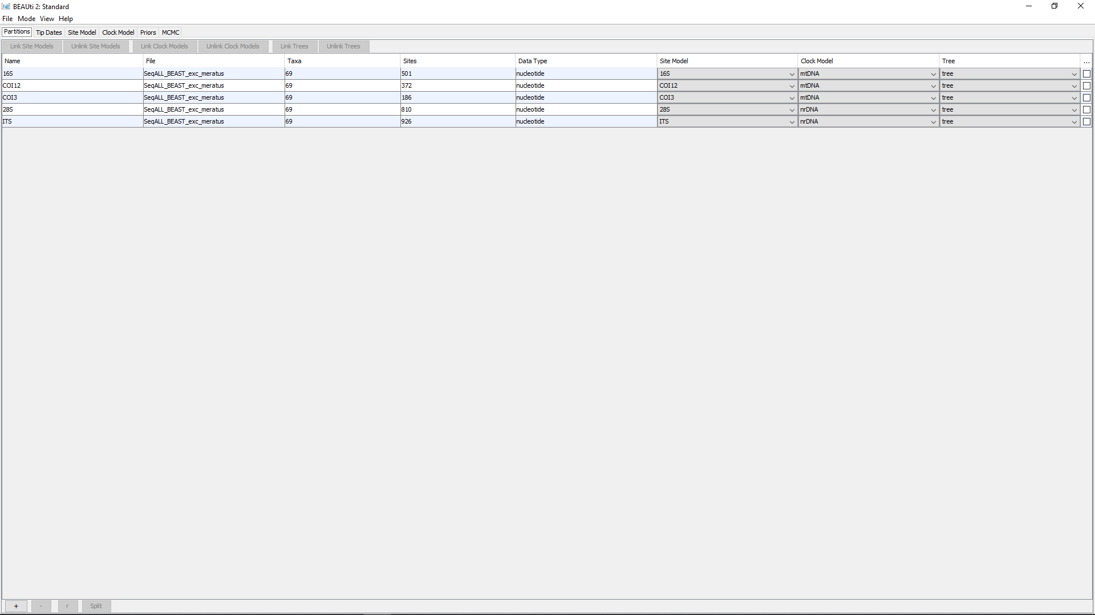

(3) SeqALL_BEAST_exc_meratus_2.xml = clock model unlink – mtDNA & nrDNA & GTR

