Probability plot of RESl1 for Adult O. strigicollis fed On B. tabaci nymphs.
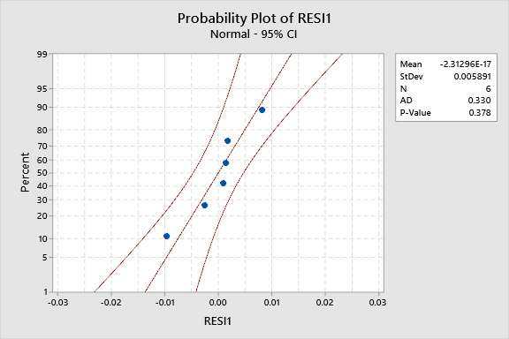
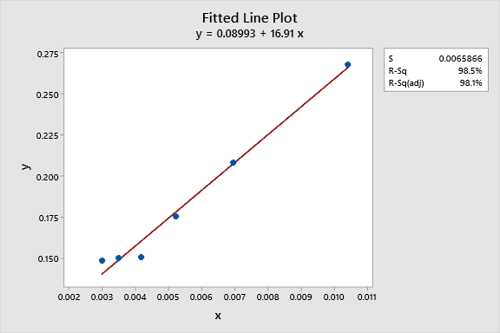
Fitted Line Plot for Adult O. strigicollis fed On B. tabaci nymphs.
Normal Probability plots for Adult O. strigicollis fed On B. tabaci nymphs.
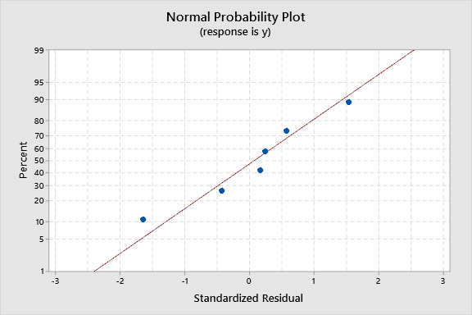
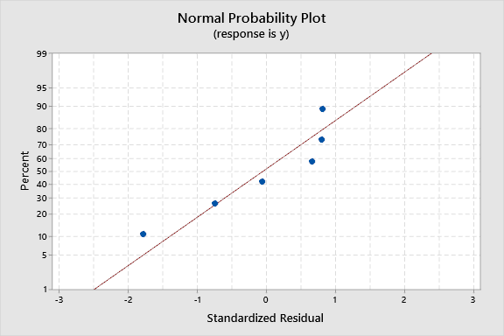
Normal Probability plots for 3rd instar O. strigicollis fed On B. tabaci nymphs.
Fitted Line plots for 3rd instar O. strigicollis fed On B. tabaci nymphs.

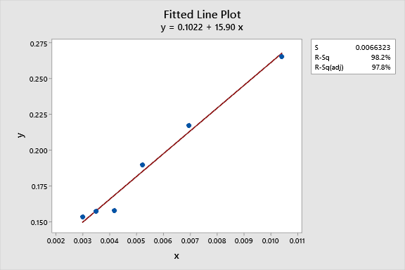
Probability plot of RESl1 for 3rd instar O. strigicollis fed On B. tabaci nymphs.
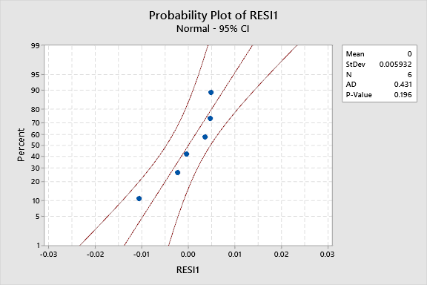

Normal Probability plot for Adult O. strigicollis fed On T. vaporariorum nymphs. 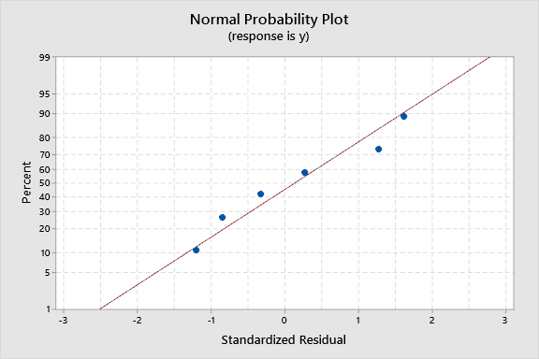
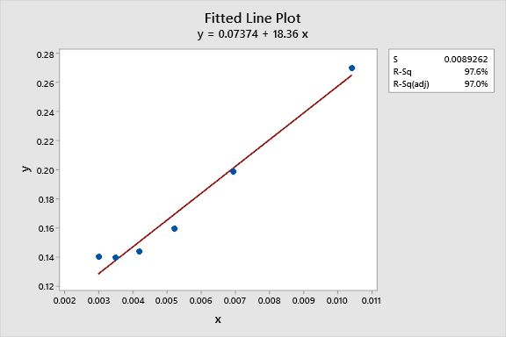
Fitted Line plots for Adult O. strigicollis fed On T. vaporariorum nymphs.
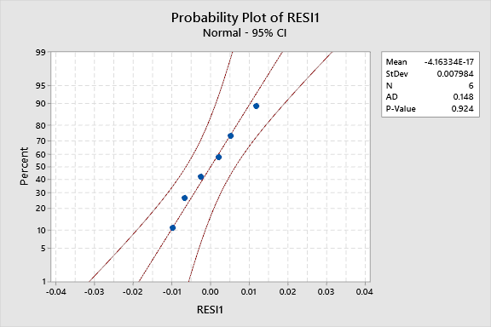
Probability Plot of RESl1 for Adult O. strigicollis fed On T. vaporariorum nymphs
Normal Probability plot for 3rd instar O. strigicollis fed On T. vaporariorum nymphs.
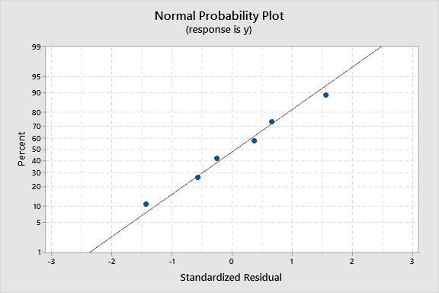
Fitted Line plot for 3rd instar O. strigicollis fed On T. vaporariorum nymphs.
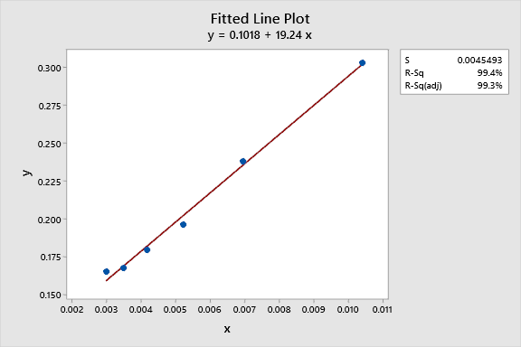

Probability Plot of SRES1 for 3rd instar O. strigicollis fed On T. vaporariorum nymphs.
