**Fig. 3** PCR amplification of the *P. serotina* C2-C3 intragenic region using the Ps1C2Fw (ATY-CAT-GGC-CTR-TGG-CCA-AG) and Ps2C3Rv (TGY-TTR-TTC-CAT-TCV-CBT-TCC) primers. Black arrows indicate the position of the expected alleles whereas white arrows highlight the unexpected alleles obtained for H25, Azu15, Pic19, Car7, Car3 and Car12.

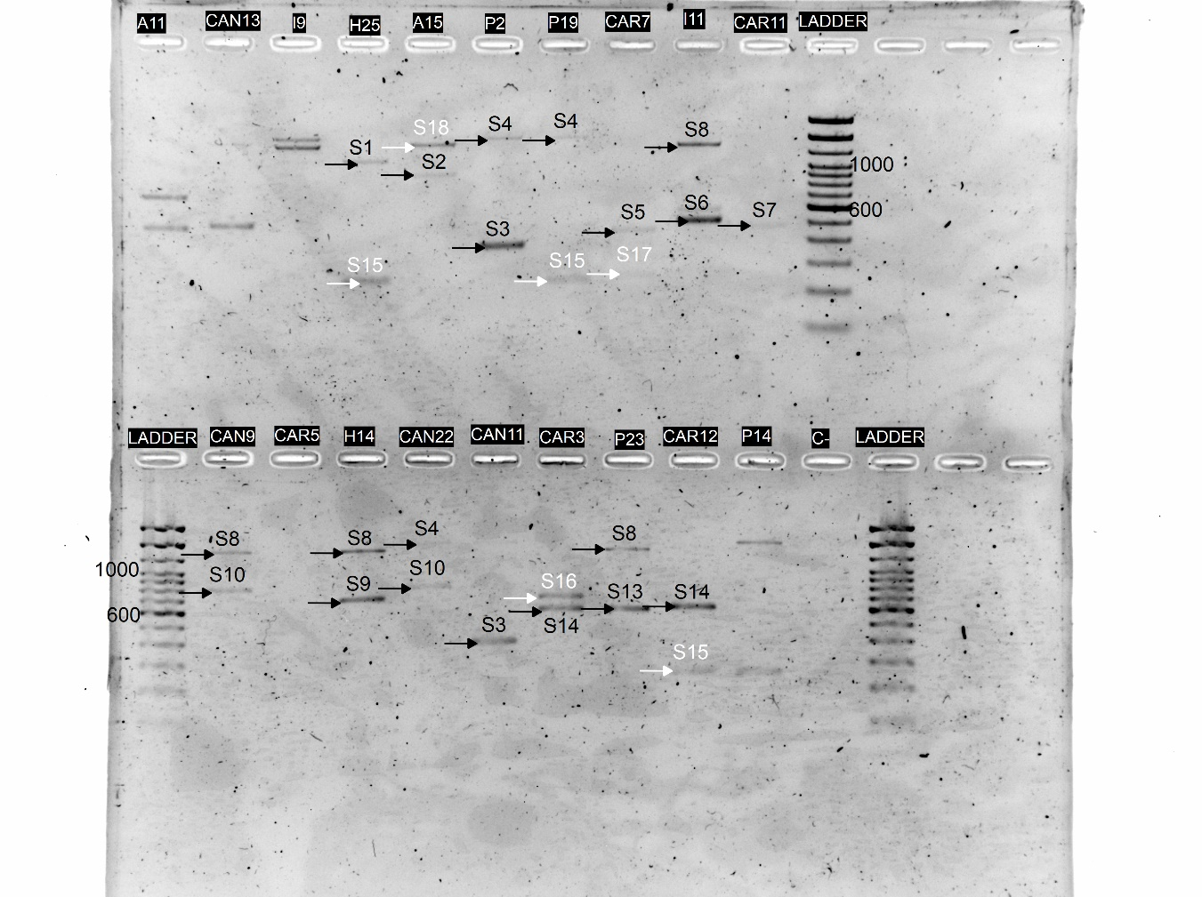

**Figure 4.** *In-vitro* CAPS patterns obtained for alleles S1, S3, S5, S17, S18. Letters indicate the restriction patterns reported for each enzyme in Table 1: RsaI, MboI and HinfI, respectively.

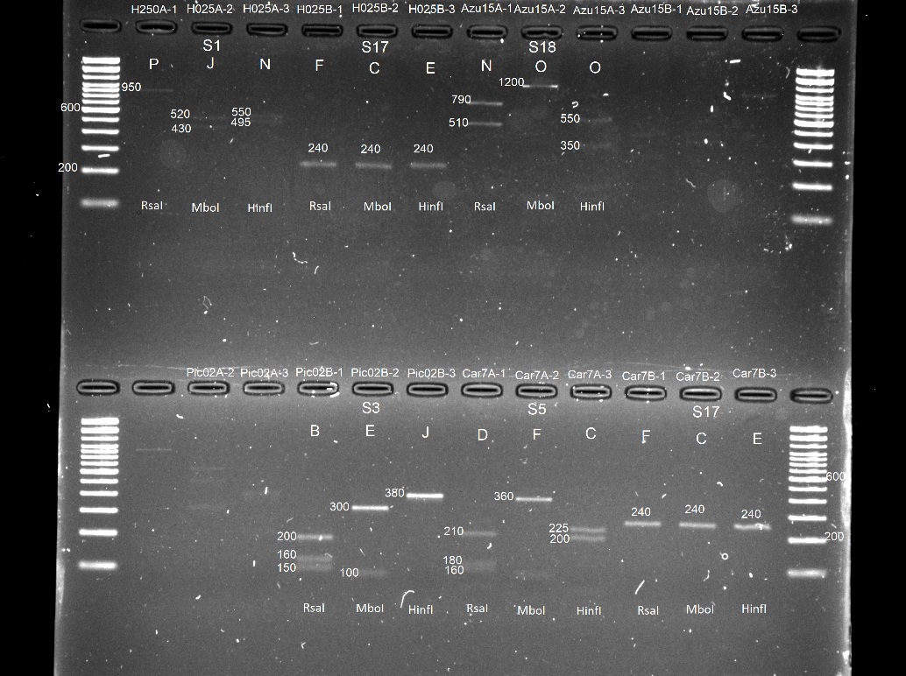

**Figure 4.** *In-vitro* CAPS patterns obtained for alleles S4, S6, S7, S10, S12. Letters indicate the restriction patterns reported for each enzyme in Table 1: RsaI, MboI and HinfI, respectively.

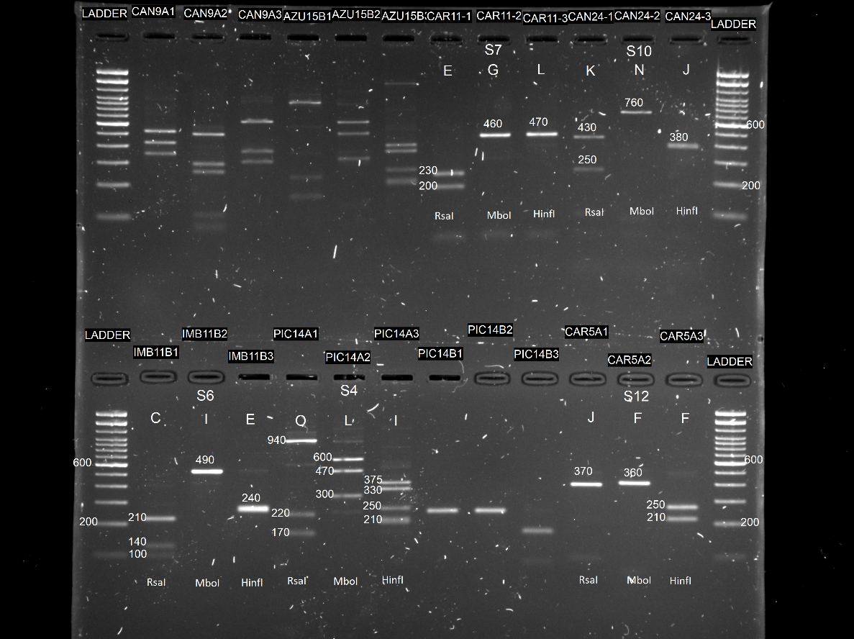

**Figure 4.** *In-vitro* CAPS patterns obtained for allele S9. Letters indicate the restriction patterns reported for each enzyme in Table 1: RsaI, MboI and HinfI, respectively.

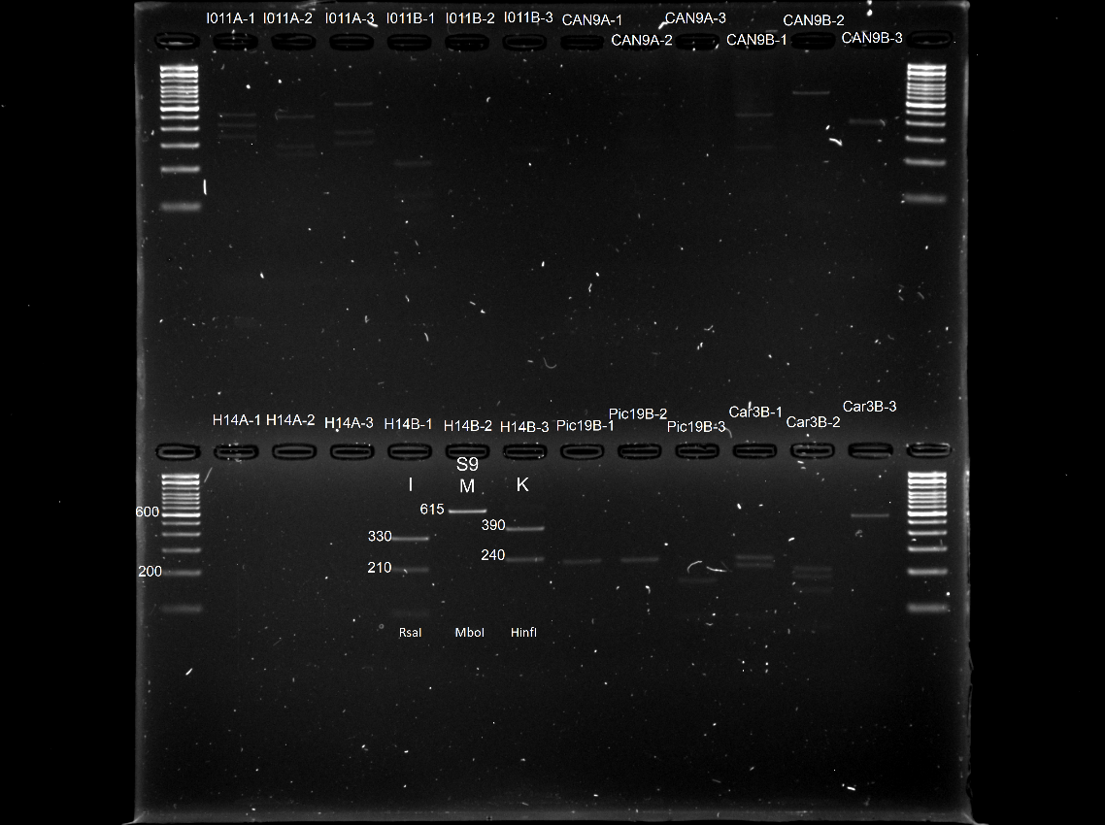

**Figure 4.** *In-vitro* CAPS patterns obtained for alleles S8, S13, S14, S15. Letters indicate the restriction patterns reported for each enzyme in Table 1: RsaI, MboI and HinfI, respectively

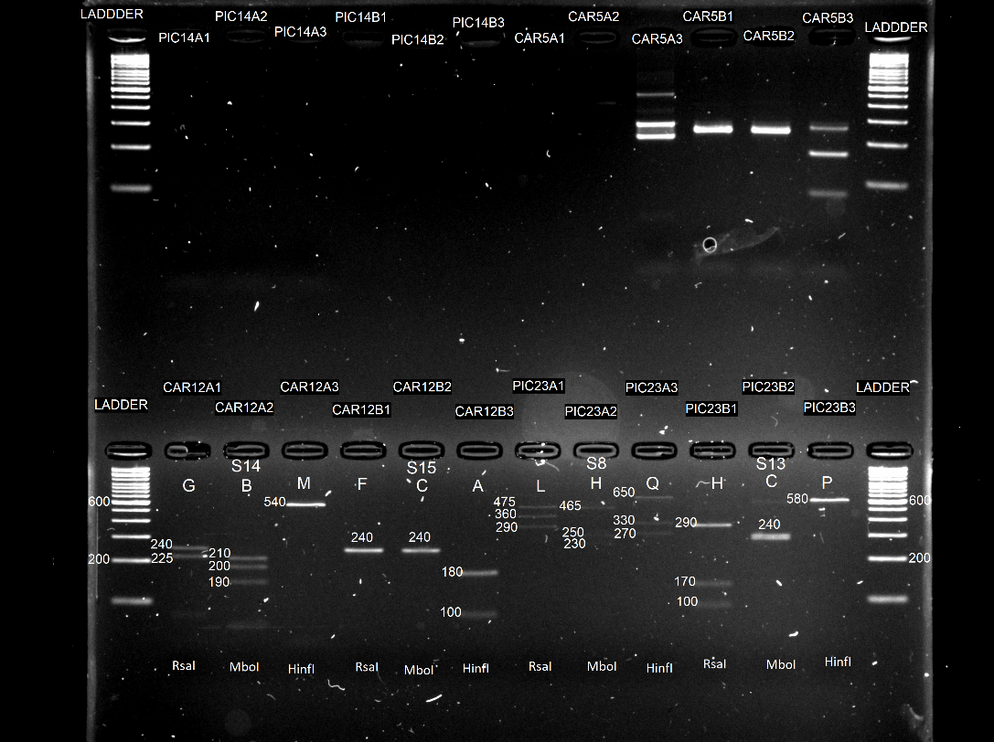

**Figure 4.** *In-vitro* CAPS patterns obtained for allele S16. Letters indicate the restriction patterns reported for each enzyme in Table 1: RsaI, MboI and HinfI, respectively

