Supplementary Material
Transcriptomic analysis reveals ethylene signal transduction genes involved in pistil development of pumpkin
Qing-Fei Li^{1,2*}, Li Zhang^{1,2}, Fei-Fei Pan^{1,2}, Wei-Li Guo^{1,2}, Bi-Hua Chen^{1,2}, He-Lian Yang^{1,2}, Guang-Yin Wang^{1,2}, Xin-Zheng Li^{1,2*}
¹ College of Horticulture and Landscape, Henan Institute of Science and Technology, Xinxiang, Henan,453003, China；
² Henan Province Engineering Research Center of Horticultural Plant Resource Utilization and Germplasm Enhancement, Xinxiang, Henan 453003, China

* Correspondence:
Xin-Zheng Li, Qing-Fei Li

Email address: liuzhw@hist.edu.cn; lqf1988@hist.edu.cn

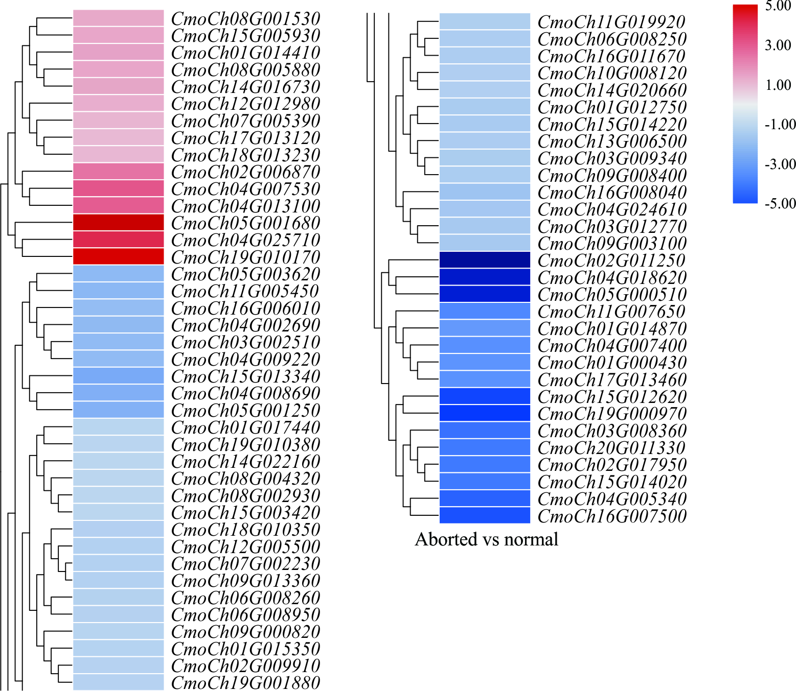
Supplementary Figure 1. Heatmap visualization of predicted ethylene related DEGs.

