Supplementary Material 3. Alignment of some COI sequences used in this work to exemplify how were made the design of primers. The region highlighted corresponding to the amplicon, including HRM primers: A) HRM 82 bp and B) HRM 124 bp.
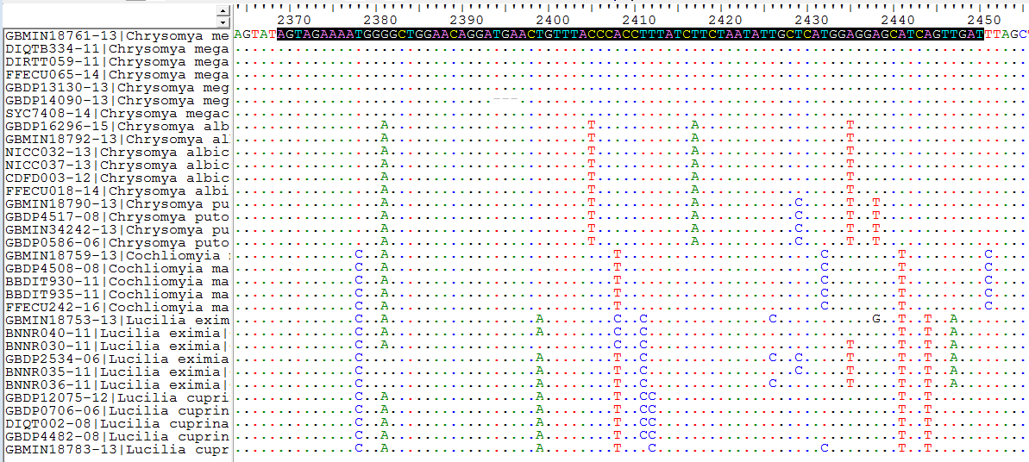
A)
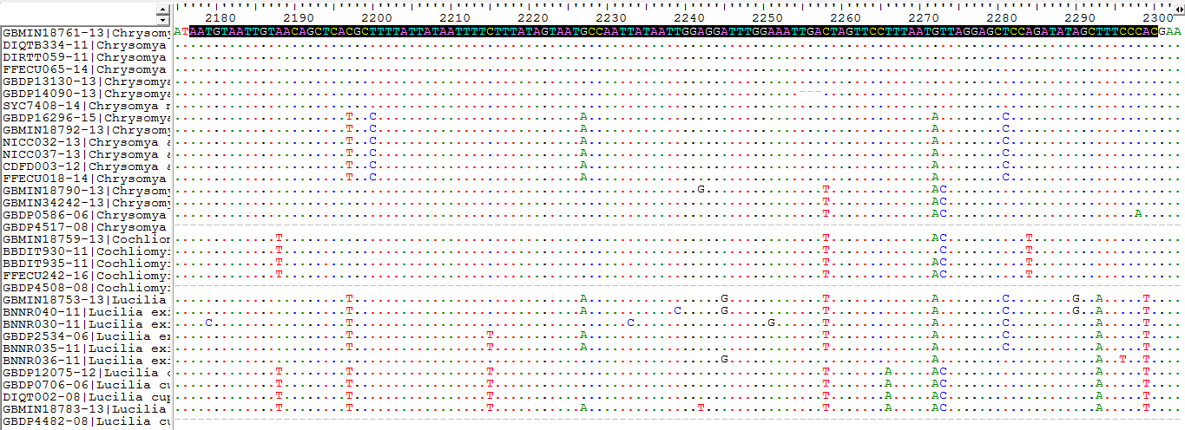
B)

Note: The number of sequences shown in these figures was reduced to fit the size of an image.

