Figure S1. Spearman correlation between mean abundances of all bird species recorded during point-counts (PC) and during mist-netting (MN, data from (Sam et al. 2019). The correlation between the data was rather close, with some birds being recorded only during point-counts but not during mist-netting. Typically, these were canopy species like pigeons and doves. A species which was often recorded during point-counts but only rarely to nets was a canopy occupying honeyeater Melidectes belfordi (abundances 19.8 in PC vs. 2 in MN).
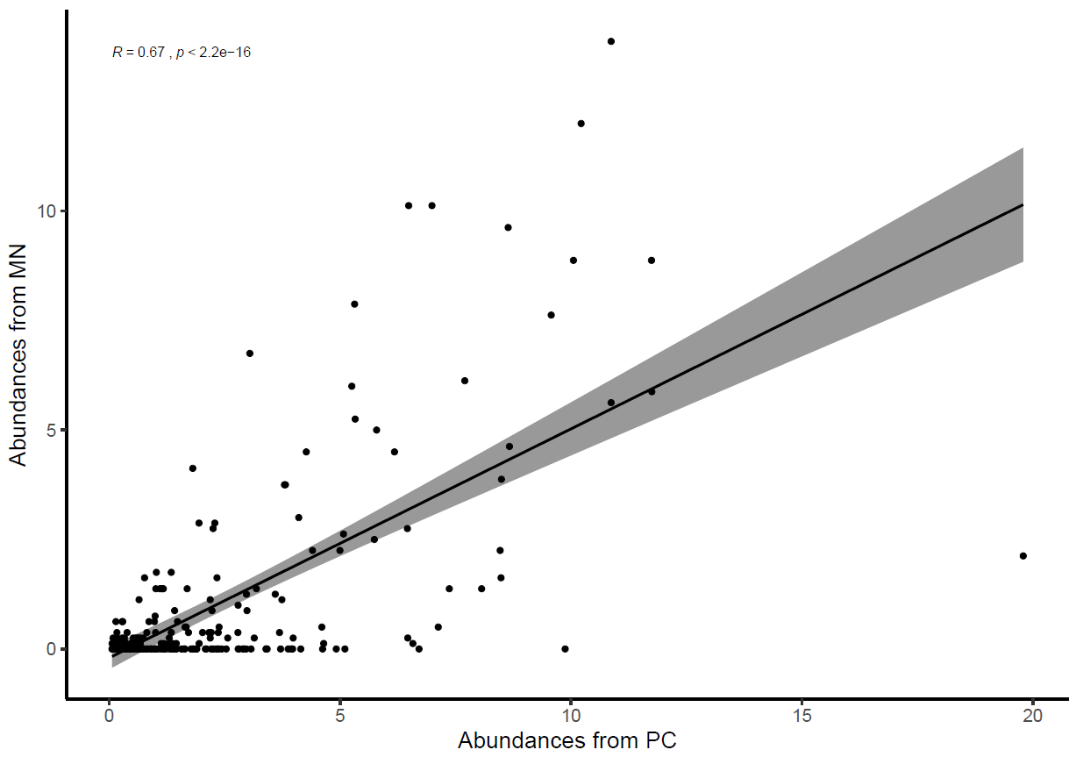

Figure S2. Non-passerine and passerine birds divided into three groups based on the position of their weighted mean point of elevational distribution on Mt. Wilhelm and their mean abundance obtained from mist-netting data (data from (Sam et al. 2019) of individual species across elevations (a) and their range sizes in km² (b). Significant differences between the groups of birds are denoted by different letters above the box-plots. Note log scale used on y-axis and different scale of y-axes in part a and b. Lowland group = elevational weighted mean point up to 800m a.s.l., mid group = elevational weighted mean point between 801 and 1600m a.s.l., and montane group = elevational weighted mean point above 1600 m a.s.l. : Kruskal-Wallis test for Passerines (N = 161) (a) χ² = 22.4 , df = 2, N = 161, P < 0.001, (b) χ² = 67.3 , df = 2, N = 161, P < 0.001. Non-passerines (N = 88) (c) χ² = 1.89, df = 2, N = 88, P =0.388 (d) χ² = 19.546, df = 2, N = 88, P < 0.001. For this analysis, weighted mean point and mean abundance was calculated from mist-netting data the same way as from point-count data.

Figure S3. Correlation between mean elevational abundances of all bird species recorded during point-counts in wet and dry season (249 species * 8 elevations = > N = 1992). Intercept shows data for passerines only (N = 1288).
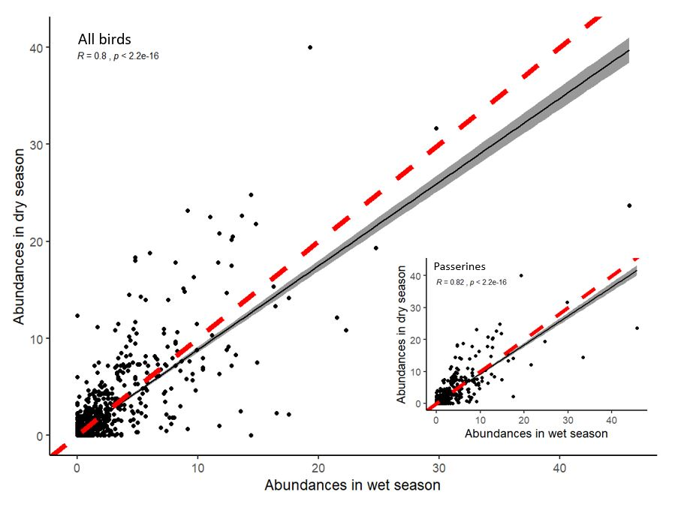

Figure S4. Differences between various measures used in the analyses. Weighted mean point - the weighted mean is similar to an ordinary arithmetic mean, except that instead of each of the elevational site within the distributional range of a bird species contributing equally to the final average, the elevational points with higher abundance contribute more than others. Note that the point might fall outside of the surveyed sites. Maximum point – one out of the eight studied elevational sites where the highest abundace of a bird species was recorded. Mean elevational abundance – mean (across 16 points and replicates in time) number of birds recorded per 12.56 ha in 15-minute-long census. For some analyses, the elevational abundance was split into mean elevational abundance in wet season (16 points * 6 replicates in time) and dry season (16 points * 8 replicates in time). Maximal mean elevational abundance – the highest mean elevational abundance recorded for the given species along the gradient. Mean abundace - mean of mean elevational abudnaces from across the sites where the birds species ocured.
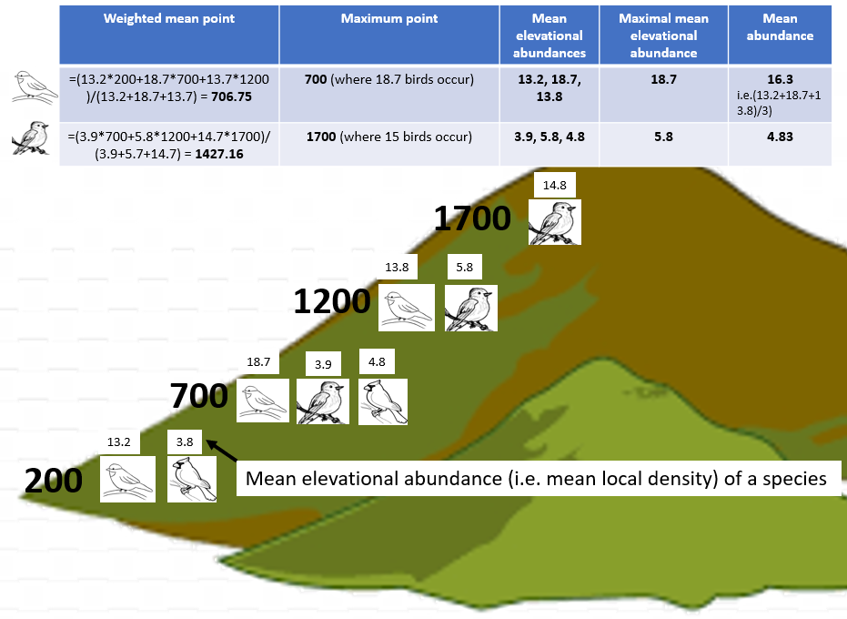
Figure S5. Mean (±SE) number of individuals per passerine and non-passerine bird species occurring in each assemblage at each elevational increment along Mt Wilhelm.

Figure S6. Maximal elevation abundances of passerine and non-passerine bird species with maximal abundances at certain elevation. Bird species with maximal abundances above 1700 m typically had higher maximal abundances than bird species with maxima at lower elevations.

Figure S7. The relationship between the mean abundance of geographical ranges (log transformed) of individual bird species. Only the relationship between mean abundances of all bird species and their ranges was significant (black line, F_{1,248} = 8.22, P = 0.004). After subsampling into passerine and non-passerine birds, the trends remained negative, albeit non-significant, for passerines (F_{1,159} = 1.17, P = 0.28) and non-passerines (F_{1,86} = 2.6, P = 0.10) separately.

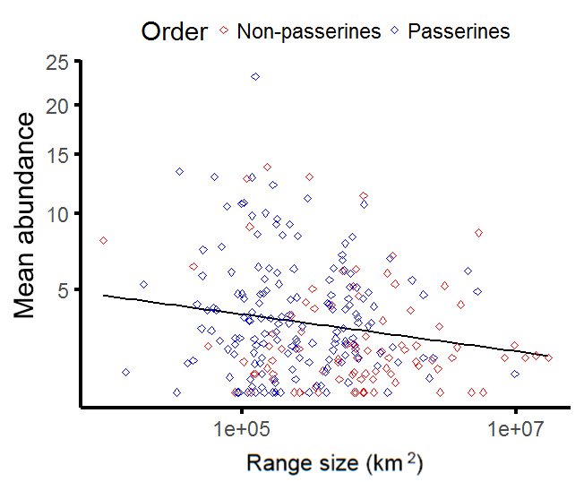

Figure S8. Abundance-range size relationship of three groups of passerine (black dashed lines) and non-passerine (red lines) bird species. (a) species with weighted mean point below 800 m a.s.l. (b) species with weighted mean point between 800 and 1600 m a.s.l. (c) species with weighted mean point above 1600 m a.s.l. Trends are depicted by regression lines fitted by the ordinary least squares method. Note log scale used on x-axes and square root transformation on y-axes. The insets depict the patterns we expected for particular species groups based on range size limitations and increasing abundance towards higher elevations

Figure S9. Passerine (a ,b) and non-passerine (c, d) birds divided into three groups based on the position of their weighted mean point of elevational distribution on Mt. Wilhelm, and their mean abundances in wet (a, c) and dry season (b, d). Kruskal-Wallis - passerines in dry season (a) χ² = 5.5, df = 2, N = 161, P < 0.05; in wet season (b) χ² = 17.3, df = 2, N = 161, P < 0.001; non-passerines in dry season (c) χ² = 1.9, df = 2, N = 88, P = 0.377; in wet season (d) χ² = 0.5, df = 2, N = 88, P =0.773. Significant differences between the groups of birds are denoted by different letters above the box-plots. Lowland group = elevational weighted mean point up to 800m a.s.l., mid group = elevational weighted mean point between 801 and 1600m a.s.l., and montane group = elevational weighted mean point above 1600 m a.s.l.

Figure S10. Correlation (Maximal mean elevational abundance point = 1.0198* Weighted mean point - 23.434, R² = 0.9745) between weighted mean point and maximal mean elevational abundance point (a) and number of species assigned to lowland, mid and montane group of species based on the weighted mean and maximal abundance points (insert in a). Passerine and non-passerine species are divided into three groups based on the position of their maximal mean elevational abundance point and their mean abundances and summarized across season (b). The pattern is also valid within season: Kruskal-Wallis - passerines in wet season (a) χ² = 9.64, df = 2, N = 161, P < 0.008; in dry season (b) χ² = 5.87, df = 2, N = 161, P < 0.05; non-passerines in wet season (c) χ² = 4.75, df = 2, N = 88, P = 0.05; in dry season (d) χ² = 6.04, df = 2, N = 88, P = 0.048. Lowland group = elevational maximal mean point up to 800m a.s.l., mid group = elevational maximal mean point between 801 and 1600m a.s.l., and montane group = elevational maximal mean point above 1600 m a.s.l.

Figure S11. Passerine (a) and non-passerine (b) birds divided into three groups based on the position of their weighted mean point of elevational distribution on Mt. Wilhelm, and the length of their elevational ranges. Kruskal-Wallis passerines (a): χ² = 22.7, df = 2, N = 161, P < 0.001; non-passerines (b) χ² = 10.8, df = 2, N = 88, P = 0.004. Significant differences between the groups of birds are denoted by different letters above the box-plots. Lowland group = elevational weighted mean point up to 800m a.s.l., mid group = elevational weighted mean point between 801 and 1600m a.s.l., and montane group = elevational weighted mean point above 1600 m a.s.l.

Figure S12. The body mass of passerine and non-passerine bird species and size of the geographical range they occupy. Passerines: F_{1,159} = 0.105, P=0.746; non-passerines: F_{1,247} = 1.24, P=0.268.
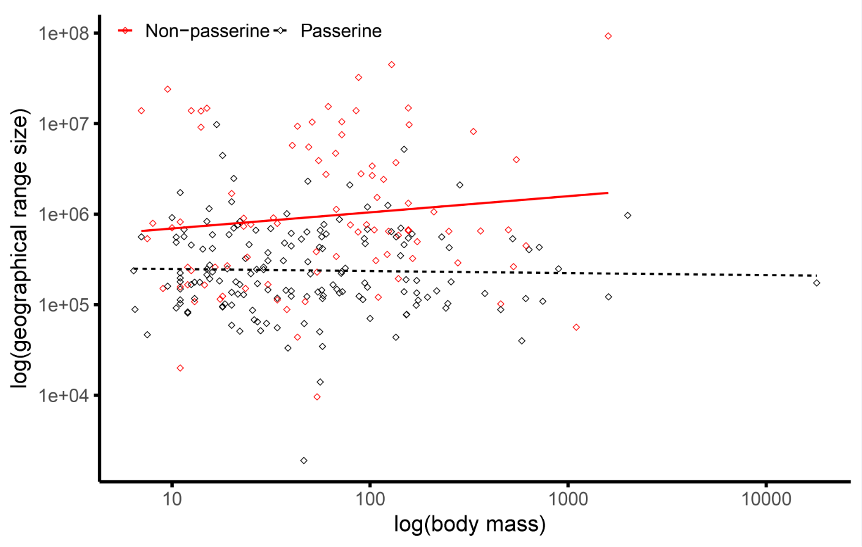

Table S1. List of bird species recorded during the point counts along the elevational gradient of Mt. Wilhelm in Papua New Guinea. Their mean elevational abundance (i.e. mean number of individuals recorded per 12.56 ha at each elevation where they were recorded) and mean abundance (i.e. across the range they occupied). Further, for each bird species the order is specified (PASS. for passerines and NON for non-passerines), the location its elevational mean-point and to which group of birds it was identified based on this weighted mean point (either lowland, mid-elevation or montane bird species). Finally, the last two columns show which feeding guild the species belong to and the size of their range (in km²). Feeding specialization was obtained from (Sam et al. 2019; Sam et al. 2017) and range are was obtained from Bird-Life International data zone.
Scientific name | Mean elevational abundance at each elevation |  |  |  |  |  |  |  | Mean abundance | Order | Weighted mean point | Group | Guild | Area
 | 200 | 700 | 1200 | 1700 | 2200 | 2700 | 3200 | 3700
Acanthiza cinerea |  |  |  | 1.83 | 1.56 | 5.77 | 1.67 |  | 2.706 | PASS. | 2450 | Mont. | In | 122000
Acanthiza murina |  |  |  |  | 7 | 3.6 | 3.14 | 10.29 | 6.007 | PASS. | 2950 | Mont. | In | 83100
Accipiter fasciatus |  |  |  |  | 2 |  |  |  | 2 | NON | 2200 | Mont. | Ca | 8000000
Accipiter meyerianus |  |  |  |  | 1 |  |  |  | 1 | NON | 2200 | Mont. | Ca | 263000
Aegotheles albertisi |  |  |  |  | 1 |  |  |  | 1 | NON | 2200 | Mont. | In | 88500
Aegotheles insignis |  |  |  |  |  | 1.33 |  |  | 1.333 | NON | 2700 | Mont. | In | 166000
Aepypodius arfakianus |  |  |  | 2.33 |  |  |  |  | 2.333 | NON | 1700 | Mid | Fr | 194000
Aerodramus hirundinaceus |  |  |  | 2.5 |  |  |  |  | 2.5 | NON | 1700 | Mid | In | 584000
Ailuroedus buccoides |  | 1.5 | 1 | 1 |  |  |  |  | 1.167 | PASS. | 1200 | Mid | Fr-In | 375000
Ailuroedus melanotis |  |  |  |  | 1 |  |  |  | 1 | PASS. | 2200 | Mont. | Fr-In | 167000
Aleadryas rufinucha |  |  |  | 1.4 | 4.4 | 2.33 | 2.73 | 1.8 | 2.532 | PASS. | 2700 | Mont. | In | 142000
Alisterus chloropterus |  | 1 | 1 |  | 8.22 | 10 |  |  | 5.056 | NON | 1700 | Mid | Fr | 324000
Alopecoenas beccarii |  |  | 1.33 | 1.67 |  |  |  |  | 1.5 | NON | 1450 | Mid | Fr | 167000
Alopecoenas jobiensis |  |  | 1 |  | 4 |  |  |  | 2.5 | NON | 1700 | Mid | Fr | 647000
Amalocichla incerta |  |  |  | 1 |  |  |  |  | 1 | PASS. | 1700 | Mont. | In | 144000
Amblyornis macgregoriae |  |  |  | 1 |  | 1 | 2.63 |  | 1.542 | PASS. | 2450 | Mont. | Fr | 14000
Anthus gutturalis |  |  |  |  |  |  | 10.8 | 16.07 | 13.436 | PASS. | 3450 | Mont. | In | 34600
Aplonis cantoroides | 4.86 |  |  |  |  |  |  |  | 4.857 | PASS. | 200 | Low. | Fr-In | 831000
Aplonis metallica | 10.71 |  |  |  |  |  |  |  | 10.714 | PASS. | 200 | Low. | Fr-In | 770000
Arses insularis | 1.71 | 2.25 | 3.43 | 3 |  |  |  |  | 2.598 | PASS. | 950 | Mid | In | 249000
Artamus maximus |  |  |  |  |  | 6.83 | 2 | 5 | 4.611 | PASS. | 3200 | Mont. | In | 249000
Astrapia stephaniae |  |  |  |  | 1 | 2.14 | 10.17 | 2.6 | 3.977 | PASS. | 2950 | Mont. | Fr | 55600
Cacatua galerita | 9 | 4.9 | 2.09 | 1 |  |  |  |  | 4.248 | NON | 950 | Mid | Fr | 4000000
Cacomantis castaneiventris | 1 | 1 | 2 | 1.88 | 2.14 | 1 |  |  | 1.503 | NON | 1450 | Mid | In | 791000
Cacomantis flabelliformis |  |  | 3 | 1.43 | 1.57 | 1.75 | 1.88 |  | 1.925 | NON | 2200 | Mont. | In | 2000000
Cacomantis leucolophus | 1.4 | 1.25 | 3.22 |  |  |  |  |  | 1.957 | NON | 700 | Low. | In | 497000
Cacomantis variolosus | 3 | 3.6 | 1.67 | 1.25 |  |  |  |  | 2.379 | NON | 950 | Mid | In | 4000000
Caligavis obscura |  |  | 1 |  |  |  |  |  | 1 | PASS. | 1200 | Mid | Fr-In | 174000
Caligavis subfrenata |  |  |  | 1.5 | 1 | 6.57 | 7.91 | 4.63 | 4.321 | PASS. | 2700 | Mont. | In-Ne | 133000
Campochaera sloetii | 1.5 |  | 3.33 |  |  |  |  |  | 2.417 | PASS. | 700 | Low. | Fr-In | 230000
Caprimulgus macrurus | 1 |  |  |  |  |  |  |  | 1 | NON | 200 | Low. | In | 6000000
Carterornis chrysomela | 2.64 | 1.8 | 3.8 |  |  |  |  |  | 2.745 | PASS. | 700 | Low. | In | 641000
Casuarius bennetti |  |  |  |  |  | 1 |  |  | 1 | NON | 2700 | Mont. | Fr | 359000
Centropus phasianinus | 2.29 | 1 |  |  |  |  |  |  | 1.643 | NON | 450 | Low. | In | 3000000
Ceyx azureus | 3 | 1.67 | 1.33 |  |  |  |  |  | 2 | NON | 700 | Low. | In | 3000000
Ceyx lepidus | 5.11 | 6.43 | 7.58 |  |  |  |  |  | 6.374 | NON | 700 | Low. | In | 43800
Ceyx pusillus | 1 |  |  |  |  |  |  |  | 1 | NON | 200 | Low. | In | 910000
Chaetorhynchus papuensis | 1 | 1 | 3.22 | 2.17 |  |  |  |  | 1.847 | PASS. | 950 | Mid | In | 306000
Chalcophaps indica | 1 | 1 |  |  |  |  |  |  | 1 | NON | 450 | Low. | Fr-In | 5000000
Chalcophaps stephani |  | 1.67 | 1 |  |  |  |  |  | 1.333 | NON | 950 | Mid | Fr | 902000
Charmosyna josefinae |  |  |  | 9.5 | 25 | 7 |  |  | 13.833 | NON | 2200 | Mont. | Ne | 151000
Charmosyna papou |  |  |  | 4.4 | 8.86 | 10.57 | 12.67 | 3.8 | 8.059 | NON | 2700 | Mont. | Ne | 9600
Charmosyna placentis | 2 | 2.5 |  |  |  |  |  |  | 2.25 | NON | 450 | Low. | Ne | 821000
Charmosyna rubronotata | 2.33 |  |  |  |  |  |  |  | 2.333 | NON | 200 | Low. | Ne | 259000
Charmosyna wilhelminae |  | 4 | 6.57 |  |  | 2.5 |  |  | 4.357 | NON | 1700 | Mid | Ne | 290000
Chlamydera lauterbachi |  |  |  |  | 1 |  |  |  | 1 | PASS. | 2200 | Mont. | Fr-In | 124000
Chrysococcyx minutillus | 1 |  |  |  |  |  |  |  | 1 | NON | 200 | Low. | In | 3000000
Chrysococcyx ruficollis |  |  |  |  |  | 1.67 |  |  | 1.667 | NON | 2700 | Mont. | In | 151000
Cicinnurus regius | 3.18 | 2.25 |  |  |  |  |  |  | 2.716 | PASS. | 450 | Low. | Fr-In | 480000
Cinnyris jugularis | 3 | 4 | 5.29 | 7.38 |  |  |  |  | 4.915 | PASS. | 950 | Mid | In-Ne | 5000000
Clytoceyx rex |  |  |  | 1.25 | 1 |  |  |  | 1.125 | NON | 1950 | Mont. | In | 341000
Clytomyias insignis |  |  |  |  |  |  | 1 | 2 | 1.5 | PASS. | 3450 | Mont. | In | 139000
Cnemophilus loriae |  |  |  | 1 | 1 | 1 | 1.5 |  | 1.125 | PASS. | 2450 | Mont. | Fr-In | 138000
Cnemophilus macgregorii |  |  |  |  | 1.4 | 1.88 | 3 | 1.4 | 1.919 | PASS. | 2950 | Mont. | Fr | 43700
Collocalia esculenta |  |  |  | 7 | 1.67 | 1 |  |  | 3.222 | NON | 2200 | Mont. | In | 3000000
Colluricincla megarhyncha | 3.58 | 4.5 | 11.92 | 11.71 | 2.5 |  |  |  | 6.844 | PASS. | 1200 | Mid | In | 1000000
Columba vitiensis |  |  |  |  | 1 | 2.33 |  |  | 1.667 | NON | 2450 | Mont. | Fr | 1000000
Coracina boyeri | 1 | 10 | 1.67 |  |  |  |  |  | 4.222 | PASS. | 700 | Low. | Fr-In | 604000
Coracina caeruleogrisea |  | 1 | 2.25 | 1.33 | 2 | 1.2 |  |  | 1.557 | PASS. | 1700 | Mont. | In | 405000
Coracina incerta | 1 | 1.33 |  |  |  |  |  |  | 1.167 | PASS. | 450 | Low. | In | 348000
Coracina longicauda |  |  |  | 1 |  | 2.67 |  |  | 1.833 | PASS. | 2200 | Mont. | In | 135000
Coracina melas | 1.25 |  |  |  |  |  |  |  | 1.25 | PASS. | 200 | Low. | In | 593000
Coracina montana |  | 1 | 4.33 | 5.73 | 1.5 | 1 |  |  | 2.712 | PASS. | 1700 | Mont. | Fr-In | 247000
Coracina papuensis | 7.27 | 3.67 | 10 | 3.4 |  |  |  |  | 6.085 | PASS. | 950 | Mid | In | 4000000
Coracina schisticeps |  |  |  |  | 1 |  |  |  | 1 | PASS. | 2200 | Mont. | Fr-In | 166000
Coracina tenuirostris | 1 |  | 1.75 |  |  |  |  |  | 1.375 | PASS. | 700 | Low. | In | 2000000
Corvus tristis | 4.88 | 3.67 | 3 | 3 |  |  |  |  | 3.635 | PASS. | 950 | Mid | Fr-In | 693000
Cracticus cassicus | 7.83 |  |  |  |  |  |  |  | 7.833 | PASS. | 200 | Low. | Fr-In | 561000
Cracticus quoyi | 1 |  |  |  |  |  |  |  | 1 | PASS. | 200 | Low. | In | 1000000
Crateroscelis murina | 1 | 8.7 | 8.79 | 6.38 |  |  |  |  | 6.218 | PASS. | 950 | Mid | In | 237000
Crateroscelis nigrorufa |  |  |  | 1.33 |  |  |  |  | 1.333 | PASS. | 1700 | Mont. | In | 114000
Crateroscelis robusta |  | 4 |  | 3.44 | 5.33 | 6 | 9.46 | 9.36 | 6.266 | PASS. | 2200 | Mont. | In | 156000
Cyclopsitta diophthalma | 1.5 | 4 | 8.54 | 2.8 |  |  |  |  | 4.21 | NON | 950 | Mid | Fr | 448000
Cyclopsitta gulielmitertii | 2.25 |  | 1.5 |  |  |  |  |  | 1.875 | NON | 700 | Low. | Fr | 102000
Dacelo gaudichaud | 10.91 | 1.5 |  |  |  |  |  |  | 6.205 | NON | 450 | Low. | In | 671000
Daphoenositta miranda |  |  |  |  |  | 2.5 | 1.71 | 1.25 | 1.821 | PASS. | 3200 | Mont. | In | 39900
Dicaeum geelvinkianum | 3.2 | 7.1 | 6.93 | 12.31 | 5.85 |  |  |  | 7.076 | PASS. | 1200 | Mid | Fr | 535000
Dicrurus bracteatus | 6.17 | 3.33 |  |  |  |  |  |  | 4.75 | PASS. | 450 | Low. | In | 2000000
Diphyllodes magnificus |  | 3.8 | 4.43 | 2.33 |  |  |  |  | 3.521 | PASS. | 1200 | Mid | Fr-In | 112000
Ducula chalconota |  |  |  | 1.33 | 3.43 | 1 |  |  | 1.921 | NON | 2200 | Mont. | Fr | 165000
Ducula pinon | 1.43 | 1.5 |  |  |  |  |  |  | 1.464 | NON | 450 | Low. | Fr | 635000
Ducula rufigaster | 1 |  |  |  |  |  |  |  | 1 | NON | 200 | Low. | Fr | 671000
Ducula zoeae | 7 | 2.43 | 4.62 |  |  |  |  |  | 4.681 | NON | 700 | Low. | Fr | 707000
Eclectus roratus | 7.08 | 3.78 | 1 |  |  |  |  |  | 3.954 | NON | 700 | Low. | Fr | 2000000
Epimachus fastosus |  |  | 1 | 1.5 | 2.67 | 4.09 |  |  | 2.314 | PASS. | 1950 | Mont. | Fr-In | 78200
Epimachus meyeri |  |  |  | 2 | 3.5 | 8.77 | 4.8 |  | 4.767 | PASS. | 2450 | Mont. | Fr-In | 135000
Erythropitta erythrogaster | 1.6 | 3.2 |  |  |  |  |  |  | 2.4 | PASS. | 450 | Low. | In | 1000000
Erythrura trichroa |  |  |  | 4 | 2.33 | 1.6 | 2 | 7 | 3.387 | PASS. | 2700 | Mont. |  | 875000
Eudynamys scolopaceus | 2.4 | 2.5 |  |  |  |  |  |  | 2.45 | NON | 450 | Low. | Fr-In | 10000000
Eugerygone rubra |  |  |  | 1 | 2.38 | 3.75 | 1.67 | 2.11 | 2.181 | PASS. | 2700 | Mont. | In | 121000
Eulacestoma nigropectus |  |  |  |  |  | 2.75 |  |  | 2.75 | PASS. | 2700 | Mont. | In | 88700
Eurystomus orientalis | 1.17 | 3 |  |  |  |  |  |  | 2.083 | NON | 450 | Low. | In | 10000000
Garritornis isidorei | 2.5 |  |  |  |  |  |  |  | 2.5 | PASS. | 200 | Low. | In | 561000
Geoffroyus geoffroyi | 2.8 |  |  |  |  |  |  |  | 2.8 | NON | 200 | Low. | Fr | 793000
Geoffroyus simplex | 1 |  |  |  |  |  |  |  | 1 | NON | 200 | Low. | Fr | 238000
Gerygone chloronota | 1.5 | 2.67 | 2.38 |  |  |  |  |  | 2.181 | PASS. | 700 | Low. | In | 1000000
Gerygone chrysogaster | 2.5 | 3.78 |  |  |  |  |  |  | 3.139 | PASS. | 450 | Low. | In | 544000
Gerygone palpebrosa | 1.67 |  | 1.8 |  |  |  |  |  | 1.733 | PASS. | 700 | Low. | In | 969000
Gerygone ruficollis |  |  |  | 6.18 | 4.38 | 7.75 | 3.17 | 1.33 | 4.561 | PASS. | 2700 | Mont. | In | 103000
Grallina bruijnii |  |  | 3 | 1 |  |  |  |  | 2 | PASS. | 1450 | Mid | In | 260000
Gymnophaps albertisii |  | 4 |  | 3.78 | 14.67 | 11.15 | 1 | 2 | 6.1 | NON | 2200 | Mont. | Fr | 536000
Harpyopsis novaeguineae |  |  | 1 | 2 |  | 1 |  |  | 1.333 | NON | 1950 | Mont. | Ca | 734000
Henicophaps albifrons | 1 | 1 | 1 |  |  |  |  |  | 1 | NON | 700 | Low. | Fr | 769000
Heteromyias albispecularis |  |  |  | 3.43 | 1 | 1 |  |  | 1.81 | PASS. | 2200 | Mont. | In | 123000
Ifrita kowaldi |  |  |  | 2 | 2 | 9.6 | 7.08 | 3.29 | 4.794 | PASS. | 2700 | Mont. | In | 91900
Lalage atrovirens | 1 |  |  |  |  |  |  |  | 1 | PASS. | 200 | Low. | Fr-In | 306000
Leptocoma sericea | 7.83 | 1.5 | 3.13 |  |  |  |  |  | 4.153 | PASS. | 700 | Low. | In-Ne | 915000
Loboparadisea sericea |  |  |  | 1.5 |  | 1 |  |  | 1.25 | PASS. | 2200 | Mont. | Fr | 174000
Lonchura spectabilis |  |  |  | 1 | 3.33 |  |  |  | 2.167 | PASS. | 1950 | Mont. | Gr | 214000
Lonchura tristissima | 4 |  |  |  |  |  |  |  | 4 | PASS. | 200 | Low. | Gr | 560000
Lophorina superba |  |  |  | 3.57 |  |  |  |  | 3.571 | PASS. | 1700 | Mont. | Fr-In | 160000
Loriculus aurantiifrons | 2.22 |  |  |  |  |  |  |  | 2.222 | NON | 200 | Low. | Ne | 20000
Lorius lory | 5.43 | 12.11 | 3.55 |  |  |  |  |  | 7.028 | NON | 700 | Low. | Ne | 10000000
Machaerirhynchus flaviventer | 1.13 | 2 | 3.85 | 1 |  |  |  |  | 1.993 | PASS. | 950 | Mid | In | 702000
Machaerirhynchus nigripectus |  |  | 6 | 4.5 | 2 | 3 | 1.33 |  | 3.367 | PASS. | 2200 | Mont. | In | 219000
Macropygia amboinensis | 3.9 | 2 | 4 | 4.27 | 3.22 |  |  |  | 3.479 | NON | 1200 | Mid | Fr | 1000000
Macropygia nigrirostris |  | 1 |  | 5 | 12 | 2.86 |  |  | 5.214 | NON | 1700 | Mid | Fr | 647000
Malurus alboscapulatus |  |  |  | 2.5 | 6 |  |  |  | 4.25 | PASS. | 1950 | Mont. | In | 431000
Manucodia chalybatus |  |  | 1.4 |  |  |  |  |  | 1.4 | PASS. | 1200 | Mid | Fr | 81000
Megalurus macrurus |  |  |  | 2 |  |  |  |  | 2 | PASS. | 1700 | Mont. | In | 2000000
Megapodius decollatus | 1 | 1.67 |  |  |  |  |  |  | 1.333 | NON | 450 | Low. | Fr-In | 10000000
Melampitta lugubris |  |  |  |  |  | 3 | 2.14 | 4 | 3.048 | PASS. | 3200 | Mont. | In | 59300
Melanocharis longicauda |  |  |  | 1 |  | 1 |  |  | 1 | PASS. | 2200 | Mont. | Fr-In | 94300
Melanocharis nigra | 5.5 | 12.33 | 6.36 | 6 | 1 |  |  |  | 6.238 | PASS. | 1200 | Mid | Fr-In | 461000
Melanocharis striativentris |  |  |  | 2.78 |  | 1.5 |  |  | 2.139 | PASS. | 2200 | Mont. | Fr | 86800
Melanocharis versteri |  |  |  | 5 | 7.92 | 5.69 | 5.54 | 4 | 5.631 | PASS. | 2700 | Mont. | Fr-In | 145000
Melanorectes nigrescens |  |  |  | 2.57 | 2.8 | 2 |  |  | 2.457 | PASS. | 2200 | Mont. | In | 126000
Melidectes belfordi |  |  |  | 10 | 22.43 | 30.57 | 39.08 | 13.91 | 23.197 | PASS. | 2700 | Mont. | In-Ne | 124000
Melidectes fuscus |  |  |  |  | 3.86 | 1.71 | 6.08 | 18.85 | 7.624 | PASS. | 2950 | Mont. | In-Ne | 70500
Melidectes princeps |  |  |  |  |  |  | 1 | 9.64 | 5.318 | PASS. | 3450 | Mont. | In-Ne | 1900
Melidectes rufocrissalis |  |  |  | 9.44 | 1 | 1.5 |  |  | 3.981 | PASS. | 2200 | Mont. | Fr-In | 64700
Melidectes torquatus |  |  | 2.5 | 4.73 | 1 |  |  |  | 2.742 | PASS. | 1700 | Mont. | Fr-In | 95800
Melidora macrorrhina | 1 | 2 |  |  |  |  |  |  | 1.5 | NON | 450 | Low. | In | 108000
Melilestes megarhynchus | 3 | 4.1 | 2.83 | 2.13 | 1 |  |  |  | 2.612 | PASS. | 1200 | Mid | In-Ne | 562000
Meliphaga analoga | 18.58 | 8.4 | 9.27 | 4.13 | 1 |  |  |  | 8.276 | PASS. | 1200 | Mid | In-Ne | 636000
Meliphaga aruensis | 1.83 | 1.5 | 3.25 |  |  |  |  |  | 2.194 | PASS. | 700 | Low. | Fr-In | 664000
Meliphaga montana |  |  | 3.88 |  |  |  |  |  | 3.875 | PASS. | 1200 | Mid | Fr-In | 118000
Meliphaga orientalis |  |  |  | 8.5 | 1.25 | 1.25 |  |  | 3.667 | PASS. | 2200 | Mont. | In-Ne | 193000
Melipotes fumigatus |  |  | 3.5 | 4.17 | 3.5 | 5.5 | 8.33 | 4.89 | 4.981 | PASS. | 2450 | Mont. | Fr-In | 149000
Merops ornatus | 2 |  |  |  |  |  |  |  | 2 | NON | 200 | Low. | In | 13760000
Microdynamis parva | 2 |  |  |  |  |  |  |  | 2 | NON | 200 | Low. | Fr | 9360000
Microeca flavovirescens | 2.63 | 4.57 | 4.22 |  |  |  |  |  | 3.806 | PASS. | 700 | Low. | In | 675000
Microeca griseoceps |  |  | 1 |  |  |  |  |  | 1 | PASS. | 1200 | Mid | In | 189000
Microeca papuana |  |  |  | 2.23 | 6.7 | 5.54 |  |  | 4.823 | PASS. | 2200 | Mont. | In | 142000
Micropsitta bruijnii |  |  | 3 |  |  |  |  |  | 3 | NON | 1200 | Mid | In-Ne | 269000
Micropsitta pusio | 6.57 | 6.29 | 5 |  |  |  |  |  | 5.952 | NON | 700 | Low. | In-Ne | 9120000
Mino anais | 1 | 1 |  |  |  |  |  |  | 1 | PASS. | 450 | Low. | Fr | 411000
Mino dumontii | 4.43 | 2.38 |  |  |  |  |  |  | 3.402 | PASS. | 450 | Low. | Fr-In | 701000
Monachella muelleriana | 1.67 |  |  |  |  |  |  |  | 1.667 | PASS. | 200 | Low. | In | 418000
Monarcha frater |  |  | 2.67 |  |  |  |  |  | 2.667 | PASS. | 1200 | Mid | In | 179000
Monarcha rubiensis | 1.33 |  |  |  |  |  |  |  | 1.333 | PASS. | 200 | Low. | In | 244000
Myiagra alecto | 2.56 | 2 | 1 |  |  |  |  |  | 1.852 | PASS. | 700 | Low. | In | 1000000
Myzomela rosenbergii |  |  | 1.5 | 11 | 28.14 | 4.64 | 5.62 | 4.3 | 9.199 | PASS. | 2450 | Mont. | In-Ne | 177000
Neopsittacus musschenbroekii |  |  | 6.5 | 5.63 | 2.33 | 2.67 | 1.5 |  | 3.725 | NON | 2200 | Mont. | Ne | 229000
Neopsittacus pullicauda |  |  |  | 6.13 | 5.2 | 10.56 | 11.18 | 12 | 9.012 | NON | 2700 | Mont. | Ne | 113000
Oedistoma iliolophus |  | 6.67 | 9.23 | 2.44 |  |  |  |  | 6.114 | PASS. | 1200 | Mid | In | 557000
Oreocharis arfaki |  |  |  | 2.91 | 3.25 | 5 | 2 | 2.5 | 3.132 | PASS. | 2700 | Mont. | Fr | 50200
Oreopsittacus arfaki |  |  |  |  | 3.43 | 11.43 | 20.25 | 16.22 | 12.832 | NON | 2950 | Mont. | Ne | 108000
Oreostruthus fuliginosus |  |  |  |  |  |  |  | 5.8 | 5.8 | PASS. | 3700 | Mont. | Fr-In | 51000
Oriolus szalayi | 5.14 |  |  |  |  |  |  |  | 5.143 | PASS. | 200 | Low. | Fr-In | 680000
Ornorectes cristatus |  |  | 2.5 |  |  |  |  |  | 2.5 | PASS. | 1200 | Mid | In | 88200
Otidiphaps nobilis |  |  | 1 |  |  |  |  |  | 1 | NON | 1200 | Mid | Fr | 260000
Pachycare flavogriseum |  |  | 1.33 | 1.33 |  |  |  |  | 1.333 | PASS. | 1450 | Mid | In | 171000
Pachycephala hyperythra | 3 | 1.17 | 9.73 | 5.29 |  |  |  |  | 4.795 | PASS. | 950 | Mid | In | 99100
Pachycephala modesta |  |  |  |  |  | 2.25 | 3 |  | 2.625 | PASS. | 2950 | Mont. | In | 68100
Pachycephala monacha |  | 1 |  |  |  |  |  |  | 1 | PASS. | 700 | Low. | In | 33200
Pachycephala schlegelii |  |  |  | 6.9 | 9.29 | 15.64 | 6.17 | 4.3 | 8.459 | PASS. | 2700 | Mont. | In | 129000
Pachycephala simplex |  | 3 | 3.5 |  |  |  |  |  | 3.25 | PASS. | 950 | Mid | In | 829000
Pachycephala soror |  | 3.5 | 7.2 | 4.27 | 2.22 | 1.5 |  |  | 3.739 | PASS. | 1700 | Mont. | In | 220000
Pachycephalopsis poliosoma |  |  | 7.83 | 2.83 |  |  |  |  | 5.333 | PASS. | 1450 | Mid | In | 185000
Paradigalla brevicauda |  |  |  |  | 1 |  |  |  | 1 | PASS. | 2200 | Mont. | Fr-In | 91700
Paradisaea minor | 8.5 | 9.6 | 15.39 |  |  |  |  |  | 11.162 | PASS. | 700 | Low. | Fr-In | 298000
Paramythia montium |  |  |  |  |  | 3.58 | 8.21 | 27.23 | 13.009 | PASS. | 3200 | Mont. | Fr | 62200
Peltops blainvillii | 2.44 | 1.29 |  |  |  |  |  |  | 1.865 | PASS. | 450 | Low. | In | 530000
Peltops montanus |  | 1.5 |  | 4 | 1 | 3.67 |  |  | 2.542 | PASS. | 1700 | Mont. | In | 324000
Peneothello bimaculata |  | 6.83 | 6.86 | 8.56 |  |  |  |  | 7.415 | PASS. | 1200 | Mid | In | 51600
Peneothello cyanus |  |  |  | 14.39 | 17.5 | 5 |  |  | 12.295 | PASS. | 2200 | Mont. | In | 167000
Peneothello sigillata |  |  |  |  |  | 11.25 | 9.92 | 10.42 | 10.53 | PASS. | 3200 | Mont. | In | 77400
Philemon buceroides | 9.82 | 1.33 |  |  |  |  |  |  | 5.576 | PASS. | 450 | Low. | In-Ne | 432000
Philemon meyeri | 7.08 | 3.5 | 2.17 |  |  |  |  |  | 4.25 | PASS. | 700 | Low. | In-Ne | 46600
Phylloscopus maforensis |  |  | 2.33 | 4.27 | 1 |  |  |  | 2.535 | PASS. | 1700 | Mont. | In | 473000
Pitohui dichrous |  | 6.88 | 15.07 | 5.64 |  |  |  |  | 9.196 | PASS. | 1200 | Mid | Fr-In | 222000
Pitohui kirhocephalus | 3.4 | 8.6 | 8.2 |  |  |  |  |  | 6.733 | PASS. | 700 | Low. | In | 538000
Pitta sordida | 2 | 2 |  |  |  |  |  |  | 2 | PASS. | 450 | Low. | In | 2000000
Podargus ocellatus |  |  |  | 1 |  |  |  |  | 1 | NON | 1700 | Mid | In | 761000
Poecilodryas albonotata |  |  |  |  | 1.25 | 1 | 1.2 |  | 1.15 | PASS. | 2700 | Mont. | In | 117000
Poecilodryas hypoleuca | 3.75 | 6 | 3.17 |  |  |  |  |  | 4.306 | PASS. | 700 | Low. | In | 417000
Probosciger aterrimus | 3.36 | 2.38 | 1.6 |  |  |  |  |  | 2.446 | NON | 700 | Low. | Fr | 14880000
Pseudeos fuscata | 3.11 |  |  | 5.75 | 20.27 | 16.43 |  |  | 11.391 | NON | 1450 | Mid | Fr-In | 766000
Pseudorectes ferrugineus | 7.83 |  | 4 |  |  |  |  |  | 5.917 | PASS. | 700 | Low. | Fr-In | 615000
Psittacella brehmii |  |  |  |  | 1 | 2 |  |  | 1.5 | NON | 2450 | Mont. | Fr | 124000
Psittacella picta |  |  |  |  |  | 1.25 | 2 | 4 | 2.417 | NON | 3200 | Mont. | Fr | 56400
Psittaculirostris edwardsii | 3 | 3 | 2.8 |  |  |  |  |  | 2.933 | NON | 700 | Low. | Fr | 1320000
Psitteuteles goldiei |  |  |  |  |  | 13 | 13 |  | 13 | NON | 2950 | Mont. | Ne | 307000
Psittrichas fulgidus | 2 |  |  |  |  |  |  |  | 2 | NON | 200 | Low. | Fr | 5512000
Pteridophora alberti |  |  |  |  |  | 1 |  |  | 1 | PASS. | 2700 | Mont. | Fr-In | 109000
Ptilinopus coronulatus | 1.5 | 1 | 2.25 | 4.6 |  |  |  |  | 2.338 | NON | 950 | Mid | Fr | 670000
Ptilinopus iozonus | 5.33 |  |  |  |  |  |  |  | 5.333 | NON | 200 | Low. | Fr | 10400000
Ptilinopus magnificus | 2.7 |  | 2.2 |  |  |  |  |  | 2.45 | NON | 700 | Low. | Fr | 32400000
Ptilinopus ornatus |  | 2.5 |  | 1 | 1.25 |  |  |  | 1.583 | NON | 1450 | Mid | Fr | 385000
Ptilinopus perlatus | 1 | 1.5 |  |  |  |  |  |  | 1.25 | NON | 450 | Low. | Fr | 10480000
Ptilinopus pulchellus | 1.88 | 1.33 | 1.5 |  |  |  |  |  | 1.569 | NON | 700 | Low. | Fr | 7536000
Ptilinopus rivoli |  |  |  | 4 | 4.75 | 3.75 | 3.75 |  | 4.063 | NON | 2450 | Mont. | Fr | 335000
Ptilinopus superbus | 1.67 | 1.33 | 4.14 |  | 2 |  |  |  | 2.286 | NON | 1200 | Mid | Fr | 2000000
Ptiloprora guisei |  |  |  | 3 | 6.5 | 5 | 1.8 |  | 4.075 | PASS. | 2450 | Mont. | Fr-In | 61900
Ptiloprora meekiana |  |  |  | 2 |  |  |  |  | 2 | PASS. | 1700 | Mont. | In | 139000
Ptiloprora perstriata |  |  |  |  | 3.5 | 18.86 | 14.79 | 6.2 | 10.836 | PASS. | 2950 | Mont. | In | 102000
Ptiloris magnificus |  | 2 | 8.31 |  |  |  |  |  | 5.154 | PASS. | 950 | Mid | Fr-In | 605000
Ptilorrhoa caerulescens | 2 | 1.83 | 2 |  |  |  |  |  | 1.944 | PASS. | 700 | Low. | In | 427000
Ptilorrhoa castanonota |  |  | 2.33 |  |  |  |  |  | 2.333 | PASS. | 1200 | Mid | In | 246000
Ptilorrhoa leucosticta |  |  |  | 1.4 | 1.5 | 2 |  |  | 1.633 | PASS. | 2200 | Mont. | In | 232000
Pycnopygius ixoides | 1.33 | 1 | 4.5 |  |  |  |  |  | 2.278 | PASS. | 700 | Low. | Fr | 460000
Rallicula forbesi |  |  |  |  |  | 1.5 |  |  | 1.5 | NON | 2700 | Mont. | In | 121000
Reinwardtoena reinwardti | 1 | 1.5 | 2 | 1.33 | 1.63 | 1.8 | 1.5 |  | 1.537 | NON | 1700 | Mid | Fr | 656000
Rhagologus leucostigma |  |  |  | 3.8 | 2.7 | 2.25 |  |  | 2.917 | PASS. | 2200 | Mont. | Fr-In | 146000
Rhipidura albolimbata |  |  |  | 11.07 | 12.33 | 12.29 | 8.46 | 6 | 10.03 | PASS. | 2700 | Mont. | In | 148000
Rhipidura atra |  | 1.5 | 3.43 | 10.79 | 7.29 | 6.9 |  |  | 5.98 | PASS. | 1700 | Mont. | In | 179000
Rhipidura brachyrhyncha |  |  |  |  | 4.13 | 10.67 | 6.62 | 3.88 | 6.321 | PASS. | 2950 | Mont. | In | 131000
Rhipidura hyperythra |  | 4 |  |  |  |  |  |  | 4 | PASS. | 700 | Low. | In | 456000
Rhipidura leucothorax | 3.83 | 1.5 | 1 |  |  |  |  |  | 2.111 | PASS. | 700 | Low. | In | 565000
Rhipidura rufidorsa |  | 3 |  |  |  |  |  |  | 3 | PASS. | 700 | Low. | In | 488000
Rhipidura rufiventris | 3.67 | 3.88 | 9.08 |  |  |  |  |  | 5.54 | PASS. | 700 | Low. | In | 2000000
Rhipidura threnothorax | 6.75 | 3.75 | 6.13 |  | 1.5 |  |  |  | 4.531 | PASS. | 1200 | Mid | In | 594000
Rhyticeros plicatus | 7.58 | 3.67 | 4.45 |  |  |  |  |  | 5.235 | NON | 700 | Low. | Fr | 24000000
Saxicola caprata |  |  |  | 2 | 1 |  |  |  | 1.5 | PASS. | 1950 | Mont. | In | 10000000
Scolopax rosenbergii |  |  |  |  |  | 1 |  |  | 1 | NON | 2700 | Mont. | In | 115000
Scythrops novaehollandiae | 2 |  |  |  |  |  |  |  | 2 | NON | 200 | Low. | Fr-In | 92800000
Sericornis arfakianus |  |  | 3 |  |  |  |  |  | 3 | PASS. | 1200 | Mid | In | 177000
Sericornis nouhuysi |  |  |  | 5.17 | 12.39 | 17.79 | 12 | 6.33 | 10.734 | PASS. | 2700 | Mont. | In | 98600
Sericornis papuensis |  |  |  | 7.67 | 7 | 18.25 | 6.36 |  | 9.82 | PASS. | 2450 | Mont. | In | 117000
Sericornis perspicillatus |  |  |  | 15.14 | 18.83 | 4.86 |  |  | 12.944 | PASS. | 2200 | Mont. | In | 117000
Sericornis spilodera |  | 4.5 | 5.33 | 2 |  | 1 |  |  | 3.208 | PASS. | 1700 | Mont. | In | 274000
Syma megarhyncha |  |  | 2.71 | 2.67 | 2.33 | 2 |  |  | 2.429 | NON | 1950 | Mont. | In | 157000
Syma torotoro | 1 | 2.75 |  |  |  |  |  |  | 1.875 | NON | 450 | Low. | In | 14800000
Symposiachrus axillaris |  |  | 3.8 | 5 | 2.08 | 3 |  |  | 3.471 | PASS. | 1950 | Mont. | In | 113000
Symposiachrus guttula | 2.6 | 3.75 | 1 |  |  |  |  |  | 2.45 | PASS. | 700 | Low. | In | 664000
Symposiachrus manadensis | 4.71 |  |  |  |  |  |  |  | 4.714 | PASS. | 200 | Low. | In | 445000
Talegalla jobiensis | 2.78 | 1.6 | 1.17 |  |  |  |  |  | 1.848 | NON | 700 | Low. | Fr-In | 4000000
Tanysiptera galatea | 2.09 | 1.4 |  |  |  |  |  |  | 1.745 | NON | 450 | Low. | In | 15440000
Timeliopsis fulvigula |  |  |  | 3.6 |  |  |  |  | 3.6 | PASS. | 1700 | Mont. | In | 137000
Toxorhamphus novaeguineae | 7.92 | 8 | 9.29 |  |  |  |  |  | 8.401 | PASS. | 700 | Low. | In-Ne | 197000
Toxorhamphus poliopterus |  |  | 6 | 12.5 | 10.29 |  |  |  | 9.595 | PASS. | 1700 | Mont. | In-Ne | 179000
Tregellasia leucops |  | 1.5 | 5.2 |  |  |  |  |  | 3.35 | PASS. | 950 | Mid | In | 183000
Trichoglossus haematodus | 13.42 | 7.4 | 4.9 |  |  |  |  |  | 8.572 | NON | 700 | Low. | Ne | 44880000
Trugon terrestris |  |  |  | 1 | 1 |  |  |  | 1 | NON | 1950 | Mont. | Fr | 652000
Turdus poliocephalus |  |  |  |  |  | 1.5 | 7.67 | 15.86 | 8.341 | PASS. | 3200 | Mont. | In | 253000
Xanthotis flaviventer |  | 5.86 | 3.2 |  |  |  |  |  | 4.529 | PASS. | 950 | Mid | In | 762000
Zosterops minor | 2 | 7.2 | 4.33 |  |  |  |  |  | 4.511 | PASS. | 700 | Low. | In | 224000
Zosterops novaeguineae |  | 2 |  | 3.92 | 5.64 | 3 |  |  | 3.64 | PASS. | 1700 | Mont. | In | 103000

Sam, K., B. Koane, D. C. Bardos, S. Jeppy, and V. Novotny. 2019. Species richness of birds along a complete rain forest elevational gradient in the tropics: Habitat complexity and food resources matter. Journal of Biogeography 46:279-290.

