Genome-wide identification and expression analyses of R2R3-MYB transcription factor genes from two Orchid species
Honghong Fan^{†1}, Manli Cui^{†1}, Ninghong Li¹, Xujuan Li¹, Yuxuan Liang², Lin Liu¹, Yongping Cai*¹, Yi Lin*¹
- School of Life Sciences, Anhui Agricultural University, Hefei 230036, China;
- Faculty of Forestry, University of British Columbia, Vancouver V6T1Z4, Canada;
hhfan0551@126.com (H.F.);1289121655@qq.com (M.C.); lnh0411@163.com(N.L.)
lxj152567@163.com (X.L.); liulin2018@ahau.edu.cn (L.L.).
*Correspondence:swkx12@ahau.edu.cn (Yongping Cai); linyi1957@126.com (Yi Lin)
Tel: +86-551-65786137 (Yongping Cai); +86-551-65786340 (Yi Lin)
† These authors contributed equally to this work.

Supplementary Table S1. The correspondence between gene serial number and nomenclature
Dendrobium officinale |  | Phalaenopsis aphrodite
DoMYB1 | Dendrobium_GLEAN_10034968 | PaMYB1 | PAXXG290370-mRNA1 gene=PAXXG290370
DoMYB2 | Dendrobium_GLEAN_10010315 | PaMYB2 | PAXXG094110-mRNA1 gene=PAXXG094110
DoMYB3 | Dendrobium_GLEAN_10045399 | PaMYB3 | PAXXG065970-mRNA1 gene=PAXXG065970
DoMYB4 | Dendrobium_GLEAN_10008951 | PaMYB4 | PAXXG114410-mRNA1 gene=PAXXG114410
DoMYB5 | Dendrobium_GLEAN_10095503 | PaMYB5 | PAXXG076770-mRNA1 gene=PAXXG076770
DoMYB6 | Dendrobium_GLEAN_10020399 | PaMYB6 | PAXXG156600-mRNA1 gene=PAXXG156600
DoMYB7 | Dendrobium_GLEAN_10019161 | PaMYB7 | PAXXG120810-mRNA1 gene=PAXXG120810
DoMYB8 | Dendrobium_GLEAN_10079201 | PaMYB8 | PAXXG301890-mRNA1 gene=PAXXG301890
DoMYB9 | Dendrobium_GLEAN_10111887 | PaMYB9 | PAXXG216740-mRNA1 gene=PAXXG216740
DoMYB10 | Dendrobium_GLEAN_10115450 | PaMYB10 | PAXXG124400-mRNA1 gene=PAXXG124400
DoMYB11 | Dendrobium_GLEAN_10080949 | PaMYB11 | PAXXG212240-mRNA1 gene=PAXXG212240
DoMYB12 | Dendrobium_GLEAN_10134249 | PaMYB12 | PAXXG112540-mRNA1 gene=PAXXG112540
DoMYB13 | Dendrobium_GLEAN_10054149 | PaMYB13 | PAXXG212220-mRNA1 gene=PAXXG212220
DoMYB14 | Dendrobium_GLEAN_10060515 | PaMYB14 | PAXXG199350-mRNA1 gene=PAXXG199350
DoMYB15 | Dendrobium_GLEAN_10085809 | PaMYB15 | PAXXG094660-mRNA1 gene=PAXXG094660
DoMYB16 | PEQU_28089-D1 | PaMYB16 | PAXXG313220-mRNA1 gene=PAXXG313220
DoMYB17 | Dendrobium_GLEAN_10044611 | PaMYB17 | PAXXG212230-mRNA1 gene=PAXXG212230
DoMYB18 | Dendrobium_GLEAN_10044608 | PaMYB18 | PAXXG076310-mRNA1 gene=PAXXG076310
DoMYB19 | Dendrobium_GLEAN_10061191 | PaMYB19 | PAXXG029600-mRNA1 gene=PAXXG029600
DoMYB20 | Dendrobium_GLEAN_10088580 | PaMYB20 | PAXXG016050-mRNA1 gene=PAXXG016050
DoMYB21 | Dendrobium_GLEAN_10130524 | PaMYB21 | PAXXG123420-mRNA1 gene=PAXXG123420
DoMYB22 | Dendrobium_GLEAN_10025992 | PaMYB22 | PAXXG071610-mRNA1 gene=PAXXG071610
DoMYB23 | Dendrobium_GLEAN_10046260 | PaMYB23 | PAXXG064080-mRNA1 gene=PAXXG064080
DoMYB24 | Dendrobium_GLEAN_10126119 | PaMYB24 | PAXXG173940-mRNA1 gene=PAXXG173940
DoMYB25 | Dendrobium_GLEAN_10012569 | PaMYB25 | PAXXG012280-mRNA1 gene=PAXXG012280
DoMYB26 | Dendrobium_GLEAN_10037242 | PaMYB26 | PAXXG120700-mRNA1 gene=PAXXG120700
DoMYB27 | Dendrobium_GLEAN_10052127 | PaMYB27 | PAXXG057720-mRNA1 gene=PAXXG057720
DoMYB28 | Dendrobium_GLEAN_10058943 | PaMYB28 | PAXXG030620-mRNA1 gene=PAXXG030620
DoMYB29 | Dendrobium_GLEAN_10138752 | PaMYB29 | PAXXG156540-mRNA1 gene=PAXXG156540
DoMYB30 | Dendrobium_GLEAN_10013815 | PaMYB30 | PAXXG052550-mRNA1 gene=PAXXG052550
DoMYB31 | Dendrobium_GLEAN_10066557 | PaMYB31 | PAXXG000780-mRNA1 gene=PAXXG000780
DoMYB32 | Dendrobium_GLEAN_10087962 | PaMYB32 | PAXXG221140-mRNA1 gene=PAXXG221140
DoMYB33 | Dendrobium_GLEAN_10025962 | PaMYB33 | PAXXG035800-mRNA1 gene=PAXXG035800
DoMYB34 | Dendrobium_GLEAN_10065189 | PaMYB34 | PAXXG289520-mRNA1 gene=PAXXG289520
DoMYB35 | Dendrobium_GLEAN_10095992 | PaMYB35 | PAXXG134010-mRNA1 gene=PAXXG134010
DoMYB36 | Dendrobium_GLEAN_10025294 | PaMYB36 | PAXXG032710-mRNA1 gene=PAXXG032710
DoMYB37 | Dendrobium_GLEAN_10062636 | PaMYB37 | PAXXG101860-mRNA1 gene=PAXXG101860
DoMYB38 | Dendrobium_GLEAN_10046758 | PaMYB38 | PAXXG086650-mRNA1 gene=PAXXG086650
DoMYB39 | Dendrobium_GLEAN_10047184 | PaMYB39 | PAXXG058610-mRNA1 gene=PAXXG058610
DoMYB40 | Dendrobium_GLEAN_10117807 | PaMYB40 | PAXXG032580-mRNA1 gene=PAXXG032580
DoMYB41 | Dendrobium_GLEAN_10008429 | PaMYB41 | PAXXG185380-mRNA1 gene=PAXXG185380
DoMYB42 | Dendrobium_GLEAN_10068757 | PaMYB42 | PAXXG050100-mRNA1 gene=PAXXG050100
DoMYB43 | Dendrobium_GLEAN_10089114 | PaMYB43 | PAXXG284530-mRNA1 gene=PAXXG284530
DoMYB44 | Dendrobium_GLEAN_10099669 | PaMYB44 | PAXXG043380-mRNA1 gene=PAXXG043380
DoMYB45 | Dendrobium_GLEAN_10099668 | PaMYB45 | PAXXG165560-mRNA1 gene=PAXXG165560
DoMYB46 | Dendrobium_GLEAN_10144161 | PaMYB46 | PAXXG077510-mRNA1 gene=PAXXG077510
DoMYB47 | Dendrobium_GLEAN_10018529 | PaMYB47 | PAXXG188610-mRNA1 gene=PAXXG188610
DoMYB48 | Dendrobium_GLEAN_10082065 | PaMYB48 | PAXXG016570-mRNA1 gene=PAXXG016570
DoMYB49 | Dendrobium_GLEAN_10090775 | PaMYB49 | PAXXG070520-mRNA1 gene=PAXXG070520
DoMYB50 | Dendrobium_GLEAN_10009978 | PaMYB50 | PAXXG185930-mRNA1 gene=PAXXG185930
DoMYB51 | Dendrobium_GLEAN_10024584 | PaMYB51 | PAXXG049360-mRNA1 gene=PAXXG049360
DoMYB52 | Dendrobium_GLEAN_10031461 | PaMYB52 | PAXXG066530-mRNA1 gene=PAXXG066530
DoMYB53 | Dendrobium_GLEAN_10110685 | PaMYB53 | PAXXG319690-mRNA1 gene=PAXXG319690
DoMYB54 | Dendrobium_GLEAN_10121338 | PaMYB54 | PAXXG043940-mRNA1 gene=PAXXG043940
DoMYB55 | Dendrobium_GLEAN_10010002 | PaMYB55 | PAXXG020210-mRNA1 gene=PAXXG020210
DoMYB56 | Dendrobium_GLEAN_10021819 | PaMYB56 | PAXXG304660-mRNA1 gene=PAXXG304660
DoMYB57 | Dendrobium_GLEAN_10035074 | PaMYB57 | PAXXG221190-mRNA1 gene=PAXXG221190
DoMYB58 | Dendrobium_GLEAN_10049521 | PaMYB58 | PAXXG122360-mRNA1 gene=PAXXG122360
DoMYB59 | Dendrobium_GLEAN_10073403 | PaMYB59 | PAXXG243400-mRNA1 gene=PAXXG243400
DoMYB60 | Dendrobium_GLEAN_10110987 | PaMYB60 | PAXXG065450-mRNA1 gene=PAXXG065450
DoMYB61 | Dendrobium_GLEAN_10115025 | PaMYB61 | PAXXG034640-mRNA1 gene=PAXXG034640
DoMYB62 | Dendrobium_GLEAN_10137837 | PaMYB62 | PAXXG242360-mRNA1 gene=PAXXG242360
DoMYB63 | Dendrobium_GLEAN_10016735 | PaMYB63 | PAXXG037080-mRNA1 gene=PAXXG037080
DoMYB64 | Dendrobium_GLEAN_10031152 | PaMYB64 | PAXXG039810-mRNA1 gene=PAXXG039810
DoMYB65 | Dendrobium_GLEAN_10041932 | PaMYB65 | PAXXG039790-mRNA1 gene=PAXXG039790
DoMYB66 | Dendrobium_GLEAN_10047321 | PaMYB66 | PAXXG099050-mRNA1 gene=PAXXG099050
DoMYB67 | PEQU_10866-D1 | PaMYB67 | PAXXG313160-mRNA1 gene=PAXXG313160
DoMYB68 | Dendrobium_GLEAN_10085657 | PaMYB68 | PAXXG344790-mRNA1 gene=PAXXG344790
DoMYB69 | Dendrobium_GLEAN_10111590 | PaMYB69 | PAXXG119190-mRNA1 gene=PAXXG119190
DoMYB70 | Dendrobium_GLEAN_10078425 | PaMYB70 | PAXXG051890-mRNA1 gene=PAXXG051890
DoMYB71 | Dendrobium_GLEAN_10036898 | PaMYB71 | PAXXG337540-mRNA1 gene=PAXXG337540
DoMYB72 | Dendrobium_GLEAN_10024521 | PaMYB72 | PAXXG006110-mRNA1 gene=PAXXG006110
DoMYB73 | Dendrobium_GLEAN_10024637 | PaMYB73 | PAXXG100080-mRNA1 gene=PAXXG100080
DoMYB74 | Dendrobium_GLEAN_10121098 | PaMYB74 | PAXXG162210-mRNA1 gene=PAXXG162210
DoMYB75 | Dendrobium_GLEAN_10035744 | PaMYB75 | PAXXG018180-mRNA1 gene=PAXXG018180
DoMYB76 | Dendrobium_GLEAN_10045773 | PaMYB76 | PAXXG145640-mRNA1 gene=PAXXG145640
DoMYB77 | Dendrobium_GLEAN_10142210 | PaMYB77 | PAXXG086530-mRNA1 gene=PAXXG086530
DoMYB78 | Dendrobium_GLEAN_10012668 | PaMYB78 | PAXXG039520-mRNA1 gene=PAXXG039520
DoMYB79 | Dendrobium_GLEAN_10033009 | PaMYB79 | PAXXG012650-mRNA1 gene=PAXXG012650
DoMYB80 | Dendrobium_GLEAN_10095264 | PaMYB80 | PAXXG240250-mRNA1 gene=PAXXG240250
DoMYB81 | Dendrobium_GLEAN_10086849 | PaMYB81 | PAXXG104200-mRNA1 gene=PAXXG104200
DoMYB82 | Dendrobium_GLEAN_10012300 | PaMYB82 | PAXXG102390-mRNA1 gene=PAXXG102390
DoMYB83 | Dendrobium_GLEAN_10012766 | PaMYB83 | PAXXG019490-mRNA1 gene=PAXXG019490
DoMYB84 | Dendrobium_GLEAN_10078959 | PaMYB84 | PAXXG123320-mRNA1 gene=PAXXG123320
DoMYB85 | Dendrobium_GLEAN_10045103 | PaMYB85 | PAXXG223570-mRNA1 gene=PAXXG223570
DoMYB86 | Dendrobium_GLEAN_10075562 | PaMYB86 | PAXXG029670-mRNA1 gene=PAXXG029670
DoMYB87 | Dendrobium_GLEAN_10052884 | PaMYB87 | PAXXG344110-mRNA1 gene=PAXXG344110
DoMYB88 | Dendrobium_GLEAN_10052883 | PaMYB88 | PAXXG139190-mRNA1 gene=PAXXG139190
DoMYB89 | Dendrobium_GLEAN_10080495 | PaMYB89 | PAXXG035040-mRNA1 gene=PAXXG035040
DoMYB90 | Dendrobium_GLEAN_10057010 | PaMYB90 | PAXXG114460-mRNA1 gene=PAXXG114460
DoMYB91 | Dendrobium_GLEAN_10066788 | PaMYB91 | PAXXG100085-mRNA1 gene=PAXXG100085
DoMYB92 | Dendrobium_GLEAN_10027065 | PaMYB92 | PAXXG030750-mRNA1 gene=PAXXG030750
DoMYB93 | Dendrobium_GLEAN_10086804 | PaMYB93 | PAXXG262150-mRNA1 gene=PAXXG262150
DoMYB94 | Dendrobium_GLEAN_10111901 | PaMYB94 | PAXXG259710-mRNA1 gene=PAXXG259710
DoMYB95 | Dendrobium_GLEAN_10051842 | PaMYB95 | PAXXG140220-mRNA1 gene=PAXXG140220
DoMYB96 | Dendrobium_GLEAN_10056850 | PaMYB96 | PAXXG060180-mRNA1 gene=PAXXG060180
DoMYB97 | Dendrobium_GLEAN_10113292 | PaMYB97 | PAXXG086900-mRNA1 gene=PAXXG086900
DoMYB98 | Dendrobium_GLEAN_10007473 | PaMYB98 | PAXXG329710-mRNA1 gene=PAXXG329710
DoMYB99 | Dendrobium_GLEAN_10134239 | PaMYB99 | PAXXG016480-mRNA1 gene=PAXXG016480
DoMYB100 | Dendrobium_GLEAN_10134233
DoMYB101 | Dendrobium_GLEAN_10046976

Supplementary Table S2. Ka/Ks analysis of D. officinale and P. aphrodite R2R3-MYB Genes
Seq 1 | Seq 2 | Ka | Ks | Ka/Ks
Ka/Ks analysis between two species
DoMYB9 | PaMYB4 | 0.1147 | 0.5096 | 0.246507629
DoMYB19 | PaMYB5 | 0.1111 | 0.4653 | 0.238770686
DoMYB26 | PaMYB15 | 0.1172 | 0.3973 | 0.294991191
DoMYB32 | PaMYB10 | 0.0828 | 0.6514 | 0.127110838
DoMYB33 | PaMYB61 | 0.2779 | 0.3118 | 0.891276459
DoMYB39 | PaMYB3 | 0.1418 | 0.5793 | 0.244778181
DoMYB47 | PaMYB32 | 0.0768 | 0.5238 | 0.146620848
DoMYB49 | PaMYB28 | 0.042 | 0.3759 | 0.111731844
DoMYB52 | PaMYB54 | 0.0872 | 0.4528 | 0.192579505
DoMYB55 | PaMYB31 | 2.5103 | 2.11 | 1.18971564
DoMYB60 | PaMYB40 | 0.0441 | 0.4924 | 0.089561332
DoMYB70 | PaMYB70 | 0.0943 | 0.4172 | 0.226030681
DoMYB71 | PaMYB46 | 0.1045 | 0.3924 | 0.266309888
DoMYB74 | PaMYB37 | 0.0649 | 0.5351 | 0.121285741
DoMYB77 | PaMYB43 | 0.1003 | 0.4603 | 0.217901369
DoMYB95 | PaMYB51 | 0.0814 | 0.3367 | 0.241758242
Ka/Ks analysis of D. officinale
DoMYB3 | DoMYB98 | 0.1683 | 1.0145 | 0.165894529
DoMYB5 | DoMYB55 | 0.2249 | 0.8099 | 0.277688604
DoMYB11 | DoMYB31 | 0.1229 | 0.6804 | 0.180629042
DoMYB13 | DoMYB14 | 0 | 0 | 0
DoMYB17 | DoMYB18 | 0.0035 | 0.0277 | 0.126353791
DoMYB22 | DoMYB24 | 0.0759 | 0.0893 | 0.849944009
DoMYB25 | DoMYB28 | 0 | 0 | 0
DoMYB26 | DoMYB32 | 0.2766 | 1.0196 | 0.271282856
DoMYB29 | DoMYB30 | 0.1152 | 0.7619 | 0.151200945
DoMYB40 | DoMYB52 | 0.2743 | 0.2161 | 1.269319759
DoMYB42 | DoMYB63 | 0.0072 | 0.0217 | 0.331797235
DoMYB44 | DoMYB45 | 0.0012 | 0 | 0
DoMYB50 | DoMYB51 | 0.0642 | 0.0505 | 1.271287129
DoMYB57 | DoMYB58 | 0.0015 | 0 | 0
DoMYB69 | DoMYB72 | 0.1358 | 1.3305 | 0.102066892
DoMYB82 | DoMYB83 | 0.0114 | 0.0065 | 1.753846154
DoMYB84 | DoMYB86 | 0.0568 | 0.1145 | 0.496069869
DoMYB87 | DoMYB88 | 0 | 0 | 0
DoMYB96 | DoMYB97 | 0.0158 | 0.0352 | 0.448863636
Ka/Ks analysis of P. aphrodite
PaMYB4 | PaMYB5 | 0.2036 | 0.7306 | 0.278675062
PaMYB10 | PaMYB18 | 0.2373 | 1.1108 | 0.213629816
PaMYB11 | PaMYB13 | 0.2037 | 0.2212 | 0.920886076
PaMYB64 | PaMYB65 | 0 | 0 | 0

Supplementary Table S3. The FPKM values of R2R3-MYB Genes in D. officinale different tissues
Gene | root tip | root | stem | leaf | flower buds | column | sepal
DoMYB4 | 0 | 0 | 0 | 0 | 7.791064 | 0 | 0.07264
DoMYB5 | 1.163071 | 1.019488 | 0 | 0 | 0 | 0 | 0.104882
DoMYB6 | 42.227398 | 0.581679 | 0 | 0 | 0 | 0 | 0
DoMYB8 | 1.517585 | 4.02296 | 1.171768 | 0.200046 | 2.230415 | 1.90697 | 1.227892
DoMYB11 | 5.15396 | 9.330065 | 0.780061 | 0 | 24.575626 | 10.367327 | 2.782314
DoMYB12 | 0 | 0 | 0 | 0 | 1.020884 | 0.255243 | 0.322008
DoMYB13 | 19.982557 | 3.455765 | 18.687738 | 0 | 0 | 0.163337 | 0.331953
DoMYB15 | 6.167905 | 16.66584 | 0 | 0 | 0 | 20.505466 | 9.861197
DoMYB16 | 0.154621 | 0 | 0.163683 | 0 | 0.188973 | 0 | 0
DoMYB17 | 0.092493 | 0.788293 | 0.275013 | 0 | 0.211013 | 27.853569 | 5.631164
DoMYB18 | 0 | 0.603958 | 0 | 0 | 0.277992 | 23.415892 | 5.759681
DoMYB19 | 3.208767 | 0 | 1.377532 | 0 | 0 | 0 | 2.026533
DoMYB20 | 62.575939 | 90.855927 | 42.775696 | 21.672766 | 67.592857 | 409.996368 | 230.484146
DoMYB21 | 1.6238 | 3.151571 | 7.141358 | 0 | 4.038577 | 17.528202 | 34.806602
DoMYB24 | 19.01816 | 5.709451 | 12.566053 | 0 | 0.185891 | 0.993376 | 0.163961
DoMYB25 | 0 | 2.654881 | 0 | 0 | 0 | 0.191889 | 0
DoMYB26 | 0 | 0 | 1.694356 | 0 | 0 | 0 | 0.186112
DoMYB28 | 0 | 2.530605 | 0 | 0 | 0 | 0.191889 | 0
DoMYB29 | 0 | 2.301601 | 0 | 0 | 2.660169 | 83.035156 | 43.324272
DoMYB30 | 0.456576 | 1.506463 | 38.205925 | 3.388831 | 12.300641 | 30.555271 | 57.603455
DoMYB31 | 0 | 0 | 7.561275 | 10.478486 | 100.131409 | 31.198084 | 57.71059
DoMYB32 | 0.423169 | 0.6594 | 0 | 0 | 0 | 6.019533 | 11.159463
DoMYB34 | 15.623549 | 15.701364 | 8.621026 | 3.585867 | 11.677266 | 16.526257 | 10.842872
DoMYB35 | 38.920853 | 16.249727 | 14.848194 | 0 | 0 | 0 | 0.341857
DoMYB36 | 13.316644 | 32.052788 | 13.332479 | 0 | 0 | 0.739228 | 1.481223
DoMYB37 | 6.098392 | 1.54512 | 13.377605 | 0 | 0 | 2.564878 | 3.747879
DoMYB38 | 58.835899 | 41.687008 | 23.691772 | 0.9149 | 15.720546 | 12.293862 | 8.608888
DoMYB39 | 5.590816 | 0 | 5.700919 | 0 | 0 | 1.560722 | 0
DoMYB40 | 0 | 0 | 0 | 0 | 1.901877 | 782.346741 | 1174.143433
DoMYB42 | 12.627621 | 2.962529 | 0 | 0 | 0 | 0 | 0
DoMYB46 | 0 | 2.19833 | 0.118739 | 0 | 5.47461 | 1.283595 | 0.791961
DoMYB47 | 15.167316 | 92.575523 | 10.59808 | 1.413621 | 2.690087 | 18.834719 | 5.856931
DoMYB48 | 3.517563 | 14.812691 | 0.654229 | 0 | 4.057217 | 9.304658 | 1.455617
DoMYB49 | 0 | 0 | 0 | 2.308003 | 0 | 0 | 0
DoMYB52 | 0 | 0 | 0 | 0 | 4.156696 | 199.335648 | 31.243479
DoMYB55 | 0.165557 | 0.242635 | 0.071034 | 0 | 0 | 0 | 0.22574
DoMYB57 | 0 | 0 | 0.202339 | 0 | 0.127756 | 0.133497 | 0
DoMYB58 | 0 | 0 | 0 | 0 | 0.13595 | 0.191154 | 0
DoMYB60 | 64.785217 | 6.510294 | 12.617698 | 0 | 0 | 0.325527 | 0
DoMYB63 | 25.528671 | 7.124429 | 11.712935 | 0 | 0 | 0 | 1.544544
DoMYB64 | 3.660298 | 1.793412 | 0 | 0 | 0.985408 | 1.099025 | 0.783881
DoMYB67 | 20.433294 | 32.511066 | 36.613266 | 16.603666 | 35.203663 | 75.015862 | 64.72934
DoMYB68 | 13.141126 | 8.050599 | 0 | 0 | 5.195398 | 6.11262 | 6.063405
DoMYB69 | 32.592529 | 53.526489 | 33.073257 | 0 | 3.351827 | 5.052813 | 1.831086
DoMYB70 | 3.671577 | 8.146753 | 0 | 0 | 0 | 0 | 0
DoMYB71 | 1.380353 | 0 | 0 | 0 | 0 | 0 | 0
DoMYB72 | 76.654472 | 54.76194 | 54.318623 | 55.228989 | 9.091622 | 83.859894 | 0
DoMYB73 | 0 | 0 | 0.297191 | 0 | 0.570398 | 0.564286 | 0
DoMYB74 | 3.790415 | 1.896996 | 5.152054 | 0 | 2.144379 | 3.323601 | 0
DoMYB75 | 0 | 0.131921 | 0 | 0 | 1.325071 | 0 | 0
DoMYB76 | 0 | 0 | 0.083386 | 0.141838 | 0.212406 | 0.055464 | 0
DoMYB77 | 5.321559 | 0 | 9.100634 | 0 | 0 | 0 | 0
DoMYB78 | 6.528449 | 15.342223 | 0 | 0 | 0 | 0 | 0
DoMYB79 | 6.151891 | 1.656904 | 5.436463 | 0 | 0.526 | 0 | 0
DoMYB80 | 4.387292 | 0 | 0 | 0.163609 | 5.154045 | 0 | 0
DoMYB81 | 0 | 1.180339 | 0 | 0 | 0 | 0 | 0
DoMYB83 | 0 | 11.594481 | 25.835283 | 2.626018 | 0.565185 | 0 | 0
DoMYB84 | 0 | 0 | 15.649305 | 12.342829 | 0.848185 | 0 | 0
DoMYB85 | 9.45335 | 1.354379 | 4.662039 | 0 | 0.741842 | 0 | 0
DoMYB86 | 0 | 0 | 0 | 0 | 18.897474 | 0 | 0
DoMYB87 | 2.622146 | 15.977431 | 0.305709 | 0 | 0.171677 | 0 | 0
DoMYB88 | 2.931346 | 12.157212 | 0.296686 | 0 | 0.217977 | 0 | 0
DoMYB91 | 154.849472 | 61.685177 | 113.982475 | 0 | 1.541404 | 0 | 0
DoMYB92 | 3.525032 | 5.373814 | 0.487152 | 2.17561 | 0 | 0 | 0
DoMYB94 | 0 | 0 | 0 | 0 | 1.246839 | 0 | 0

Supplementary Table S4. Primer sequences used in qPCR
Subfamily classification | Primer name | Sequence (5'-3')
Subfamily 1 | DoMYB29-S | TGAGAATTATGGGGGAGCAAATACT
 | DoMYB29-AS | GAGAAGCATCATCAAGAGACAAATC
 | DoMYB30-S | ACCTAAGGCCAGGAATCAAGC
 | DoMYB30-AS | AGAAGCTATGGCTGCCCATC
 | DoMYB49-S | GCCATCGCCTCTTATCTTC
 | DoMYB49-AS | CGGCGAACTCTGGGTTTA
 | DoMYB93-S | AAGCTCTCTCCGAGGCCTTA
 | DoMYB93-AS | TTTCGGGGTGCTCTTCATCC
 | DoMYB101-S | TGGAACACCCACCTCAAGAA
 | DoMYB101-AS | GATGGGGTAGCCTCCATGAAC
Subfamily 4 | DoMYB54-S | TCTTGACCTCACCATAAGCCTACCT
 | DoMYB54-AS | CAGCTCTGCAACATATTACAGCTGC
 | DoMYB62-S | GGCATCGATCCCCAAACTCA
 | DoMYB62-AS | TCGGACGTATCGACGGTTTC
 | DoMYB67-S | TCACACCAACAAAGGGGCAT
 | DoMYB67-AS | GGCAACTCTTCCCACAACGA
 | DoMYB69-S | CCGGGAAGGACTGACAATGA
 | DoMYB69-AS | CTTGTTGCTCGTGGAGTGGA
 | DoMYB72-S | GGCGCTTGGACTAAGGAAGA
 | DoMYB72-AS | TGAGATCAGGGCGGAGGTAA
Subfamily 7 | DoMYB26-S | TCCGCCTCCATTCTTTGT
 | DoMYB26-AS | GCATTTCGCTTCATTGTTAT
 | DoMYB32-S | CCCGGTCGAACGGATAATGA
 | DoMYB32-AS | TTGGCCTTGGGGTTGCTTC
Subfamily 9 | DoMYB11-S | CAGCAGCACCGTTTGTAAGC
 | DoMYB11-AS | GCTTCATCCGACAGCATTCC
 | DoMYB31-S | ACGCCAGAGGAGGACCAGAA
 | DoMYB31-AS | CCTTGGATTCTTGGTGGC
 | DoMYB46-S | CAGGCAGGACTGATAACGA
 | DoMYB46-AS | GGGTGCGTATGTATCAGGATT
Subfamily 19 | DoMYB40-S | GCCTCCTGGTTTCCGTTT
 | DoMYB40-AS | AAACGGAAACCAGGAGGC
 | DoMYB52-S | ATGGTCCACGGTCCCTTCC
 | DoMYB52-AS | TGCCTACAGTGGAAGTATCAA
Subfamily 22 | DoMYB4-S | GGTTGCGTTGGTGCAATCAG
 | DoMYB4-AS | TACGACCAGGTAGAAGGCGA
 | DoMYB8-S | CGGCATCGCAGGAAAGAATG
 | DoMYB8-AS | GGCGATTCGGACTCCTAGTG
 | DoMYB20-S | CGGTGGTGCAACCAACTTTC
 | DoMYB20-AS | ATGGCGTTATCCGTACGACC
Actin | β-actin-AS | GGCCACTAGCATATAGGGAAAG
 | β-actin-S | TCCCAAGGCAAACAGAGAAA

Supplementary Table S5. Blast2Go annotation details of MYB protein sequences

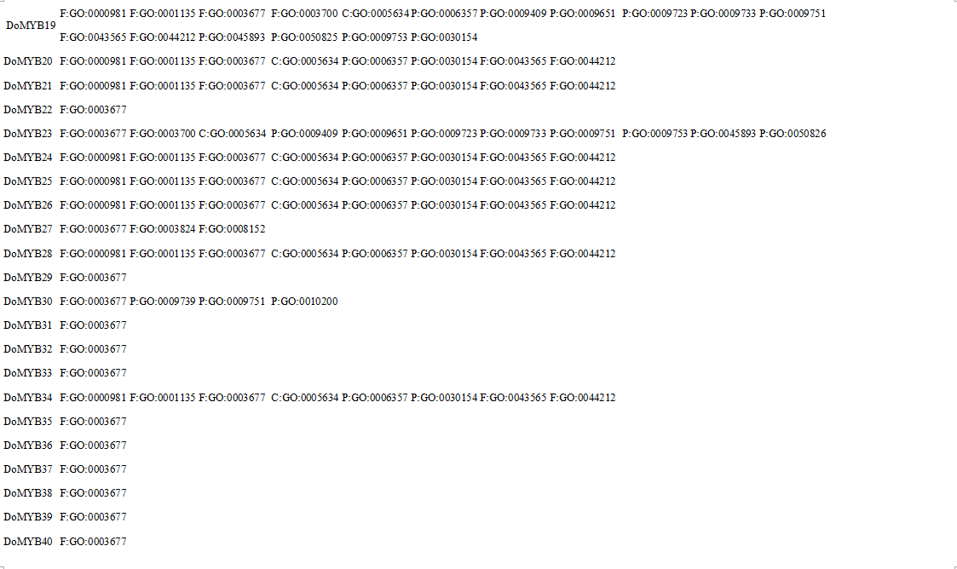
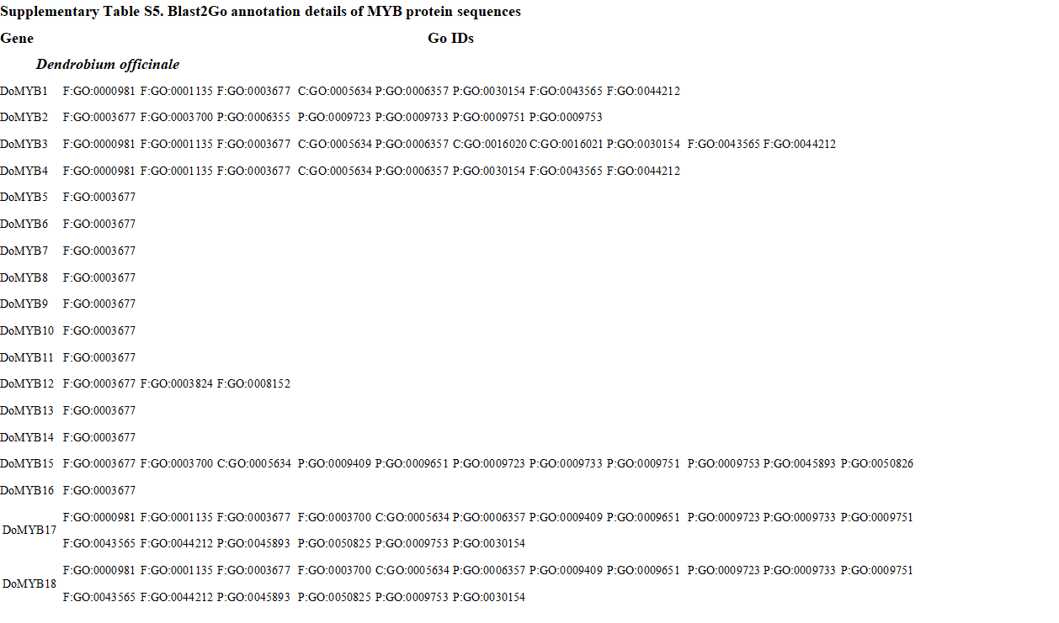

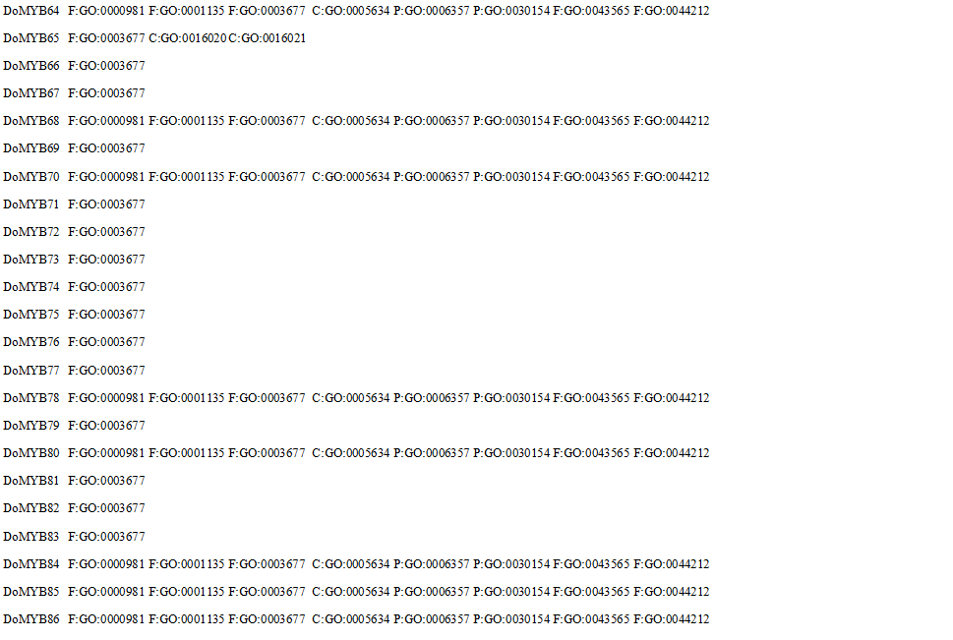
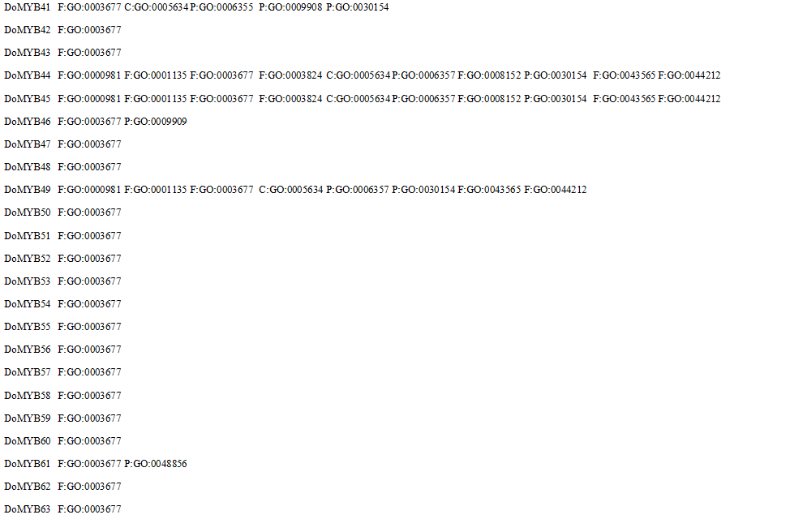

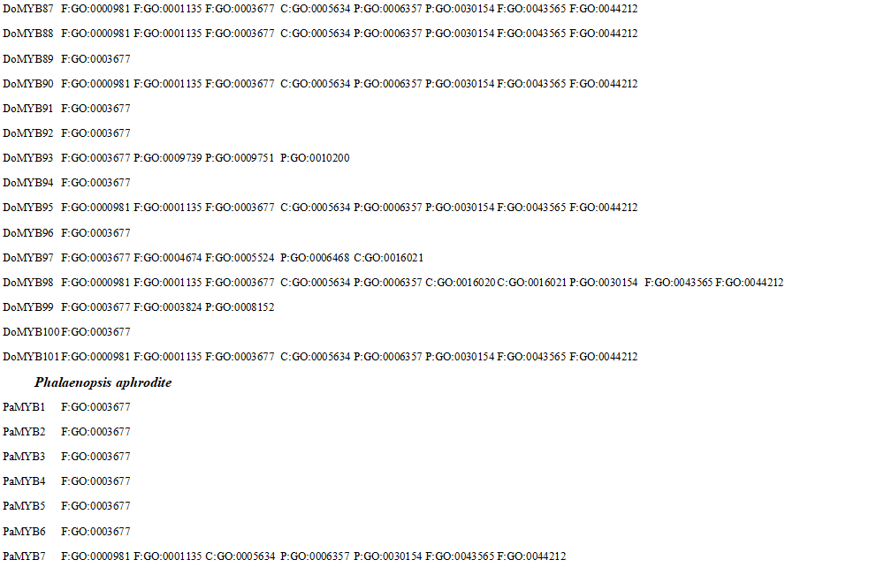
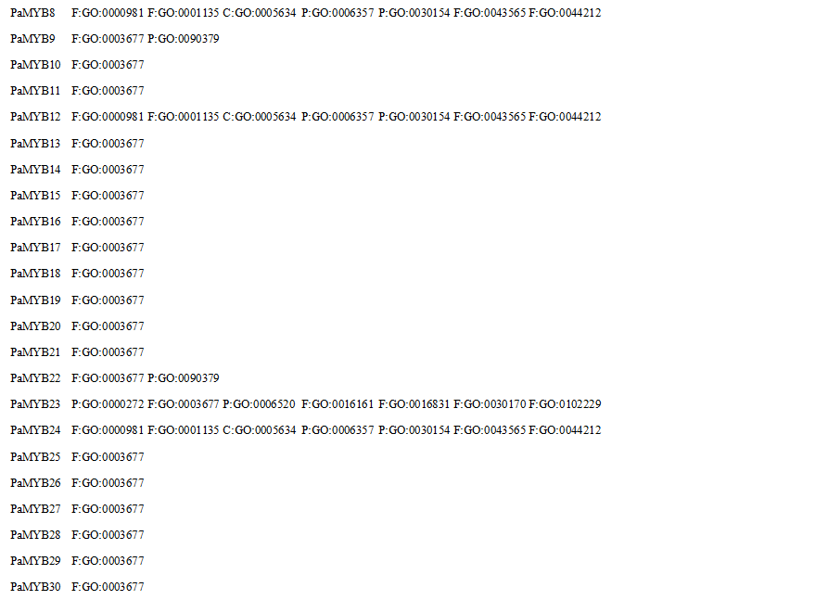

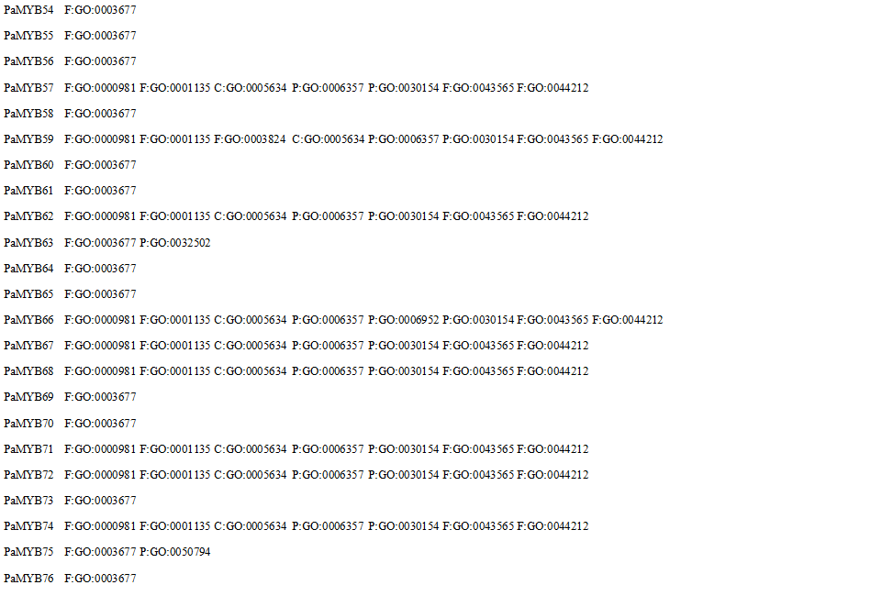
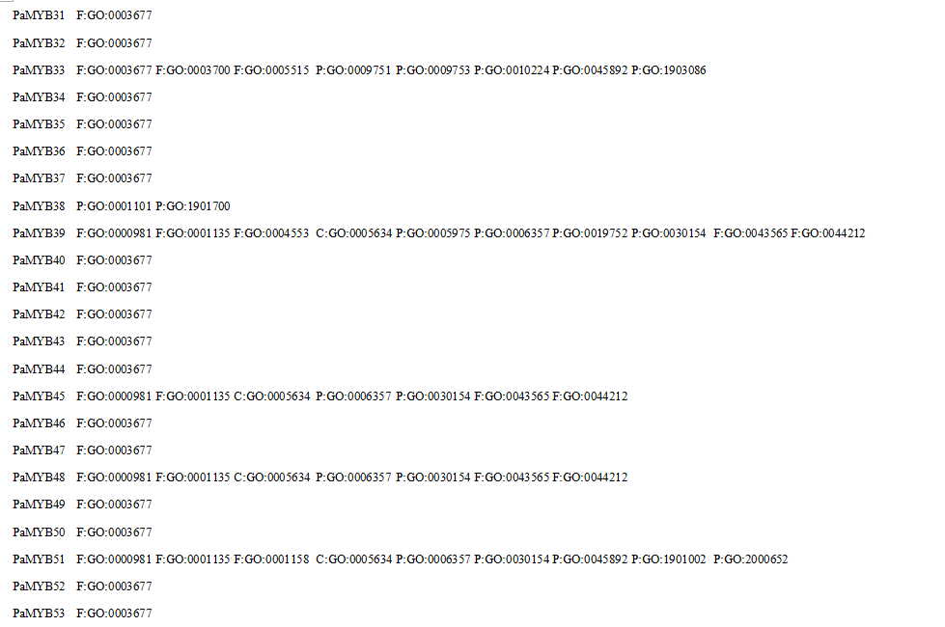

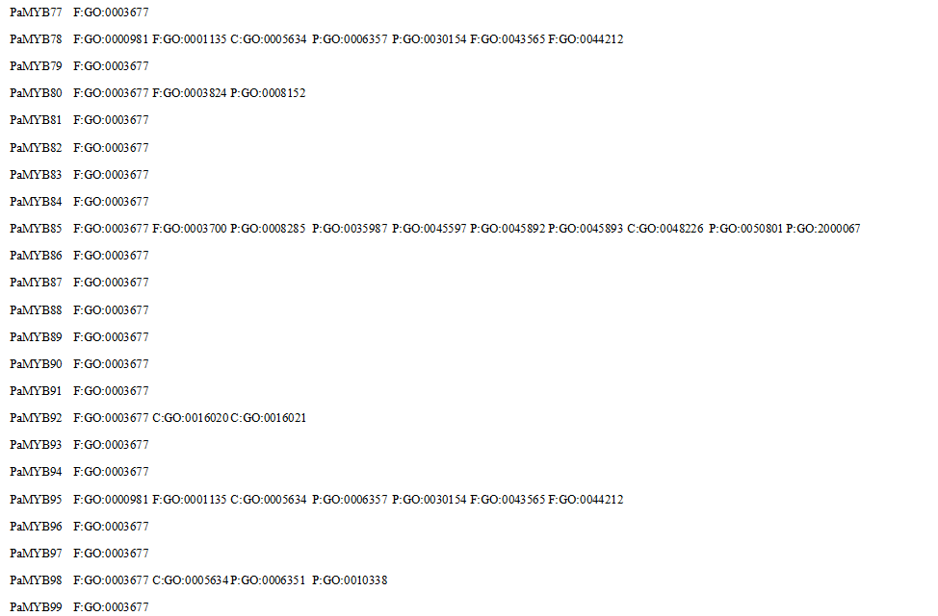

Supplementary Table S6. The similarity values of R2R3-PaMYB cluster
Gene 1 | Gene 2 | Similarity values
PaMYB4 | PaMYB5 | 58.05%
PaMYB6 | PaMYB7 | 47.93%
PaMYB8 | PaMYB9 | 70.19%
PaMYB10 | PaMYB18 | 60.15%
PaMYB11 | PaMYB13 | 73.75%
PaMYB16 | PaMYB20 | 59.17%
PaMYB19 | PaMYB21 | 67.97%
PaMYB23 | PaMYB39 | 54.39%
PaMYB25 | PaMYB27 | 41%
PaMYB29 | PaMYB31 | 55.12%
PaMYB32 | PaMYB34 | 49.76%
PaMYB37 | PaMYB52 | 52.17%
PaMYB40 | PaMYB43 | 35.51%
PaMYB44 | PaMYB60 | 35.74%
PaMYB45 | PaMYB57 | 43.69%
PaMYB48 | PaMYB50 | 68.97%
PaMYB49 | PaMYB51 | 47.43%
PaMYB53 | PaMYB56 | 58.16%
PaMYB54 | PaMYB58 | 62.78%
PaMYB55 | PaMYB61 | 42.34%
PaMYB62 | PaMYB72 | 64.68%
PaMYB64 | PaMYB65 | 100%
PaMYB67 | PaMYB69 | 47.54%
PaMYB73 | PaMYB91 | 87.25%
PaMYB74 | PaMYB79 | 54.88%
PaMYB75 | PaMYB85 | 50.46%
PaMYB76 | PaMYB94 | 37.62%
PaMYB78 | PaMYB87 | 51.20%
PaMYB80 | PaMYB97 | 18.34%
PaMYB82 | PaMYB88 | 46.46%
PaMYB83 | PaMYB90 | 48.88%
PaMYB84 | PaMYB86 | 53.33%
PaMYB89 | PaMYB93 | 37.22%

Supplementary Fig. S1 Phylogenetic relationships, intron pattern, and architecture of conserved protein motifs in R2R3-MYB proteins from P. Aphrodite. (B) The conserved motifs in the PaR2R3-MYB proteins were identified using MEME software. The grey lines represent nonconserved sequences, and each motif is indicated by a colored box numbered at the bottom. The lengths of the motifs in each protein are proportionally displayed; (C) Exon-intron structures were predicted and manually curated for the putative intact PaR2R3-MYB gene models. The yellow boxes and black lines represent exons and introns, respectively.

Supplementary Fig. S2 Gene Ontology (GO) analysis of the R2R3-MYB genes from D. officinale (A/B) and P. aphrodite (C/D). The size of each slice in the pie chart indicates the relative abundance of that GO term in the R2R3-MYBs.

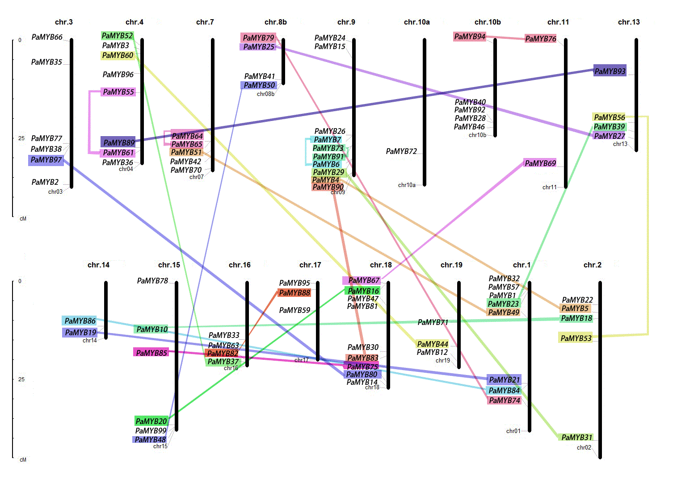

Supplementary Fig. S3 Chromosomal location analysis of the PaMYB genes. The colorful mark represented the PaMYB cluster. The chromosomal position of each PaMYB was mapped according to the GFF (General Feature Format) file from the online website (http://orchidstra2.abrc.sinica.edu.tw/orchidstra2/pagenome.php). The chromosome number is indicated at the end of each chromosome. The scale is in mega bases (Mb).

Supplementary Fig. S4 Coexpression network of the R2R3-DoMYB genes in tissues (A) and their responses to salt, drought, MeJA, SA and ABA treatments (B). Relative expression of 20 R2R3-MYB genes under 300 mM NaCl, 300 mM mannitol and 100 μM abscisic acid (ABA) treatments at 0, 1, 2, 3, 4, 7 d. Relative expression of 20 R2R3-MYB genes under 100 μM methyl jasmonate (MeJA), 100 μM salicylic acid (SA) treatments at 0, 2, 4, 8, 24, 48 and 72 h.

