**Figure S1.** Tree cover loss (>30% canopy cover) in primate range regions for the period 2001–2018. **(A)** Neotropics, **(B)** Africa (Madagascar is included in this graph, but it is distinguished by the yellow bar), **(C)** Southeast Asia, **(D)** South Asia. Source of data Global Forest Watch (http://www.globalforestwatch.org; accessed March 2020). Countries ranked by the amount of forest loss.

**(A)**



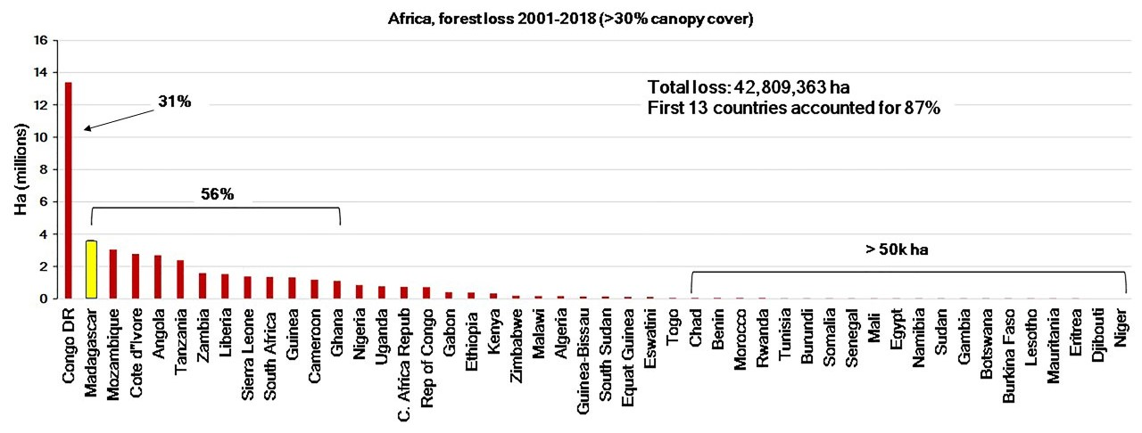**(B)**

Ha (millions)

**(C)**



Ha (millions)

**(D)**

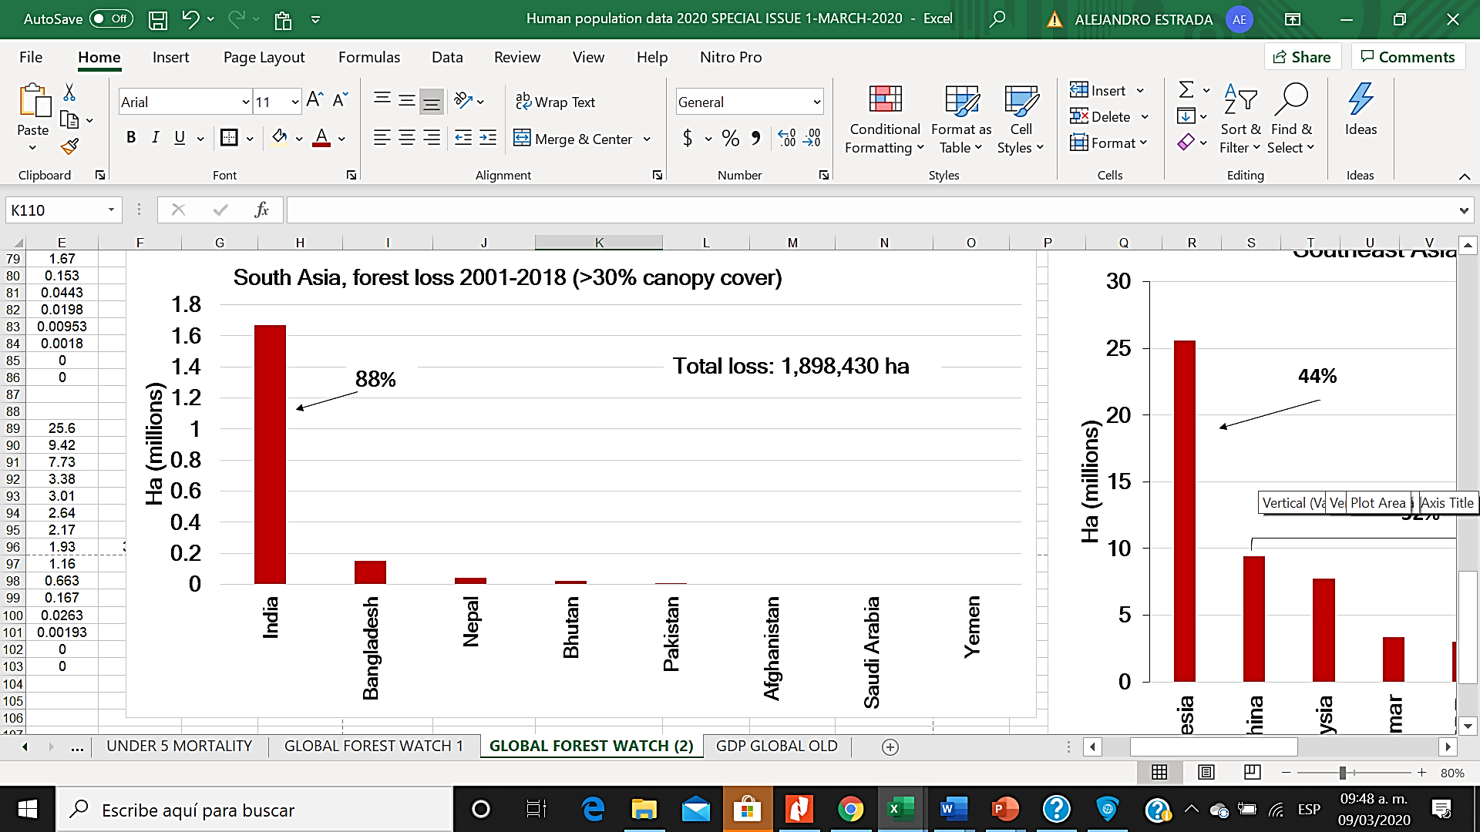

Ha (millions)