**SUPPLEMENTARY TABLES, FIGURES AND TEXT**

**Appendix S1.** Allowable fishing activities in Rockfish Conservation Areas (RCAs) of British Columbia. While Fisheries and Oceans Canada created RCAs to protect rockfish from the highest-risk fisheries (namely commercial and/or recreational fishers using bottom trawl, longline, or hook-and-line gear), this table lists (by sector) allowable fishing activities within RCAs (data source: Fisheries and Oceans Canada).

|  |  |  |  |
| --- | --- | --- | --- |
| Commercial fishing sector | Recreational fishing sector | | Indigenous Peoples |
| Invertebrates by hand picking or dive | Invertebrates by hand picking or dive | | Food, social and ceremonial fisheries (includes harvests of rockfish and other groundfish by longline or hook-and-line gear) |
| Crab by trap | Crab by trap | |  |
| Prawn by trap | Shrimp/prawn by trap | | |
| Scallops by trawl | Smelt by gillnet | |  |
| Salmon by seine or gillnet |  |  |  |
| Herring by gillnet, seine and spawn-on-kelp |  | |  |
| Sardine by gillnet, seine, and trap |  |  |  |
| Smelt by gillnet |  |  |  |
| Euphausiid (krill) by mid-water trawl |  |  |  |
| Groundfish by mid-water trawl |  |  |  |

**Appendix S2.** Characteristics of RCAs of British Columbia’s Central Coast (Data source: Fisheries and Oceans Canada) and number of dives conducted at each location, by treatment (protected = within RCA; control = paired site ≤10km from RCA boundary). See Fig. 1 in main text.

|  |  |  |  |  |
| --- | --- | --- | --- | --- |
| RCA | Area (km2) | Year established | Number of dives conducted | |
|  |  |  | Protected | Control |
| West Aristazabal | 493.1 | 2005 | 10 | 16 |
| 1Goose Island | 105.5 | 2004 | 7 | 4 |
| Smith Sound | 70.8 | 2004 | 13 | 16 |
| 1McMullin Group | 68.8 | 2004 | 5 | 14 |
| Kitasu Bay | 64.8 | 2005 | 18 | 12 |
| 2West Calvert Island | 57.1 | 2005 | 1 | 3 |
| Fish Egg Inlet | 28.2 | 2004 | 9 | 20 |

1 Though contiguous to each other, these RCAs are managed separately and were analyzed separately.

2Excluded from analysis due to low sample size.

**Appendix S3.** Topographic structural complexity scores recorded during dive surveys.

|  |  |
| --- | --- |
| Score | Definition |
| 0 | Fines (e.g. sand or mud) |
| 1 | cobbles and/or cracks in bedrock are small and few |
| 2 | boulders <50-cm diameter, large cracks in bedrock often present |
| 3 | boulders 50-100 cm diameter and a combination of smaller boulders or abundant large cracks in bedrock. |
| 4 | boulders with >100 cm diameter, and a combination of smaller boulders or large cracks in bedrock. |

**Appendix S4.** Estimated vs. actual sizes of fish models suspended in the water column. These tests were conducted early during diver training and not repeated during the study (prior colleagues trained AF who trained TL who trained DVM). In the figure, the black line is the 1-to-1 diagonal. For each diver, the table below indicates the test date, R2 for the linear regression of estimated vs. actual sizes, mean error (estimated minus actual size), and years of data collection for the study. Other divers were involved in the work but they collected only habitat data.



|  |  |  |  |  |
| --- | --- | --- | --- | --- |
| **Diver** | **Date of test** | **R2** | **Mean error (cm)** | **Survey years** |
| AF | 9-Jul-2010 | 0.97 | -1.3 | 2013-2019 |
| DVM | 6-Feb-2017 | 0.99 | -1.5 | 2016-2019 |
| TL | 6-Feb-2017 | 0.99 | 0.7 | 2016-2019 |

**Appendix S5.** Rockfish species observed but excluded from analysis.

|  |  |  |
| --- | --- | --- |
| **Scientific name** | **Common Name** | **Reasons for excluding** |
| *S. jordani* | Shortbelly rockfish | Unfished species with too few observations for analysis. |
| *S. auriculatus* | Brown rockfish | Exploited species lacking literature data on growth rates in British Columbia or vicinity. |
| *S. diaconus* | Deacon rockfish | Exploited species classed as the only low mobility-benthopelagic species, but observations too few for analyses. |
| *S. proriger* | Redstripe rockfish | Exploited species lacking information on movement behavior. |
| *S. variabilis* and *S. ciliatus* | Dusky and dark rockfish | Two closely related species which are exploited but difficult to distinguish during visual dive surveys |

**Appendix S6.** Relationship between von Bertalanffy growth parameter *k* and maximum lifespan. Each data point is associated with the common name of the corresponding rockfish species. Values are averaged for males and females. Table 1 (main text) provides actual values, data sources and scientific names of species. Note the lack of a *k* value for Tiger rockfish.

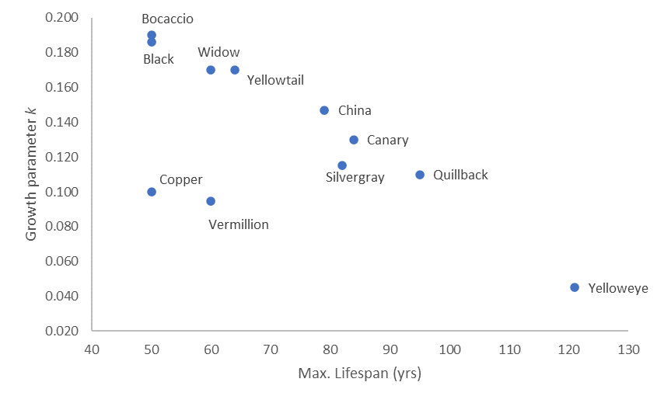

**Appendix S7.** Estimating *k* for tiger rockfish (*S. nigrocinctus*).

Based on data displayed in Appendix S6 for *k* and maximum lifespan (*L*):

1. $k=0.291-0.002×L$, if outliers for Copper and Vermillion rockfishes are excluded (R² = 0.97), and
2. $k=0.232-0.0014×L$, if all data are included (R² = 0.47).

For tiger rockfish, *L*= 116 and $k=0.059$ if using equation (a), or $k=0.070$ if using equation (b). Results in the main text are based on $k=0.059$, while Appendix S16 shows similar results when $k=0.070$ is used.

**Appendix S8.** Information used to determine movement classes in Table 1 of main text.

|  |  |  |  |
| --- | --- | --- | --- |
| ***Sebastes* species** | **Common Name** | **Movement class** | **Movement description** |
| *\*S emphaeus* | Puget Sound rockfish | **\*** | **\*** |
| *S. melanops* | Black rockfish | High | 175th percentile of distances moved = 16.0 km. |
| *S. paucispinis* | Bocaccio | High | 2In California, 10 of 16 tagged fish (63%) spent >90% of time outside a 12-km2 study area. |
| *S. caurinus* | Copper rockfish | Low | 175th percentile of distances moved = 1.6 km |
| *S. miniatus* | Vermilion rockfish | Low | 175th percentile of distances moved = 0.1 km. |
| *S. entomelas* | Widow rockfish | High | 3Expert opinion classifies adults and subadults as very mobile. |
| *S. flavidus* | Yellowtail rockfish | High | 175th percentile of distances moved = 118.7 km. |
| *S. nebulosus* | China rockfish | Low | Love *et al.* (2002) describe the species as “territorial” with horizontal movements estimated at <10 m off Vancouver.  4,5Limited tag data show low mobility and site fidelity during periods lasting 217 days to 2 years. |
| *S. brevispinis* | Silvergray rockfish | High | 3Expert opinion classifies adults and subadults as likely very mobile and benthopelagic. |
| *S. pinniger* | Canary rockfish | High | 4Tagged indviduals moved straight-line distances of up 700 km over 4 years.  5Large horizontal movements recorded within a 52 km2 acoustic array, and some individuals were inferred to leave the study area. Vertical movements also were large (up to 27 m). |
| *S. maliger* | Quillback rockfish | Low | 175th percentile of distances moved = 0.1 km. |
| *S. nigrocinctus* | Tiger rockfish | Low | 6Adults are territorial and generally remain near rocky shelters.  5Acoustic data on a single 37-cm-long individual showed little movement over 2 years. |
| *S. ruberrimus* | Yelloweye rockfish | Low | 6Adults are territorial and spend much of their time within crevices.  5Acoustically-tagged subadults (N=3, TL= 39–51 cm) had strong site fidelity. |

*Movement data were unavailable but no required.

1Freiwald (2012).

2Starr et al. (2002).

3Experts consulted: MS Love, DR Haggarty, CN Rooper.

4Lea *et al.* (1999).

5Hannah & Rankin (2011).

6Butler *et al.* (2012).

References

Butler, J.L., Love, M.S. & Laidig, T.E. (2012). *A guide to the rockfish, thornyheads, and scorpionfishes of the northeast Pacific.* University of California Press, Berkley, CA.

Freiwald, J. (2012). Movement of adult temperate reef fishes off the west coast of North America. *Can. J. Fish. Aquat. Sci.*, 69, 1362–1374.

Hannah, R.W. & Rankin, P.S. (2011). Site Fidelity and Movement of Eight Species of Pacific Rockfish at a High-Relief Rocky Reef on the Oregon Coast. *North Am. J. Fish. Manag.*, 31, 483–494.

Lea, R.N., McAllister, R.D. & VenTresca, D.A. (1999). Biological Aspects of Nearshore Rockfishes of the Genus Sebastes from Central California With Notes On Ecologically Related Sport Fishes. *Calif. Dep. Fish Game Fish Bull.*, 177, 1–109.

Love, M., Yoklavich, M. & Thorsteinson, L. (2002). *The Rockfishes of the Northeast Pacific*. University of California Press, Berkley, CA.

Starr, R.M., Heine, J.N., Felton, J.M. & Cailliet, G.M. (2002). Movements of bocaccio (Sebastes paucispinis) and greenspotted (S. chlorostictus) rockfishes in a Monterey submarine canyon: implications for the design of marine reserves. *Fish. Bull.*, 100, 324–337.

**Appendix S9.** Number of sites sampled by RCA age, treatment, and location. Most sites (68%) were sampled when RCAs were 13-15 years old.



**Appendix S10.** Number of individual fish observed, by RCA age. Only observations that met analysis criteria are included (see main text). For exploited species, 72.3% of 13224 observations occurred when RCAs were 13-15 years.

**a) Exploited species**



**b) Puget Sound rockfish**



**Appendix S11.** Number of individual rockfishes observed, by species, location, and RCA treatment (in = protected vs. out = control). Bottom two rows give totals for exploited species classed as low mobility-demersal (LM-D) or high mobility-benthopelagic (HM-B); these totals exclude Puget Sound rockfish (*S. emphaeus*), the only unfished species. Sample sizes are skew-corrected and only observations that met analysis criteria are shown (see main text). See Table 1 of main text for other scientific names.

|  |  |  |  |  |  |  |  |  |  |  |  |  |
| --- | --- | --- | --- | --- | --- | --- | --- | --- | --- | --- | --- | --- |
| Rockfish species | Fish Egg Inlet | | Goose Island | | Kitasu Bay | | McMullin Group | | Smith Sound | | W. Aristazabal Is. | |
|  | in | out | in | out | in | out | in | out | in | out | in | out |
| Black | 0 | 62 | 131 | 172 | 57 | 412 | 58 | 666 | 510 | 61 | 80 | 352 |
| Bocaccio | 4 | 0 | 20 | 0 | 30 | 190 | 0 | 11 | 0 | 0 | 0 | 0 |
| Canary | 0 | 0 | 0 | 6 | 7 | 28 | 0 | 0 | 54 | 9 | 0 | 24 |
| China | 0 | 2 | 58 | 47 | 28 | 56 | 60 | 120 | 83 | 36 | 68 | 89 |
| Copper | 5 | 99 | 59 | 51 | 53 | 21 | 26 | 72 | 25 | 56 | 9 | 24 |
| Puget Sound | 576 | 11 | 20 | 144 | 420 | 544 | 5 | 7 | 257 | 77 | 33 | 203 |
| Quillback | 111 | 360 | 95 | 45 | 418 | 151 | 37 | 173 | 182 | 197 | 74 | 232 |
| Silvergray | 1 | 31 | 0 | 0 | 2 | 0 | 0 | 0 | 20 | 7 | 0 | 0 |
| Tiger | 0 | 1 | 7 | 8 | 36 | 38 | 7 | 11 | 3 | 0 | 7 | 5 |
| Vermillion | 6 | 11 | 92 | 6 | 7 | 2 | 5 | 7 | 3 | 5 | 0 | 9 |
| Widow | 0 | 759 | 0 | 0 | 350 | 350 | 0 | 0 | 167 | 182 | 0 | 40 |
| Yelloweye | 0 | 15 | 0 | 6 | 4 | 10 | 5 | 3 | 19 | 11 | 1 | 2 |
| Yellowtail | 354 | 922 | 36 | 9 | 1476 | 505 | 85 | 300 | 190 | 339 | 122 | 462 |
| Total: LM-D | 122 | 488 | 311 | 163 | 546 | 278 | 140 | 386 | 315 | 305 | 159 | 361 |
| Total: HM-B | 359 | 1774 | 187 | 187 | 1922 | 1485 | 143 | 977 | 941 | 598 | 202 | 878 |

**Appendix S12.** Size frequency distributions, by species and RCA treatment. Asterisks indicate high mobility-benthopelagic species; the remainder are low mobility-demersal (except Puget Sound rockfish). Red arrows indicate approximate size at 50% maturity (see values, data sources and scientific species names in Table 1 of main text). Sample sizes and the percent of fish that had reached or exceeded length at 50% maturity (TL50mat) are indicated. Only observations that met analysis criteria are included.

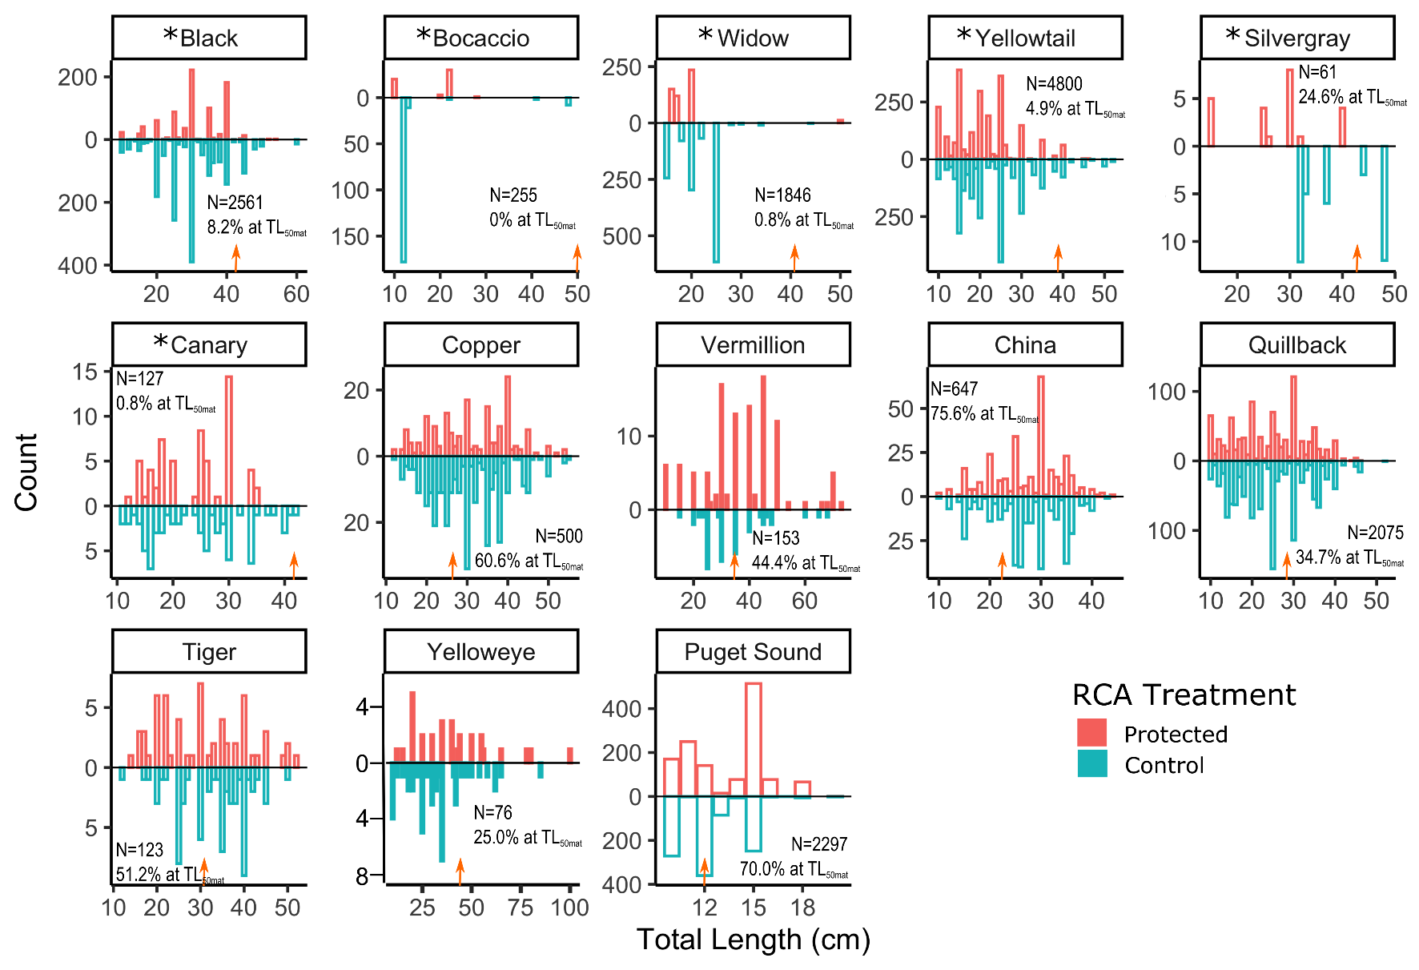

**Appendix S13a.** AICc model selection statistics for competing generalized least squares models (GLSMs) for exploited species. The top row indicates the best supported model (Fig. 2a in main text). Variable inclusion is shown by plus symbols. Additional models with less support are not shown. (Complexity refers to topographic structural complexity). These results are based on the parameter k value for tiger rockfish obtained with equation (a) in Appendix S7).



**Appendix S13b**. AICc model selection statistics for competing GLSMs for the unfished Puget Sound rockfish. The top row indicates the best supported model (Fig. 2b in main text). Variable inclusion is shown by plus symbols.

|  |  |  |  |  |  |  |  |  |  |
| --- | --- | --- | --- | --- | --- | --- | --- | --- | --- |
| Complexity | Depth | RCA treatment | RCA location | RCA treatment X RCA location | df | logLik | AICc | delta | weight |
| + | + |  |  |  | 6 | -201.82 | 416.6 | 0 | 0.438 |
| + | + | + |  |  | 7 | -201.09 | 417.4 | 0.85 | 0.287 |
| + | + | + | + | + | 17 | -188.92 | 419.3 | 2.74 | 0.111 |
| + | + |  | + |  | 11 | -197.30 | 419.6 | 3.05 | 0.095 |
| + | + | + | + |  | 12 | -196.34 | 420.3 | 3.71 | 0.069 |

**Appendix S14.** Diagnostics for the top GLSMs shown in Fig. 2 of main text.

1. Exploited species



1. Puget Sound rockfish



**Appendix S15.** Length anomalies for the unfished Puget Sound rockfish estimated by the best GLSM (Fig. 2b of main text) in relation to topographic structural complexity (at depth = 30 m) and depth (at topographic structural complexity = 3).

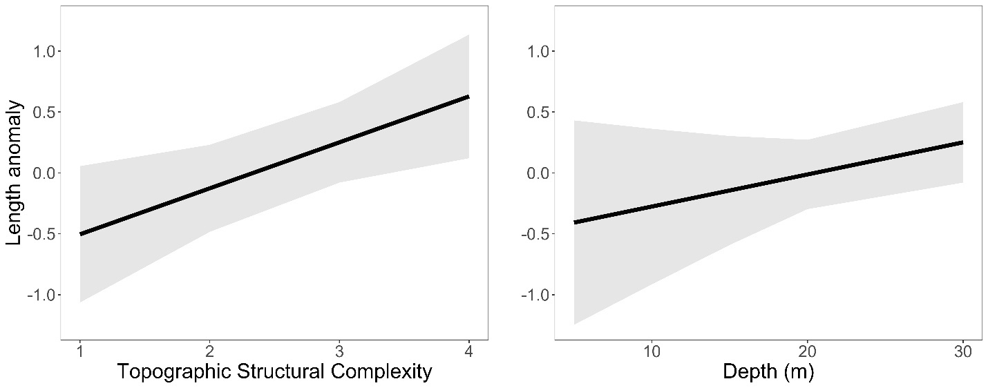

**Appendix S16.** Best generalized least squares model (as determined by AICc model selection) describing body size responses by exploited species when using the alternative value of $k=0.070$ for tiger rockfish; see Appendix S7. Panel (a) shows standardised coefficients with 95% confidence intervals (horizontal lines) and relative importance values. Panel (b) shows estimated responses by demersal species at 30 m depth and structural complexity = 3; results are very similar to those shown in the main text (i.e., when $k=0.059$ is used for tiger rockfish).

a)

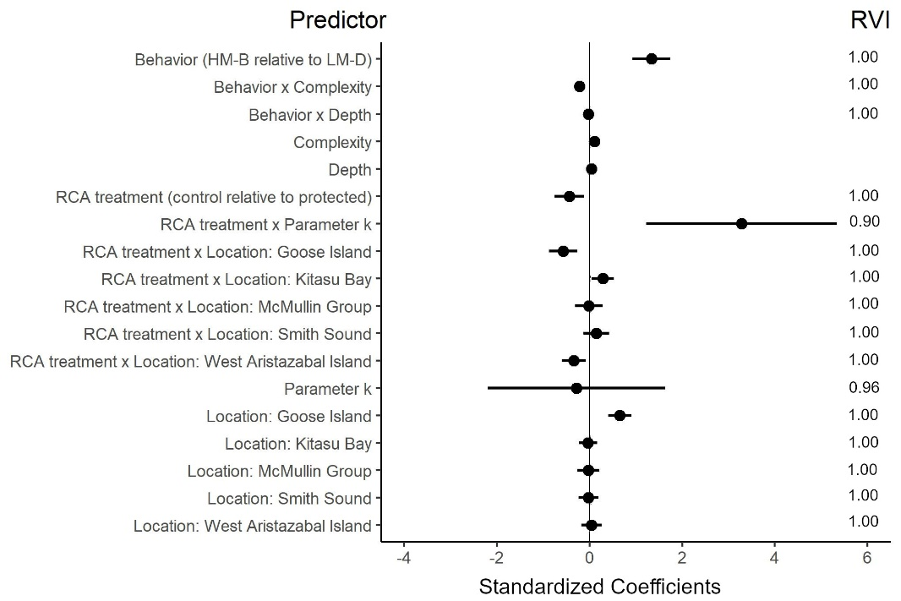

b)

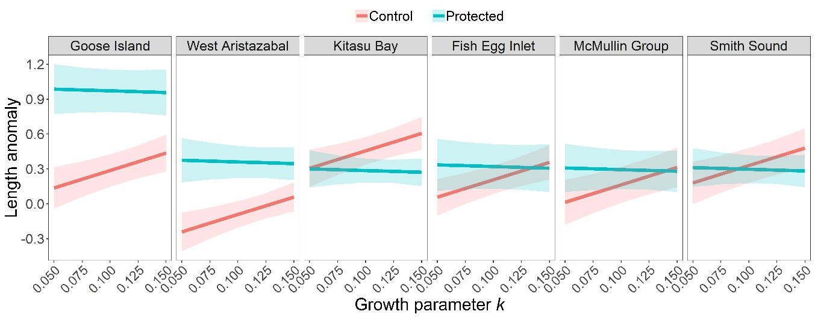

Appendix S17. Descriptive scatterplots of length anomalies of exploited species in relation to (a) parameter *k*, RCA treatment, RCA location and behavioral class (all depths and complexity values pooled), and (b) in relation to topographic structural complexity or depth, by behavioral class and RCA treatment (all locations and *k* values pooled).

a)

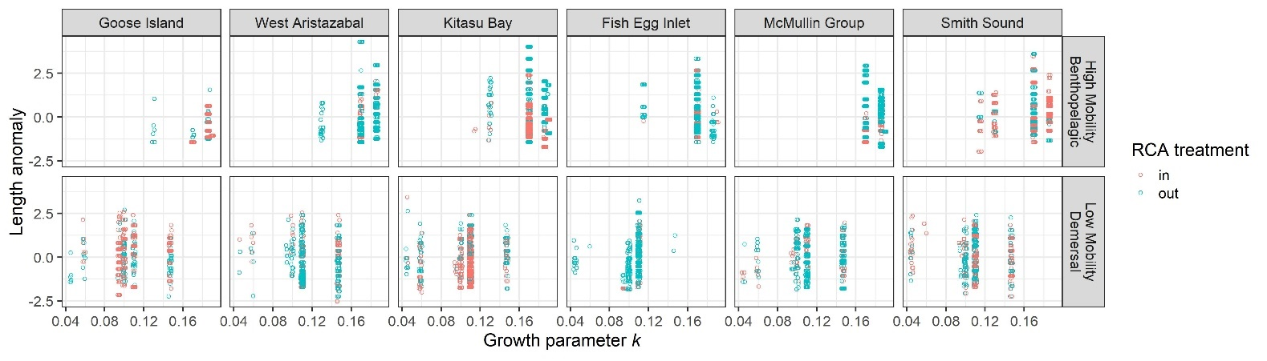

b)

