Hypercarnivorous teeth and healed injuries to Canis chihliensis from early Pleistocene Nihewan beds, China, support social hunting for ancestral wolves

Hao-wen Tong^{1,2,*}, Xi Chen³, Bei Zhang^{1,2,4}, Bruce Rothschild⁵, Stuart C. White⁶, Mairin Balisi⁷, and Xiaoming Wang^{1,7,*}
¹ Key Laboratory of Vertebrate Evolution and Human Origins of Chinese Academy of Sciences, Institute of Vertebrate Paleontology and Paleoanthropology, Chinese Academy of Sciences, Beijing, China
² CAS Center for Excellence in Life and Paleoenvironment, Beijing, China
³ Nanjing Normal University, Nanjing, China
⁴ University of Chinese Academy of Sciences, Beijing, China
⁵ Department of Vertebrate Paleontology, Carnegie Museum of Natural History, Pittsburgh, Pennsylvania, USA
⁶ School of Dentistry, University of California, Los Angeles, California, USA
⁷ Natural History Museum of Los Angeles County, California, USA.

Supplementary Information
The following are additional figures cited in the main text.
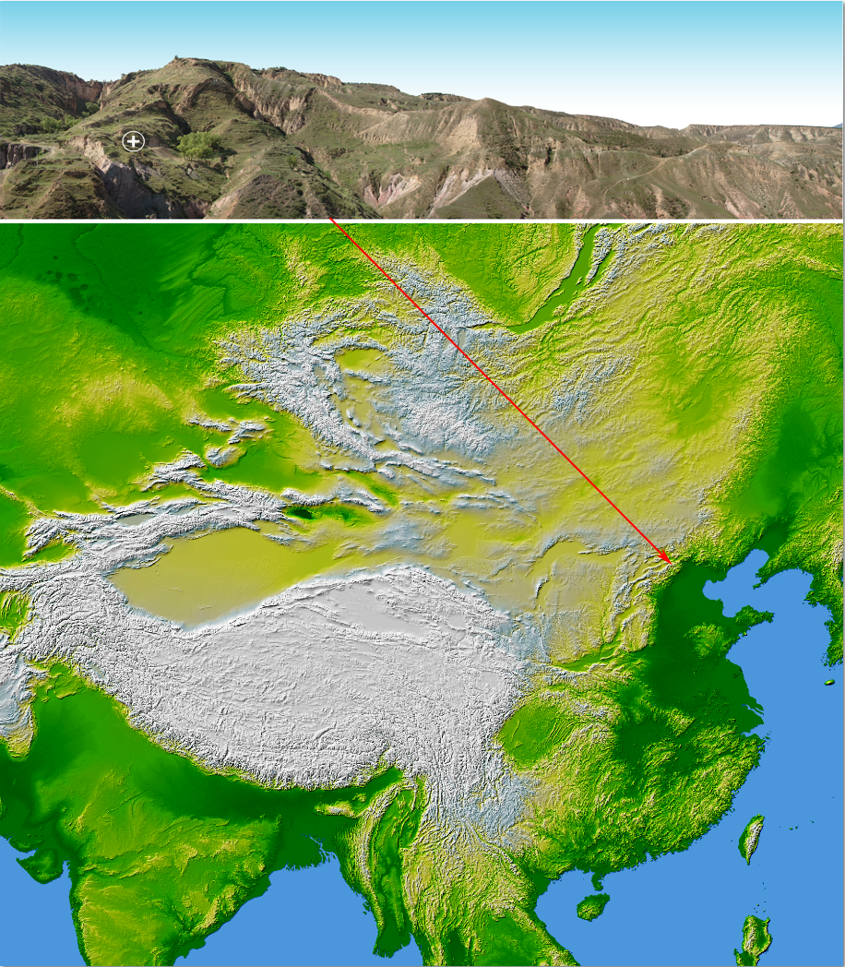
Figure S1 Photograph of the Shanshenmiaozui Site and map location of the Nihewan Basin. Topographic image is modified from NASA Earth Observatory (https://earthobservatory.nasa.gov/images/3741/topography-of-the-world).

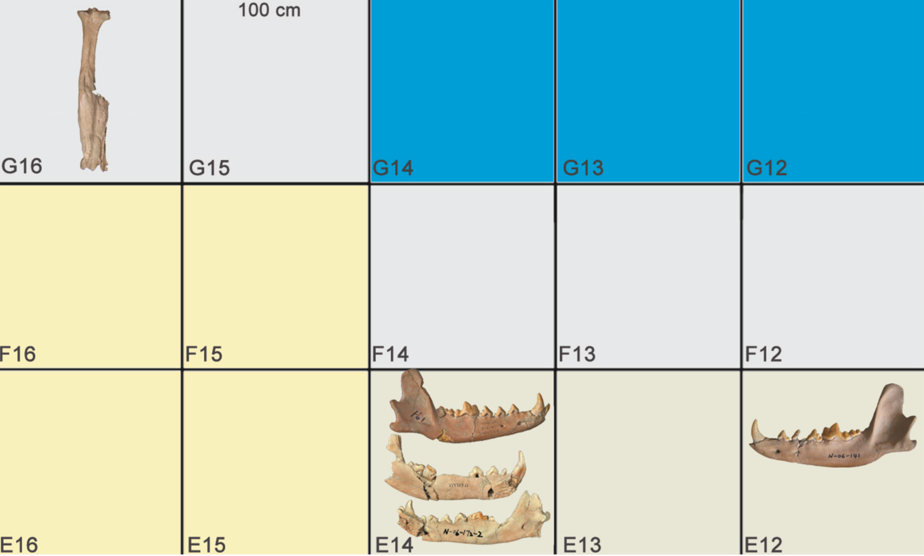
Figure S2 Excavation grid (1 x 1 m) with representative Canis specimens discussed in this paper.

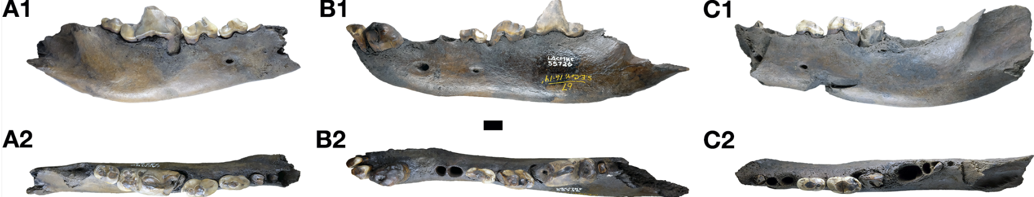

Figure S3 Examples of dentaries of Canis dirus from the late Pleistocene Rancho La Brea asphalt seeps bearing abscesses, alveolar resorption, and tooth fracture in the p4-m1 region similar to those in the pathological C. chihliensis dentaries. A1, B1, and C1 lateral views; A2, B2, and C2 occlusal views. Scale bar = 1 cm. A, LACMHC 13262, right dentary with heavy occlusal wear and alveolar abscess with root drainage on the anterior m1, from Pit 4; B, LACMHC 55726, left dentary with heavy occlusal wear, possible abscess around the anterior alveoli of p4 and m1, and m1 fractured anteriorly, from Pit 61/67; C, LACMHC 55730, left dentary with heavy occlusal wear, fractured m1, and alveolar reaction around the roots, also from Pit 61/67.

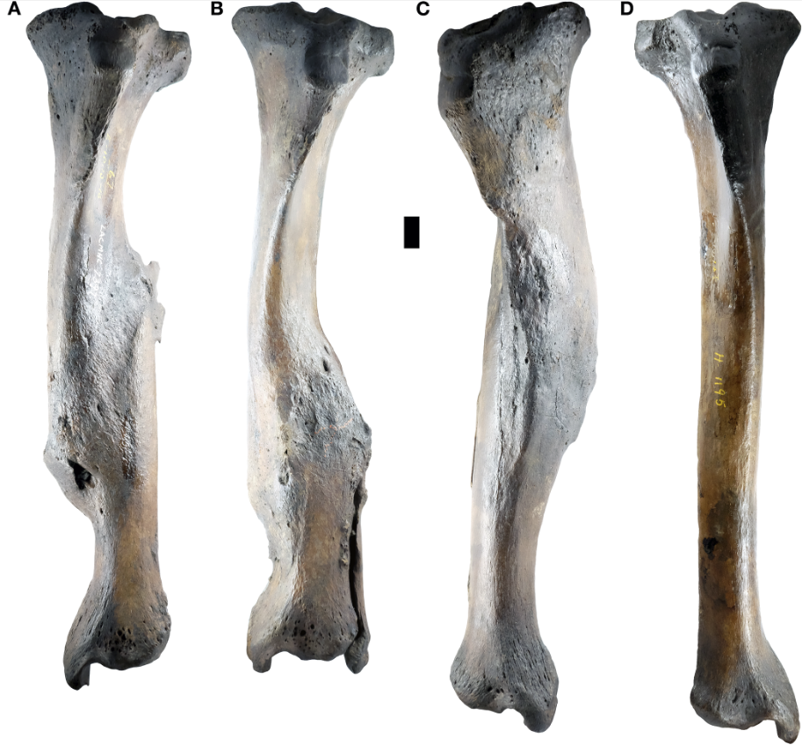
Figure S4 Examples of tibiae of Canis dirus from the late Pleistocene Rancho La Brea asphalt seeps bearing healed oblique fractures of the mid-shaft with foreshortening of the bone, similar to that in the pathological C. chihliensis tibia (Figs. 4, 5). Scale bar = 1 cm. A, LACMHC 7397, left tibia, from Pit 61/67; B, LACMHC 7396, left tibia with distal fibula attached and involved in the oblique fracture, from Pit 61/67; C, LACMHC 7336, right tibia with fused fibula fragment, from Pit 61/67; D, LACMHC H-1195, non-pathologic right tibia for comparison, no deposit data available.

