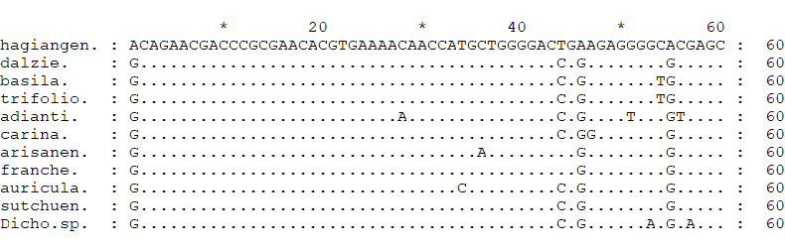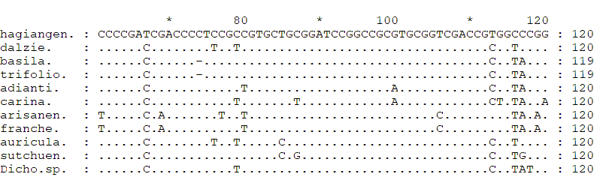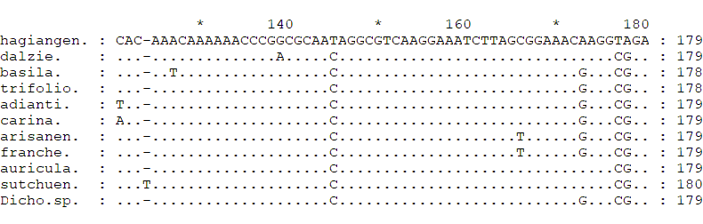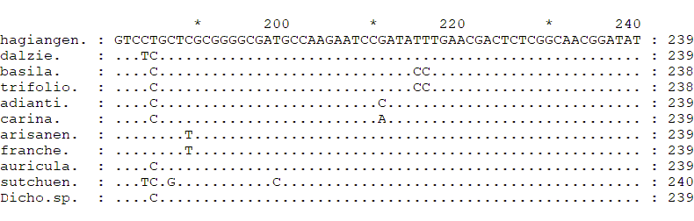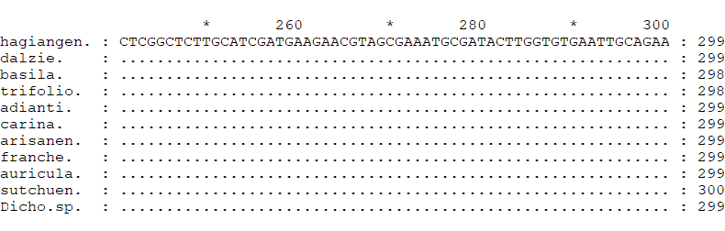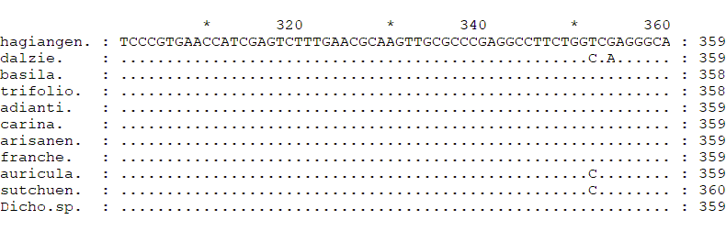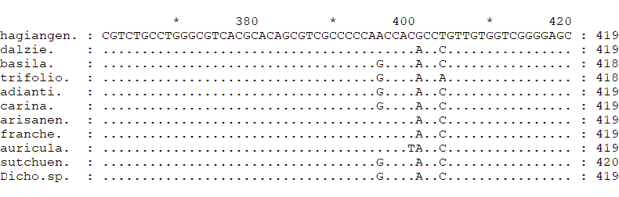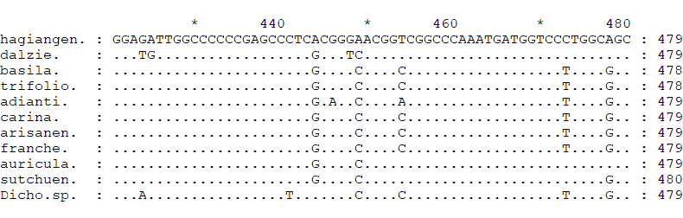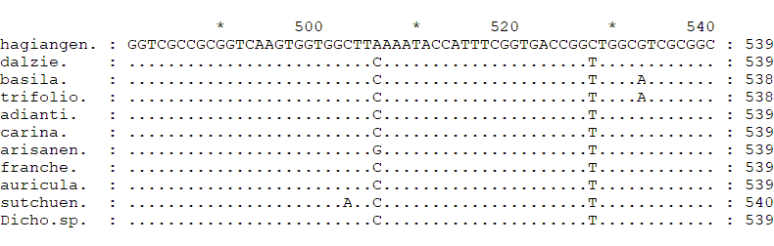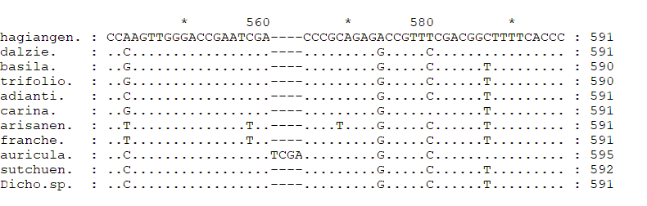 Supplemental. Multiple sequence alignment of the ITS sequence of Dichocarpum hagiangensis with Dichocarpum group (hagiangen.=D. hagiangensis; dalzie.=D. dalzielii; basila.=D. basilare; trifolio.=D. trifoliolatum; adianti.=D. adiantifolium; carina.=D. carinatum; arisanen.=D. arisanense; franche.=D. franchetii; auricula.=D. auriculatum; sutchuen.=D. sutchuense; Dicho.sp.= Dichocarpum sp.)

